**Using Microsoft Project do the following project schedule and then answer the questions that follow**

* Create a project for developing a website with the following phases
  + Requirements
  + Analysis
  + Development
  + Testing
* Onboard your team
  + Messi (BA) Rate 100 $/hr
  + Rocky (Dev) Rate 125 $/hr + Overtime rate 150$/hr
  + Kate (QA) Rate 80 $/hr
* Create two tasks under each phase and assign resources appropriately
  + For requirements
    - BRD Authoring (Messi – 100%) – 2 weeks
    - BRD Review (Messi – 50%, Rocky 50%) – 3 days
  + Analysis
    - FSD authoring (Messi – 100%) – 2 weeks
    - FSD Review (Messi – 50%, Rocky 50%) – 5 days
  + Development
    - Developing the website (Rocky 100%, Messi 25%) – 5 weeks
    - Unit Testing (Rocky 100%, Messi 25%) – 2 weeks
  + Testing
    - Test case authoring (Kate 100%) – 1 week
    - Test case execution (Kate 75%, Messi 25%, Rocky 75%) – 4 weeks
* Dependencies
  + BRD Review can start half way when Authoring is done
* As it takes 3 days only for BRD review and assuming it cannot be completed before the Authoring , I have changed the Finish to start – 7Days to FINISH to FINISH
  + FSD Authoring can start in paralles to BRD review
  + FSD review has to finish 1 day after authoring.(it changes after resource scheduling)
  + Development has to start after analysis is completed
  + Test case authoring can start after BRD review is completed
  + Test case execution has to start after unit testing is completed

**Demonstrate the following**

1. Develop the project schedule showing dependencies

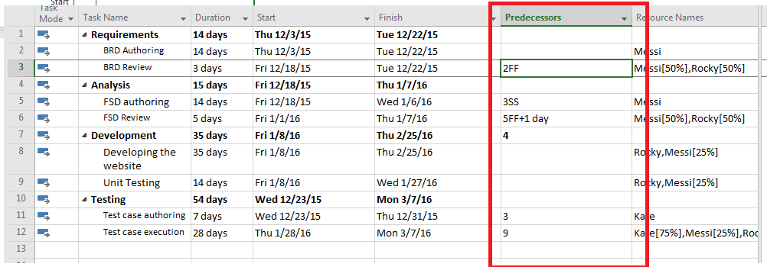

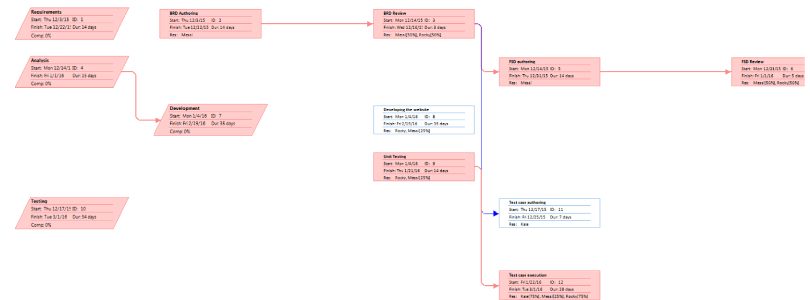

1. **Gantt Chart: Copy—>Copy Picture—>Select the date rage**

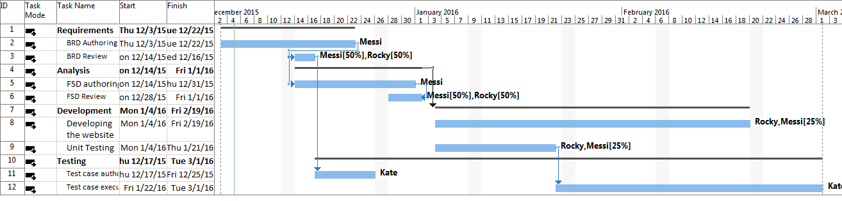

1. **Critical path: Marked in red- The path that defines the length of the project. Alterations to the schedule in the Critical path alter the schedule of the project**

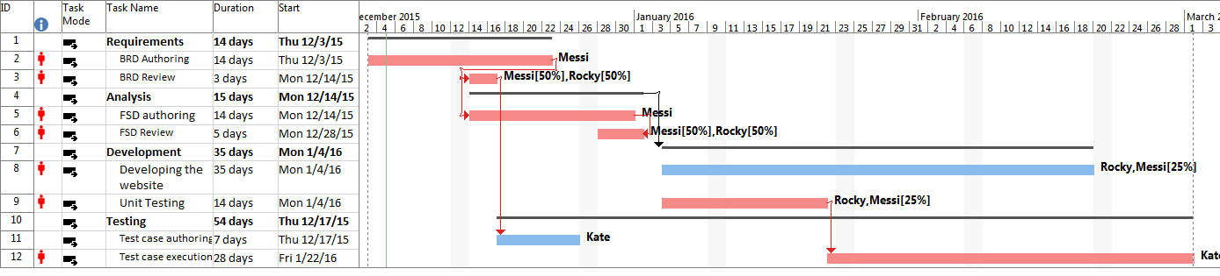

1. **Resource Leveling: Resource🡪Level Resource -- Method to not overwork resources. Distribute or alter schedule to maintain the 8 hrs**

Leveling Messi – Date changed to March 21

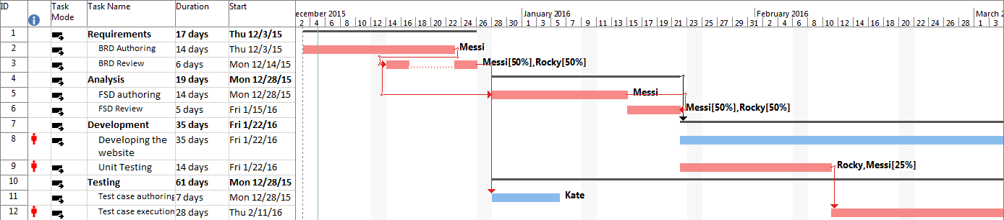

1. **Setting project baseline**

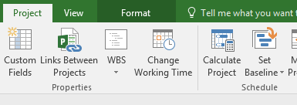

1. Earned value cost indicators🡪 View Table🡪More Table --- Indicator that show the current progress VS baselined cost for that point.

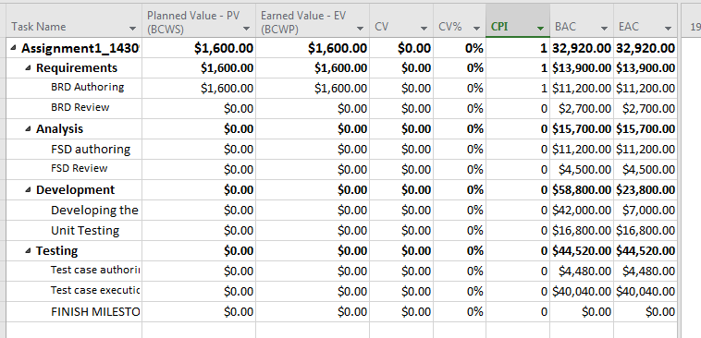

BAC- Baselined cost

EAC- Estimated cost

1. Earned value schedule indicators

Indicator that show the current schedule (how much work is completed) progress VS baselined progress for that point.

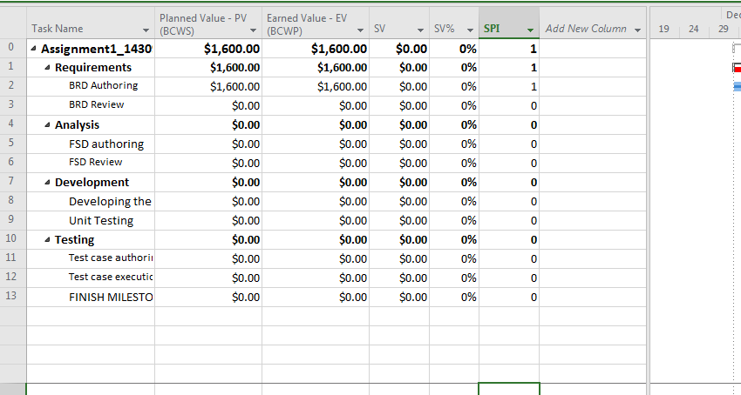

Possible bug in excel

1. **Showing slack in the Gantt chart**

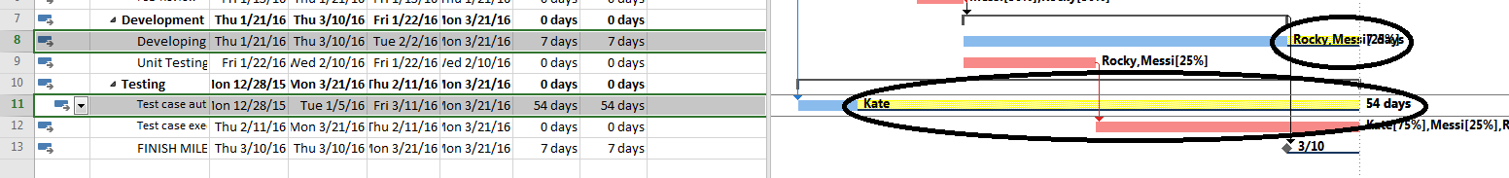

Slack marked in yellow

How much a project can be delayed in a non-critical path.

Format(check Slacks) or

Format---BarStyles—

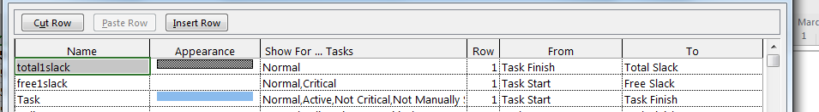

1. **Add a milestone**

Add a mile stone with duration 0 for development phase 7



1. Demonstrate a custom report to show resource usage (optional)

Reports-🡪resource overview

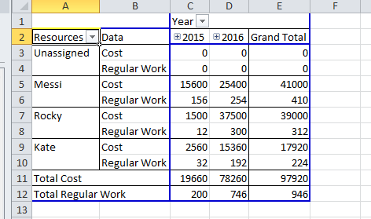

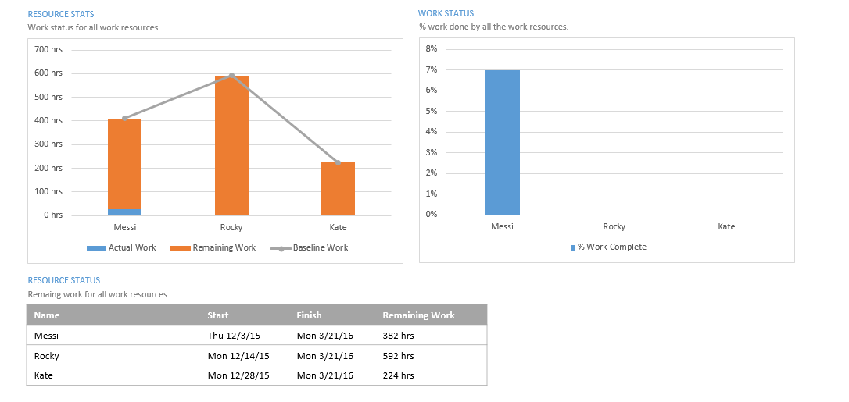

1. Timeline to copy into a presentation

[]

Start

Finish

Dec 6, '15

Dec 13, '15

Dec 20, '15

Dec 27, '15

Jan 3, '16

Jan 10, '16

Jan 17, '16

Jan 24, '16

Jan 31, '16

Feb 7, '16

Feb 14, '16

Feb 21, '16

Feb 28, '16

Mar 6, '16

Mar 13, '16

Mar 20, '16

**Today**

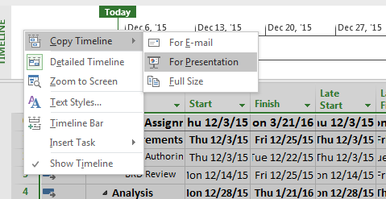

1. Calculate Budget

