Question no. 1

#include <iostream>

// The following lines are using declarations, where we tell the compiler that we'll be using these names from the std namespace.

using std::cout;

using std::endl;

using std::string;

// These are constant declarations. They define some strings and a character that we'll use later in our program.

const char SEMI_COLON = ';';

const string VERB1 = "went up ";

const string VERB2 = "down came ";

const string VERB3 = "washed ";

const string VERB4 = "out came ";

const string VERB5 = "dried up ";

int main(void){

// These are string variable declarations. They will hold the lines of our nursery rhyme.

string firstLine;

string secondLine;

string thirdLine;

string fourthLine;

// Here we're constructing the lines of the nursery rhyme by concatenating strings with the + operator.

firstLine = "The itsy bitsy spider " + VERB1 +"the water spout";

secondLine = VERB2 + "the rain and " + VERB3 +"the spider out";

thirdLine = VERB4 + "the sun and " + VERB5 +"all the rain";

fourthLine = "and the itsy bitsy spider " + VERB1 +"the spout again";

// Finally, we print out the lines to the console. We use the << operator to send strings to cout, which represents the console.

cout << firstLine << SEMI_COLON << endl;

cout << secondLine << SEMI_COLON << endl;

cout << thirdLine << SEMI_COLON;

cout << endl;

cout << fourthLine << '.' << endl;

// The return statement signifies the end of the main function. 0 is typically returned to indicate that the program has run successfully.

return 0;

}

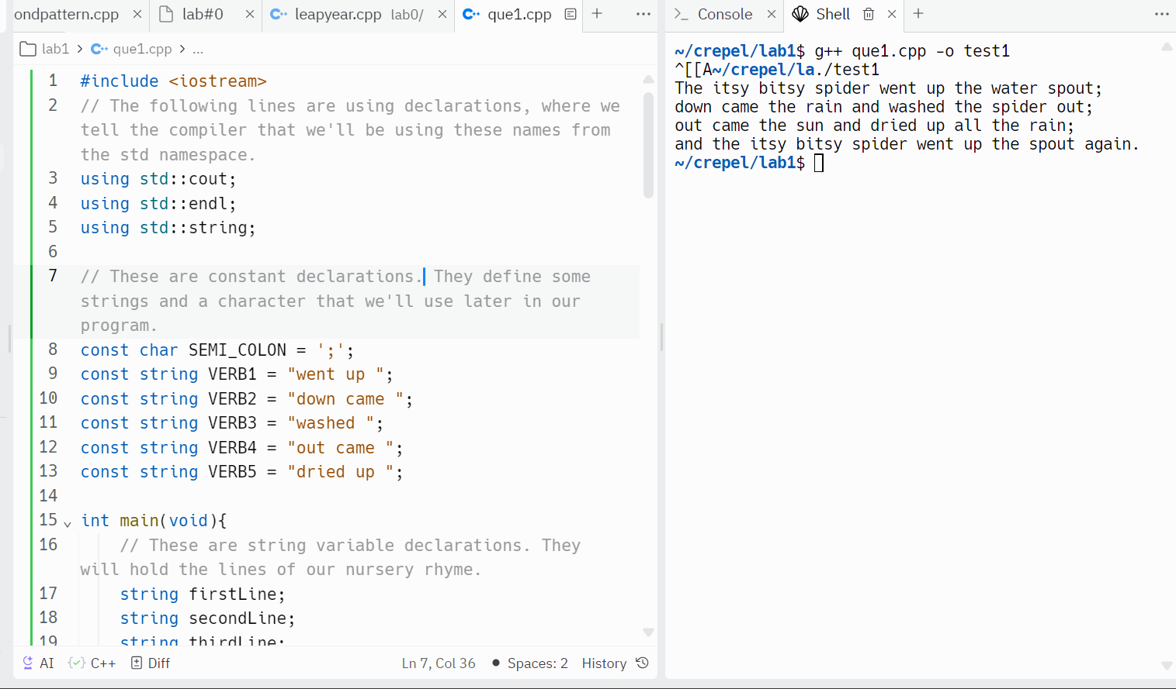

Question no. 2

a)

#include <iostream>

using namespace std;

int main (){

string firstName, lastName;

string date;

cout << "Enter your first name: ";

cin >> firstName;

cout << "Enter your last name: ";

cin >> lastName;

cout << "Enter today's date (mm:dd:yyyy): ";

cin >> date;

cout << lastName << ", " << firstName << " " << date << endl;

return 0;

}

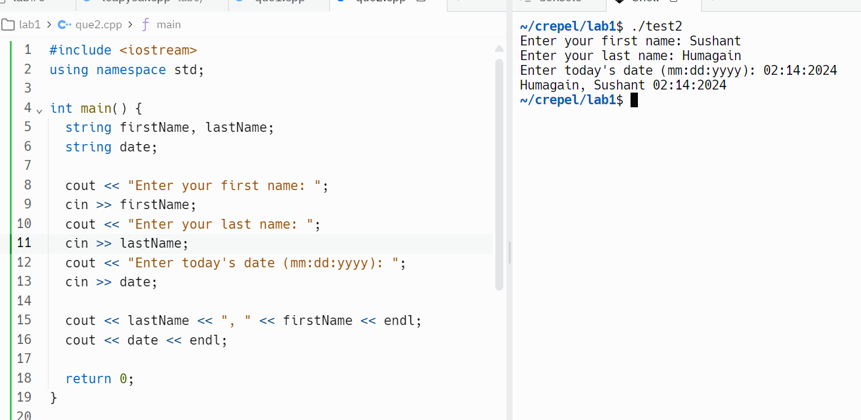

b)#include <iostream>

using namespace std;

int main (){

string firstName, lastName;

string date;

cout << "Enter your first name: ";

cin >> firstName;

cout << "Enter your last name: ";

cin >> lastName;

cout << "Enter today's date (mm:dd:yyyy): ";

cin >> date;

cout << lastName << ", " << firstName << endl << endl;

cout << date << endl;

return 0;

}

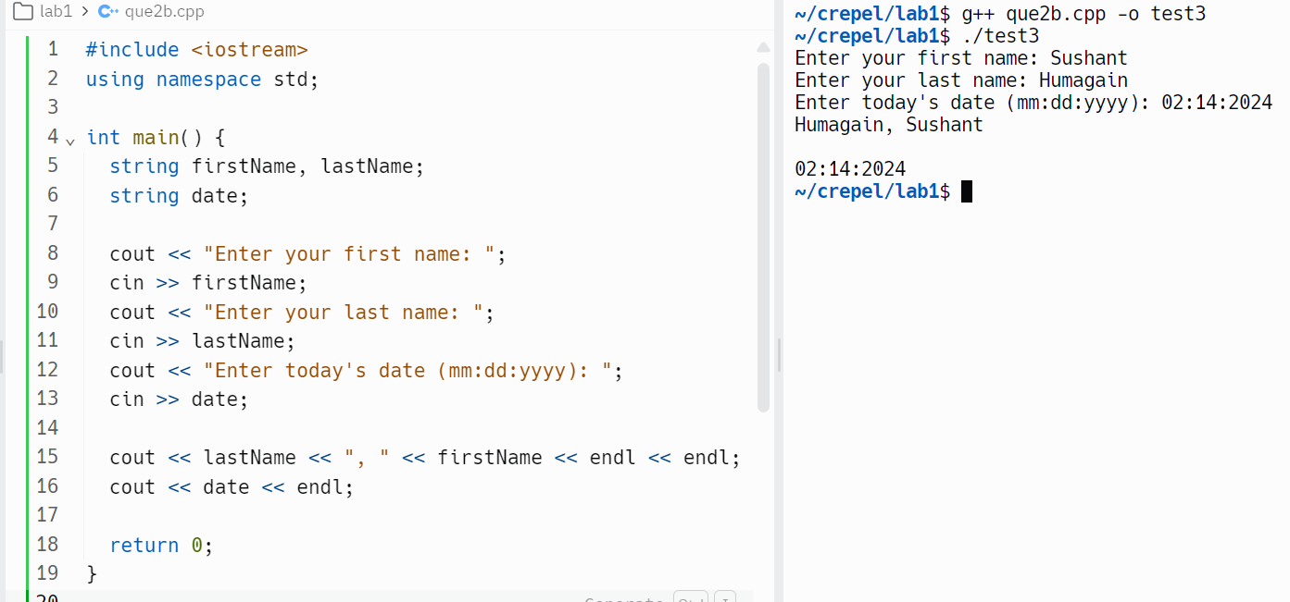

c)#include <iostream>

using namespace std;

int main (){

string firstName, lastName;

string date;

cout << "Enter your first name: ";

cin >> firstName;

cout << "Enter your last name: ";

cin >> lastName;

cout << "Enter today's date (mm:dd:yyyy): ";

cin >> date;

cout << firstName << " " << lastName << endl << endl;

cout << date << endl;

return 0;

}

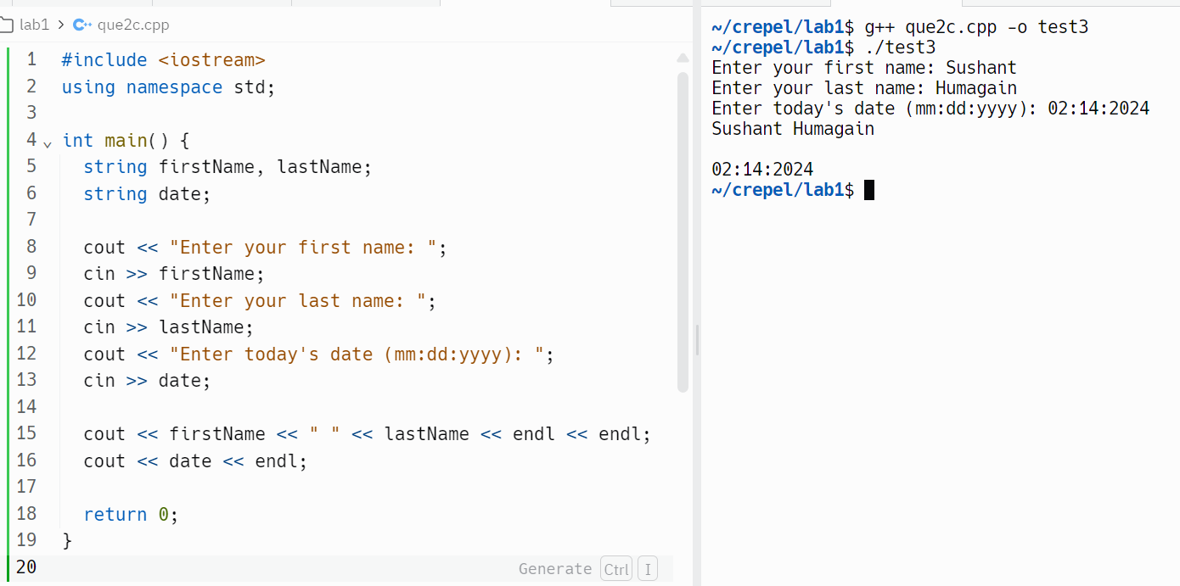

**Question no. 3**

a)#include <iostream>

using std::cout, std::string;

int main (){

const string NAME = "YourFirstName YourLastName"; // Replace with your name

cout << "Length of NAME: " << NAME.length() << "\n";

cout << "Size of NAME: " << NAME.size() << "\n";

return 0;

}

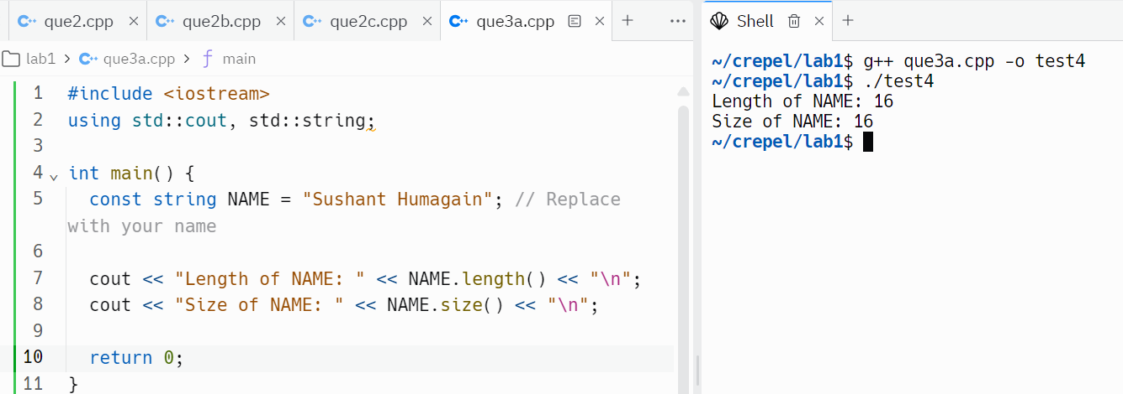

b)

#include <iostream>

using std::cout, std::string;

int main (){

const string NAME = "YourFirstName YourLastName"; // Replace with your name

size_t spaceIndex = NAME.find(' ');

string firstName = NAME.substr(0, spaceIndex);

string lastName = NAME.substr(spaceIndex + 1);

cout << lastName << ", " << firstName << "\n";

return 0;

}

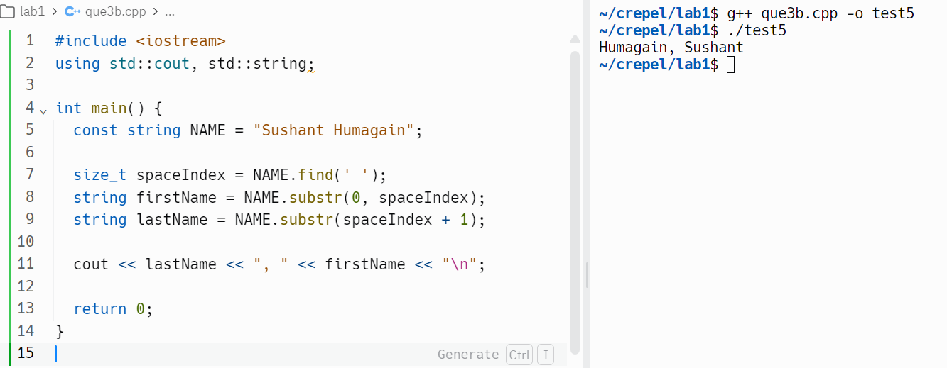

c)#include <iostream>

using std::cout, std::string;

int main (){

const string NAME = "YourFirstName YourLastName"; // Replace with your name

size_t spaceIndex = NAME.find(' ');

string firstName = NAME.substr(0, spaceIndex);

string lastName = NAME.substr(spaceIndex + 1);

cout << lastName << ", " << firstName[0] << "\n";

return 0;

}

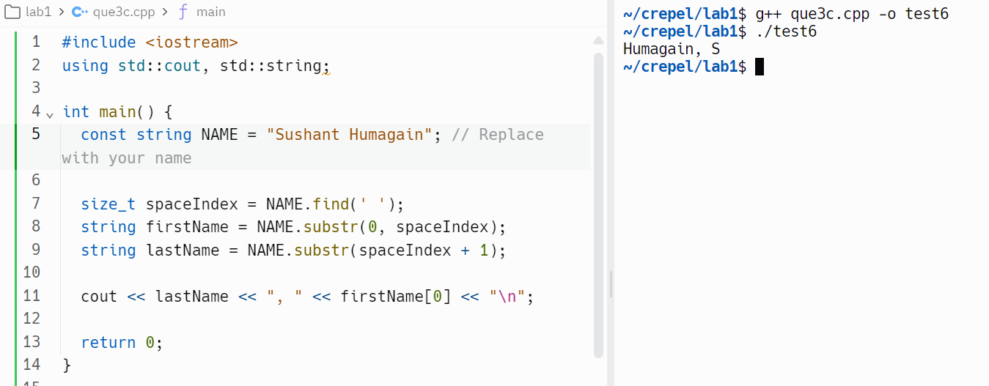

**Question no. 4**

#include <iostream>

#include <iomanip>

using std::cout;

int main (){

cout << std::fixed << std::showpoint;

const int NUM1 = 1066;

const int NUM2 = 1492;

const int NUM3 = 512;

const int NUM4 = 1;

const int NUM5 = -23;

cout << std::setw(5) << NUM1 << "\n";

cout << std::setw(5) << NUM2 << "\n";

cout << std::setw(5) << NUM3 << "\n";

cout << std::setw(5) << NUM4 << "\n";

cout << std::setw(5) << NUM5 << "\n";

return 0;

}

1. 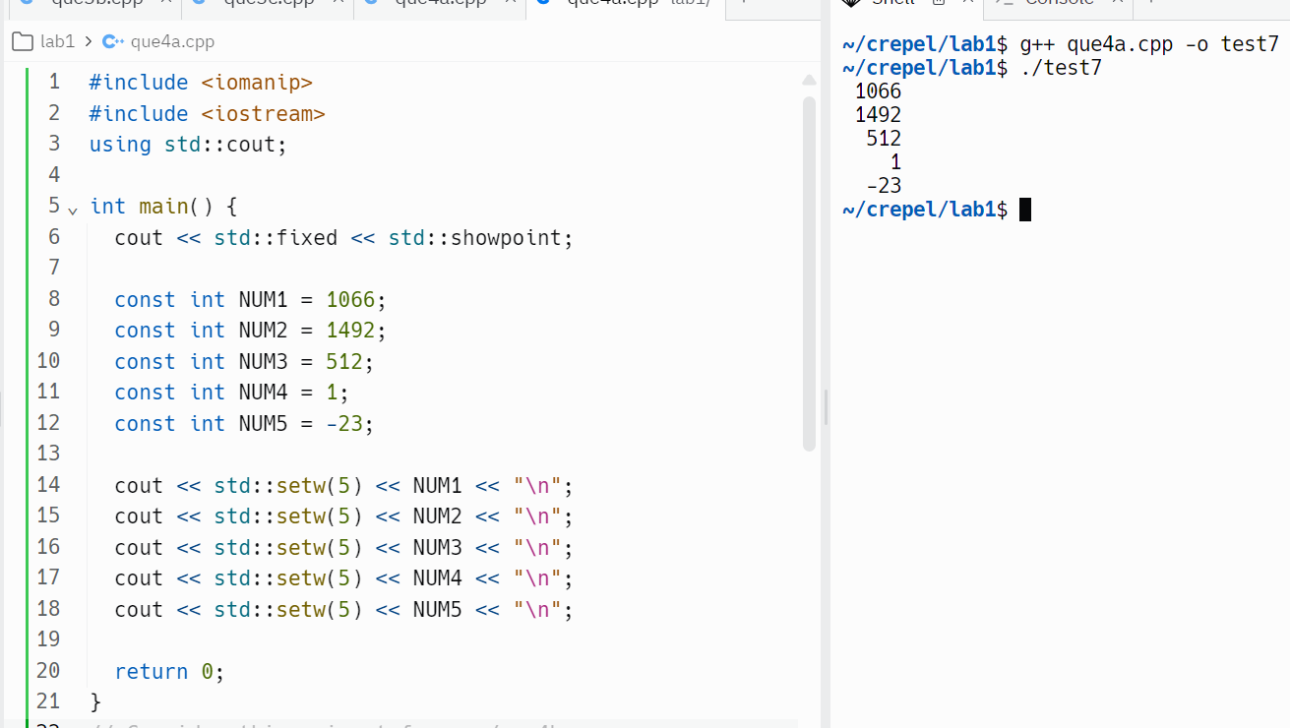

#include <iostream>

#include <iomanip>

using std::cout;

int main (){

cout << std::fixed << std::showpoint;

const int NUM1 = 1066;

const int NUM2 = 1492;

const int NUM3 = 512;

const int NUM4 = 1;

const int NUM5 = -23;

double answer = static_cast<double>(NUM1 + NUM2) / (NUM3 + NUM4 + NUM5);

cout << std::setprecision(4) << "The answer is " << answer << "\n";

return 0;

}

1. 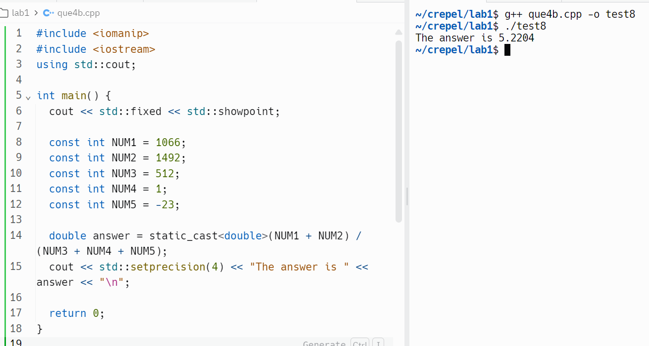

#include <iostream>

#include <iomanip>

using std::cout;

int main (){

cout << std::fixed << std::showpoint;

const double NUM1 = 23.62;

const double NUM2 = 46.0;

const double NUM3 = 43.4443;

const double NUM4 = 100.1;

const double NUM5 = 98.98;

cout << std::setw(7) << std::setprecision(2) << NUM1 << "\n";

cout << std::setw(7) << std::setprecision(2) << NUM2 << "\n";

cout << std::setw(7) << std::setprecision(2) << NUM3 << "\n";

cout << std::setw(7) << std::setprecision(2) << NUM4 << "\n";

cout << std::setw(7) << std::setprecision(2) << NUM5 << "\n";

return 0;

}

1. 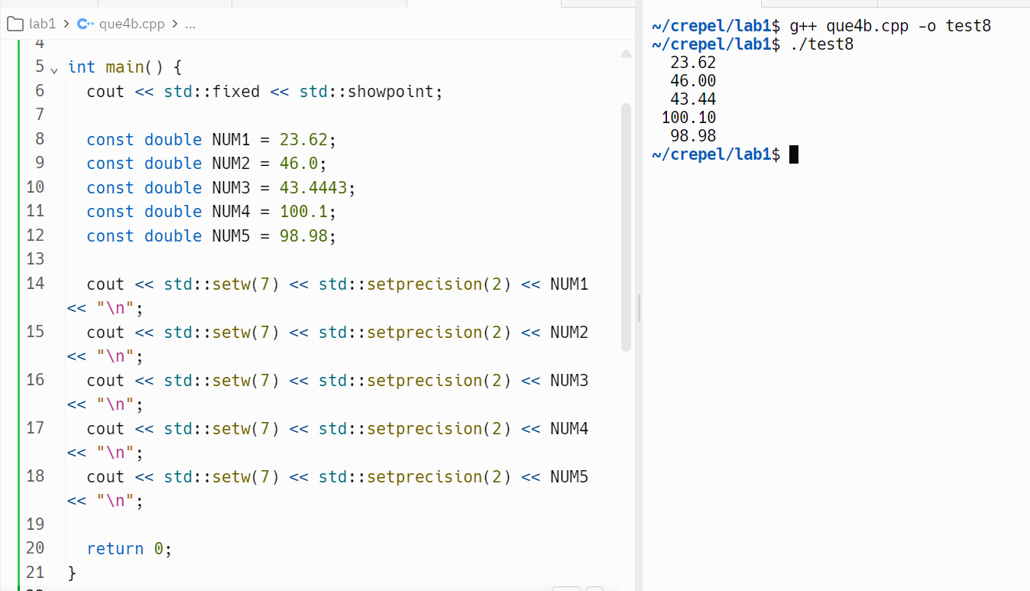

#include <iostream>

#include <iomanip>

using std::cout;

int main (){

cout << std::fixed << std::showpoint;

const double NUM1 = 23.62;

const double NUM2 = 46.0;

const double NUM3 = 43.4443;

const double NUM4 = 100.1;

const double NUM5 = 98.98;

double sum = NUM1 + NUM2 + NUM3 + NUM4 + NUM5;

cout << "The sum of the numbers is " << std::setprecision(2) << sum << "\n";

return 0;

}

1. 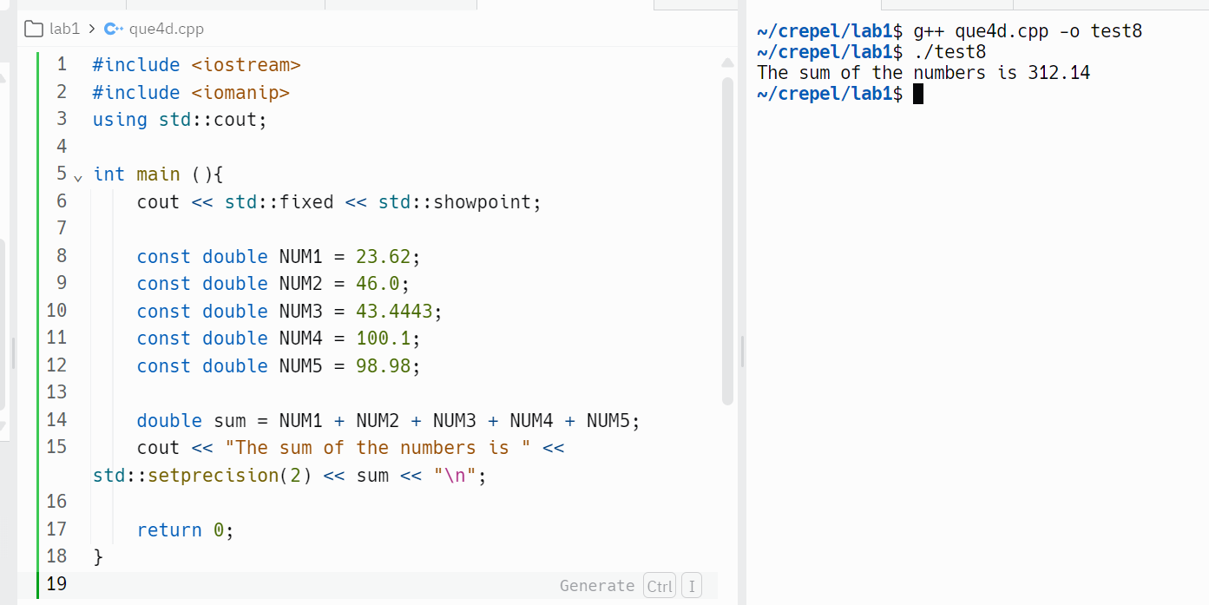

**Question no. 5**

a)

#include <iostream>

#include <iomanip>

using std::cout;

int main (){

cout << " Good Morning" << " Sarah" << " Sunshine!" << "\n";

return 0;

}

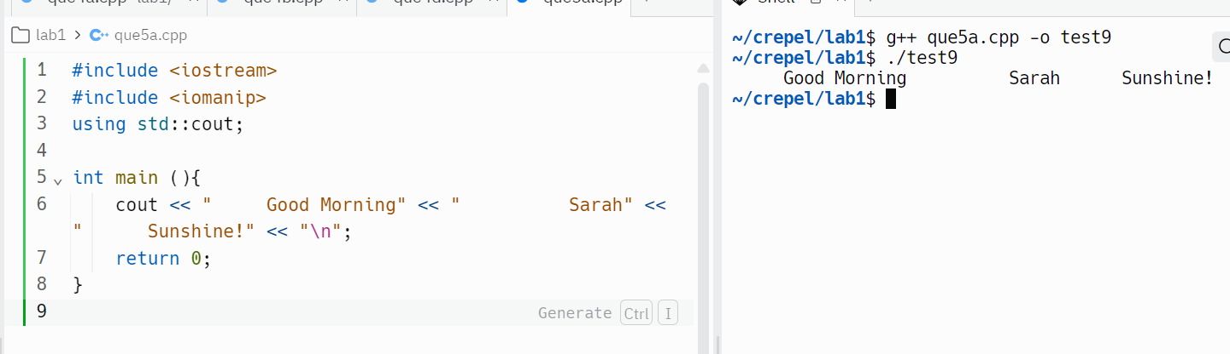

b)

#include <iostream>

#include <iomanip>

using std::cout;

int main (){

cout << std::setw(20) << "Good Morning";

cout << std::setw(20) << "Sarah";

cout << std::setw(20) << "Sunshine!" << "\n";

return 0;

}

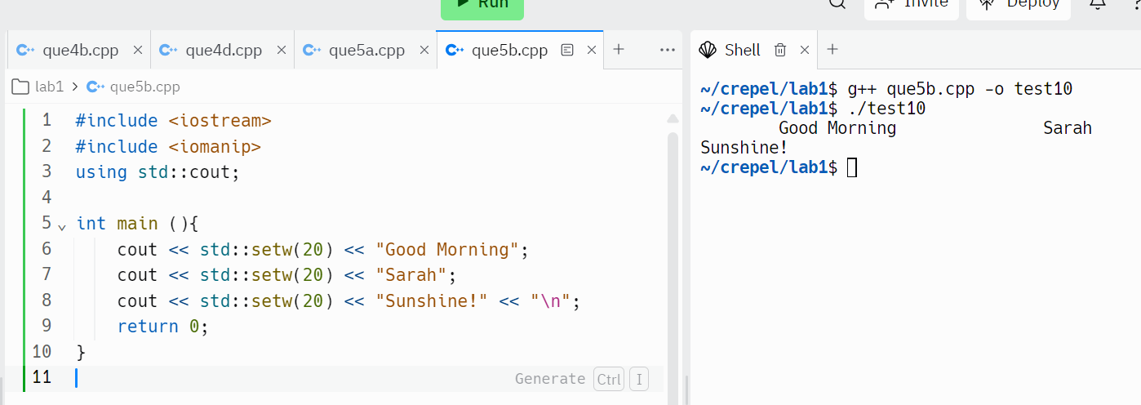

c)

#include <iostream>

#include <iomanip>

using std::cout;

int main (){

cout << std::setw(20) << "Good Morning" << "\n\n";

cout << std::setw(20) << "Sarah" << "\n\n";

cout << std::setw(20) << "Sunshine!" << "\n";

return 0;

}

