**Que no. 1**

**Code:**

#include <iostream>

using namespace std;

#define MAX 10

class student {

private:

char name[30];

int courseNum;

int total;

float perc;

public:

void getDetails(void); // member function to get student's details

void putDetails(void); // member function to print student's details

};

// Member function definition, outside of the class

void student::getDetails(void) {

cout << "Enter name: ";

cin >> name;

cout << "Enter course number: ";

cin >> courseNum;

cout << "Enter total marks out of 500: ";

cin >> total;

perc = (float)total / 500 * 100;

}

// Member function definition, outside of the class

void student::putDetails(void) {

cout << "Student details:\n";

cout << "Name: " << name << ", Course Number: " << courseNum

<< ", Total: " << total << ", Percentage: " << perc << endl;

}

int main(void) {

student std[MAX]; // Array of objects creation

int n, loop;

cout << "Enter total number of students: ";

cin >> n;

for (loop = 0; loop < n; loop++) {

cout << "Enter details of student " << loop + 1 << ":\n";

std[loop].getDetails();

}

cout << endl;

for (loop = 0; loop < n; loop++) {

cout << "Details of student " << (loop + 1) << ":\n";

std[loop].putDetails();

}

return 0;

}

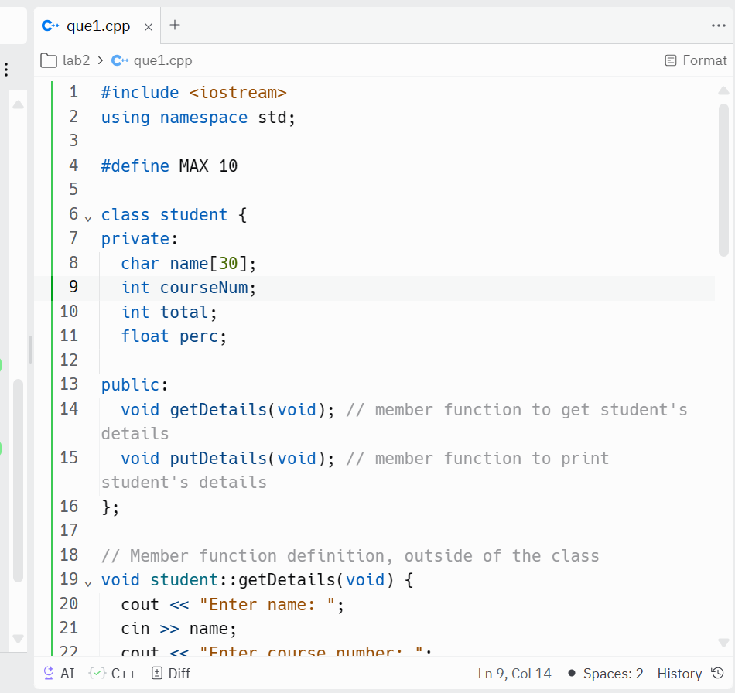

Output :

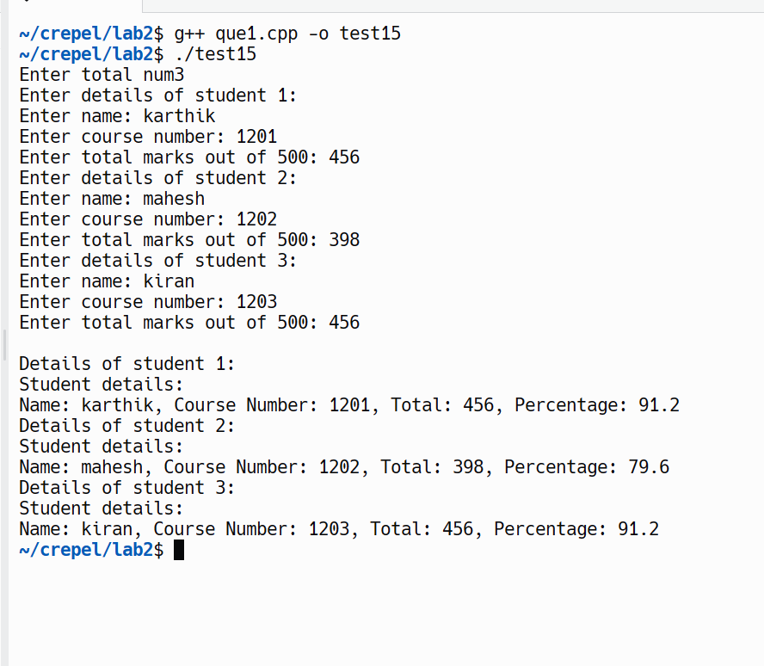

Que no. 2

Code:

#include <iostream>

using namespace std;

class sample {

private:

int a;

char b;

float c;

public:

void get_data() {

cout << "Enter an integer value: ";

cin >> a;

cout << "Enter a character: ";

cin >> b;

cout << "Enter a float value: ";

cin >> c;

}

void print_data() {

cout << "Values read from keyboard are" << endl;

cout << "Integer value: " << a << endl;

cout << "Character is: " << b << endl;

cout << "Float value is: " << c << endl;

}

};

int main() {

sample s;

s.get_data();

s.print_data();

return 0;

}

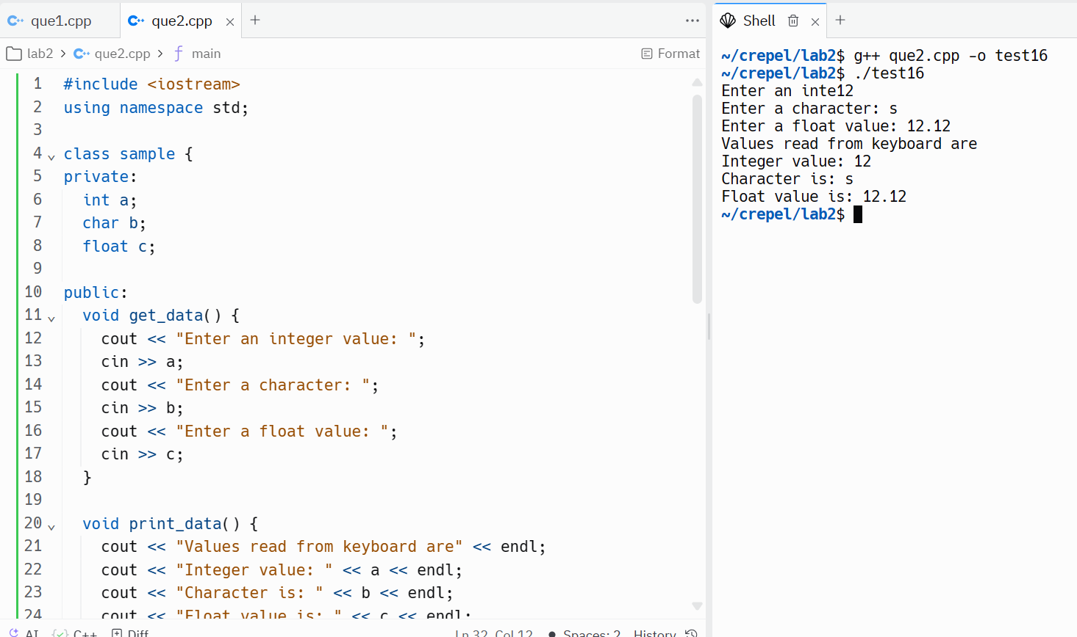

Que no. 3

Code:

#include <iostream>

using namespace std;

class Rectangle {

private:

float length;

float width;

public:

void setLength(float len) {

length = len;

}

void setWidth(float wid) {

width = wid;

}

float perimeter() {

return 2 * (length + width);

}

float area() {

return length * width;

}

void show() {

cout << "Length: " << length << ", Width: " << width << endl;

}

int sameArea(Rectangle other) {

return (area() == other.area());

}

};

int main() {

Rectangle rect1, rect2;

// Set dimensions for rect1

rect1.setLength(5);

rect1.setWidth(2.5);

// Set dimensions for rect2

rect2.setLength(5);

rect2.setWidth(18.9);

// Display properties of rect1

cout << "Rectangle 1:" << endl;

rect1.show();

cout << "Area: " << rect1.area() << ", Perimeter: " << rect1.perimeter() << endl;

// Display properties of rect2

cout << "\nRectangle 2:" << endl;

rect2.show();

cout << "Area: " << rect2.area() << ", Perimeter: " << rect2.perimeter() << endl;

// Check if rectangles have the same area

if (rect1.sameArea(rect2)) {

cout << "\nBoth rectangles have the same area." << endl;

} else {

cout << "\nThe rectangles do not have the same area." << endl;

}

// Modify rect1 dimensions

rect1.setLength(15);

rect1.setWidth(6.3);

// Display updated properties of rect1

cout << "\nUpdated Rectangle 1:" << endl;

rect1.show();

cout << "Area: " << rect1.area() << ", Perimeter: " << rect1.perimeter() << endl;

// Check again if rectangles have the same area

if (rect1.sameArea(rect2)) {

cout << "\nBoth rectangles have the same area." << endl;

} else {

cout << "\nThe rectangles do not have the same area." << endl;

}

return 0;

}

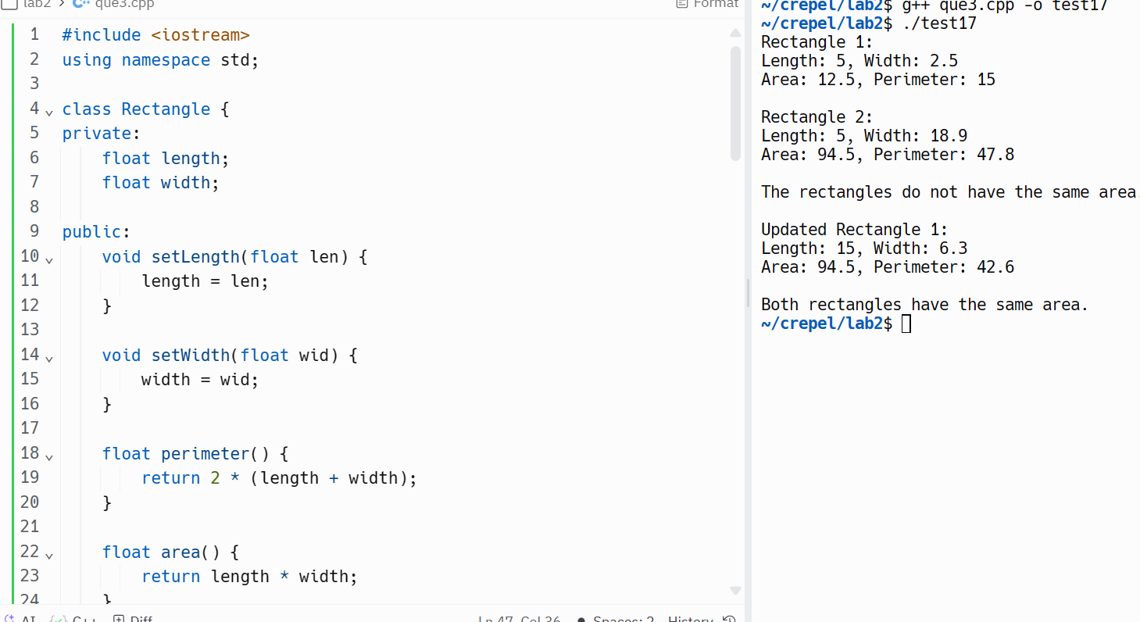

Que no. 4

#include <iostream>

#include <string>

#include <vector>

class MusicIns {

private:

std::vector<std::string> stringInstruments;

std::vector<std::string> windInstruments;

std::vector<std::string> percInstruments;

public:

// Initialize string instruments

void string() {

stringInstruments = {"Veena", "guitar", "sitar", "sarod", "mandolin"};

}

// Initialize wind instruments

void wind() {

windInstruments = {"Flute", "clarinet", "saxophone", "nadaswaram", "piccolo"};

}

// Initialize percussion instruments

void perc() {

percInstruments = {"Table", "mridangam", "bongos", "drums", "tambour"};

}

// Display the contents of the arrays

void show() {

std::cout << "String Instruments:\n";

for (const auto& instrument : stringInstruments) {

std::cout << "- " << instrument << "\n";

}

std::cout << "\nWind Instruments:\n";

for (const auto& instrument : windInstruments) {

std::cout << "- " << instrument << "\n";

}

std::cout << "\nPercussion Instruments:\n";

for (const auto& instrument : percInstruments) {

std::cout << "- " << instrument << "\n";

}

}

};

int main() {

MusicIns music;

music.string();

music.wind();

music.perc();

// Display the contents of the arrays

music.show();

return 0;

}

