**Sushant Humagain**

**ID-19760hs**

**Calculus-I**

**Assignment-1**

**#Question-1:**

**#Solution-1a:**

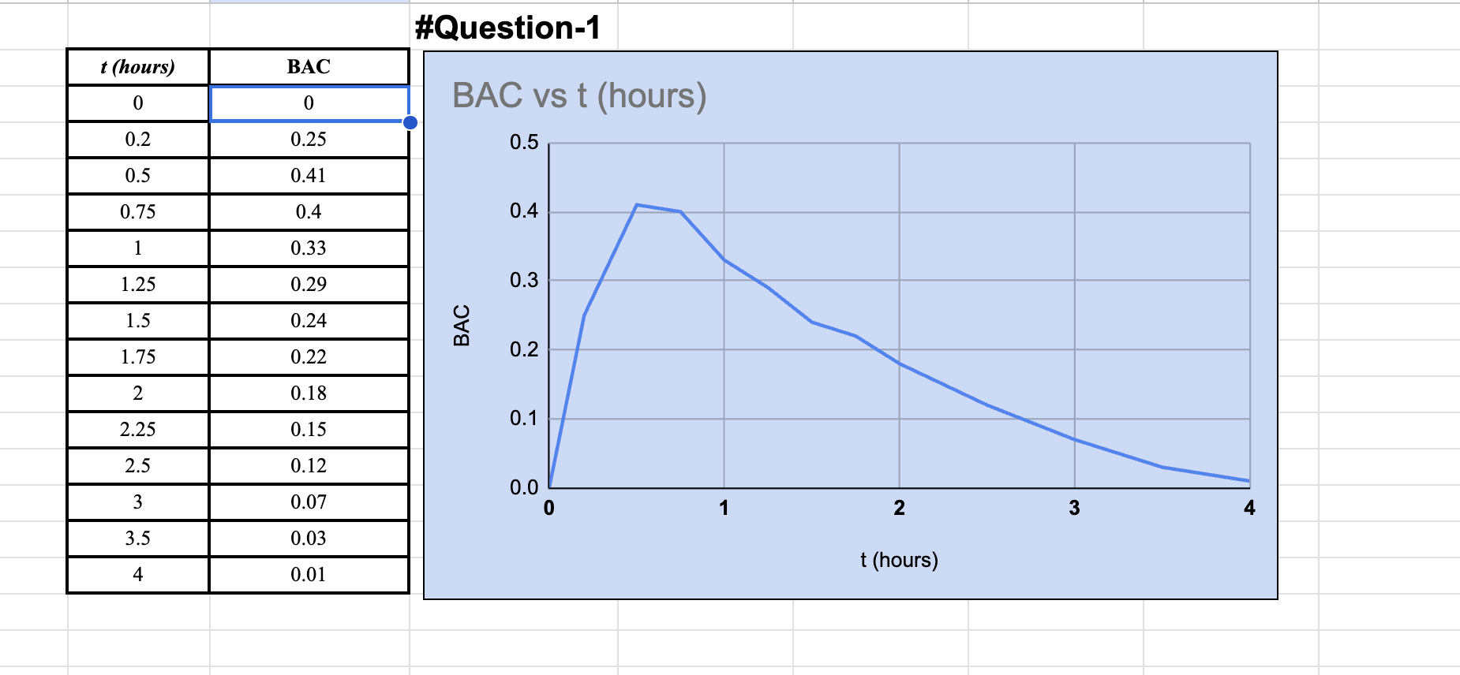

**#Solution-1b:**

According to the graph, the blood alcohol concentration (BAC) shows a clear pattern after rapid alcohol consumption. Initially, at the start (t=0 hours), no alcohol is detected in the blood, indicating a BAC of 0 mg/mL. The BAC gradually increases as time progresses, with a rapid rise observed in the first few hours. In just 0.5 hours, the BAC reaches its peak at 0.41 mg/mL.

Following this peak, the rate of increase in BAC starts to diminish. Over the next hour (1.5 hours in total), the BAC decreases to 0.24 mg/mL. This suggests that the absorption of alcohol into the bloodstream slows down compared to the initial rapid phase.

√ 2 Beyond the 1.5-hour mark, the BAC continues to decline, although at a slower rate. This gradual decrease eventually leads to a BAC of 0.01 mg/mL after 4 hours. It is important to note that the rate of elimination becomes less pronounced during this phase compared to the earlier hours.

In summary, after consuming alcohol rapidly, the BAC initially rises quickly, peaks at 0.41 mg/mL within half an hour, and then gradually decreases. The absorption rate slows down, leading to a slower decline in BAC over time until it reaches a negligible level after approximately 4 hours.

**#Question-2:**

**#solution:**

First let’s rearrange the equation, to find the expression for function f(x)

Given equation:

Rearranging the equation: = 4-

= ± √4-

= 2 ±

From here we can see that,

= 2 +

OR

= 2 - 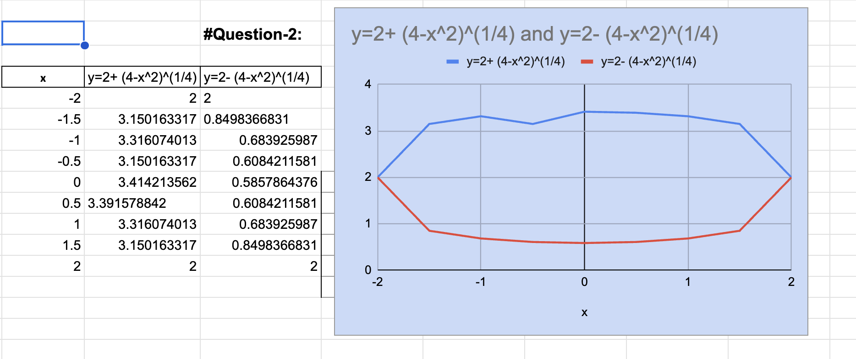

**#Question-3**

**#Solution-3a:**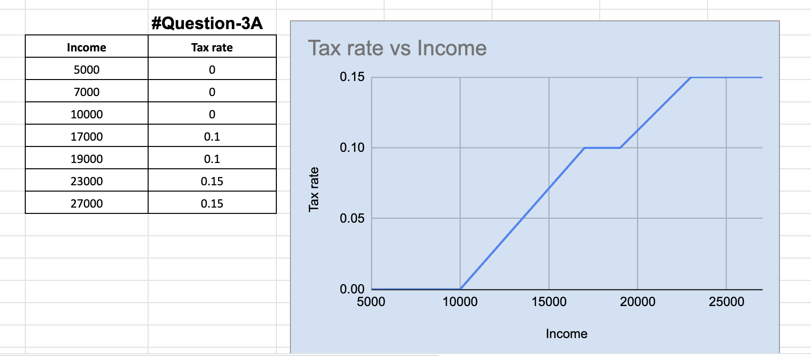

**#Solution-3b:**

Let's calculate the tax assessed on an income of $14,000,

First, we must determine the taxable amount by subtracting the non-taxable portion ($10,000) from the total income($14,000).

=$(14,000 - 10,000)

=$4,000

The taxable amount of $4,000 is multiplied by the tax rate of 10% (0.10) to obtain the tax assessed: $4,000 * 0.10 = $400.

Similarly, for an income of $26,000,

=$(26,000 - 10,000)

=$16,000

For the first portion of $10,000, taxed at a rate of 10%, the tax assessed is calculated as $10,000 * 0.10 = $1,000.

For the remaining amount of $6,000, taxed at a rate of 15%, the tax assessed is obtained by multiplying $6,000 by 0.15: $6,000 * 0.15 = $900.

Finally, the two tax amounts are summed up to get the total tax assessed:

$1,000 + $900 = $1,900.

**#Solution-3c:**

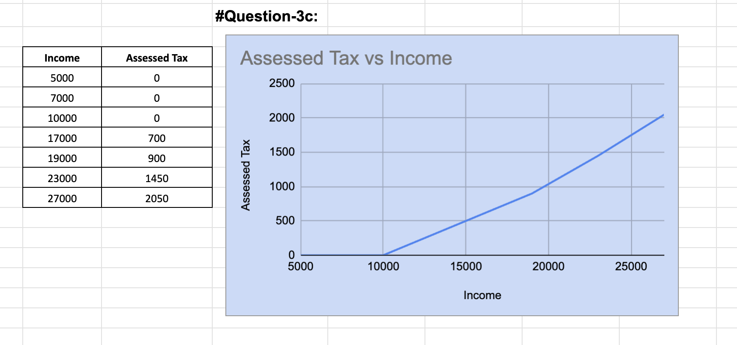

**#Question-4:**

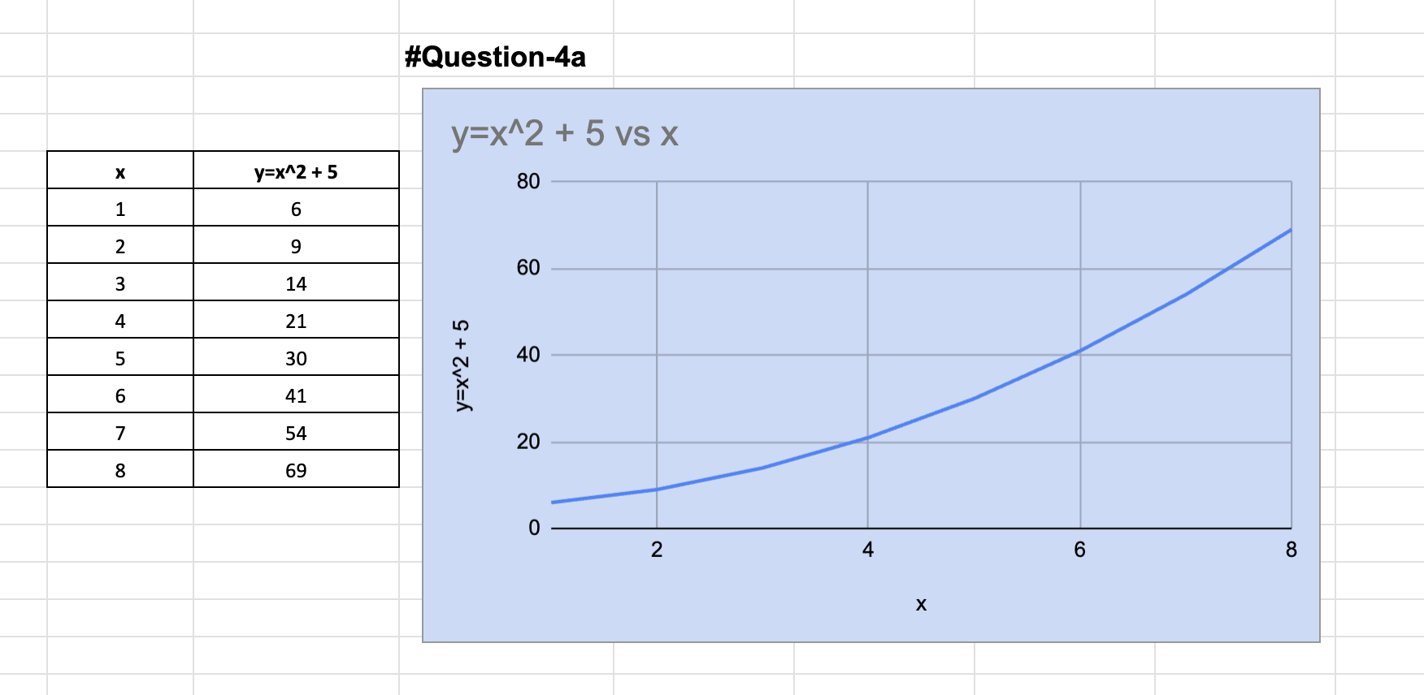

**#Solution-4b:**

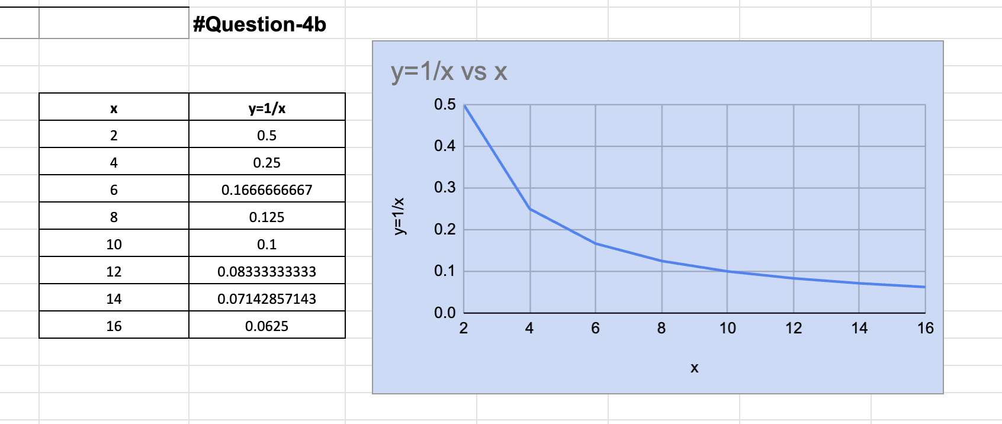

**#Question-5:**

**#Solution-5a:**

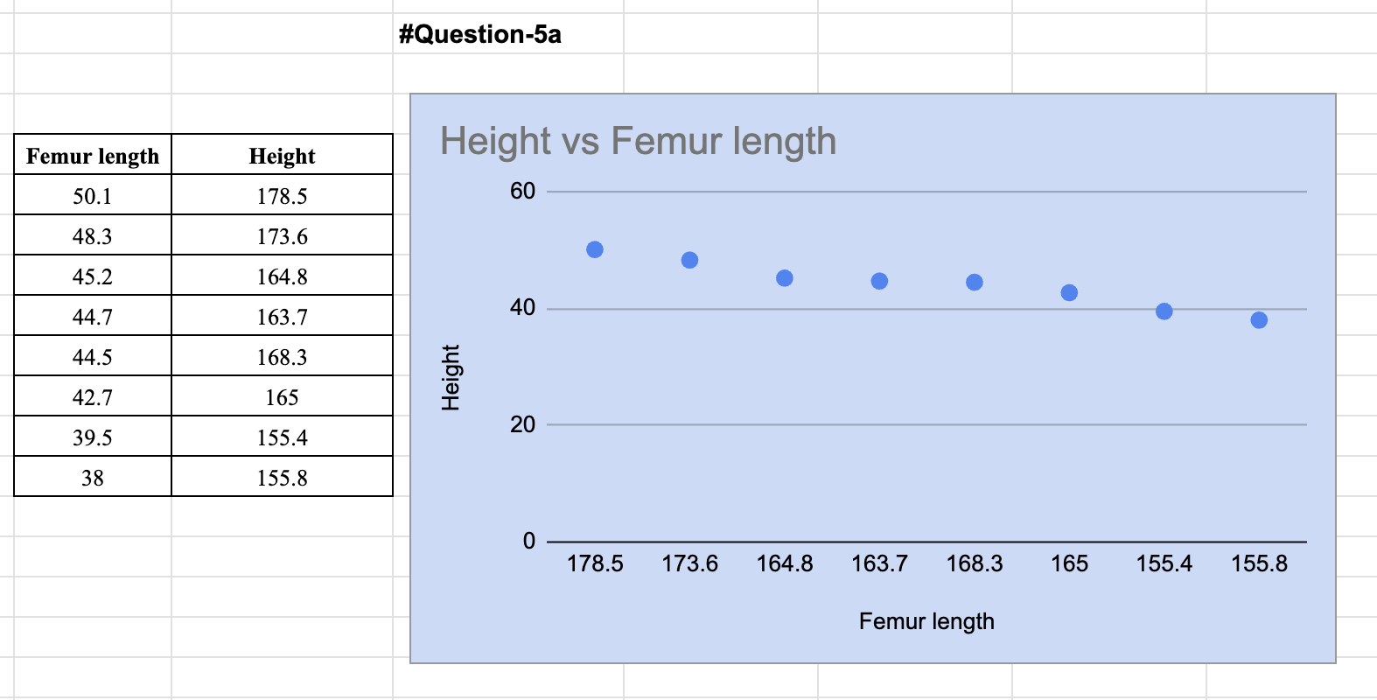

**#Solution-5b:**

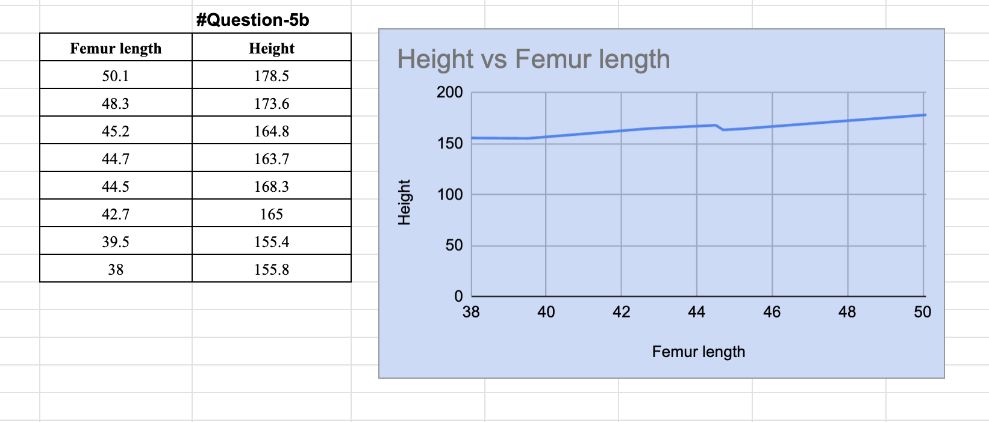

**#Solution-5c:**

Considering the given equation:

y = 1.8807x + 82.65,

where y represents the height

and x represents the femur length.

Given that the femur length (x) is 53 cm, we can substitute this value into the equation to find the corresponding height (y).

By plugging in x = 53, we get

or, y = 1.8807 * 53 + 82.65

or, y = 99.7871 + 82.65

y = 182.4371 cm

Therefore, the person's height is approximately 182.44 cm.

**#Question-6:**

**#Solution-6a**

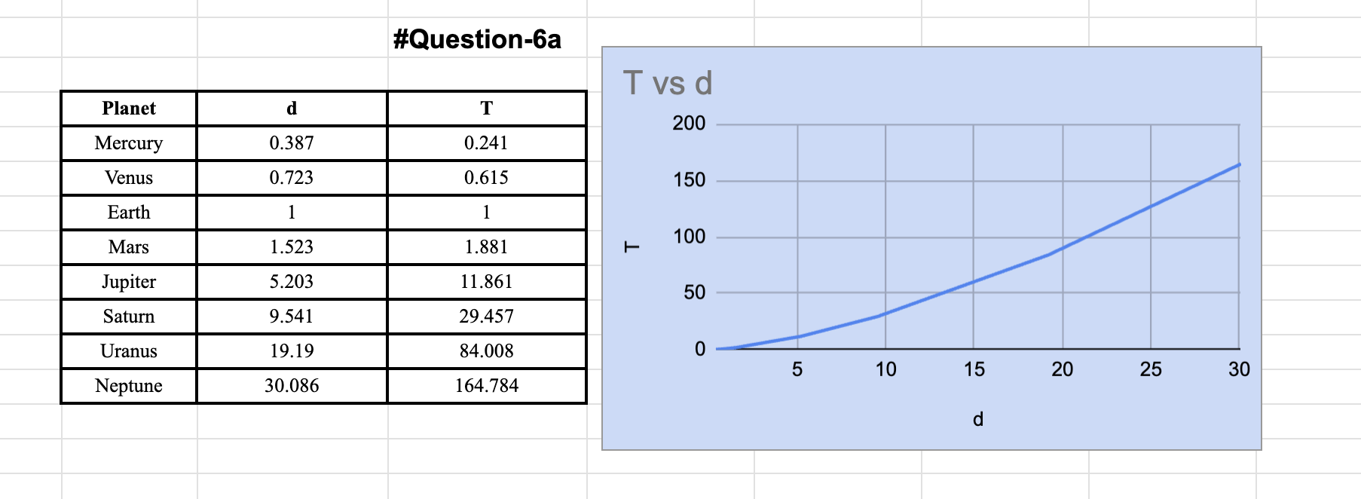

**#Solution-6b:**

Below is the graph that is passing through the origin. By Kepler’s Third law of planetary motion, T2 𝖺 𝑑3. Hence, the law is proven.

**#Solution-6c:**

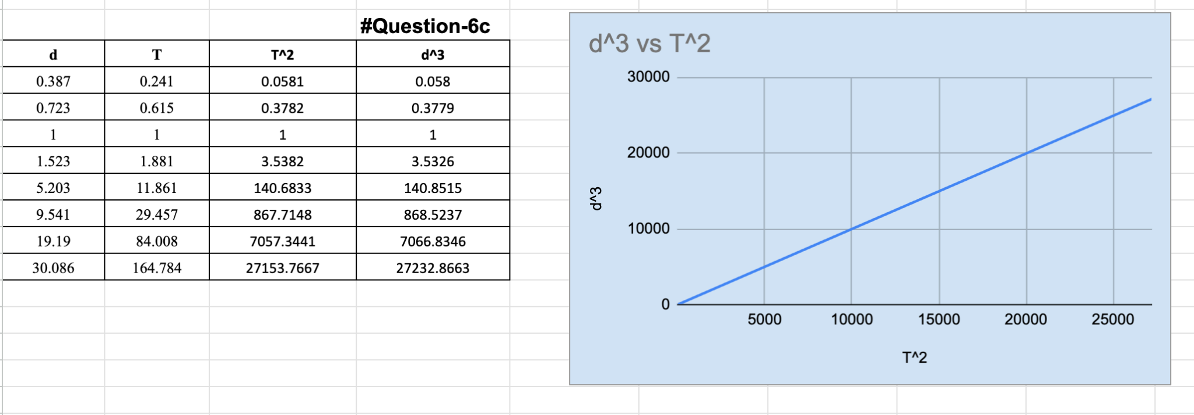

**#Question-7:**

**#Solution-7a:**

The graph of y = f(|x|) is obtained by taking the absolute value of the x-values in the function f(x). It reflects the portion of the graph of f(x) that lies in the positive x-axis to the negative x-axis. If x is positive, the coordinate point becomes (x, y).

However, if x is negative, the coordinate becomes(-x,y). The absolute function is related equatorially by;

y = f(|x|) = f(x) if x is positive.

So, the graph of an absolute function is a reflection of the graph of f(x) at the y-axis when the value of x < 0 or negative.

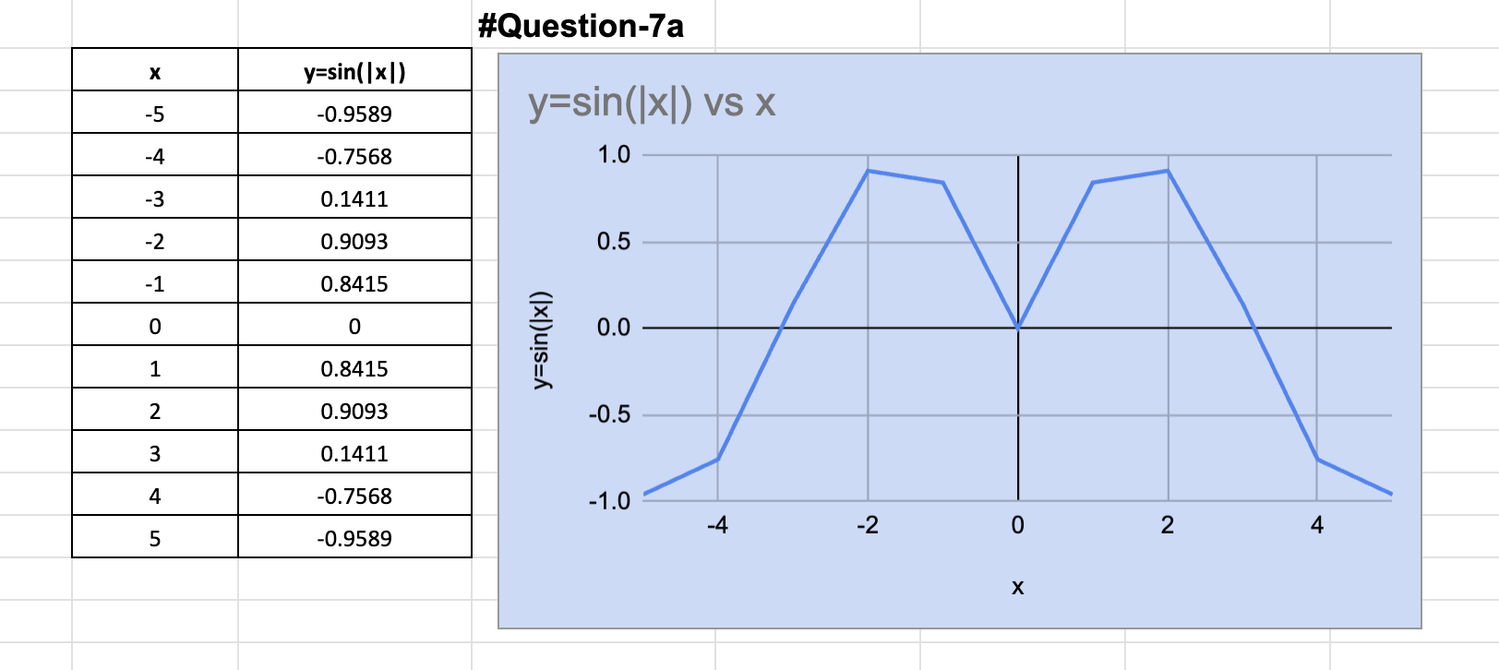

**#Solution-7b:**

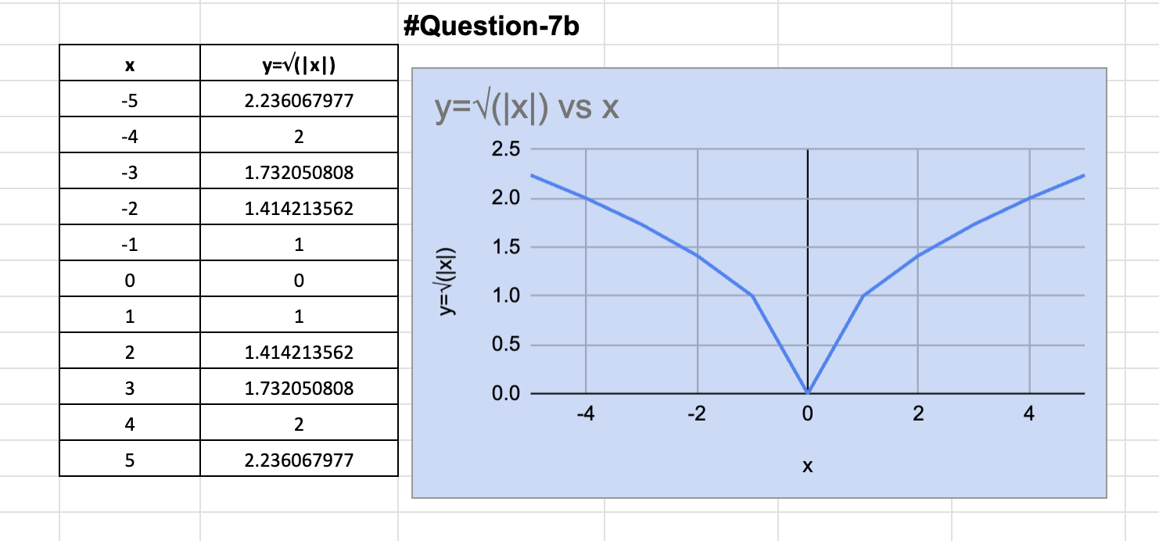

**#Question-8:**

**#Solutions**:

*a. (𝑔 ○ 𝑓) (6)*

=g (f(6))

= g(6)

It is undefined because g is not defined at 6.

*b.(𝑔 ○ 𝑔)(−2)*

= g (g(-2))

= g(1)

= 4

*c. (𝑓 ○ 𝑓) (4)*

= f (f(4))

= f (2)

= −2