**#Solution-1:**

a)We can see that, the slope of the graph appears to have at the origin is: -0.0509 x – 0.070.

slope=y⇒-0.0509x - 0.070⇒R^2=0.0421

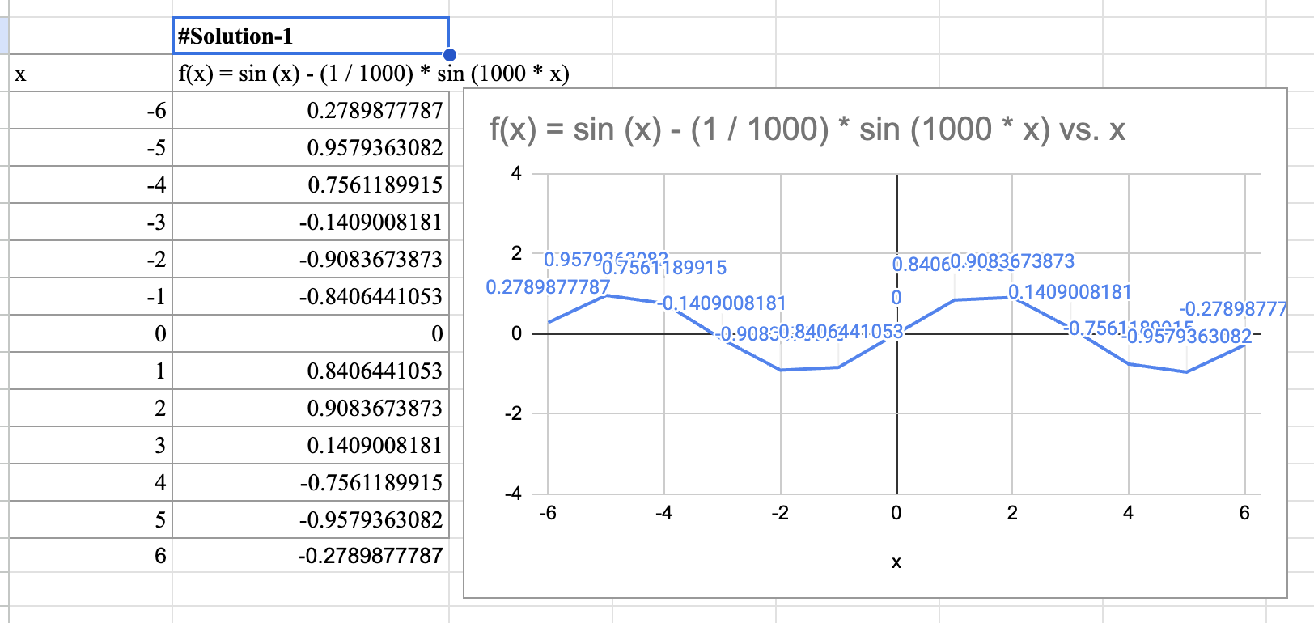

b)The values of x-axis and y-axis on the graph to match the viewing window [-0.4, 0.4] by [-0.25, 0.25]. We can observe that, the slope is still the same, which agrees with an answer from part(a)

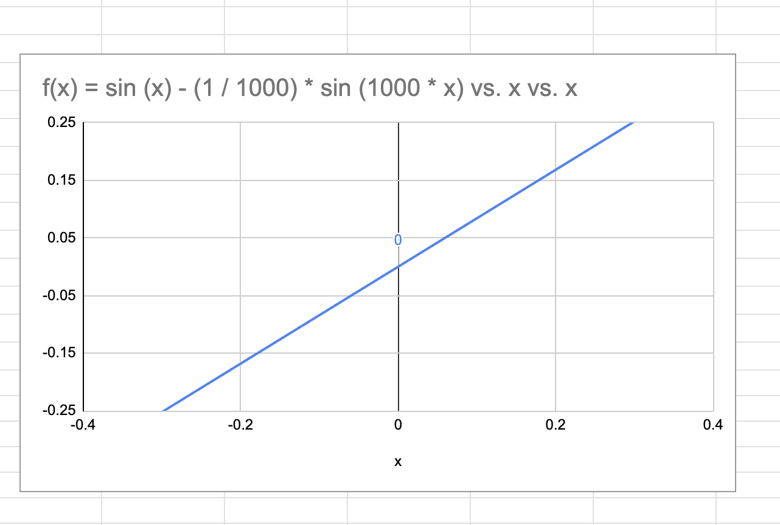

c)Now the graph gets much stronger. The slope of the curve at 0 which is f’(0) is - 0.0509. The slope remains the same.

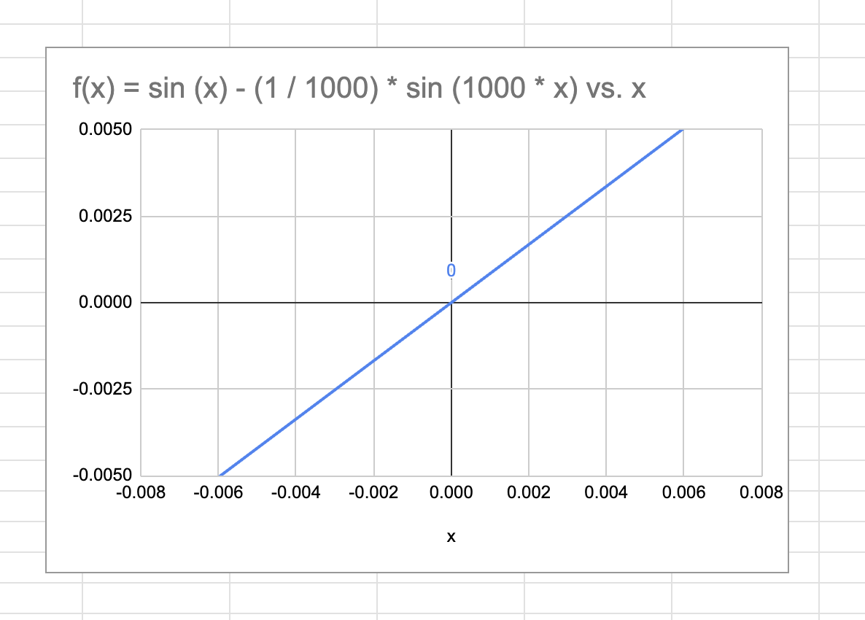

**#Solution-2:**

Zooming at (-1,0) f is differentiable at (-1,0) because it is smooth at (-1,0) and there are no sudden changes.

Zooming at the origin f is NOT differentiable because it has a kink at the origin. There are sudden changes in the slope.

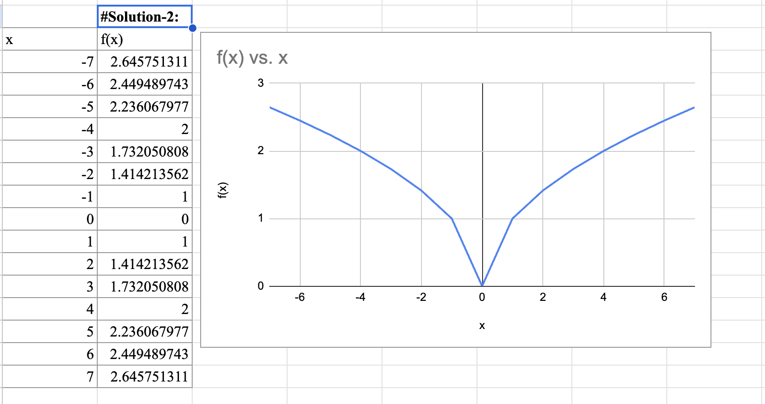

**#Solution-3:**

**a) Find 𝑓′ ― (4) and 𝑓′ + (4) for the function**

To find f'-(4). we substitute the value of 4 in the function.

We get,

f'(-4) = [Here, if h<0, 4+h is also less than 4]

= since, from definition, f(4)=1/(5-x)=1]

=

= -1

To find f'+(4). we substitute the value of 4 in the function. We get,

f'(+4) = [Here, if h>0, 4+h is greater than 4]

= [ From the definition, if x is > or equal to 4, we use 1/ (5-x)]

=

=

=

=

=

= 1

**b)**

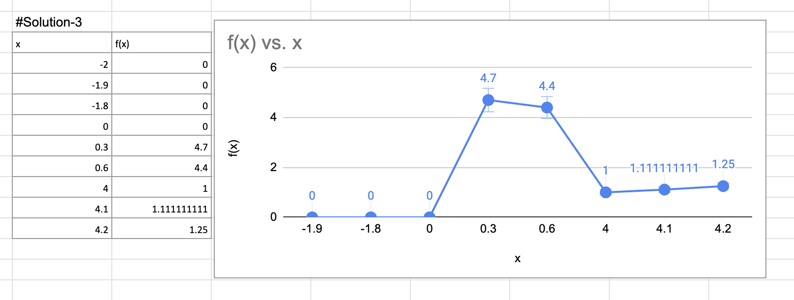

**c) Where is f discontinuous?**

The graph of f is discontinuous at x=0 and x=5.

**d) Where is f not differentiable?**

The graph of f is not differentiable at x=0 and x=4 and x=5.

**#Solution-4:**

To show that 𝑔′(𝑥) = 𝑥𝑓′(𝑥) +𝑓(𝑥), we'll use the definition of the derivative. The derivative of 𝑔(𝑥) with respect to 𝑥 is defined as:

𝑔′(𝑥) =

Let's substitute the function 𝑔(𝑥) = 𝑥𝑓(𝑥) into the above expression:

𝑔′(𝑥) =

Now, let's simplify the expression:

𝑔′(𝑥) =

𝑔′(𝑥) =

Next, we can rewrite the expression as:

𝑔′(𝑥) =+

The first term in the above expression simplifies to 𝑓(𝑥) and the second term simplifies to 𝑎𝑓′(𝑎).

Therefore, we have:

𝑔′(𝑥) = 𝑓(𝑥) + 𝑎𝑓′(𝑎)

Since 𝑎 is a constant, we can substitute 𝑎 with 𝑥 in the equation to get the desired result:

𝑔′(𝑥) = 𝑥𝑓′(𝑥) + 𝑓(𝑥)

Thus, we have shown that 𝑔′(𝑥) = 𝑥𝑓′(𝑥) + 𝑓(𝑥) using the definition of a derivative.

**#Solution-5:**

a) Boyle’s Law can be expressed mathematically as: P . V = *k*

where *k* is a constant for a given amount of gas at a constant temperature.

To express V as a function of P, we rearrange the equation:

V =

Given that the pressure P = 50*kPa* when the volume V = 0.106m^3, we can find *k* :

*k=* P . V = 50*k*Pa *.* 0.106m^3 = 5.3*k*Pa . m^3

So, the function V(P) is:

V(P)=

(b) To find, we take the derivative of V(P) :

V(P)=

The derivative is:

=

When P = 50kPa:

= - ⇒ ⇒ -0.00212m^3 /kPa

The derivative represents the rate at which the volume of the gas changes for pressure at constant temperature. Its value indicates that for every 1 kPa increase in pressure, the volume decreases by approximately 0.00212m^3. The units of the derivative are m^3 /kPa.

**#Solution-6:**

**a) Use a calculator to model tire life with a quadratic function of the pressure.**

**→** Here, the input to the function is the pressure and the output is the tire life.

The quadratic function will be: L(P) = a * P ^2 + b * P + c

Now we get,

L(P) = −0.2754P^2 + 19.7485P − 273.5523

**b)Use the model to estimate dL/dP when P = 30 and P = 40. What is the meaning of the**

**derivative? What are the units? What is the significance of the signs of the derivatives?**

dL/dP = −0.5508P + 19.7485

so,

dL/dP(P =30)

= −0.5508 (30) + 19.7485

≈ 3.22 lb/in²

dL/dP(P=40)

= −0.5508 (40) + 19.7485

≈ −2.28 lb/in²

Here, the derivative gives the rate of change of tire life as a function if the pressure. The units are

thousands of miles/ (lb/in^2). (As with all derivatives, the units are units of output from the original function divided by units of input to the original function. At P = 30, the derivative is positive, so tire life is increasing, while at P = 40 the derivative is negative, so tire life is decreasing.