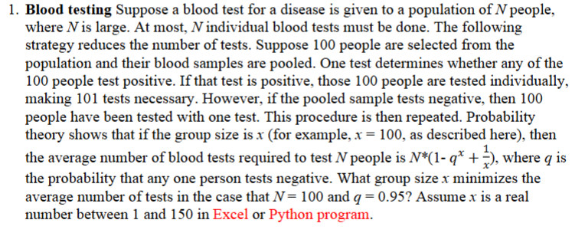

#Question-1:

import numpy as np

from scipy.optimize import minimize_scalar

# Defining constants

N = 100

q = 0.95

# Defining the function to minimize

def average_tests(x):

return N * (1 - q**x + 1/x)

# Using a bounded minimization method to find the optimal x

result = minimize_scalar(average_tests, bounds=(1, 150), method='bounded')

# Printing the optimal group size and the corresponding average number of tests

optimal_x = result.x

optimal_tests = result.fun

print(f"Optimal group size (x): {optimal_x:.2f}")

print(f"Minimum average number of tests: {optimal_tests:.2f}")

Ans = 

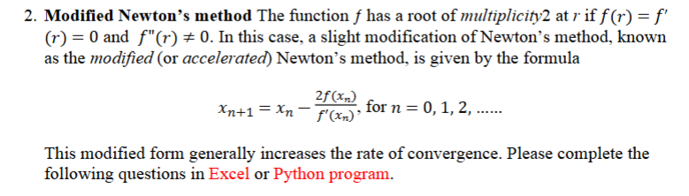

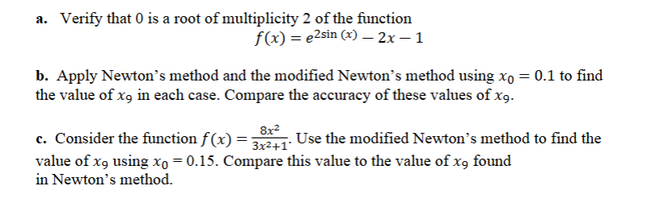

#Question-2

import numpy as np

import sympy as sp

# Part (a): Verifying that 0 is a root of multiplicity 2 of the given function

x = sp.symbols('x')

f_sym = sp.exp(2 * sp.sin(x)) - 2 * x - 1

f_prime_sym = sp.diff(f_sym, x)

f_double_prime_sym = sp.diff(f_prime_sym, x)

# Evaluating f(0), f'(0), f''(0)

root_value = f_sym.subs(x, 0)

first_derivative = f_prime_sym.subs(x, 0)

second_derivative = f_double_prime_sym.subs(x, 0)

print("Part (a): Verifying root at x = 0")

print(f"f(0) = {root_value}")

print(f"f'(0) = {first_derivative}")

print(f"f''(0) = {second_derivative}")

print("Conclusion: 0 is a root of multiplicity 2 since f(0) = 0, f'(0) = 0, and f''(0) ≠ 0.")

print("\n")

# Part (b): Newton's and Modified Newton's methods for f(x) = e^(2sin(x)) - 2x - 1

def f_b(x):

return np.exp(2 * np.sin(x)) - 2 * x - 1

def df_b(x):

return 2 * np.exp(2 * np.sin(x)) * np.cos(x) - 2

# Newton's Method

def newtons_method(func, dfunc, x0, iterations, epsilon=1e-10):

for i in range(iterations):

derivative = dfunc(x0)

if abs(derivative) < epsilon: # Avoid division by zero

print("Derivative near zero. Stopping iterations.")

break

x0 = x0 - func(x0) / derivative

return x0

# Modified Newton's Method

def modified_newtons_method(func, dfunc, x0, iterations, epsilon=1e-10):

for i in range(iterations):

derivative = dfunc(x0)

if abs(derivative) < epsilon: # Avoid division by zero

print("Derivative near zero. Stopping iterations.")

break

x0 = x0 - 2 * func(x0) / derivative

return x0

# Initial guess and iterations for part (b)

x0_b = 0.1

iterations = 9

x9_newton = newtons_method(f_b, df_b, x0_b, iterations)

x9_modified_newton = modified_newtons_method(f_b, df_b, x0_b, iterations)

print("Part (b): Finding x9 for both methods")

print(f"x9 (Newton's Method): {x9_newton}")

print(f"x9 (Modified Newton's Method): {x9_modified_newton}")

print("\n")

# Part (c): Modified Newton's method for f(x) = (8x^2) / (3x^2 + 1)

def f_c(x):

return (8 * x**2) / (3 * x**2 + 1)

def df_c(x):

numerator = 16 * x * (3 * x**2 + 1) - 48 * x**3

denominator = (3 * x**2 + 1)**2

return numerator / denominator

x0_c = 0.15

x9_part_c = modified_newtons_method(f_c, df_c, x0_c, iterations)

print("Part (c): Finding x9 using Modified Newton's Method for Part (c)")

print(f"x9 (Modified Newton's Method, Part c): {x9_part_c}")

Ans =

