Question no. 1

Consider the ER diagram shown in Figure below (Fig1.1) for part of a BANK database.

Each bank can have multiple branches, and each branch can have multiple accounts and

loans. 15 points

a. List the strong (nonweak) entity types in the ER diagram.

⇒ the strong(nonweak) entity types in the ER diagram are BANK, BANK_BRANCHES, ACCOUNT, LOAN AND CUSTOMER

b. Is there a weak entity type? If so, give its name, partial key, and identifying

Relationship.

⇒ There is no weak entity type in the diagram.

c. What constraints do the partial key and the identifying relationship of the weak entity type

specify in this diagram?

⇒ Because there is no weak entity type in this diagram, no partial key or identifying relationship is used to specify constraints.

d. List the names of all relationship types, and specify the (min, max) constraint on each

participation of an entity type in a relationship type.Justify your choices.

⇒ the relationship of each entity as follow:

1. BRANCHES

-> BANK(one to many): each bank must have at least one branch but can have multiple branches.

-> BANK_BRANCHE(one to many): Each branch belongs to one and only one bank but a bank can have multiple branches.

1. ACCTS

-> BANK_BRANCH (one to many) : A branch can have multiple accounts but each account is associated with one and only one branch.

-> ACCOUNT (one to many): An account belongs to one and only one branch but a branch can have multiple accounts.

1. LOANS:

->BANK_BRANCH (one to many) – A branch can give out multiple loans but each loan is associated with one and only one branch.

->LOAN (one to many) – A loan belongs to one and only one branch but a branch can give out multiple loans.

1. A.C:

-> ACCOUNT (many to one) – An account can be associated with multiple customers and a customer can be associated with multiple accounts.

->CUSTOMER (many to one) – A customer can be associated with multiple accounts and an account can be associated with multiple customers.

1. L.C:

-> LOAN(many to one)- A loan may belong to many customers; similarly, a customer may take many loans.

e. List concisely the user requirements that led to this ER schema design.

→ User requirements that led to this ER schema design could include the need for tracking the relationships between banks, their branches, the accounts and loans they manage, as well as the customers who own those accounts or have taken out those loans.

f. Suppose that every customer must have at least one account but is restricted to at most two

loans at a time, and that a bank branch cannot have more than 1,000 loans. How does this

show up on the (min, max) constraints?

-> These constraints would appear on the ER diagram as follows:

- Every CUSTOMER must be related to at least one ACCOUNT, making it an identifying relationship for CUSTOMER, making it dependent on ACCOUNT, therefore making it a weak entity if we consider these constraints.

- The maximum number of edges from any given CUSTOMER node to LOAN nodes is two, indicating that they cannot have more than two loans at the same time.

-The maximum number of edges from any given BANK_BRANCH node to LOAN nodes is 1000, indicating that a branch cannot have more than 1,000 loans.

Question no 2

→

1. Student-to-Social Security Card: 1:1 (Each student has one social security card, and each card is associated with a specific student.)
2. Student to Teacher: M:N. (A student can have several teachers, and a teacher can have many students.)
3. Classroom to Wall: 1:N. (A classroom has numerous walls, yet each wall is part of the same classroom.)
4. Country to Current President ratio: 1:1. (Each country has a current president, who governs one country.)
5. Course to Textbook: M/N (A textbook can be used in more than one course.)
6. Item(s) to Order: M:N (An order can include many things, and an item may appear in multiple orders.)
7. Student to Class: M:N (A student attends multiple classes, and a class consists of multiple students.)
8. Class to Instructor: M:N (A class may be taught by different instructors at different times or simultaneously, and an instructor may teach several classes.)
9. Instructor to Office: 1:M (An instructor may have access to several offices but generally uses one office primarily; an office could potentially be used by more than one instructor.)
10. eBay Auction Item to eBay Bid: 1 to N (An auction item can have several bids, but each bid is associated with a single auction item).

Question no.3

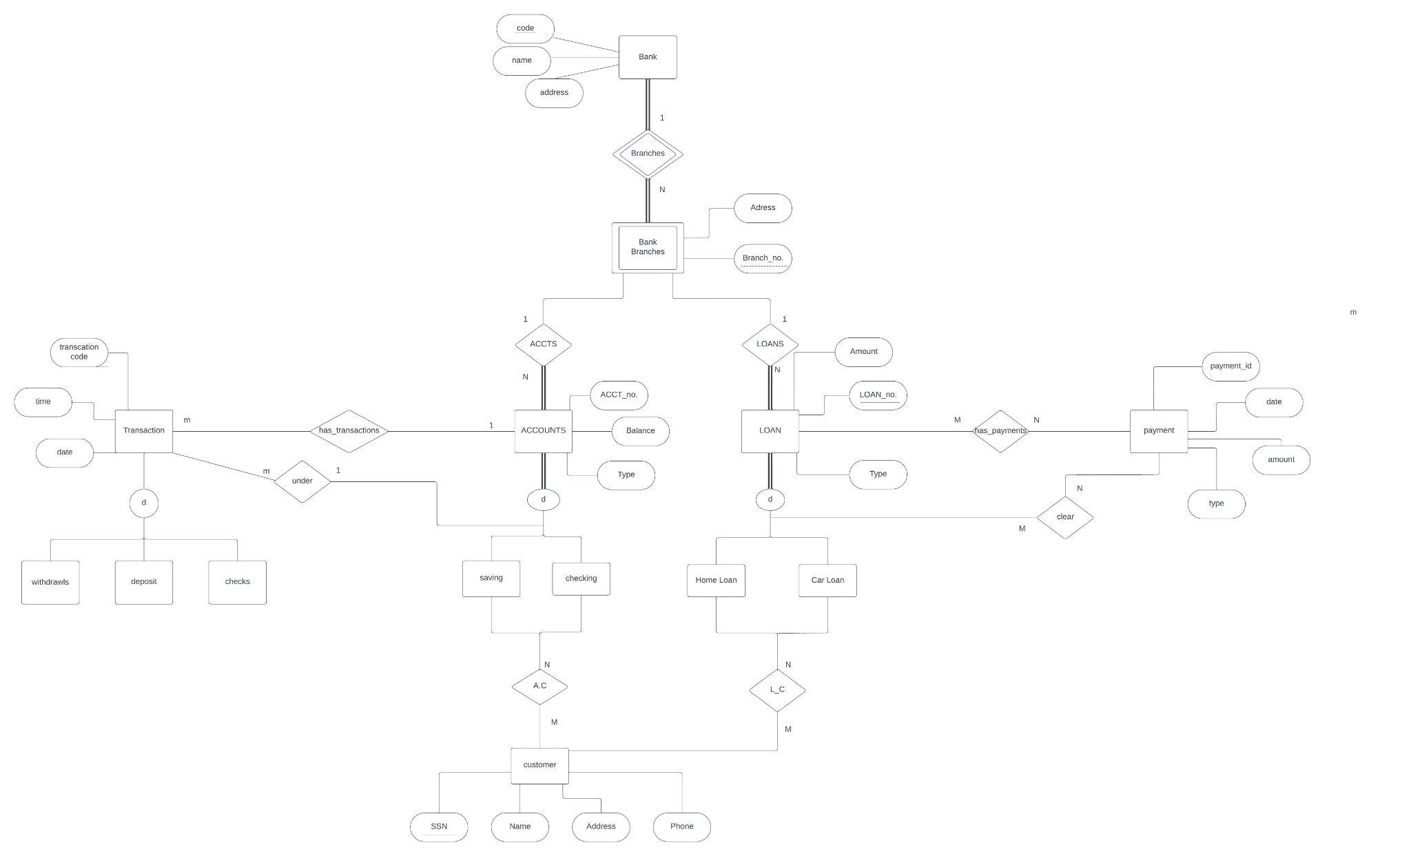

**Question no.4**

Attributes and Keys for Each Entity Type:

* **Computer**: Attributes - Model, Processor, RAM; **Key** - Serial Number
* **Laptop**: Attributes - Screen Size, Battery Life; Inherits attributes from Computer
* **Desktop**: Attributes - Form Factor, Power Supply; Inherits attributes from Computer
* **Software**: Attributes - Version, License Type; **Key** - Software ID
* **Operating System**: Attributes - Platform (Windows, MacOS, Linux), Version; Inherits attributes from Software
* **Accessory**: Attributes - Type (keyboard/mouse/monitor), Brand; **Key** - Accessory ID
* **Component**: Attributes – Type (memory/video card/sound card), Specifications; **Key** – Component ID

Max Cardinality Constraints:

* A computer can have multiple components but a component is installed in one computer.
* A laptop or desktop can be sold with multiple accessories but an accessory is sold with one laptop/desktop.
* Each computer has one installed operating system but an OS can be installed on many computers.

Narrative Description: The EER diagram illustrates the organization of a company’s computer systems. It categorizes computers into laptops and desktops as sub-categories. Computers have components like memory, video cards, and sound cards installed in them. Each type of computer can support various software including operating systems.

Accessories such as keyboards, mice and monitors are sold with both laptops and desktops. The ‘SoldWith’ relationship indicates that these accessories are often bundled with the purchase of a new machine.

The ‘InstalledOS’ relationship shows that each computer has an operating system installed which is a type of software. The ‘Supports’ relationship indicates that both laptops and desktops support various types of software installations.

Question no. 5

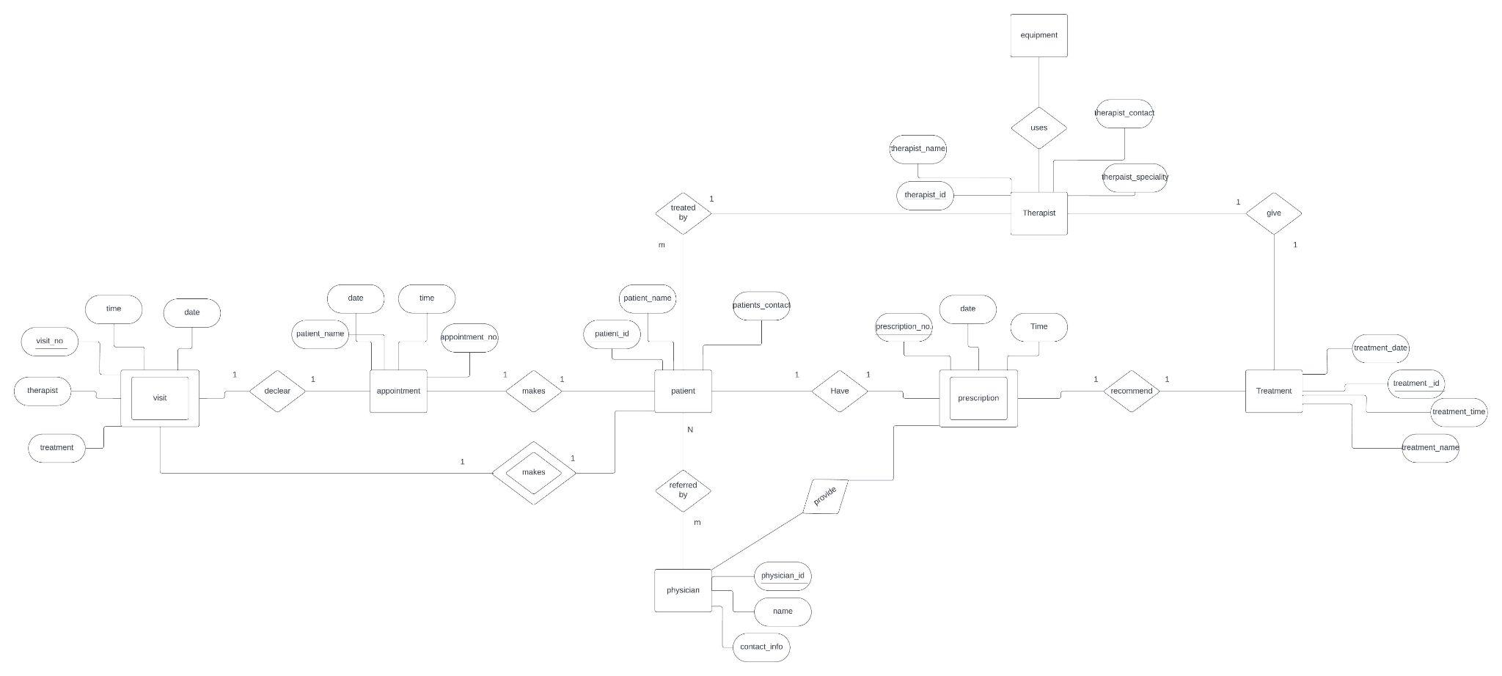

Question no. 6

