Question no. 1

#include <fstream> // Include the file stream library for file processing

#include <iomanip> // Include the input/output manipulation library for printing format on the monitor

#include <iostream> // Include the input/output stream library

using namespace std; // Use the standard namespace

// Function prototype for GetInches

int GetInches(ifstream &rainFile, int numberOfDays);

int main() { // Start of the main function

float average; // Declare a float variable to store the average rainfall

float totalRain; // Declare a float variable to store the total accumulated rain

int numberOfDays; // Declare an integer variable to store the number of days in calculation

ifstream rainFile; // Declare an input file stream variable to read data from hard drive to memory

cout << fixed << showpoint; // Set the decimal point to be always shown and the number to be shown in fixed point notation

rainFile.open("Rain.In"); // Open the file named "Rain.In"

rainFile >> numberOfDays; // Read the first value from the file into numberOfDays

totalRain = GetInches(rainFile, numberOfDays); // Call the GetInches function and store the returned value in totalRain

if (totalRain == 0.0) // If totalRain is 0.0

cout << "There was no rain during this period." << endl; // Print this message

else { // Otherwise

average = totalRain / numberOfDays; // Calculate the average rainfall

cout << "The average rain fall over " << numberOfDays; // Print part of the message

cout << " days is " << setw(1) << setprecision(3) << average << endl; // Print the rest of the message with the average rainfall

}

return 0; // Return 0 indicating successful execution

} // End of the main function

int GetInches(ifstream &rainFile, int numberOfDays) { // Start of the GetInches function

float inches; // Declare a float variable to store a day's worth of rain

int counter; // Declare an integer variable as a loop control variable

float totalRain = 0.0; // Initialize totalRain to 0.0

counter = 1; // Initialize counter to 1

while (counter <= numberOfDays) { // While counter is less than or equal to numberOfDays

rainFile >> inches; // Read a value from the file into inches

totalRain = totalRain + inches; // Add inches to totalRain

counter++; // Increment counter

}

return totalRain; // Return totalRain

} // End of the GetInches function

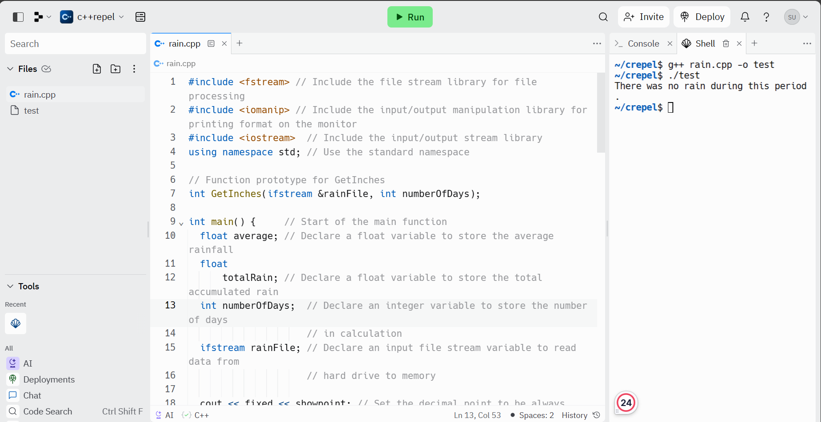

#question no. 2

// Program Area calculates the area of a square.

// The user is prompted to enter the number of inches on each

// side. Note that "endl" in line 7 ends in the letter "l", not

// the number one.

#include <iostream> // Include the input/output stream library

using namespace std; // Use the standard namespace

int main (){ // Start of the main function

int inches; // Declare an integer variable to store the number of inches on a side

cout << "Enter the number of inches on a side " // Print a message asking the user to enter the number of inches on a side

<< endl; // End the line and move the cursor to the next line

cout << "Press the return key." // Print a message asking the user to press the return key

<< endl; // End the line and move the cursor to the next line

cin >> inches; // Read the user's input into the variable inches

cout << endl // End the line and move the cursor to the next line

<< "The area is " << inches * inches <<"." // Calculate the area by squaring the number of inches and print the result

<< endl; // End the line and move the cursor to the next line

return 0; // Return 0 indicating successful execution

} // End of the main function

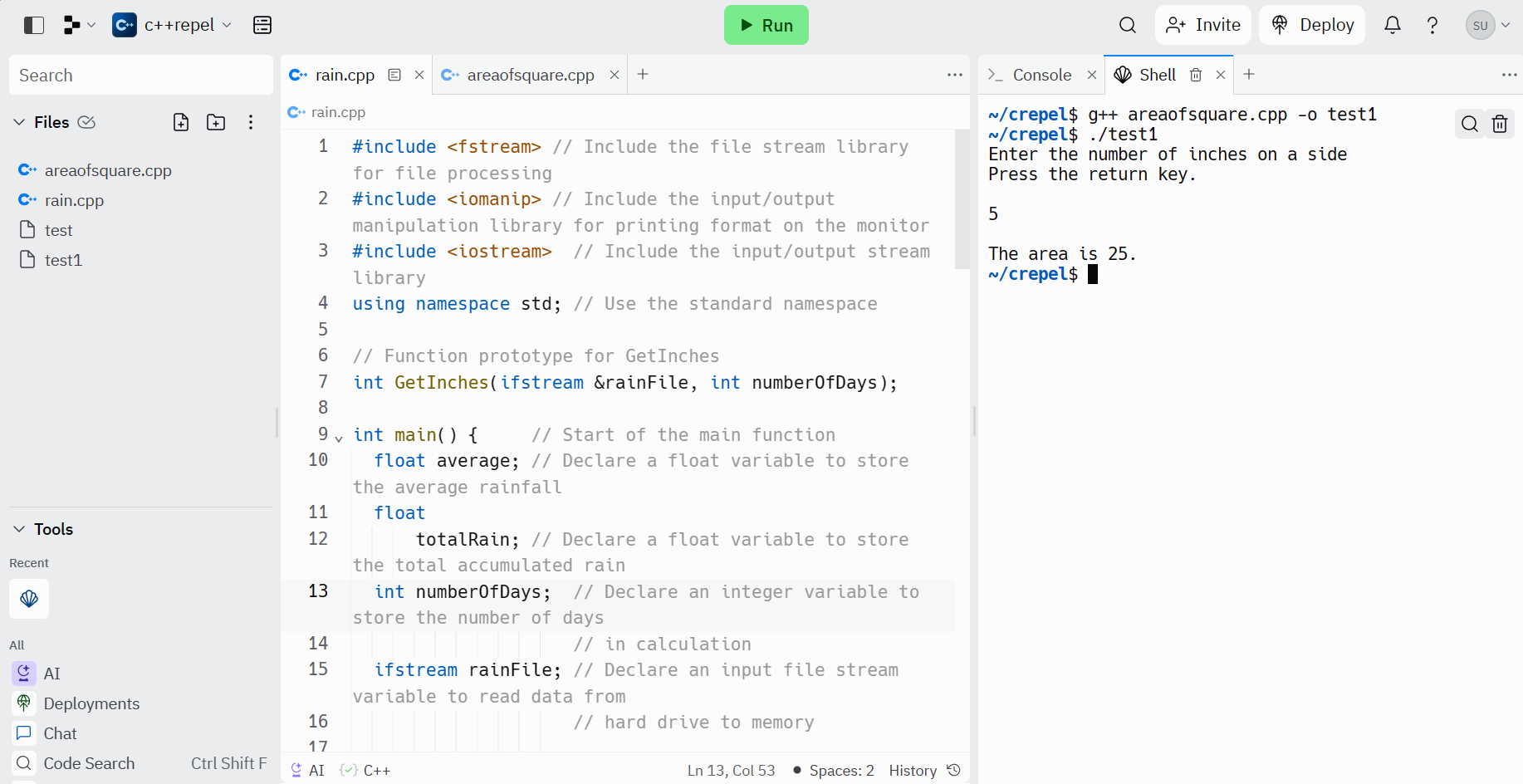

Question no.3

#include <iostream>

using namespace std;

bool logic_to_find_leapYear(int year) {

if (year % 4 != 0) {

return false;

} else if (year % 100 != 0) {

return true;

} else if (year % 400 != 0) {

return false;

} else {

return true;

}

}

int main() {

int year;

cout << "Enter a year AD, for example, 1997" << endl;

cin >> year;

if (logic_to_find_leapYear(year)) {

cout << year << " is a leap year" << endl;

} else {

cout << year << " is not a leap year" << endl;

}

}

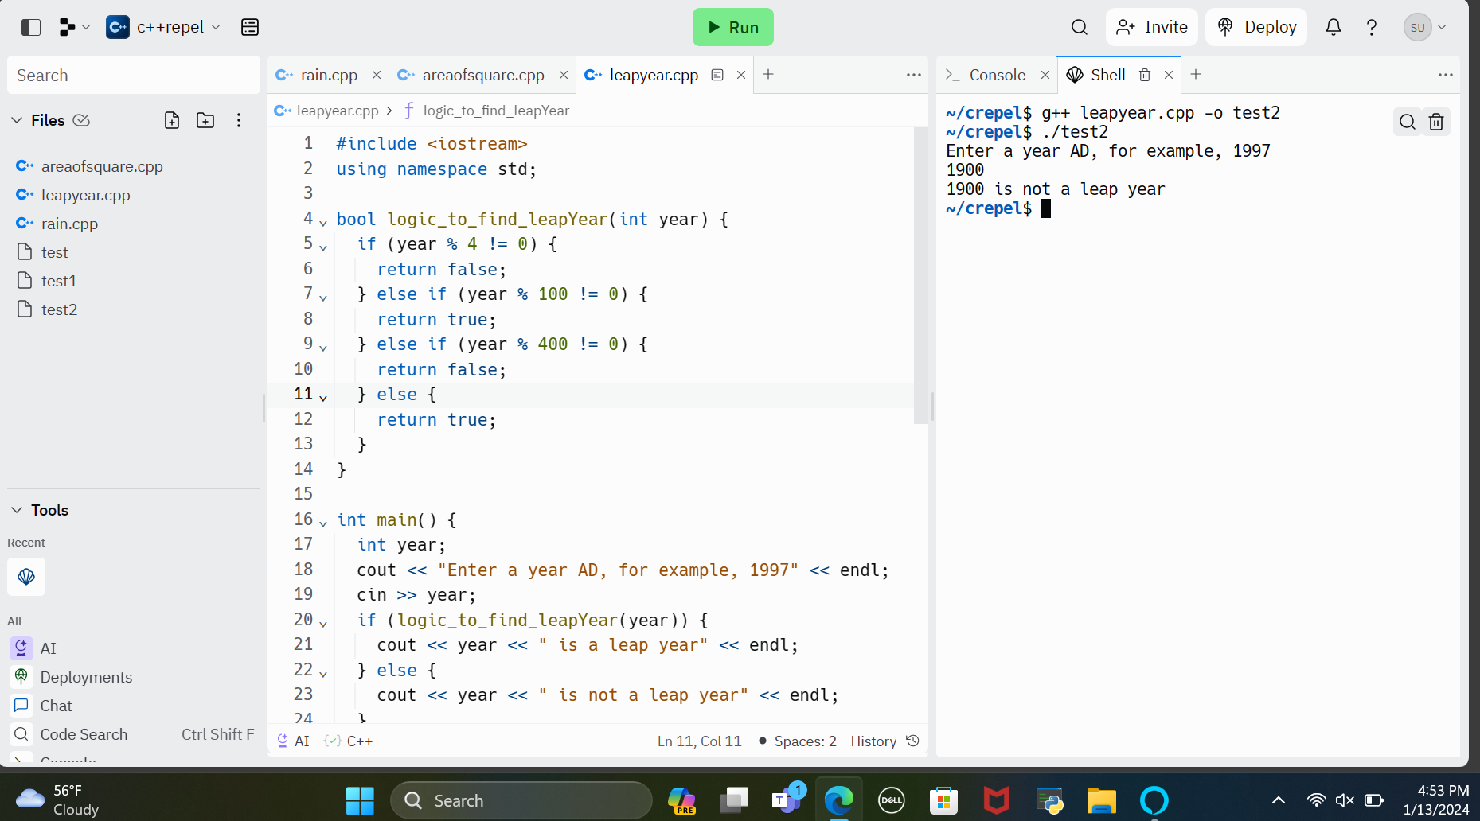

Question no.4

#include <iostream>

using namespace std;

int main() {

int n, i, j, space = 1;

cout << "Enter the number of rows: ";

cin >> n;

space = n - 1;

for (j = 1; j <= n; j++) {

for (i = 1; i <= space; i++) {

cout << " ";

}

space--;

for (i = 1; i <= 2 * j - 1; i++) {

if (i == 1 || i == 2 * j - 1) {

cout << "*";

} else {

cout << " ";

}

}

cout << endl;

}

space = 1;

for (j = 1; j <= n - 1; j++) {

for (i = 1; i <= space; i++) {

cout << " ";

}

space++;

for (i = 1; i <= 2 * (n - j) - 1; i++) {

if (i == 1 || i == 2 * (n - j) - 1) {

cout << "*";

} else {

cout << " ";

}

}

cout << endl;

}

}

