## Ministry Name: Ministry of Commerce and Industries

1. **Problem Statement Title: “Sentiment analysis of incoming calls on Helpdesk”**

## Team Name: Senti6

1. **Institute Name: Walchand Institute of Technology, Solapur.**
2. **Theme Name: Miscellaneous**

# Abstract

The problem at hand involved the development of a specialized sentiment analysis solution tailored for analyzing the sentiments expressed in incoming calls to helpdesks, call centers, and customer service departments. This need arose due to the ever-increasing volume of customer interactions in these domains, making it crucial for businesses to gain insights into customer sentiments conveyed during phone conversations.

Sentiment analysis, in this context, referred to the process of automatically determining the emotional tone or sentiment of text or speech. It held great potential for providing valuable information about customer satisfaction, identifying potential issues, and highlighting areas for improvement in customer service delivery.

The operator, in the past, analyzed sentiments in audio recordings and explored the limitations of relying on text transcripts for sentiment analysis. We acknowledged that building a text-to- speech system for sentiment analysis was not only time-consuming and data-intensive but also speaker-dependent. This presented practical challenges as it required extensive labeled data for each speaker, making it impractical for real-world applications.

As an alternative, the operator proposed using acoustic features for sentiment analysis. This approach was speaker-independent and promised better performance. It was noted that not all acoustic features were equally relevant, with prosodic features like tone and aspects such as power and pitch playing significant roles in capturing sentiment variations.

Additionally, the operator acknowledged the challenge of dealing with audio recordings that contained multiple sources, including music, noise, or multiple speakers. To address this, we introduced the concept of speaker diarization, a technique used to separate speakers when multiple individuals spoke in turn. This was deemed crucial for accurate sentiment analysis in such complex scenarios.

In the realm of text-based sentiment analysis, the Natural Language Toolkit (NLTK) was recognized as a valuable tool for natural language processing (NLP). In the past, NLTK was widely used for various applications, such as evaluating customer feedback, monitoring social media conversations, and conducting market research.

The process of text-based sentiment analysis in the past involved initial steps like text preprocessing, which encompassed tasks such as breaking text into words (tokenization), converting text to lowercase, and removing common words like "the" and punctuation. These seemingly straightforward steps laid the foundation for more accurate sentiment analysis.

The heart of the process was sentiment classification, which utilized algorithms available in NLTK, including Support Vector Machines. These algorithms, in the past, learned from labeled examples of text with sentiments (e.g., positive or negative) and subsequently predicted sentiments in new text based on their training. NLTK, in essence, empowered users to understand the emotional tone within text, akin to having a language expert on hand to decode sentiments hidden in words.

# Following solution deals was proposed:

## Customer Satisfaction using Sentiment Analysis:

This solution involves analyzing customer feedback, such as reviews, comments, or survey responses, using sentiment analysis techniques.

Sentiment analysis helps in gauging the sentiment (positive, negative, or neutral) of customers towards your products, services, or brand.

## Targeting Effective Business Areas - Up-Sell, Prevent Customer Churn:

This solution focuses on using data analytics and customer segmentation to identify opportunities for upselling and preventing customer churn.

By analyzing customer behavior and preferences, businesses can target specific products or services to upsell to existing customers.

## 3.360 View of Each Call:

This solution aims to provide a comprehensive view of each customer interaction, especially in call center or customer support settings.

It involves integrating various data sources, including call recordings, customer history, and real- time information, to empower customer service representatives with a complete understanding of the customer's situation.

Feedback Prioritization:

These solutions collectively aim to enhance customer satisfaction, optimize business operations, and improve customer retention by leveraging data analysis and automation technologies. They are valuable tools for businesses looking to stay competitive and meet the evolving expectations of their customers.

# Why is the need for sentiment analysis of incoming calls on Helpdesk?

Sentiment analysis for incoming calls on the Helpdesk is vital because it helps us understand the emotions and feelings of our customers when they contact us. It allows us to gauge whether they are satisfied, frustrated, or somewhere in between. This understanding is valuable because it enables us to respond appropriately, prioritize urgent cases, improve the quality of our support, provide better training for our team, boost team morale, and gain insights into what customers like or dislike about our products or services. In essence, sentiment analysis empowers us to offer more personalized and effective customer support, ultimately leading to higher customer

satisfaction and improved service quality.

* **Customer Satisfaction:** Understanding how customers feel when they contact the Helpdesk is crucial for ensuring their satisfaction. Sentiment analysis allows us to gauge whether customers are happy, frustrated, or neutral during their interactions.
* **Issue Identification**: Sentiment analysis helps in identifying potential issues or pain points that customers may be experiencing. By pinpointing areas of concern, we can take proactive steps to address these issues and improve our services.
* **Quality Improvement**: Analyzing sentiment in incoming calls provides valuable feedback on the quality of customer support. It helps us identify areas where we excel and areas where we need improvement, enabling us to enhance the overall service delivery.
* **Resource Allocation:** By categorizing calls based on sentiment, we can allocate resources more efficiently. Urgent or highly emotional calls can be prioritized, ensuring that customers with critical issues receive prompt attention.
* **Training and Development:** Sentiment analysis can be a valuable tool for training and development purposes. It allows us to learn from past interactions, understand common customer concerns, and train our team to provide more effective support.
* **Customer Insights:** Analyzing sentiment provides insights into what customers appreciate or dislike about our products or services. This information can inform product development and marketing strategies.
* **Competitive Advantage:** Businesses that actively analyze customer sentiment gain a competitive advantage by demonstrating their commitment to customer satisfaction. Positive sentiment can also be leveraged in marketing efforts.

Sentiment analysis of incoming calls on a Helpdesk is essential for optimizing customer support, improving customer satisfaction, and ensuring the overall success of the business. It helps in identifying and addressing issues, allocating resources effectively, and continuously enhancing the quality of service provided to customers.

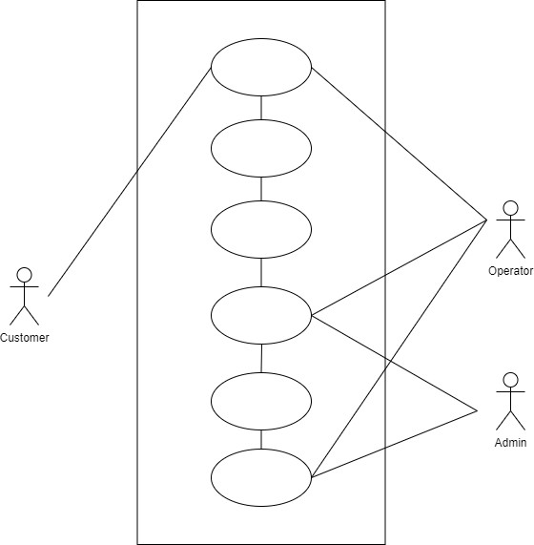

Sentiment Analysis

Call

ML Model

Sentiment

Database

Function

Dashboard

# Fig1.Use cases

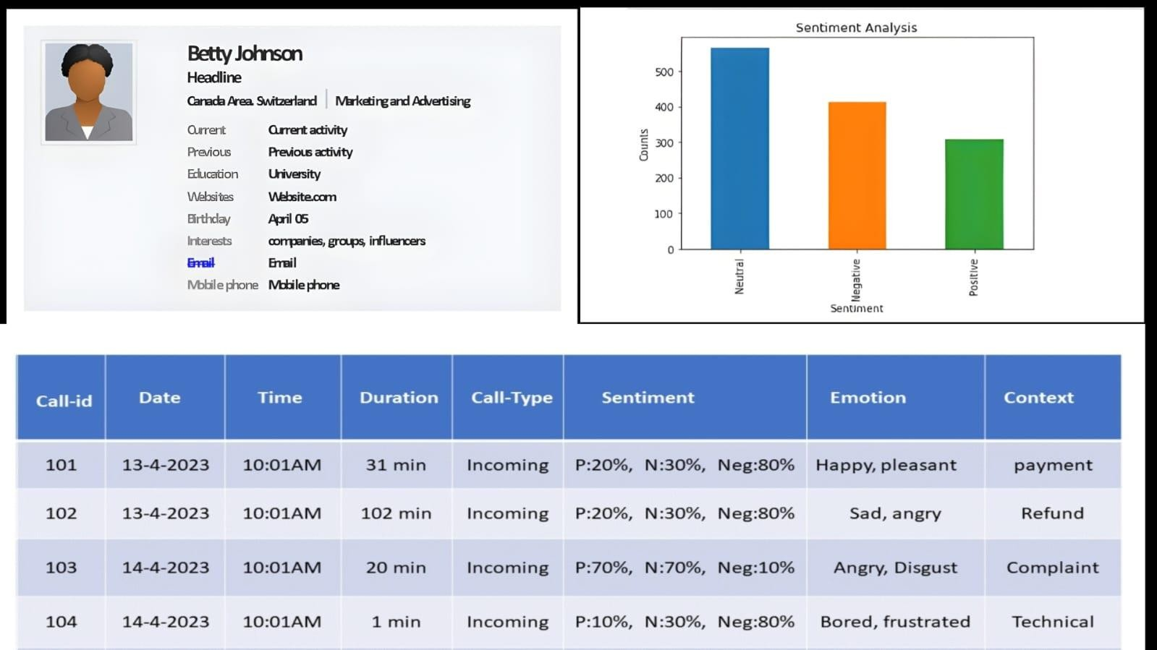

**Fig2.Sample operator Dashboard**