13. Write a java program to read, read write using RandomAccessFile.
SOURCE CODE:
import java.io.*;
public class RandomAccessFileExample {
public static void main(String[] args) {
try {
RandomAccessFile file = new RandomAccessFile("data.txt", "rw");

file.writeUTF("Hello Bidisha");
file.writeInt(25);
file.seek(0);
String text = file.readUTF();
int num = file.readInt();

System.out.println("Text: " + text);
System.out.println("Number: " + num);

file.close();
}
catch(Exception e) {
System.out.println(e);
}
}
}

OUTPUT:
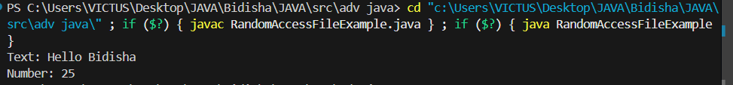

14. Write a java program to demonstrate Object serialization and deserialization.
SOURCE CODE:
import java.io.*;
class Student implements Serializable {
int id;
String name;

Student(int id, String name) {
this.id = id;
this.name = name;
}
}
public class SerializationDemo {
public static void main(String[] args) {
try {
Student s = new Student(101, "Bidisha");
FileOutputStream fos = new FileOutputStream("student.dat");
ObjectOutputStream oos = new ObjectOutputStream(fos);
oos.writeObject(s);
oos.close();

FileInputStream fis = new FileInputStream("student.dat");
ObjectInputStream ois = new ObjectInputStream(fis);
Student s1 = (Student) ois.readObject();

System.out.println("ID: " + s1.id);
System.out.println("Name: " + s1.name);

ois.close();

} catch(Exception e) {
System.out.println(e);
}
}
}

OUTPUT:
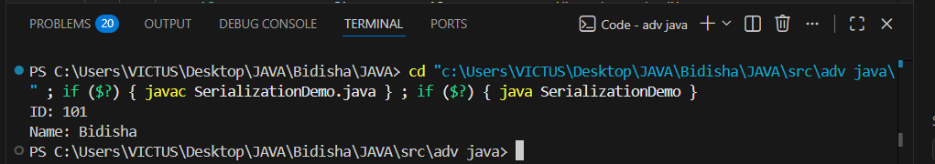

15. Write a Java program to demonstrate inter-thread communication or Co-operation threading.
SOURCE CODE:
import java.lang.*;
class Data {
int value;
boolean available = false;
synchronized void produce(int v) {
try {
if (available)
wait();
value = v;
System.out.println("Produced: " + value);
available = true;
notify();
} catch(Exception e) {}
}
synchronized void consume() {
try {
if (!available)
wait();

System.out.println("Consumed: " + value);
available = false;
notify();
} catch(Exception e) {}
}
}

class Producer extends Thread {
Data d;
Producer(Data d) {
this.d = d;
}
public void run() {
d.produce(100);
}
}
class Consumer extends Thread {
Data d;
Consumer(Data d) {
this.d = d;
}

public void run() {
d.consume();
}
}
public class InterThreadCommunication {
public static void main(String[] args) {
Data d = new Data();
Producer p = new Producer(d);
Consumer c = new Consumer(d);
p.start();
c.start();
}
}

OUTPUT:
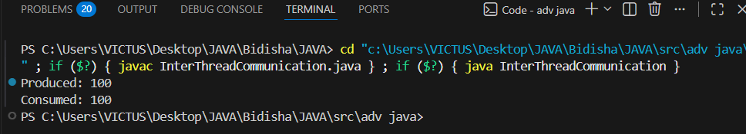

16. Write java program to demonstrate Multithreading using synchronized Method.
SOURCE CODE:
import java.io.*;
class BankAccount {
int balance = 0;
synchronized void deposit(int amount) {
balance += amount;
System.out.println(Thread.currentThread().getName() + " deposited " + amount +
", Current Balance: " + balance);
try {
Thread.sleep(200);
} catch (InterruptedException e) {
System.out.println(e);
}
}
}
class Customer extends Thread {
BankAccount account;
int amount;

Customer(BankAccount account, int amount) {
this.account = account;
this.amount = amount;
}

public void run() {
account.deposit(amount);
}
}

public class SynchronizedBankDemo {
public static void main(String[] args) {
BankAccount account = new BankAccount();
Customer c1 = new Customer(account, 100);
Customer c2 = new Customer(account, 200);
c1.setName("Customer 1");
c2.setName("Customer 2");
c1.start();
c2.start();
}
}

OUTPUT:
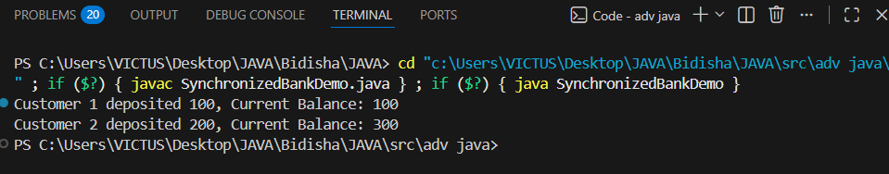

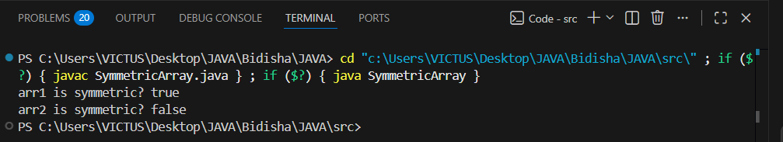

17. An array is said to be centered if it contains an odd number of elements and all elements except the middle one are strictly greater than the middle element.
Write a Java function that accepts an integer array and returns 1 if the array is centered; otherwise returns 0.
SOURCE CODE:
public class CenteredArray {
public static int isCentered(int[] arr) {
if (arr.length % 2 == 0)
return 0;
int mid = arr.length / 2;
int middleValue = arr[mid];

for (int i = 0; i < arr.length; i++) {
if (i != mid && arr[i] <= middleValue) {
return 0;
}
}

return 1;
}
public static void main(String[] args) {
int[] a1 = {3, 2, 1, 4, 5};
int[] a2 = {3, 2, 3, 4};
int[] a3 = {1};
System.out.println(isCentered(a1));
System.out.println(isCentered(a2));
System.out.println(isCentered(a3));
}
}
OUTPUT:
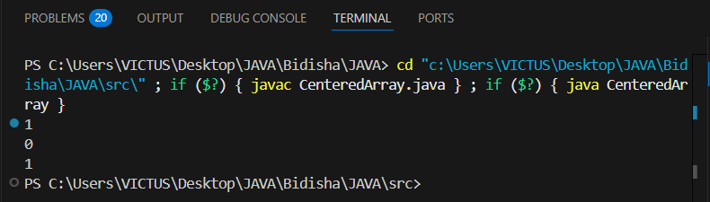

18. An integer array is called balanced if it has an odd number of elements and the sum of elements on the left side of the middle element is equal to the sum of elements on the right side.Write a Java function to check whether the array is balanced.
SOURCE CODE:
public class BalancedArray {
public static int isBalanced(int[] arr) {
if (arr.length % 2 == 0)
return 0;
int mid = arr.length / 2;
int leftSum = 0, rightSum = 0;
for (int i = 0; i < mid; i++) {
leftSum += arr[i];
}
for (int i = mid + 1; i < arr.length; i++) {
rightSum += arr[i];
}

return (leftSum == rightSum) ? 1 : 0;
}

public static void main(String[] args) {
int[] a1 = {1, 2, 3, 2, 1};
int[] a2 = {2, 3, 4, 1, 2};
int[] a3 = {5};

System.out.println("Array 1 Balanced? : " + isBalanced(a1));
System.out.println("Array 2 Balanced? : " + isBalanced(a2));
System.out.println("Array 3 Balanced? : " + isBalanced(a3));
}
}

OUTPUT:
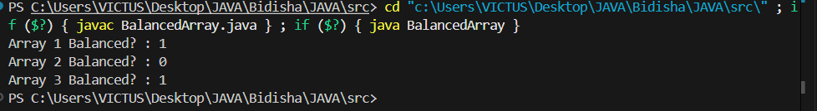
19. An array is called odd-even array if elements at even indices are even and elements at odd indices are odd.Write a Java program to verify whether the given array satisfies this condition.
SOURCE CODE:
import java.util.Scanner;
public class OddEvenArray {
public static void main(String[] args) {
Scanner sc = new Scanner(System.in);
System.out.print("Enter array size: ");
int n = sc.nextInt();
int[] arr = new int[n];
System.out.println("Enter array elements:");
for (int i = 0; i < n; i++) {
arr[i] = sc.nextInt();
}
boolean isOddEven = true;

for (int i = 0; i < n; i++) {
if (i % 2 == 0 && arr[i] % 2 != 0) {
isOddEven = false;
break;
}
if (i % 2 != 0 && arr[i] % 2 == 0) {
isOddEven = false;
break;
}
}

if (isOddEven)
System.out.println("The array is an Odd-Even Array");
else
System.out.println("The array is NOT an Odd-Even Array");

sc.close();
}
}

OUTPUT:
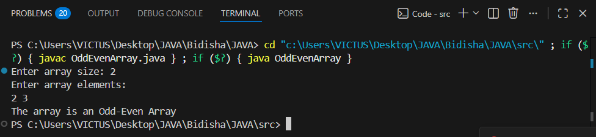
20. An array is called symmetric if it reads the same from left to right and right to left.
Write a Java function to check whether an array is symmetric.
SOURCE CODE:
public class SymmetricArray {
public static boolean isSymmetric(int[] arr) {
int n = arr.length;
for (int i = 0; i < n / 2; i++) {
if (arr[i] != arr[n - 1 - i]) {
return false;
}
}
return true;
}

public static void main(String[] args) {
int[] a1 = {1, 2, 3, 2, 1};
int[] a2 = {1, 2, 3, 4};

if (isSymmetric(a1))
System.out.println("Array 1 is Symmetric");
else
System.out.println("Array 1 is Not Symmetric");

if (isSymmetric(a2))
System.out.println("Array 2 is Symmetric");
else
System.out.println("Array 2 is Not Symmetric");
}
}

OUTPUT:

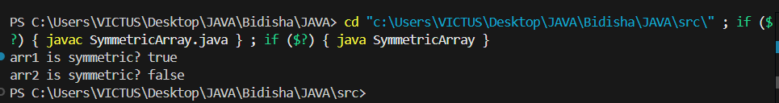

21. Write a Java program to initialize and display jagged array elements with sum of each row.
SOURCE CODE:
public class JaggedArraySum {
public static void main(String[] args) {
int[][] arr = {
{1, 2, 3},
{4, 5},
{6, 7, 8, 9}
};
for (int i = 0; i < arr.length; i++) {
int sum = 0;
for (int j = 0; j < arr[i].length; j++) {
System.out.print(arr[i][j] + " ");
sum += arr[i][j];
}
System.out.println(" | Sum = " + sum);
}
}
}

OUTPUT:
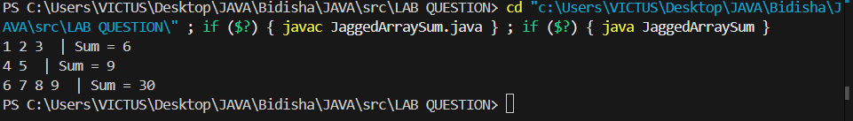

22. Write a Java program to initialize and display 2D array elements with sum of each row.
SOURCE CODE:
public class Array2DSum {
public static void main(String[] args) {
int[][] arr = {
{1, 2, 3},
{4, 5, 6},
{7, 8, 9}
};
for (int i = 0; i < arr.length; i++) {
int sum = 0;
System.out.print("Row " + (i + 1) + ": ");
for (int j = 0; j < arr[i].length; j++) {
System.out.print(arr[i][j] + " ");
sum += arr[i][j];
}
System.out.println("| Sum = " + sum);
}
}
}

OUTPUT:
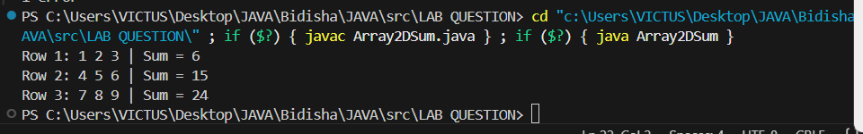

23. Write a Java program to initialize and display jagged array elements with sum of each column.
SOURCE CODE:
public class JaggedColumnSum {
public static void main(String[] args) {
int[][] arr = {
{1, 2, 3},
{4, 5},
{6, 7, 8, 9}
};
int max = 0;
for (int i = 0; i < arr.length; i++) {
if (arr[i].length > max) {
max = arr[i].length;
}
}
for (int j = 0; j < max; j++) {
int sum = 0;
System.out.print("Column " + (j + 1) + ": ");

for (int i = 0; i < arr.length; i++) {
if (j < arr[i].length) {
System.out.print(arr[i][j] + " ");
sum += arr[i][j];
}
}
System.out.println("| Sum = " + sum);
}
}
}

OUTPUT:
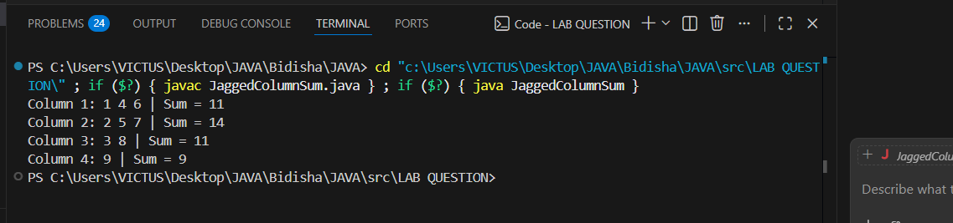

24. Write a Java program to find the maximum element in each row of a 2D array.
SOURCE CODE:
public class MaxInRow {
public static void main(String[] args) {
int[][] arr = {
{3, 5, 1},
{7, 2, 8},
{4, 9, 6}
};
for (int i = 0; i < arr.length; i++) {
int max = arr[i][0];
for (int j = 1; j < arr[i].length; j++) {
if (arr[i][j] > max) {
max = arr[i][j];
}
}
System.out.println("Maximum element in row " + (i + 1) + " = " + max);
}
}
}

OUTPUT:
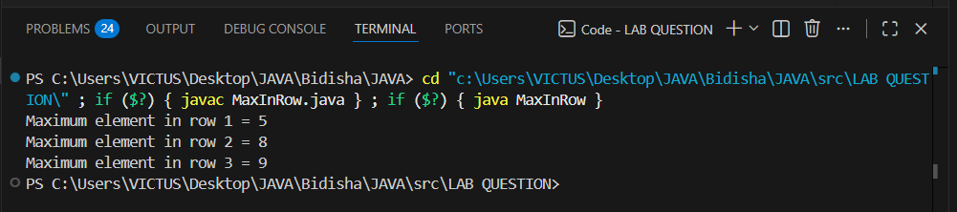

25. Write a Java program to count even and odd numbers in a jagged array.

SOURCE CODE:

public class EvenOddJagged {
public static void main(String[] args) {
int[][] arr = {
{1, 2, 3},
{4, 5},
{6, 7, 8, 9}
};
int even = 0, odd = 0;

for (int i = 0; i < arr.length; i++) {
for (int j = 0; j < arr[i].length; j++) {

if (arr[i][j] % 2 == 0)
even++;
else
odd++;
}
}

System.out.println("Even numbers = " + even);
System.out.println("Odd numbers = " + odd);
}
}

OUTPUT:

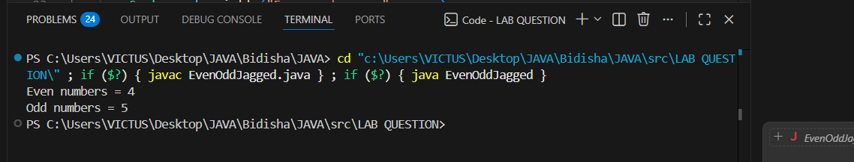
26. Write a Java program to transpose a 2D array.
SOURCE CODE:
public class TransposeMatrix {
public static void main(String[] args) {
int[][] arr = {
{1, 2, 3},
{4, 5, 6}
};
int rows = arr.length;
int cols = arr[0].length;
System.out.println("Original Matrix:");
for (int i = 0; i < rows; i++) {
for (int j = 0; j < cols; j++) {
System.out.print(arr[i][j] + " ");
}
System.out.println();
}
System.out.println("Transpose Matrix:");
for (int i = 0; i < cols; i++) {
for (int j = 0; j < rows; j++) {
System.out.print(arr[j][i] + " ");
}
System.out.println();
}
}
}

OUTPUT:

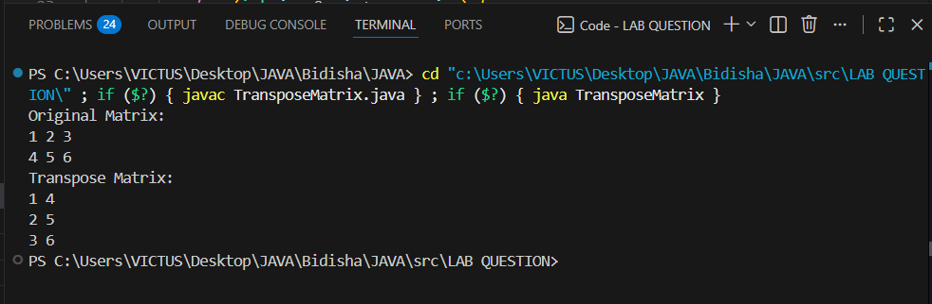

27. Write a Java program to read data from server using socket.
SOURCE CODE:
SocketServer.java
import java.io.*;
import java.net.*;
public class SocketServer {
public static void main(String[] args) throws IOException {
int port = 5000;
ServerSocket serverSocket = new ServerSocket(port);
System.out.println("Server started on port " + port);

Socket client = serverSocket.accept();
System.out.println("Client connected: " + client.getInetAddress());

PrintWriter out = new PrintWriter(client.getOutputStream(), true);
out.println("Hello from server!");
out.println("This is a test message.");

out.close();
client.close();
serverSocket.close();
}
}

SocketClient.java
import java.io.*;
import java.net.*;
public class SocketClient {
public static void main(String[] args) {
String serverAddress = "localhost";
int port = 5000;
try {
Socket socket = new Socket(serverAddress, port);
System.out.println("Connected to server: " + serverAddress);

BufferedReader in = new BufferedReader(new InputStreamReader(socket.getInputStream()));
String line;

System.out.println("Data from server:");
while ((line = in.readLine()) != null) {
System.out.println(line);
}
in.close();
socket.close();
} catch (IOException e) {
System.out.println("Error: " + e.getMessage());
}
}
}

OUTPUT:
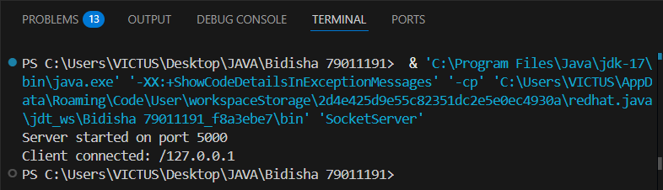
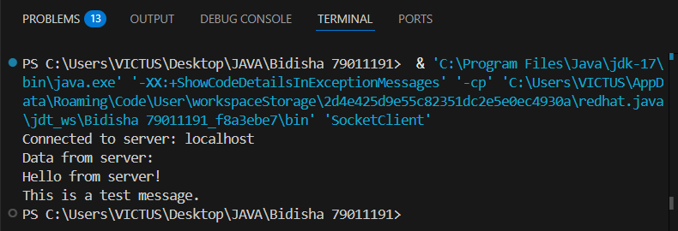
28. Write a java program to write data to server using socket.
SOURCE CODE:
SimpleServer.java
import java.io.*;
import java.net.*;
public class SimpleServer {
public static void main(String[] args) {
int port = 5000;
try {
ServerSocket server = new ServerSocket(port);
System.out.println("Server started on port " + port);

Socket client = server.accept();
System.out.println("Client connected: " + client.getInetAddress());

BufferedReader in = new BufferedReader(new InputStreamReader(client.getInputStream()));
String message = in.readLine();
System.out.println("Received from client: " + message);

in.close();
client.close();
server.close();
} catch (IOException e) {
System.out.println("Error: " + e.getMessage());
}
}
}

SimpleClient.java

import java.io.*;
import java.net.*;
public class SimpleClient {
public static void main(String[] args) {
String serverIP = "localhost";
int port = 5000;
try {
Socket socket = new Socket(serverIP, port);
System.out.println("Connected to server at " + serverIP + ":" + port);

PrintWriter out = new PrintWriter(socket.getOutputStream(), true);
out.println("Hello Server! This is client speaking.");

out.close();
socket.close();

} catch (IOException e) {
System.out.println("Error: " + e.getMessage());
}
}
}

OUTPUT:
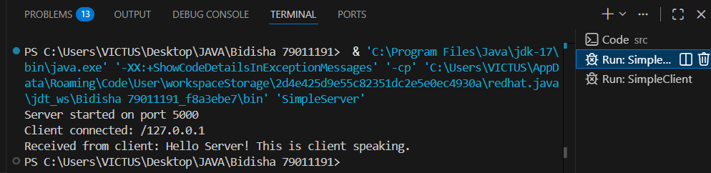
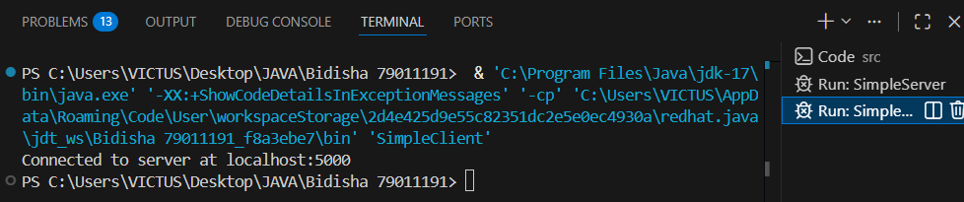

29. Write a java program to perform basic two way operation between client and server using TCP.
SOURCE CODE:
TCPServer.java
import java.io.*;
import java.net.*;
import java.util.Scanner;
public class TCPServer {
public static void main(String[] args) throws Exception {
ServerSocket serverSocket = new ServerSocket(5000);
System.out.println("Server started. Waiting for client...");
Socket socket = serverSocket.accept();
System.out.println("Client connected!");
BufferedReader in = new BufferedReader(
new InputStreamReader(socket.getInputStream()));
PrintWriter out = new PrintWriter(
socket.getOutputStream(), true);
Scanner sc = new Scanner(System.in);
String message;
while (true) {
if (in.ready()) {
message = in.readLine();
System.out.println("Client: " + message);
if (message.equalsIgnoreCase("exit"))
break;
}
if (System.in.available() > 0) {
message = sc.nextLine();
out.println(message);
if (message.equalsIgnoreCase("exit"))
break;
}
}
socket.close();
serverSocket.close();
System.out.println("Chat ended.");
}
}

TCPClient.java

import java.io.*;
import java.net.*;
import java.util.Scanner;
public class TCPClient {
public static void main(String[] args) throws Exception {
Socket socket = new Socket("localhost", 5000);
System.out.println("Connected to Server!");
BufferedReader in = new BufferedReader(
new InputStreamReader(socket.getInputStream()));
PrintWriter out = new PrintWriter(
socket.getOutputStream(), true);
Scanner sc = new Scanner(System.in);
String message;
while (true) {
if (System.in.available() > 0) {
message = sc.nextLine();
out.println(message);
if (message.equalsIgnoreCase("exit"))
break;
}

if (in.ready()) {
message = in.readLine();
System.out.println("Server: " + message);
if (message.equalsIgnoreCase("exit"))
break;
}
}
socket.close();
System.out.println("Chat ended.");
}
}

OUTPUT:
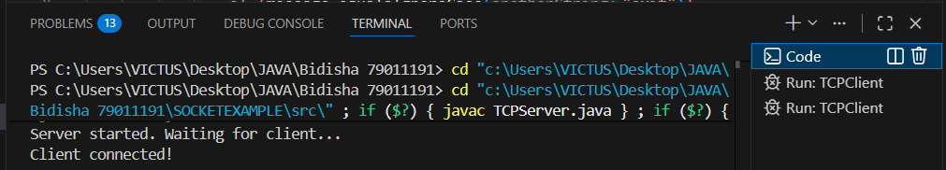
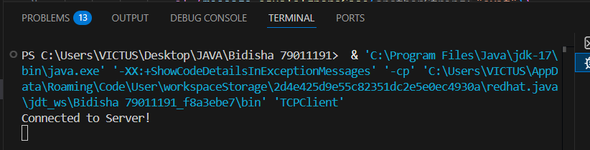
30. Write a simple chat application using TCP Socket.
SOURCE CODE:
ChatServer.java
import java.io.*;
import java.net.*;

public class ChatServer {
public static void main(String[] args) throws IOException {
ServerSocket serverSocket = new ServerSocket(1234);
System.out.println("Server is waiting for client...");

Socket socket = serverSocket.accept();
System.out.println("Client connected!");

BufferedReader in = new BufferedReader(
new InputStreamReader(socket.getInputStream()));
PrintWriter out = new PrintWriter(socket.getOutputStream(), true);

BufferedReader console = new BufferedReader(
new InputStreamReader(System.in));

String message;

while (true) {
message = in.readLine();
if (message.equalsIgnoreCase("exit")) {
System.out.println("Client disconnected.");
break;
}
System.out.println("Client: " + message);
System.out.print("You: ");
String reply = console.readLine();
out.println(reply);

if (reply.equalsIgnoreCase("exit")) {
break;
}
}
socket.close();
serverSocket.close();
System.out.println("Server closed.");
}
}

ChatClient.java
import java.io.*;
import java.net.*;
public class ChatClient {
public static void main(String[] args) throws IOException {
Socket socket = new Socket("localhost", 1234);
System.out.println("Connected to server!");
BufferedReader in = new BufferedReader(
new InputStreamReader(socket.getInputStream()));
PrintWriter out = new PrintWriter(socket.getOutputStream(), true);

BufferedReader console = new BufferedReader(
new InputStreamReader(System.in));
String message;
while (true) {
System.out.print("You: ");
message = console.readLine();
out.println(message);

if (message.equalsIgnoreCase("exit")) {
break;
}

String reply = in.readLine();
if (reply.equalsIgnoreCase("exit")) {
System.out.println("Server disconnected.");
break;
}
System.out.println("Server: " + reply);
}
socket.close();
System.out.println("Client closed.");
}
}

OUTPUT:
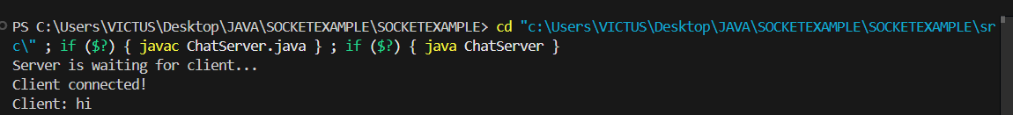
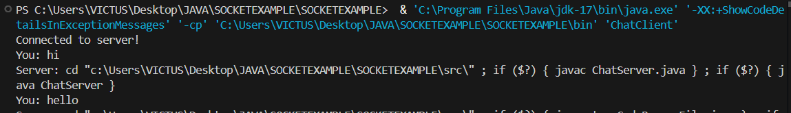
31. Write a simple UDP java program to send data from client to server.
SOURCE CODE:
UDPServers.java
import java.net.*;
public class UDPServers {
public static void main(String[] args) {
try {
DatagramSocket serverSocket = new DatagramSocket(9876);
byte[] receiveData = new byte[1024];

DatagramPacket receivePacket = new DatagramPacket(receiveData, receiveData.length);
serverSocket.receive(receivePacket);

String message = new String(receivePacket.getData(), 0, receivePacket.getLength());
System.out.println("Server received: " + message);

serverSocket.close();
} catch (Exception e) {
System.out.println(e.getMessage());
}
}
}

UDPClient.java

import java.net.*;
public class UDPClient {
public static void main(String[] args) {
try {
DatagramSocket clientSocket = new DatagramSocket();
InetAddress IPAddress = InetAddress.getByName("localhost");
String message = "Hello UDPServers! This is client.";
byte[] sendData = message.getBytes();
DatagramPacket sendPacket = new DatagramPacket(sendData, sendData.length, IPAddress, 9876);
clientSocket.send(sendPacket);

clientSocket.close();
} catch (Exception e) {
System.out.println(e.getMessage());
}
}
}

OUTPUT:

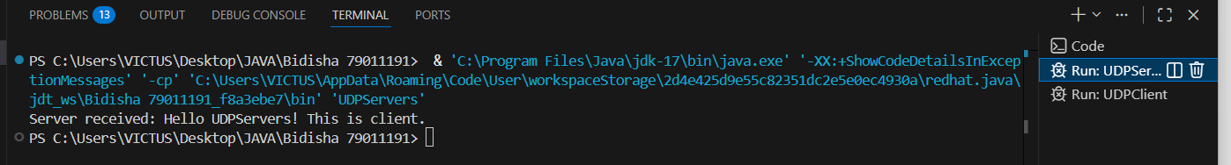

32. Write a UDP client and server socket program in which server identifies the number sent by client either even or odd and replies the client accordingly.

SOURCE CODE:

UDPServeer.java

import java.net.*;
public class UDPServeer {
public static void main(String[] args) {
try {
DatagramSocket serverSocket = new DatagramSocket(9876);
byte[] receiveData = new byte[1024];
byte[] sendData;

System.out.println("Server is running...");

while (true) {
DatagramPacket receivePacket = new DatagramPacket(receiveData, receiveData.length);
serverSocket.receive(receivePacket);

String numStr = new String(receivePacket.getData(), 0, receivePacket.getLength());
int number = Integer.parseInt(numStr);

String result = (number % 2 == 0) ? "Even" : "Odd";

InetAddress clientIP = receivePacket.getAddress();
int clientPort = receivePacket.getPort();
sendData = result.getBytes();

DatagramPacket sendPacket = new DatagramPacket(sendData, sendData.length, clientIP, clientPort);
serverSocket.send(sendPacket);
}

} catch (Exception e) {
System.out.println(e.getMessage());
}
}
}

UDPCliennt.java

import java.net.*;
import java.util.Scanner;
public class UDPCliennt {
public static void main(String[] args) {
try {
DatagramSocket clientSocket = new DatagramSocket();
InetAddress serverIP = InetAddress.getByName("localhost");
Scanner sc = new Scanner(System.in);

System.out.print("Enter a number: ");
String number = sc.nextLine();
byte[] sendData = number.getBytes();

DatagramPacket sendPacket = new DatagramPacket(sendData, sendData.length, serverIP, 9876);
clientSocket.send(sendPacket);

byte[] receiveData = new byte[1024];
DatagramPacket receivePacket = new DatagramPacket(receiveData, receiveData.length);
clientSocket.receive(receivePacket);

String result = new String(receivePacket.getData(), 0, receivePacket.getLength());
System.out.println("Server says: " + result);

clientSocket.close();
sc.close();
} catch (Exception e) {
System.out.println(e.getMessage());
}
}
}

OUTPUT:

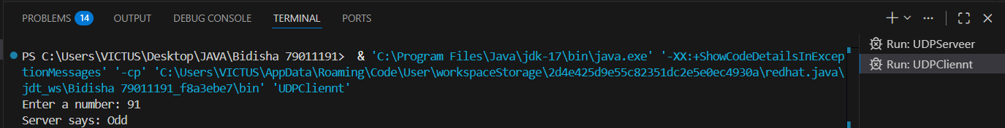
33. Write a UDP client-server socket program where the client sends a number to the server. The server checks whether the number is prime or not.
SOURCE CODE:

ServerUDP.java

import java.net.*;
public class ServerUDP {
public static boolean isPrime(int n) {
if (n <= 1) return false;
for (int i = 2; i <= Math.sqrt(n); i++) {
if (n % i == 0) return false;
}
return true;
}

public static void main(String[] args) {
try {
DatagramSocket serverSocket = new DatagramSocket(9876);
byte[] receiveData = new byte[1024];
byte[] sendData;

System.out.println("Server is running...");

while (true) {
DatagramPacket receivePacket = new DatagramPacket(receiveData, receiveData.length);
serverSocket.receive(receivePacket);

String numStr = new String(receivePacket.getData(), 0, receivePacket.getLength());
int number = Integer.parseInt(numStr);

String result = isPrime(number) ? "Prime" : "Not Prime";

InetAddress clientIP = receivePacket.getAddress();
int clientPort = receivePacket.getPort();
sendData = result.getBytes();

DatagramPacket sendPacket = new DatagramPacket(sendData, sendData.length, clientIP, clientPort);
serverSocket.send(sendPacket);
}

} catch (Exception e) {
System.out.println(e.getMessage());
}
}
}

ClientUDP.java

import java.net.*;
import java.util.Scanner;
public class ClientUDP {
public static void main(String[] args) {
try {
DatagramSocket clientSocket = new DatagramSocket();
InetAddress serverIP = InetAddress.getByName("localhost");
Scanner sc = new Scanner(System.in);
System.out.print("Enter a number: ");
String number = sc.nextLine();
byte[] sendData = number.getBytes();

DatagramPacket sendPacket = new DatagramPacket(sendData, sendData.length, serverIP, 9876);
clientSocket.send(sendPacket);
byte[] receiveData = new byte[1024];
DatagramPacket receivePacket = new DatagramPacket(receiveData, receiveData.length);
clientSocket.receive(receivePacket);

String result = new String(receivePacket.getData(), 0, receivePacket.getLength());
System.out.println("Server says: " + result);

clientSocket.close();
sc.close();
} catch (Exception e) {
System.out.println(e.getMessage());
}
}
}

OUTPUT:

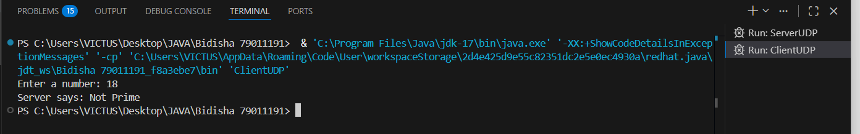
34. Write a UDP client-server program where the client requests the current time, and the server responds with the system's current time.
SOURCECODE:
ServersUDP.java
import java.net.*;
import java.text.SimpleDateFormat;
import java.util.Date;

public class ServersUDP {
public static void main(String[] args) {
try {
DatagramSocket serverSocket = new DatagramSocket(9876);
byte[] receiveData = new byte[1024];
byte[] sendData;

System.out.println("Server is running...");

while (true) {
DatagramPacket receivePacket = new DatagramPacket(receiveData, receiveData.length);
serverSocket.receive(receivePacket);

InetAddress clientIP = receivePacket.getAddress();
int clientPort = receivePacket.getPort();

SimpleDateFormat sdf = new SimpleDateFormat("HH:mm:ss dd-MM-yyyy");
String currentTime = sdf.format(new Date());

sendData = currentTime.getBytes();
DatagramPacket sendPacket = new DatagramPacket(sendData, sendData.length, clientIP, clientPort);
serverSocket.send(sendPacket);
}

} catch (Exception e) {
System.out.println(e.getMessage());
}
}
}

ServersClient.java

import java.net.*;
public class ClientsUDP {
public static void main(String[] args) {
try {
DatagramSocket clientSocket = new DatagramSocket();
InetAddress serverIP = InetAddress.getByName("localhost");

String request = "TIME";
byte[] sendData = request.getBytes();
DatagramPacket sendPacket = new DatagramPacket(sendData, sendData.length, serverIP, 9876);
clientSocket.send(sendPacket);

byte[] receiveData = new byte[1024];
DatagramPacket receivePacket = new DatagramPacket(receiveData, receiveData.length);
clientSocket.receive(receivePacket);

String serverTime = new String(receivePacket.getData(), 0, receivePacket.getLength());
System.out.println("Current time from server: " + serverTime);

clientSocket.close();
} catch (Exception e) {
System.out.println(e.getMessage());
}
}
}

OUTPUT:
