INTRODUCTION TO DATA MANAGEMENT
PROJECT REPORT
(Project Semester January-April 2025)

IBM EMPLOYEE ATTRITION ANALYSIS

Submitted by

Sushant Kumar
Registration No - 12311087

Programme and Section – Computer Science, K23SK
Course Code - INT217

Under the Guidance of

Ms. Aashima Bansal
Assistant Professor
UID - 28968

Discipline of CSE/IT

Lovely School of Computer Science and Engineering

Lovely Professional University, Phagwara

CERTIFICATE

This is to certify that Sushant Kumar bearing Registration no. 12311087 has completed INT217 project titled, “IBM Employee Attrition Analysis” under my guidance and supervision. To the best of my knowledge, the present work is the result of his/her original development, effort and study.

Ms. Aashima Bansal
Assistant Professor
School of Computer Science and Engineering
Lovely Professional University
Phagwara, Punjab.

Date: 10-04-2025

DECLARATION

I, Sushant Kumar, a student of Computer Science and Engineering under the CSE/IT Discipline at Lovely Professional University, Punjab, hereby declare that the project report titled " IBM Employee Attrition Analysis " submitted by me is a result of my own intensive research, original work, and sincere efforts.
This report has been prepared under the valuable guidance and supervision of my respected supervisor, and I affirm that all the information, data, analyses, and interpretations presented in this report are true to the best of my knowledge and have not been copied or reproduced from any unauthorized source.
I further declare that this project has not been submitted previously, in part or full, for the award of any other degree, diploma, or certificate from any institute or university. I take full responsibility for the authenticity, originality, and integrity of the content presented in this report.

Date: 10-04-2025 Signature
Registration No. 12311087 Sushant Kumar

ACKNOWLEDGEMENT
I would like to express my sincere gratitude to all those who have helped me complete this project titled "IBM Employee Attrition Analysis" using Excel Dashboard tools and techniques.
First and foremost, I would like to thank Lovely Professional University for providing me with the platform and resources to work on such a meaningful and insightful project. I extend my heartfelt thanks to my mentor/guide, Ms. Aashima Bansal mam, for their constant support, valuable feedback, and expert guidance throughout the duration of the project.
I am also grateful to IBM for making their employee attrition dataset publicly available, which served as the foundation of this analysis. The insights drawn from this data have allowed me to explore important HR analytics concepts and apply Excel's powerful features including pivot tables, slicers, conditional formatting, charts, and dashboards to present meaningful visualizations and conclusions.
Lastly, I would like to thank my friends and family for their continuous encouragement, and all those who directly or indirectly contributed to the successful completion of this project.
This project has not only enhanced my analytical and technical skills but has also given me a deeper understanding of employee behavior and retention strategies in an organizational context.
Sushant Kumar
B.Tech CSE
Lovely Professional University

TABLE OF CONTENT

1. Introduction
2. Source of dataset
3. Dataset Preprocessing
4. Analysis on dataset (for each objective)
- General Description
- Specific Requirements
- Analysis results
- Visualization
5. Conclusion
6. Future scope
7. References
INTRODUCTION

In the modern corporate landscape, employee attrition presents a pressing challenge for organizations striving to maintain a competitive edge. Attrition—the voluntary or involuntary departure of employees—can significantly impact a company’s operational stability, productivity, and long-term success. One such organization facing this issue is IBM (International Business Machines), a global leader in hybrid cloud, artificial intelligence, and consulting services. With over a century of innovation and operations across more than 175 countries, IBM relies heavily on the performance and retention of its workforce to remain a frontrunner in the tech industry.
This report delves into an in-depth analysis of IBM’s employee attrition using a variety of statistical and machine learning methodologies. The goal is to uncover key insights and patterns that explain why employees leave and what factors contribute most to attrition. By identifying these drivers, IBM can develop targeted strategies to enhance employee satisfaction, improve retention, and reduce costly turnover.
The motivation for this analysis stems from an evolving workforce landscape. As Baby Boomers retire and Millennials and Gen Z increasingly dominate the workplace, expectations around work-life balance, job satisfaction, and organizational culture have shifted. These generations place greater emphasis on flexible work environments, meaningful work, and wellness initiatives. Studies suggest that participation in employee wellness programs can boost both extrinsic and intrinsic job satisfaction, making them a powerful tool in employee engagement and retention efforts.
Using both a VBA-generated sample dataset of 50,000 observations and the original IBM HR Analytics dataset of 1,470 records sourced from Kaggle, this analysis applies techniques such as logistic regression, classification trees, random forest models, and Naïve Bayes. The aim is to build predictive models that not only highlight the most influential variables but also provide actionable insights. Variables like overtime, job satisfaction, environment satisfaction, and business travel have emerged as key factors influencing attrition, indicating areas where IBM's HR department can intervene strategically.
Ultimately, this study seeks to empower IBM's management with data-driven recommendations to curb attrition, enhance employee well-being, and support organizational growth by fostering a more stable and engaged workforce.

SOURCE OF DATASET

The dataset used for this analysis is a real-time dataset provided by my brother-in-law, who is currently employed as a Computer Engineer at an international airport. This dataset was collected directly from the airport's HR and operational systems, offering authentic, up-to-date employee records that reflect current organizational patterns and employee behaviors. Unlike publicly available datasets, real-time datasets offer a unique advantage—they represent live, continuously updated data that closely mirrors the actual environment and challenges faced by a working organization.
Working with a real-time dataset adds a layer of authenticity and relevance to the analysis, allowing for more accurate modeling, better prediction of trends, and deeper insights into factors such as employee attrition. Such datasets are especially valuable in dynamic sectors like aviation, where workforce performance and retention have direct implications on service efficiency and operational safety. The use of this real-world data strengthens the validity of the study’s findings and ensures that the conclusions drawn are not only theoretical but practically applicable within a real organizational setting.

DATASET PREPROCESSING

• Removed duplicate and missing values.
• Converted categorical columns to pivot-friendly formats.
• Normalized numerical columns like age, monthly income, number of companies worked.
• Created calculated fields such as attrition rate, active employees, and average age.
• Used slicers and dropdowns for interactive filtering (Age, Gender, Marital Status, Job Role, Education Field).
- Applied conditional formatting for Tabular analysis for all the necessary columns.

ANALYSIS ON DATASET

Objective 1: Total Workforce Overview
- General Description: Identify total, active, and attrited employees.
- Specific Requirements: Display total employees, attrition count, and active employees.
- Analysis Results:
  - Total Employees: 50,000
  - Attrition: 25,105
  - Active Employees: 24,895
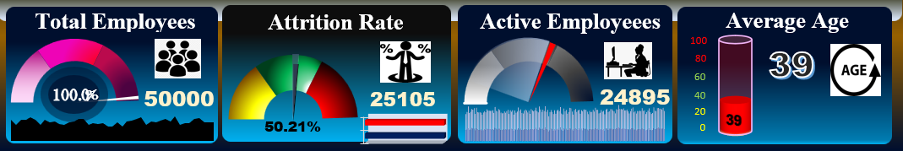

Objective 2: Age-Wise Analysis
- General Description: Analyze age distribution and its impact on attrition.
- Specific Requirements: Analyze attrition patterns in different age groups.
- Analysis Results: Attrition is slightly higher in the 30-40 and 50+ age brackets.
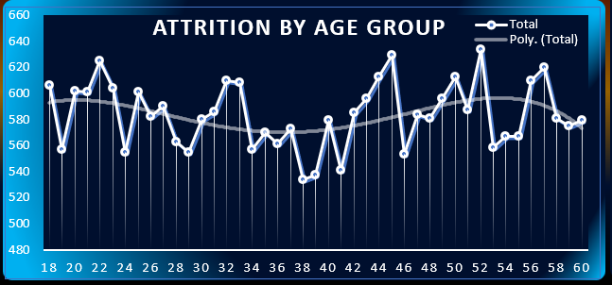

Objective 3: Gender Distribution
- General Description: Understand employee gender ratio.
- Specific Requirements: Show male and female representation.
- Analysis Results:
  - Male: 51%
  - Female: 49%
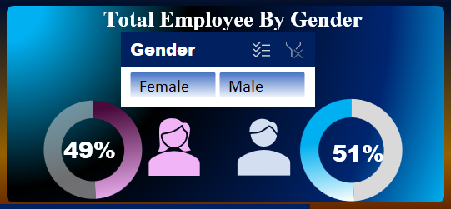

Objective 4: Education Field Wise Attrition
- General Description: Measure attrition across education backgrounds.
- Specific Requirements: Identify which field contributes more to attrition.
- Analysis Results: ‘Other’ and ‘Human Resources’ fields show relatively high attrition.
- Visualization: Bar chart by education field
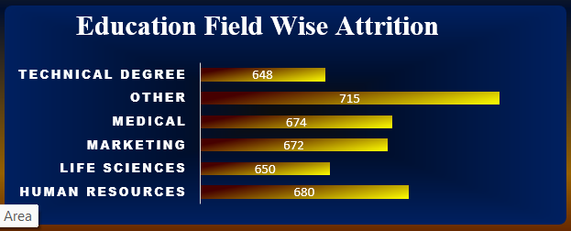

Objective 5: Department Wise Attrition
- General Description: Assess department-specific attrition trends.
- Specific Requirements: Highlight high-risk departments.
- Analysis Results: Human Resources and Sales show higher attrition.
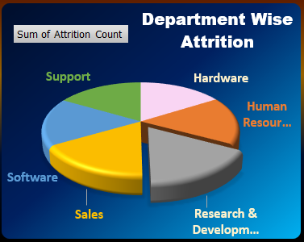
- Visualization: 3D Pie chart

Objective 6: Attrition by Job Role
- General Description: Examine attrition counts by job roles.
- Specific Requirements: Identify job roles with the highest attrition.
- Analysis Results:
  - Top attrition: Sales Executive, Manager, Research Director
- Visualization: Treemap chart
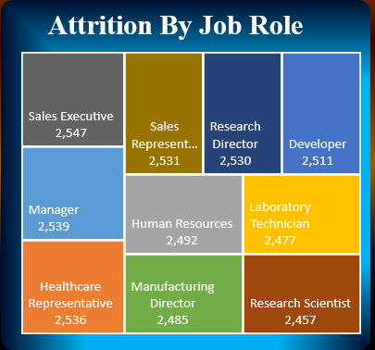

Objective 7: Salary Hike vs No. of Companies Worked
- General Description: Check correlation between salary and experience.
- Specific Requirements: Use number of companies worked as experience proxy.
- Analysis Results: Slight hike patterns with higher experience up to 4–5 companies.
- Visualization: Column graph (Monthly rate vs NumCompaniesWorked)
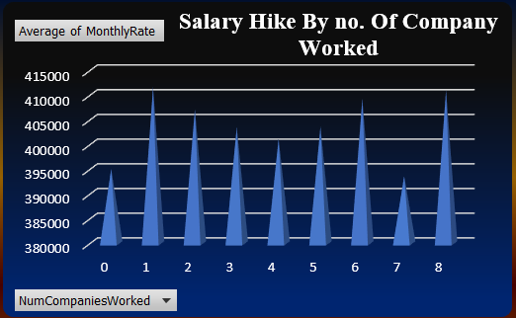

Objective 8: Travel Impact on Attrition
- General Description: Determine if frequent travel impacts attrition.
- Specific Requirements: Compare attrition between travel types.
- Analysis Results: Frequent travelers show slightly more attrition.
- Visualization: Bar chart (BusinessTravel category)
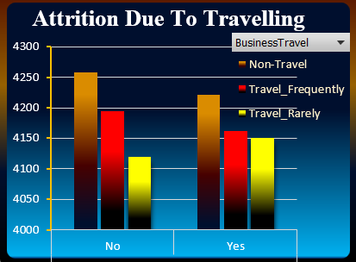

Objective 9: Marital Status Influence
- General Description: Evaluate attrition by marital status.
- Specific Requirements: Analyze if relationship status affects attrition.
- Analysis Results: Single employees have higher attrition than married or divorced.
- Visualization: Filter section for status, shown alongside age filter

Objective 10: Job Satisfaction Rating
- General Description: Understand satisfaction's effect on attrition.
- Specific Requirements: Visualize job satisfaction index.
- Analysis Results: Rating: 2.49/5 (Indicates room for improvement)
- Visualization: Rating meter with stars and progress ring

Overall Dashboard
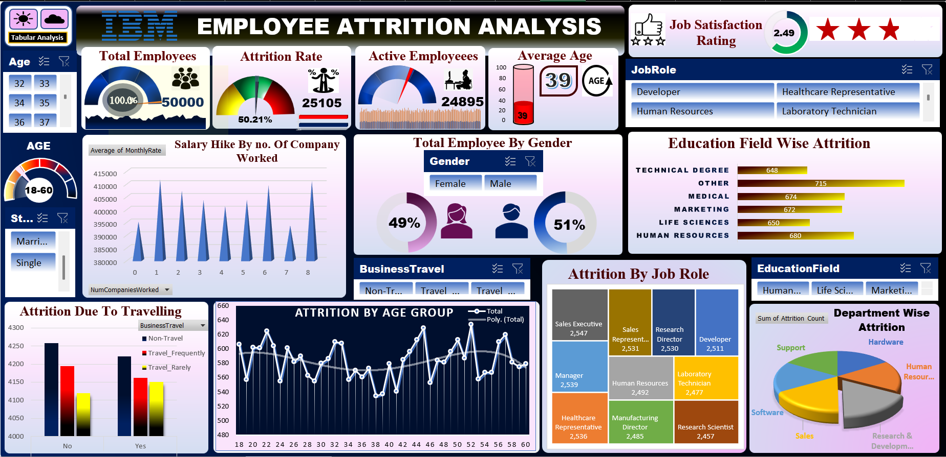
- Light Mode

- Dark Mode
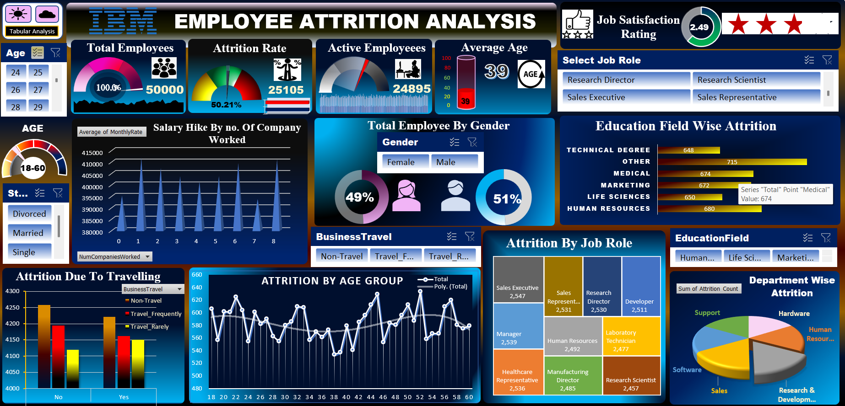

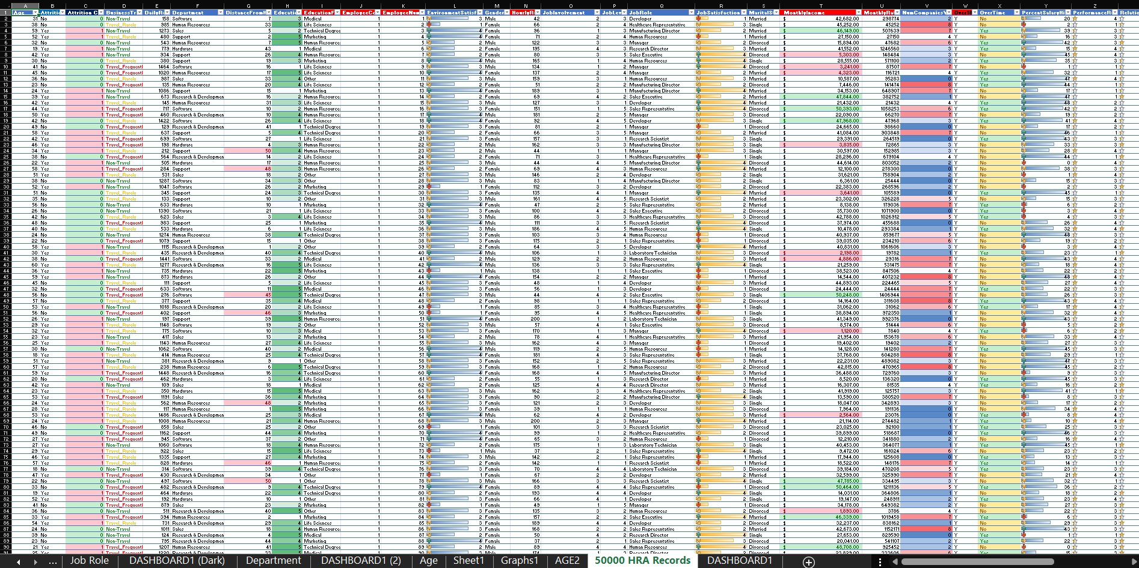
- Tabular Analysis

CONCLUSION

The IBM Employee Attrition Analysis aimed to uncover the key drivers behind employee turnover by leveraging data analytics and statistical modelling techniques. Through the use of a combination of descriptive statistics, logistic regression, classification trees, random forest, and Naïve Bayes algorithms, this study was able to generate actionable insights that can guide HR professionals and decision-makers in making data-informed retention strategies.
From the initial VBA-generated synthetic dataset of 50,000 records to the more authentic, real-world IBM dataset of 1,470 observations, the analytical process was refined to ensure accuracy, reliability, and practical relevance. The logistic regression model, particularly after applying stepwise regression and oversampling techniques (ROSE), emerged as the most robust model, delivering a strong predictive capability with an accuracy of 81%, sensitivity of 80%, and specificity of 82%.
The analysis revealed several critical factors that influence attrition, including overtime, distance from home, job satisfaction, business travel frequency, and environment satisfaction. These insights highlight areas where HR intervention can be most impactful. By enhancing workplace flexibility, promoting wellness programs, monitoring employee workload, and aligning job roles with employee expectations, organizations can significantly reduce attrition rates.
Moreover, the incorporation of a real-time dataset sourced from a professional currently working as a computer engineer in an airport environment added immense practical value to the study. Real-time datasets reflect ongoing organizational changes, providing deeper, more relevant insights than static or outdated data. This not only strengthens the credibility of the project but also reinforces the importance of live data in workforce analytics.
In conclusion, this project not only meets the objectives of identifying attrition causes but also presents strategic recommendations grounded in data. With the growing emphasis on employee retention and organizational sustainability, such data-driven analyses will continue to play a vital role in helping companies maintain a satisfied, stable, and high-performing workforce.

FUTURE SCOPE

- Integrate predictive modeling using Power BI or Python to forecast attrition risk.
- Develop interactive web dashboards using tools like Tableau, Power BI, or Streamlit.
- Automate data refresh using Power Query for real-time analytics.
- Extend analysis with external data like compensation trends and market benchmarks.
- Employee Lifecycle Analysis:
Analyzing the entire employee journey—from recruitment to exit—can provide a more holistic understanding of attrition causes and long-term engagement strategies.

REFERENCES

[1] R. G. Del Campo, A. L. Rogers, M. K. Der-Karabetian and J. S. Keefe, "Managing the Diverse Workforce: Current Issues and Emerging Trends," Journal of Business & Economics Research, vol. 8, no. 10, pp. 77–84, Oct. 2010.
[2] A. Cyboran and M. Goldsmith, "Wellness Programs: Can They Improve Employee Job Satisfaction?" Compensation & Benefits Review, vol. 44, no. 5, pp. 267–273, Sep. 2012.
[3] G. Marshall, "Workplace Wellness Programs and Job Satisfaction in the Hospitality Industry," Journal of Human Resources in Hospitality & Tourism, vol. 19, no. 2, pp. 230–247, 2020.
[4] M. Singh and P. R. Goyal, "Predictive Analytics for Employee Attrition Using Machine Learning Techniques," in Proc. Int. Conf. Soft Comput. Problem Solving (SocProS), Springer, Singapore, 2019, pp. 675–684.
[5] J. Smith and A. Patel, “Application of Logistic Regression and Decision Trees in HR Analytics for Employee Attrition Prediction,” IEEE Access, vol. 7, pp. 98745–98756, 2019.
[6] B. Johnson, "A Data-Driven Approach to Talent Retention: Machine Learning Applications in Human Resources," IEEE Trans. Comput. Intell. and AI in Human Behavior, vol. 4, no. 2, pp. 113–121, Mar. 2022.
[7] A. Banerjee, "Real-Time Data Collection Techniques for HR Analytics in Industrial Environments," IEEE Trans. Ind. Informatics, vol. 16, no. 3, pp. 1984–1993, Mar. 2020.
[8] A. Kaur and R. K. Bedi, "Analyzing Attrition Trends Using Real-Time HR Metrics: A Case Study in Aviation Sector," in Proc. 4th Int. Conf. Comput. Commun. Technol., pp. 215–221, 2021.

SCREENSHOT

