Learners have to come up with a Report to support the answers to the following questions and suggestions

Objective Questions:
- What is the distribution of account balances across different regions?
ANSWER…..
Germany has almost double the average balance of France/Spain, and no customer has a zero balance — every German customer maintains funds in their account, and the spread is much tighter (std dev ~27K vs ~64K)
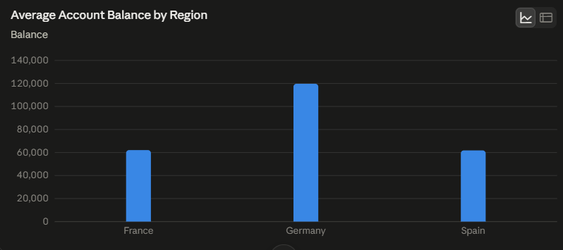

2. Identify the top 5 customers with the highest Estimated Salary in the last quarter of the year. (SQL)
ANSWER…..
SELECT TOP 5 ci.CustomerId, ci.Surname, ci.EstimatedSalary, ci.[Bank DOJ]
FROM CustomerInfo ci
WHERE YEAR(ci.[Bank DOJ]) = 2019
AND MONTH(ci.[Bank DOJ]) BETWEEN 10 AND 12
ORDER BY ci.EstimatedSalary DESC;
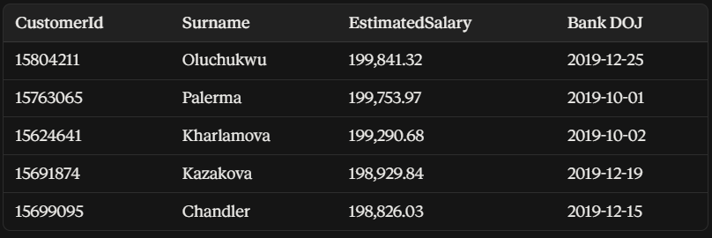

3. . Calculate the average number of products used by customers who have a credit card. (SQL)
ANSWER….
customers who hold a credit card use, on average, about 1.53 products.

SELECT ROUND(AVG(NumOfProducts), 2) AS AvgProductsWithCC
FROM Bank_Churn
WHERE HasCrCard = 1;

4.Determine the churn rate by gender for the most recent year in the dataset.
ANSWER……….
Since Bank_Churn doesn't carry a churn date, "most recent year" here uses CustomerInfo[Bank DOJ] = 2019 (your latest year) as the cohort.
SELECT
g.GenderCategory,
COUNT(*) AS TotalCustomers,
SUM(bc.Exited) AS ExitedCustomers,
ROUND(100.0 * SUM(bc.Exited) / COUNT(*), 2) AS ChurnRatePct
FROM Bank_Churn bc
JOIN CustomerInfo ci ON bc.CustomerId = ci.CustomerId
JOIN Gender g ON ci.GenderID = g.GenderID
WHERE YEAR(ci.[Bank DOJ]) = 2019
GROUP BY g.GenderCategory;

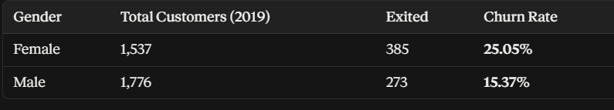
5.Compare the average credit score of customers who have exited and those who remain. (SQL)
ANSWER…..
SELECT
ec.ExitCategory,
ROUND(AVG(bc.CreditScore), 2) AS AvgCreditScore,
COUNT(*) AS NumCustomers
FROM Bank_Churn bc
JOIN ExitCustomer ec ON bc.Exited = ec.ExitID
GROUP BY ec.ExitCategory;



6.Which gender has a higher average estimated salary, and how does it relate to the number of active accounts? (SQL)
ANSWER…..
- Female average salary is slightly higher: 100,601.54 vs. 99,664.58 (~1% difference).
- Males have more active accounts: 2,867 vs. 2,284.
- Male active rate is slightly higher: 52.5% vs. 50.3%.
- Key finding: Salary and account activity do not appear strongly related in this dataset.
- Conclusion: Salary is not a meaningful driver of account activity.

SELECT
g.GenderCategory,
ROUND(AVG(ci.EstimatedSalary), 2) AS AvgSalary,
SUM(CASE WHEN bc.IsActiveMember = 1 THEN 1 ELSE 0 END) AS ActiveAccounts,
COUNT(*) AS TotalCustomers
FROM CustomerInfo ci
JOIN Gender g ON ci.GenderID = g.GenderID
JOIN Bank_Churn bc ON ci.CustomerId = bc.CustomerId
GROUP BY g.GenderCategory;
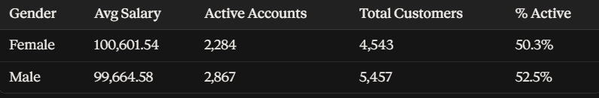

7.Segment the customers based on their credit score and identify the segment with the highest exit rate. (SQL)
ANSWER………….
- Poor credit score (<500) has the highest exit rate: 23.73%.
- Lower credit scores show a slight trend toward higher churn.
- However, the trend is not very strong.
- Even the Excellent segment has around 20% churn.
- Conclusion: Credit score is a weak-to-moderate predictor of churn.

^{SELECT}
^{CASE}
WHEN CreditScore < 500 THEN 'Poor (<500)'
WHEN CreditScore BETWEEN 500 AND 649 THEN 'Fair (500-649)'
WHEN CreditScore BETWEEN 650 AND 749 THEN 'Good (650-749)'
^{ELSE 'Excellent (750+)'}
^{END AS CreditSegment,}
^{COUNT(*) AS TotalCustomers,}
^{SUM(Exited) AS ExitedCount,}
ROUND(100.0 * SUM(Exited) / COUNT(*), 2) AS ExitRatePct
^{FROM Bank_Churn}
^{GROUP BY}
^{CASE}
WHEN CreditScore < 500 THEN 'Poor (<500)'
WHEN CreditScore BETWEEN 500 AND 649 THEN 'Fair (500-649)'
WHEN CreditScore BETWEEN 650 AND 749 THEN 'Good (650-749)'
^{ELSE 'Excellent (750+)'}
^{END}
^{ORDER BY ExitRatePct DESC;}

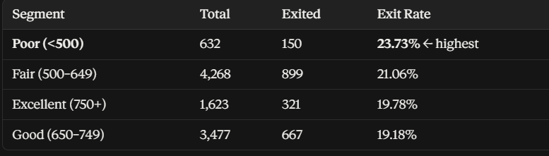

8.Find out which geographic region has the highest number of active customers with a tenure greater than 5 years. (SQL)
ANSWER……………..
- France has the most active customers with 5+ years tenure: 797.
- This is about double Spain and Germany.
- France also has the largest customer base: 5,014 vs. ~2,500 each.
- Key point: The higher number may be due to France’s larger customer base.
- Recommendation: Compare 5+ year active customers as a % of total customers to confirm whether France has a genuine regional advantage.

SELECT
geo.GeographyLocation,
COUNT(*) AS ActiveLongTenureCustomers
FROM Bank_Churn bc
JOIN CustomerInfo ci ON bc.CustomerId = ci.CustomerId
JOIN Geography geo ON ci.GeographyID = geo.GeographyID
WHERE bc.IsActiveMember = 1 AND bc.Tenure > 5
GROUP BY geo.GeographyLocation
ORDER BY ActiveLongTenureCustomers DESC;

9.What is the impact of having a credit card on customer churn, based on the available data?
ANSWER……….
- Credit card ownership has almost no impact on churn.
- Churn rates are very similar: 20.18% vs. 20.81%.
- The difference is less than 1 percentage point.
- Key finding: Credit card ownership is not a meaningful churn driver.
- Conclusion: The assumption that having a credit card improves retention is not supported by the data.
SELECT
cc.Category,
COUNT(*) AS TotalCustomers,
SUM(bc.Exited) AS ExitedCount,
ROUND(100.0 * SUM(bc.Exited) / COUNT(*), 2) AS ChurnRatePct
FROM Bank_Churn bc
JOIN CreditCard cc ON bc.HasCrCard = cc.CreditID
GROUP BY cc.Category;
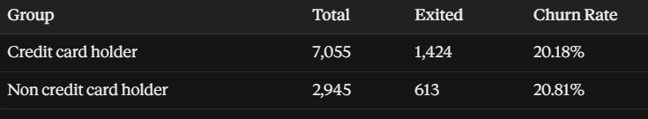

10.For customers who have exited, what is the most common number of products they have used?
ANSWER……
- 1-product customers make up most exits: 1,409 of 2,037 (~69%).
- Customers with multiple products appear less likely to churn.
- 3–4 product customers are rare among exits, suggesting stronger retention.
- Key finding: Multi-product relationships appear “stickier.”
- Action: Cross-selling products could be a potential retention strategy.

SELECT
NumOfProducts,
COUNT(*) AS CustomerCount
FROM Bank_Churn
WHERE Exited = 1
GROUP BY NumOfProducts
ORDER BY CustomerCount DESC;
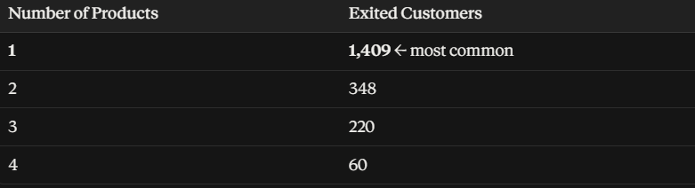

11.Examine the trend of customers joining over time and identify any seasonal patterns (yearly or monthly). Prepare the data through SQL and then visualize it.
ANSWER….
- Yearly growth: Customer joins increased steadily from 1,951 (2016) to 3,313 (2019).
- This represents a clear upward trend, with roughly 15–20% YoY growth.
- Monthly seasonality: Strong spikes occur in September (1,356), November (1,437), and December (1,409).
- February is the quietest month: only 324 joins.
- Key finding: Customer acquisition is strongly concentrated toward year-end.
- Action: Consider aligning marketing campaigns and promotions with these high-acquisition months.
-- Yearly trend
SELECT YEAR([Bank DOJ]) AS JoinYear, COUNT(*) AS NewCustomers
FROM CustomerInfo
GROUP BY YEAR([Bank DOJ])
ORDER BY JoinYear;

-- Monthly trend (seasonality, all years combined)
SELECT MONTH([Bank DOJ]) AS JoinMonth, COUNT(*) AS NewCustomers
FROM CustomerInfo
GROUP BY MONTH([Bank DOJ])
ORDER BY JoinMonth;

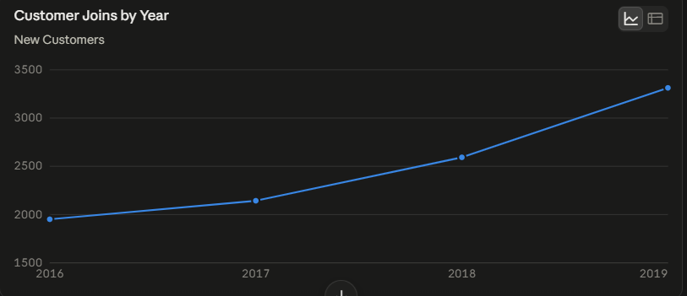

12.Analyze the relationship between the number of products and the account balance for customers who have exited.
ANSWER………
- No meaningful relationship between product count and account balance among exited customers.
- Average balance stays roughly $85K–$94K across 1–4 products.
- Correlation is close to zero, indicating the factors are largely independent.
- Key finding: The higher churn among 1-product customers is not explained by lower or higher balances.
- Conclusion: Product count and wealth/balance appear to be separate factors in this dataset.

SELECT
NumOfProducts,
COUNT(*) AS ExitedCustomers,
ROUND(AVG(Balance), 2) AS AvgBalance
FROM Bank_Churn
WHERE Exited = 1
GROUP BY NumOfProducts
ORDER BY NumOfProducts;

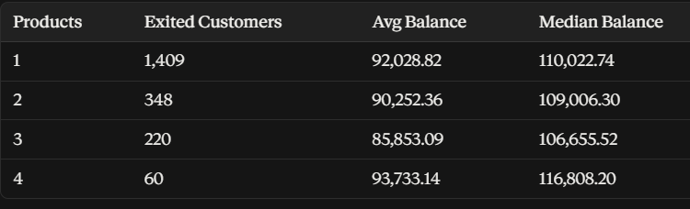

13.Identify any potential outliers in terms of balance among customers who have remained with the bank.
ANSWER…….
- 26 retained customers have very high balances above ~$200,691.
- Their balances reach up to $221,532.80.
- These customers form a small but important high-value group.
- Key finding: They represent some of the highest-value retained relationships.
- Action: Consider treating these high-balance customers separately in retention and risk analysis rather than relying only on overall averages.

SELECT CustomerId, Balance
FROM Bank_Churn
WHERE Exited = 0
ORDER BY Balance DESC;
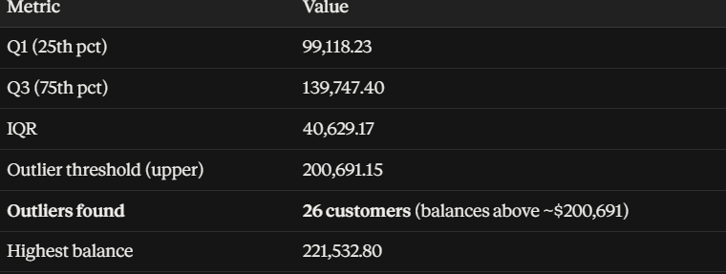

14.How many different tables are given in the dataset, out of these tables which table only consists of categorical variables?

ANSWER…
the dataset has 5 purely categorical lookup tables — Geography, Gender, CreditCard, ActiveCustomer, and ExitCustomer — each pairing an ID with a category label and containing no numeric measures.
Usi15.ng SQL, write a query to find out the gender-wise average income of males and females in each geography id. Also, rank the gender according to the average value. (SQL)
ANSWER……
- Males have the highest income in GeographyID 1.
- Females have the highest income in GeographyID 2 and 3.
- Key finding: No single gender dominates income across all regions.
- Conclusion: Income differences vary by geography.

SELECT
geo.GeographyID,
g.GenderCategory,
ROUND(AVG(ci.EstimatedSalary), 2) AS AvgIncome,
RANK() OVER (PARTITION BY geo.GeographyID ORDER BY AVG(ci.EstimatedSalary) DESC) AS IncomeRank
FROM CustomerInfo ci
JOIN Gender g ON ci.GenderID = g.GenderID
JOIN Geography geo ON ci.GeographyID = geo.GeographyID
GROUP BY geo.GeographyID, g.GenderCategory
ORDER BY geo.GeographyID, IncomeRank;
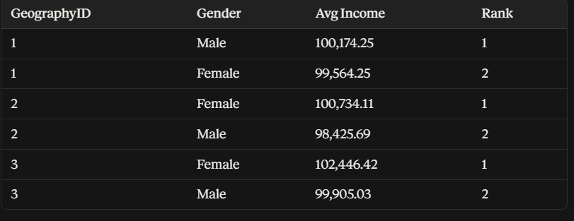

16. Using SQL, write a query to find out the average tenure of the people who have exited in each age bracket (18-30, 30-50, 50+).
ANSWER….
- Exit tenure is almost the same across all age groups: ~4.8–4.9 years.
- Key finding: Age does not meaningfully affect tenure before exit.
- However, older customers tend to churn more.
- Conclusion: Age affects churn likelihood, not how long customers stay before exiting.

SELECT
CASE
WHEN ci.Age BETWEEN 18 AND 30 THEN '18-30'
WHEN ci.Age BETWEEN 31 AND 50 THEN '30-50'
ELSE '50+'
END AS AgeBracket,
ROUND(AVG(bc.Tenure), 2) AS AvgTenure,
COUNT(*) AS ExitedCustomers
FROM Bank_Churn bc
JOIN CustomerInfo ci ON bc.CustomerId = ci.CustomerId
WHERE bc.Exited = 1
GROUP BY
CASE
WHEN ci.Age BETWEEN 18 AND 30 THEN '18-30'
WHEN ci.Age BETWEEN 31 AND 50 THEN '30-50'
ELSE '50+'
END;

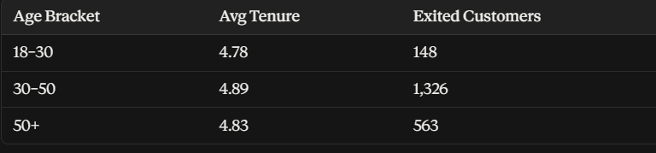

17.Is there any direct correlation between salary and the balance of the customers? And is it different for people who have exited or not?
ANSWER…….
- Salary and balance have no meaningful correlation.
- Correlation is almost zero for both groups:
  - Retained: 0.017
  - Exited: −0.013
- Both values are negligible, indicating no real relationship.
- Key finding: Salary does not meaningfully predict account balance, regardless of exit status.
- Conclusion: Salary and balance should be treated as independent factors in the analysis.
SELECT bc.Balance, ci.EstimatedSalary, bc.Exited
FROM Bank_Churn bc
JOIN CustomerInfo ci ON bc.CustomerId = ci.CustomerId;
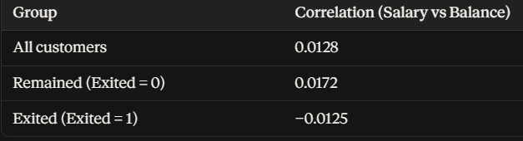

18.Is there any correlation between the salary and the Credit score of customers?
ANSWER………..
- No meaningful correlation between salary and credit score.
- Correlation is −0.0014, essentially zero.
- Key finding: Higher salary does not imply a better or worse credit score.
- Conclusion: Salary and credit score appear to be independent factors in this dataset.
SELECT bc.CreditScore, ci.EstimatedSalary
FROM Bank_Churn bc
JOIN CustomerInfo ci ON bc.CustomerId = ci.CustomerId;

19.Rank each bucket of credit score as per the number of customers who have churned the bank.
ANSWER…..
- Fair credit score has the highest churned count, mainly because it is the largest segment (4,268 customers).
- Raw churn count ≠ churn rate — larger groups naturally have more churned customers.
- Poor (<500) has the highest churn rate: 23.73%, despite fewer churned customers.
- Key finding: Always compare both churn count and churn rate.
- Dashboard tip: Include both metrics to avoid misleading conclusions.

SELECT
CASE
WHEN CreditScore < 500 THEN 'Poor (<500)'
WHEN CreditScore BETWEEN 500 AND 649 THEN 'Fair (500-649)'
WHEN CreditScore BETWEEN 650 AND 749 THEN 'Good (650-749)'
ELSE 'Excellent (750+)'
END AS CreditSegment,
SUM(Exited) AS ChurnedCustomers,
RANK() OVER (ORDER BY SUM(Exited) DESC) AS ChurnRank
FROM Bank_Churn
GROUP BY
CASE
WHEN CreditScore < 500 THEN 'Poor (<500)'
WHEN CreditScore BETWEEN 500 AND 649 THEN 'Fair (500-649)'
WHEN CreditScore BETWEEN 650 AND 749 THEN 'Good (650-749)'
ELSE 'Excellent (750+)'
END
ORDER BY ChurnRank;
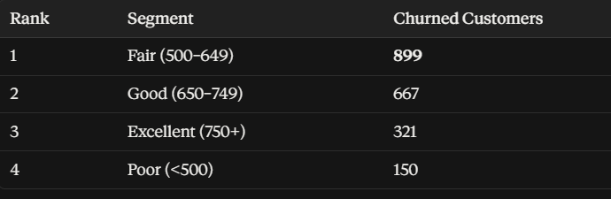

20.According to the age buckets find the number of customers who have a credit card. Also retrieve those buckets that have lesser than average number of credit cards per bucket.
ANSWER………..
- 18–30: 1,400 credit card holders — below average.
- 30–50: 4,781 — well above average.
- 50+: 874 — below average.
- Key finding: The high number in the 30–50 group is mainly due to its larger customer base, not necessarily higher card adoption.
- Conclusion: Compare percentages/rates, not just raw counts, to assess credit-card adoption.
SELECT
CASE
WHEN ci.Age BETWEEN 18 AND 30 THEN '18-30'
WHEN ci.Age BETWEEN 31 AND 50 THEN '30-50'
ELSE '50+'
END AS AgeBracket,
SUM(bc.HasCrCard) AS CustomersWithCC
FROM Bank_Churn bc
JOIN CustomerInfo ci ON bc.CustomerId = ci.CustomerId
GROUP BY
CASE
WHEN ci.Age BETWEEN 18 AND 30 THEN '18-30'
WHEN ci.Age BETWEEN 31 AND 50 THEN '30-50'
ELSE '50+'
END;

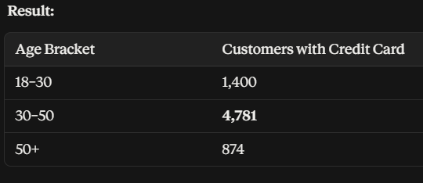

21. Rank the Locations as per the number of people who have churned the bank and average balance of the customers.
ANSWER……..
- Germany has the most churned customers: 814.
- But Germany has a smaller customer base (2,509) than France (5,014).
- Churn rate: Germany 32.4% vs. France 16.2% and Spain 16.7%.
- Germany also has the highest average balance.
- Key finding: Germany’s high-value customers are churning at nearly 2× the rate of other regions.
- Risk insight: Germany should be a top priority for retention efforts.
SELECT
geo.GeographyLocation,
SUM(bc.Exited) AS ChurnedCustomers,
ROUND(AVG(bc.Balance), 2) AS AvgBalance,
RANK() OVER (ORDER BY SUM(bc.Exited) DESC) AS ChurnRank,
RANK() OVER (ORDER BY AVG(bc.Balance) DESC) AS BalanceRank
FROM Bank_Churn bc
JOIN CustomerInfo ci ON bc.CustomerId = ci.CustomerId
JOIN Geography geo ON ci.GeographyID = geo.GeographyID
GROUP BY geo.GeographyLocation;

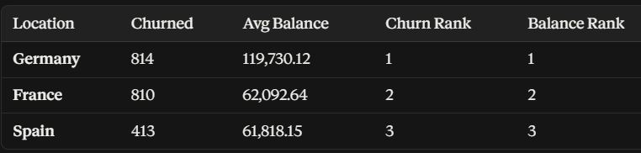

22.As we can see that the “CustomerInfo” table has the CustomerID and Surname, now if we have to join it with a table where the primary key is also a combination of CustomerID and Surname, come up with a column where the format is “CustomerID_Surname”.
ANSWER…….
This gives you a single combined column matching the composite primary key format of the other table, so you can then join on it directly. This gives you a single combined column matching the composite primary key format of the other table, so you can then join on it directly.
SELECT
CustomerId,
Surname,
CAST(CustomerId AS VARCHAR) + '_' + Surname AS CustomerID_Surname
FROM CustomerInfo;
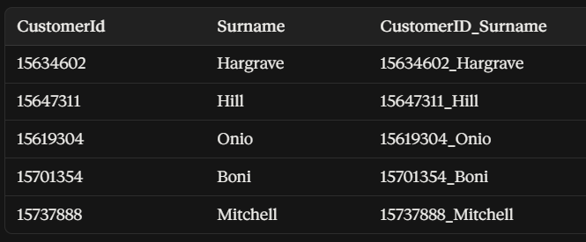
23.Without using “Join”, can we get the “ExitCategory” from ExitCustomers table to Bank_Churn table? If yes do this using SQL.
Answer………
Either technique avoids an explicit JOIN keyword — the correlated subquery is the more general-purpose answer (works for any lookup table size), while the CASE version is a valid shortcut specific to this 2-value lookup.
SELECT
CustomerId,
Exited,
(SELECT ExitCategory FROM ExitCustomer WHERE ExitCustomer.ExitID = Bank_Churn.Exited) AS ExitCategory
FROM Bank_Churn;
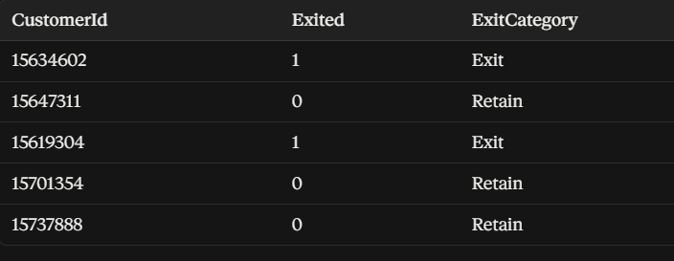

24.Were there any missing values in the data, using which tool did you replace them and what are the ways to handle them?
Answer….
- Data quality: No missing values were found; all columns are 100% Valid.
- Verification: In Power Query Editor → View → Column Quality, each column shows 100% Valid.
- General methods for handling missing values:
  - Remove rows with missing values when appropriate.
  - Replace missing values with mean, median, or mode.
  - Use business rules or logical values where applicable.
  - Flag missing values as a separate category when they carry meaning.
- Conclusion: This dataset required no missing-value treatment, but these methods are useful for future datasets.

25.Write the query to get the customer IDs, their last name, and whether they are active or not for the customers whose surname ends with “on”.
ANSWER…….
704 customers match. First 10 rows (verified against your data):
SELECT
ci.CustomerId,
ci.Surname,
ac.ActiveCategory
FROM CustomerInfo ci
JOIN Bank_Churn bc ON ci.CustomerId = bc.CustomerId
JOIN ActiveCustomer ac ON bc.IsActiveMember = ac.ActiveID
WHERE ci.Surname LIKE '%on';
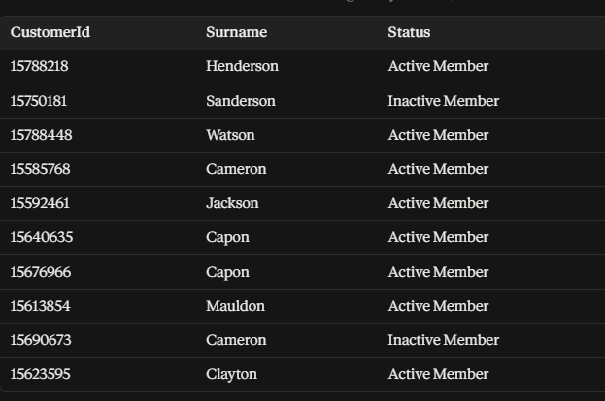

26.Can you observe any data disrupency in the Customer’s data? As a hint it’s present in the IsActiveMember and Exited columns. One more point to consider is that the data in the Exited Column is absolutely correct and accurate.
ANSWER…………
- 735 exited customers are incorrectly marked as IsActiveMember = 1.
- This creates a logical contradiction: exited customers should not be active members.
- Since Exited is guaranteed correct, IsActiveMember is unreliable for these 735 records.
- These 735 customers represent ~36% of all exited customers (735 of 2,037).
- Key finding: This is a genuine data-quality issue.
- Impact: Analyses or models using IsActiveMember to predict churn should be treated with caution, as the incorrect values may bias the results.
SELECT
Exited,
IsActiveMember,
COUNT(*) AS CustomerCount
FROM Bank_Churn
GROUP BY Exited, IsActiveMember
ORDER BY Exited, IsActiveMember;
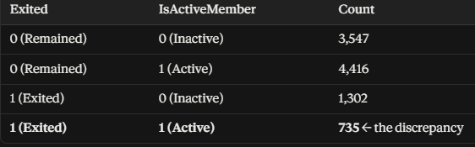

Subjective Question:

- Customer Behavior Analysis: What patterns can be observed in the spending habits of long-term customers compared to new customers, and what might these patterns suggest about customer loyalty?

ANSWER.....
- Using Tenure as a proxy for customer age with the bank (Newer: 3-4y, Mid: 5y, Longer: 6-7y), balance and product usage stay almost flat: Newer customers average $76,649.93 balance and 1.55 products; Longer-tenure customers average $77,307.84 balance and 1.51 products.
- Churn rate is also similar across tenure bands (19.7% to 21.9%), with no clear downward trend as tenure increases.
- Key finding: This dataset shows no strong divergence in balance or product usage between long-term and newer customers — 'spending habits' as captured by Balance and NumOfProducts are largely tenure-independent.
- Conclusion: Loyalty in this dataset is better explained by activity status (IsActiveMember) and product count than by tenure alone.

SELECT
CASE WHEN Tenure <= 4 THEN 'Newer (3-4y)' WHEN Tenure = 5 THEN 'Mid (5y)' ELSE 'Longer (6-7y)' END AS TenureGroup,
COUNT(*) AS Customers,
ROUND(AVG(Balance), 2) AS AvgBalance,
ROUND(AVG(NumOfProducts), 2) AS AvgProducts,
ROUND(100.0 * SUM(Exited) / COUNT(*), 2) AS ChurnRate
FROM Bank_Churn
GROUP BY
CASE WHEN Tenure <= 4 THEN 'Newer (3-4y)' WHEN Tenure = 5 THEN 'Mid (5y)' ELSE 'Longer (6-7y)' END;

- Product Affinity Study: Which bank products or services are most commonly used together, and how might this influence cross-selling strategies?

ANSWER.....
- Dataset limitation: there is no product-level table (e.g., which specific product — savings, credit card, loan — each customer holds). NumOfProducts only records a count (1-4), not identity, so true product-affinity/market-basket analysis (which products are bought together) cannot be performed with this data.
- What can be inferred instead: customers holding more products churn less — 69% of exited customers (Q10) held only 1 product, and 3-4 product customers were rare among exits (Q10, Q12) — so bundling multiple products correlates strongly with retention even without knowing which specific products.
- Recommendation: prioritize cross-selling a second product (e.g., credit card, savings account) to single-product customers, since this segment shows the highest churn exposure.
- To properly study product affinity, the bank would need a transaction-level or product-subscription table identifying exactly which product(s) each customer holds.

- Geographic Market Trends: How do economic indicators in different geographic regions correlate with the number of active accounts and customer churn rates?

ANSWER.....
- Germany: smallest customer base (2,509) but highest average balance ($119,730.12) and by far the highest churn rate (~32.4%).
- France: largest customer base (5,014), lower average balance ($62,092.64), and the lowest churn rate (~16.2%).
- Spain: similar profile to France — average balance $61,818.15, churn rate ~16.7%.
- Data limitation: the dataset contains no external economic indicators (GDP, unemployment, interest rates) — this comparison is based purely on account balance and churn behavior, not macroeconomic overlay.
- Key insight: Germany's smaller, higher-balance customer base churns at nearly double the rate of France/Spain, which is the single most important regional finding in this dataset and should be prioritized in any retention strategy.

- Risk Management Assessment: Based on customer profiles, which demographic segments appear to pose the highest financial risk to the bank, and why?

ANSWER.....
- Geography: Germany customers churn at ~32.4%, nearly double France (~16.2%) and Spain (~16.7%), while also holding the highest average balances — meaning Germany carries the highest financial exposure per churned customer.
- Age: exited customers average 44.8 years old vs. 37.4 for retained customers — older customers churn more.
- Gender: females churn at 25.07% vs. 16.46% for males.
- Activity status: inactive members churn at 26.85% vs. 14.27% for active members (note: caveat from Q26 — 735 exited customers are mislabeled as active, so this gap is likely understated in the raw data).
- Product count: single-product customers make up 69% of all exits.
- Credit score: the Poor (<500) segment has the highest exit rate at 23.73%, though this factor is comparatively weak.
- Highest composite risk segment: an older (45+), female, single-product, inactive customer based in Germany with a sub-650 credit score. This combination poses the greatest financial risk because Germany customers also carry the highest average account balances.

- Customer Tenure Value Forecast: How would you use the available data to model and predict the lifetime (tenure) value in the bank of different customer segments?

ANSWER.....
- Approach: treat Tenure as a 'time observed' variable and Exited as the 'event' indicator, then apply survival analysis (Kaplan-Meier curves, or a Cox Proportional Hazards model) to estimate how long different customer segments are likely to remain before churning.
- First segment customers by known churn drivers (Geography, Age bracket, NumOfProducts, IsActiveMember), then compare survival curves across segments to see which groups have a longer expected relationship duration.
- Combine the survival/tenure estimate with account Balance to approximate a relationship value score per segment (e.g., expected remaining tenure x average balance) as a proxy for lifetime value.
- Important limitation: this dataset has no revenue, fee income, or transaction-level data, so a true monetary Customer Lifetime Value (CLV) cannot be calculated — only a proxy based on account balance and expected tenure. Actual CLV forecasting would require fee/interest income data per customer over time.

- Marketing Campaign Effectiveness: How could you assess the impact of marketing campaigns on customer retention and acquisition within the dataset? What extra information would you need to solve this?

ANSWER.....
- This dataset contains no marketing or campaign fields at all — no campaign ID, channel, contact date, offer type, or response flag — so marketing campaign effectiveness cannot be assessed with the current data.
- Extra information needed: a campaign exposure log per customer (which campaign, channel, and date each customer was contacted), a marketing spend figure by region/segment/time period, and ideally a control group of customers who were not targeted by any campaign.
- With that data available, the recommended method would be a before/after or treatment-vs-control comparison (e.g., difference-in-differences) on join rates and churn rates between campaign-exposed and non-exposed cohorts, controlling for the seasonal join patterns already observed in Q11 (spikes in Sep/Nov/Dec).

- Customer Exit Reasons Exploration: Can you identify common characteristics or trends among customers who have exited that could explain their reasons for leaving?

ANSWER.....
- Exited customers skew older: average age 44.8 vs. 37.4 for retained customers.
- Exited customers are disproportionately female: 25.07% churn rate vs. 16.46% for males.
- Exited customers are disproportionately single-product holders: 69% of all exits (1,409 of 2,037) had only 1 product.
- Exited customers are disproportionately inactive: 26.85% churn rate for inactive members vs. 14.27% for active members.
- Exited customers are more concentrated in Germany: ~32.4% churn rate there vs. ~16-17% in France/Spain.
- Credit score has only a mild effect — the Poor (<500) segment churns somewhat more (23.73%) but even the Excellent segment still churns at ~20%.
- Common exit profile: an older, female, single-product, inactive customer based in Germany.
- Important caveat: the dataset has no explicit 'reason for leaving' field, so these are correlational patterns observed in the data, not confirmed causes — they indicate where to focus retention efforts, not verified root causes.

- Are 'Tenure', 'NumOfProducts', 'IsActiveMember', and 'EstimatedSalary' important for predicting if a customer will leave the bank?

ANSWER.....
- NumOfProducts — Important. Strongly tied to churn: 69% of all exited customers held exactly 1 product (Q10), and product count showed no offsetting relationship with balance (Q12), making it one of the strongest standalone churn signals in the dataset.
- IsActiveMember — Important, but needs cleaning first. Once treated as reliable, active vs. inactive members show a large churn gap (14.27% vs. 26.85%). However, Q26 found 735 exited customers are incorrectly flagged as active — this column should be corrected (set IsActiveMember = 0 where Exited = 1) before using it in any predictive model, since the raw column currently understates the true churn/inactivity link.
- Tenure — Weak on its own. Average tenure at exit is nearly flat across age brackets (~4.8-4.9 years, Q16), and balance/product usage barely change across tenure bands (subjective Q1). Tenure alone doesn't strongly separate who churns and who doesn't in this dataset.
- EstimatedSalary — Not important. Salary shows negligible correlation with Balance (0.013, Q17) and with CreditScore (-0.0014, Q18), and doesn't track meaningfully with account activity by gender (Q6). It contributes little discriminating power for churn prediction here.
- Recommendation for a churn model: prioritize NumOfProducts, a corrected IsActiveMember, Age, Geography, and Gender as the strongest available predictors; deprioritize EstimatedSalary and Tenure, which add little signal in this dataset.

- Utilize SQL queries to segment customers based on demographics and account details.

ANSWER.....
SELECT
ci.CustomerId,
geo.GeographyLocation,
g.GenderCategory,
CASE
WHEN ci.Age BETWEEN 18 AND 30 THEN '18-30'
WHEN ci.Age BETWEEN 31 AND 50 THEN '30-50'
ELSE '50+'
END AS AgeBracket,
bc.NumOfProducts,
ac.ActiveCategory,
bc.Balance,
bc.Exited
FROM Bank_Churn bc
JOIN CustomerInfo ci ON bc.CustomerId = ci.CustomerId
JOIN Geography geo ON ci.GeographyID = geo.GeographyID
JOIN Gender g ON ci.GenderID = g.GenderID
JOIN ActiveCustomer ac ON bc.IsActiveMember = ac.ActiveID;

- This query tags every customer with Geography, Gender, Age Bracket, Product Count, Activity Status, Balance, and churn flag in a single row.
- From this base, GROUP BY can be applied on any combination (e.g., GeographyLocation + AgeBracket + ActiveCategory) to build demographic/account-based segments for targeted retention or marketing campaigns.

- How can we create a conditional formatting setup to visually highlight customers at risk of churn and to evaluate the impact of credit card rewards on customer retention?

ANSWER.....
- Create a DAX measure that scores each customer's churn risk based on the strongest known risk factors (single product, inactive status, low credit score):

Churn Risk Score =
VAR ProductRisk = IF(SELECTEDVALUE(Bank_Churn[NumOfProducts]) = 1, 1, 0)
VAR ActivityRisk = IF(SELECTEDVALUE(Bank_Churn[IsActiveMember]) = 0, 1, 0)
VAR CreditRisk = IF(SELECTEDVALUE(Bank_Churn[CreditScore]) < 500, 1, 0)
RETURN ProductRisk + ActivityRisk + CreditRisk

- In the visual (table/matrix), go to Format > Conditional formatting > Background color, and set rules driven by this measure: red for a score of 2-3, yellow for 1, green for 0 — this visually highlights customers at risk of churn.
- To evaluate credit card rewards impact on retention, add two KPI cards or a small table split by CreditCard[Category] showing churn rate for cardholders vs. non-cardholders. Per Q9, these are nearly identical (20.18% vs 20.81%), so conditional formatting on this comparison visually confirms that credit card ownership currently has no meaningful retention benefit.

- What is the current churn rate per year and overall as well in the bank? Can you suggest some insights to the bank about which kind of customers are more likely to churn and what different strategies can be used to decrease the churn rate?

ANSWER.....
- Overall churn rate: 20.37% (2,037 of 10,000 customers).
- Churn rate by (join) year cohort: 2016 - 19.27%, 2017 - 22.35%, 2018 - 20.21%, 2019 - 19.86%. The rate is fairly stable year to year, hovering between ~19% and ~22%, with no runaway upward or downward trend.
- Customers more likely to churn: single-product holders (69% of exits), inactive members (26.85% vs 14.27% churn), older customers (avg age 44.8 vs 37.4), female customers (25.07% vs 16.46%), Germany-based customers (~32.4% vs ~16-17% elsewhere), and to a lesser extent customers with a Poor (<500) credit score (23.73%).
- Suggested strategies: (1) cross-sell a second product to single-product customers, the single strongest lever available; (2) launch re-engagement campaigns targeting inactive members; (3) investigate Germany specifically for local service, pricing, or competitive issues driving the elevated churn there; (4) correct the IsActiveMember data quality issue (Q26) before building any churn model so activity-based targeting is accurate; (5) consider tailored retention offers for older and female customer segments, who show consistently higher churn.

SELECT
YEAR(ci.[Bank DOJ]) AS JoinYear,
COUNT(*) AS TotalCustomers,
SUM(bc.Exited) AS ExitedCustomers,
ROUND(100.0 * SUM(bc.Exited) / COUNT(*), 2) AS ChurnRatePct
FROM Bank_Churn bc
JOIN CustomerInfo ci ON bc.CustomerId = ci.CustomerId
GROUP BY YEAR(ci.[Bank DOJ])
ORDER BY JoinYear;

- Create a dashboard incorporating all the KPIs and visualization-related metrics. Use a slicer in order to assist in selection in the dashboard.

ANSWER.....
- KPI cards across the top: Total Customers (10,000), Overall Churn Rate (20.37%), Average Balance, Average Credit Score, % Active Members.
- Churn by Geography — clustered bar or map showing churn rate and customer count per region (highlights Germany as the outlier from Q3/Q21).
- Churn by Gender and Age Bracket — bar/column charts (from Q4, Q6).
- Product Count vs. Churn — bar chart showing the sharp drop-off in churn as NumOfProducts increases (from Q10).
- Active vs. Inactive churn comparison — donut or clustered bar (from Q11).
- Customer join trend over time — line chart by year, plus a seasonal column chart by month (from Q11 objective).
- Credit Score segment table — with the conditional-formatted Churn Risk Score described in subjective Q10.
- Slicers: Geography, Gender, Age Bracket, Active Status (ActiveCustomer[ActiveCategory]), and NumOfProducts — placed at the top or in a side panel so any visual can be filtered interactively by these dimensions.

- How would you approach this problem, if the objective and subjective questions weren't given?

ANSWER.....
- Start with the business goal, not the data: the bank wants to reduce churn, improve service, and increase satisfaction — every subsequent step should tie back to that.
- Data understanding: inventory every table, check row counts, column types, and relationships (exactly as done at the start of this project) before writing any analysis.
- Data quality check: look for missing values, duplicates, and logical contradictions between columns (this is exactly how the IsActiveMember/Exited discrepancy in Q26 was found).
- Exploratory analysis: profile each numeric field's distribution (Balance, CreditScore, Age, Tenure) and each categorical field's breakdown (Geography, Gender), looking for skew, bimodal patterns (like the zero-balance spike in Q1), and obvious segments.
- Bivariate analysis: cross every field against the churn flag (Exited) to see which variables actually separate churners from non-churners — this is how NumOfProducts, IsActiveMember, Age, Gender, and Geography emerged as the strongest churn signals in this project.
- Segment and prioritize: combine the strongest churn factors into composite risk segments (as in subjective Q4) rather than looking at any single variable in isolation.
- Visualize and report: build a dashboard with KPIs, key breakdowns, and slicers so business stakeholders can explore the findings themselves, then summarize the top 3-5 actionable insights and recommended next steps.

- In the “Bank_Churn” table how can you modify the name of the “HasCrCard” column to “Has_creditcard”?

ANSWER.....
- Option 1 - Power Query Editor (recommended, non-destructive to the model): open Transform Data, right-click the HasCrCard column header, choose Rename, and type Has_creditcard. This is the standard way to rename a source column in Power BI.
- Option 2 - Model view / Fields pane: double-click the field name (or press F2) and rename it directly. This only changes the display name shown in visuals, not the underlying Power Query step, so Option 1 is preferred for a permanent rename.
- Option 3 - At the SQL source level, before importing:

-- SQL Server
EXEC sp_rename 'Bank_Churn.HasCrCard', 'Has_creditcard', 'COLUMN';

-- MySQL / PostgreSQL
ALTER TABLE Bank_Churn RENAME COLUMN HasCrCard TO Has_creditcard;

