# **Steps and working:**

1. Input sequence

Ex: CAGTAGGATGAATGACCAAGCCAAGTTGTCGTCTCCAACCGTCCATACCGCGGACCCCAAATCTTGGTAG

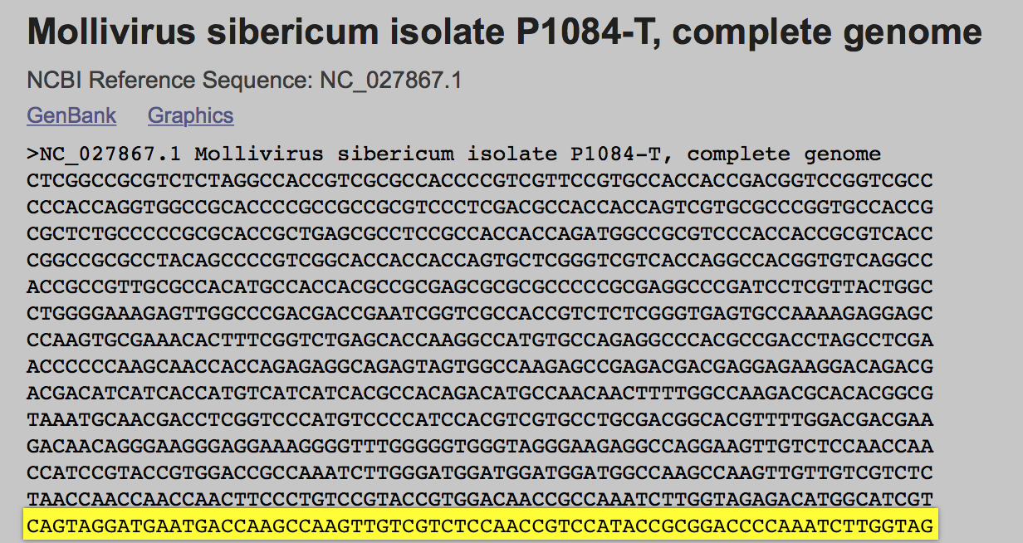

1. Click on ‘Search’
2. The search algorithm starts in the background

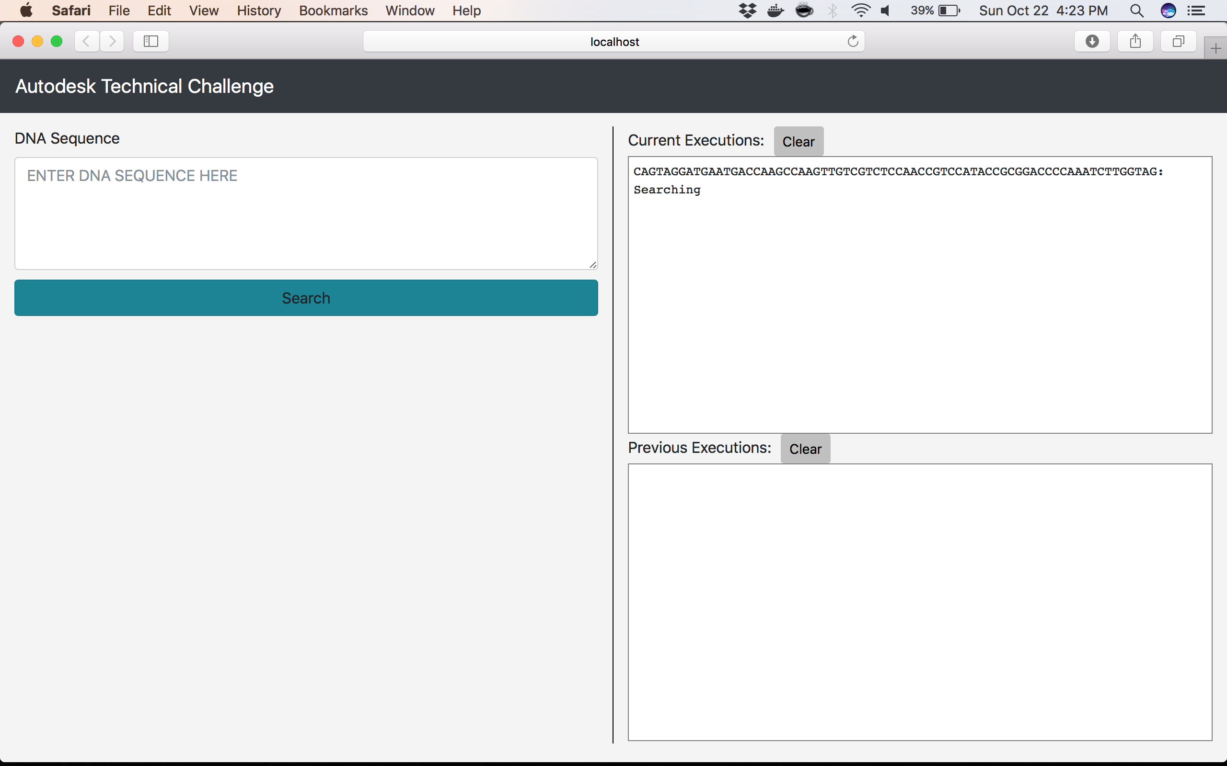

1. Current execution console on the left gets updated, when the algorithm completes

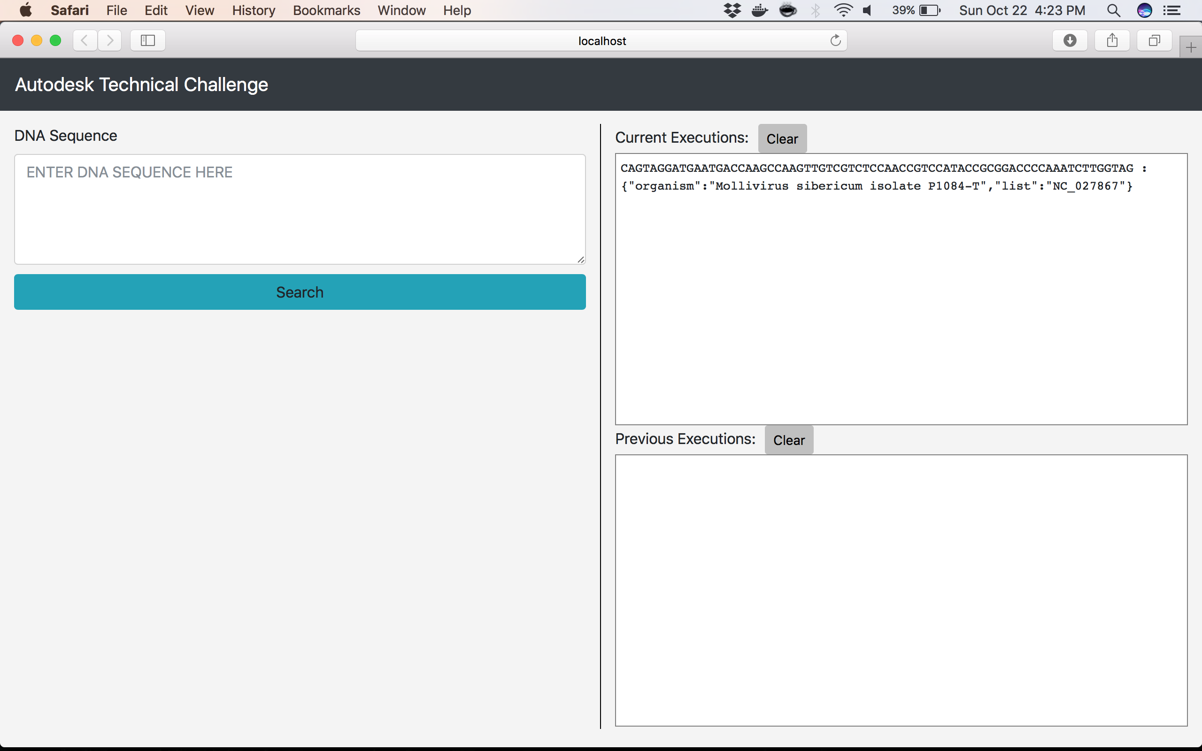

1. Multiple searches can be run concurrently

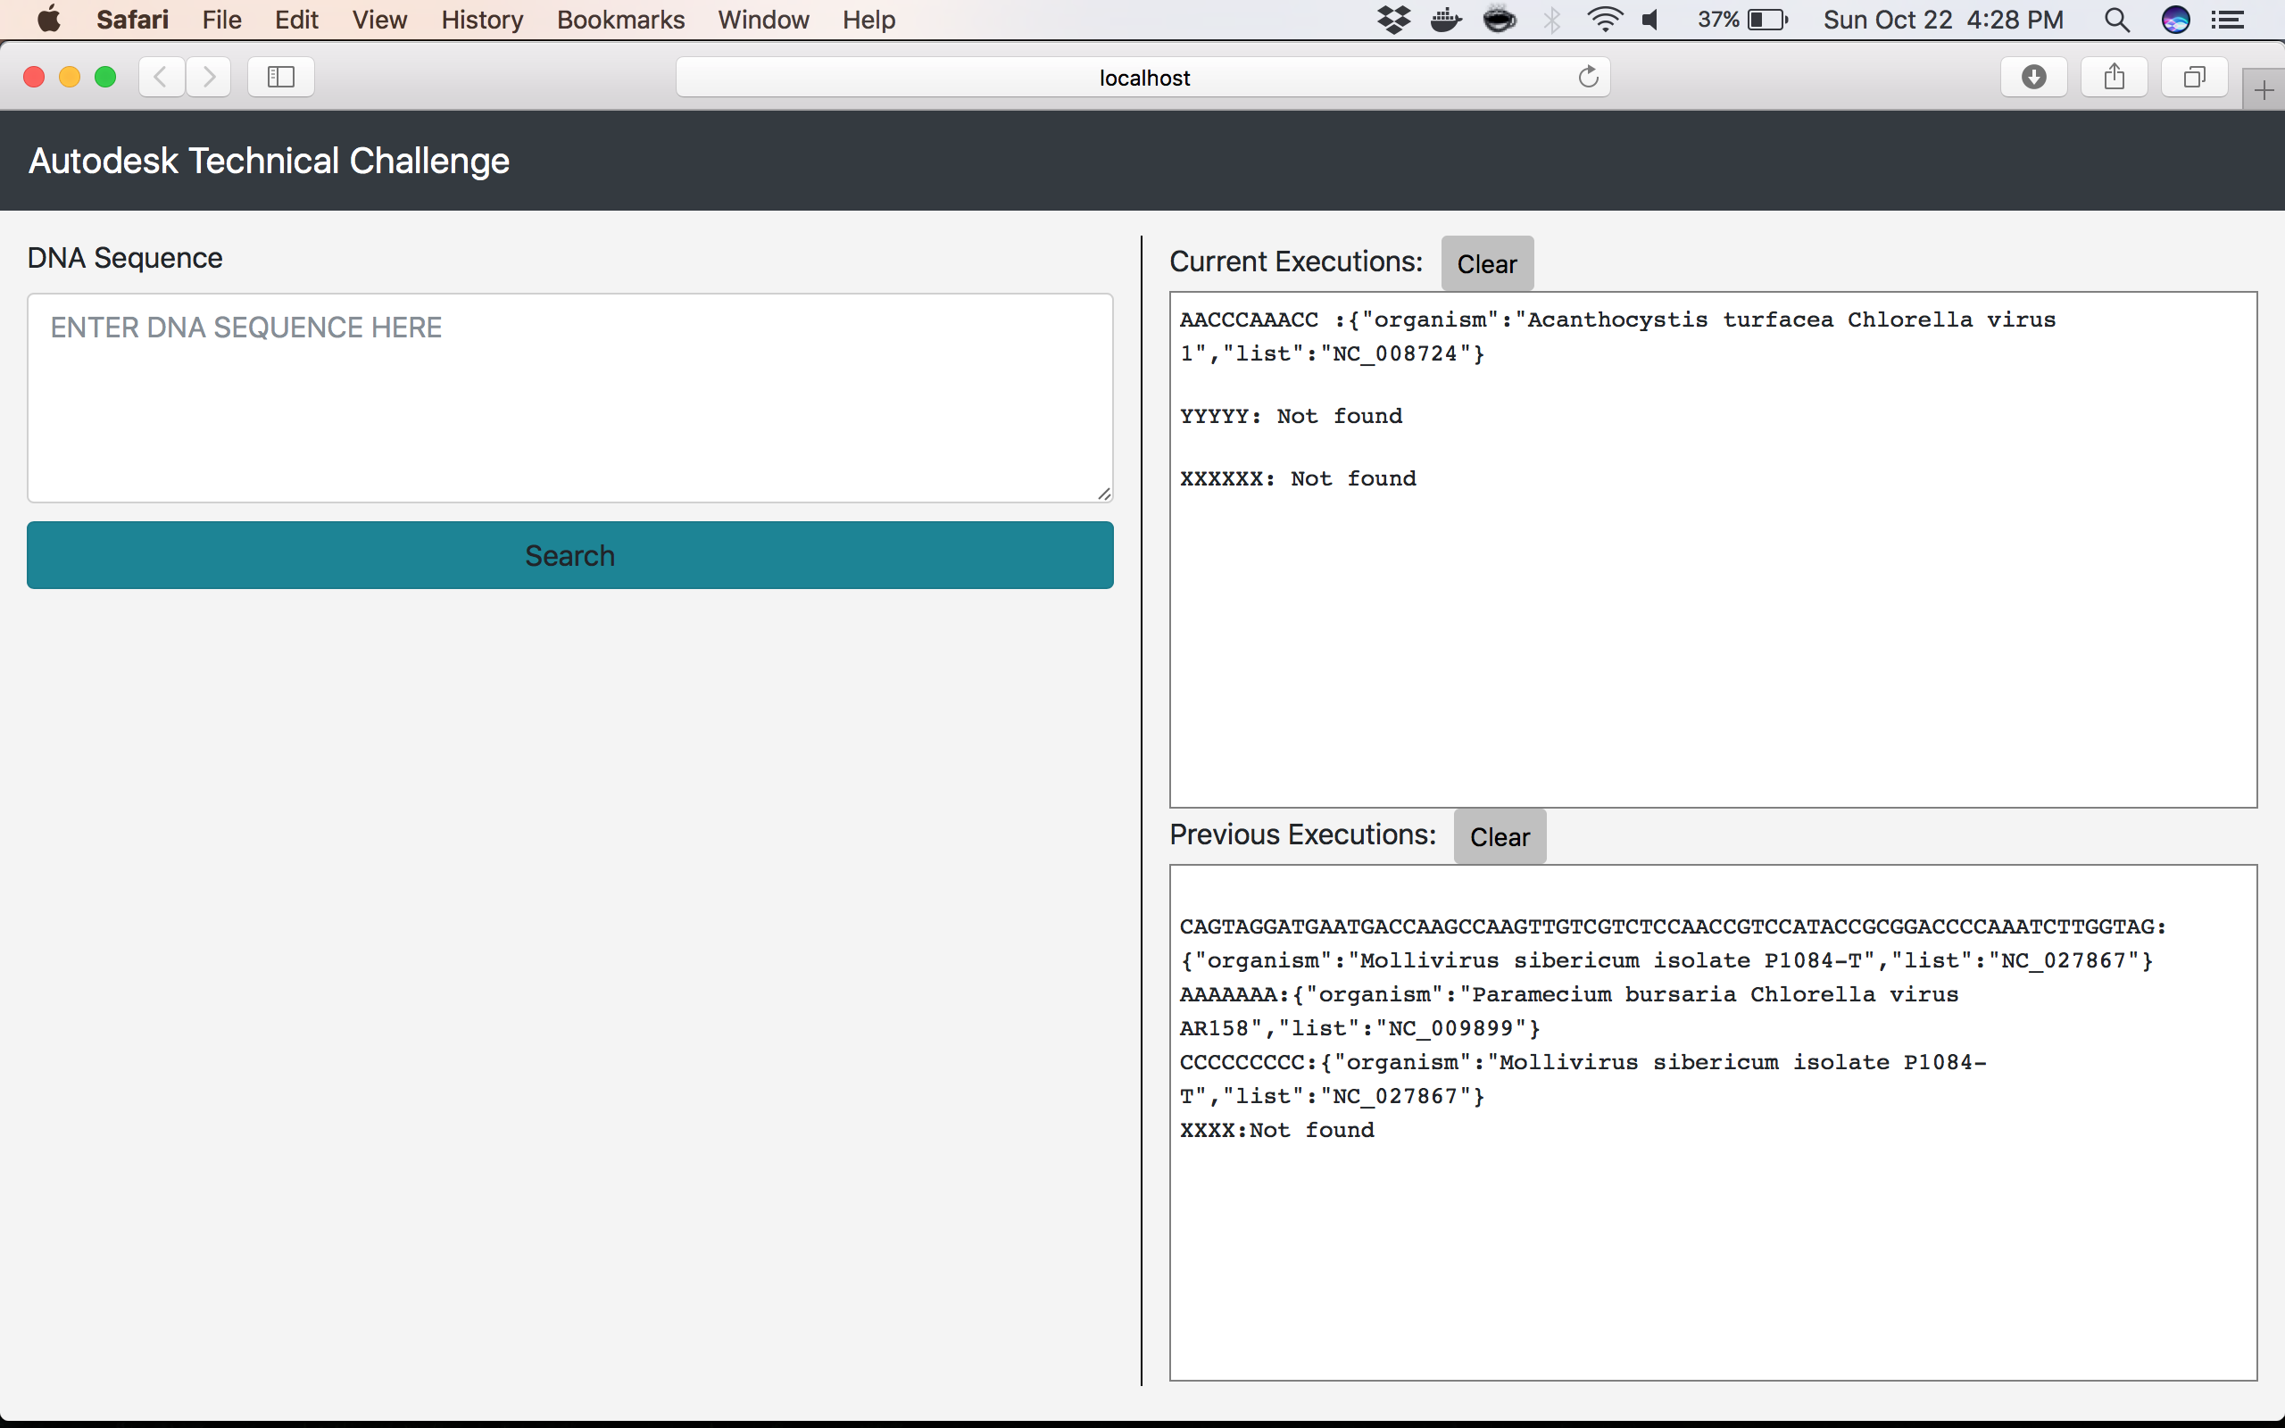

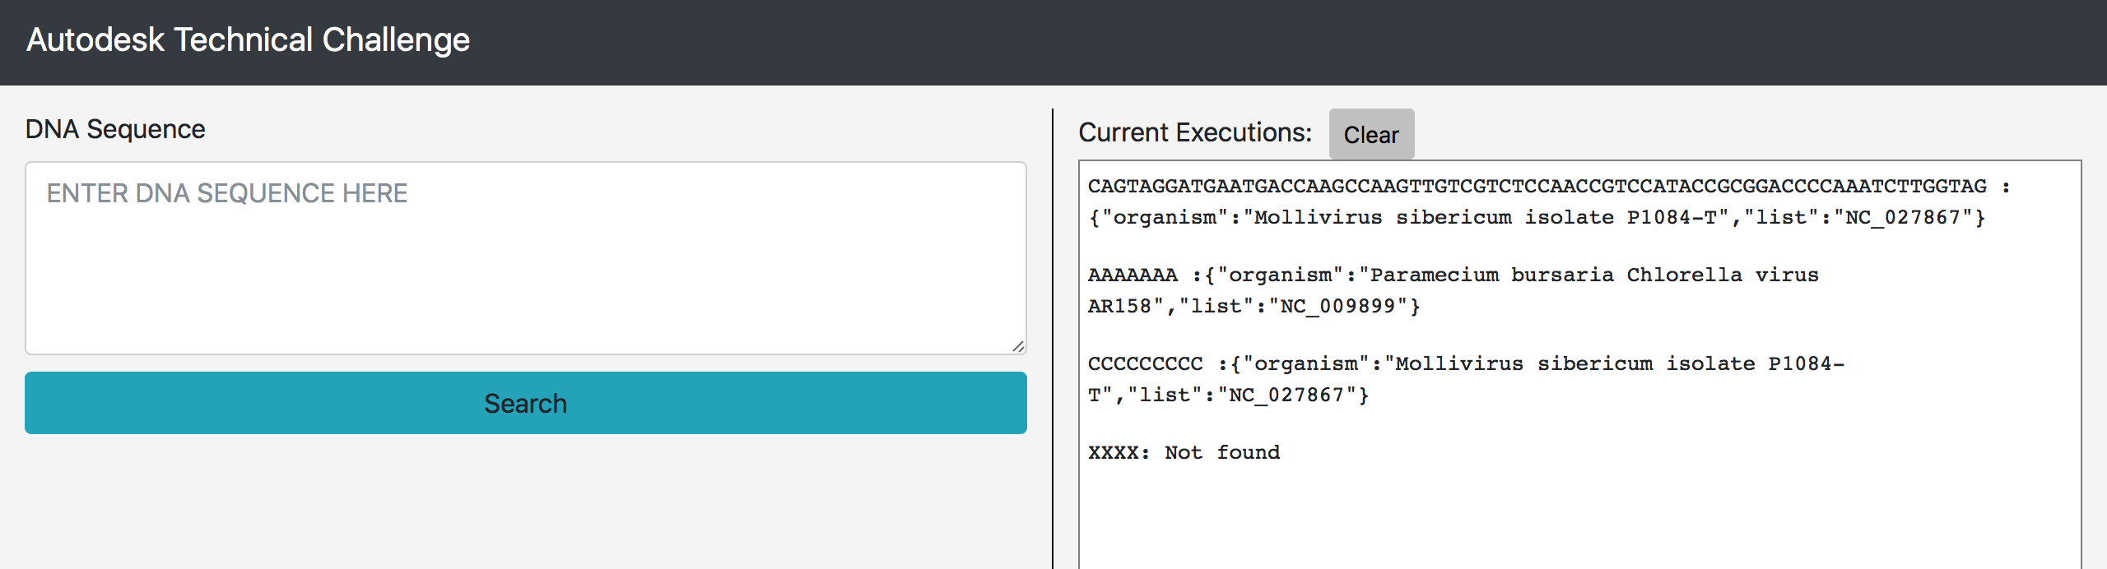

1. When the browser is refreshed/re-opened, all previous searches can be found in the previous executions console

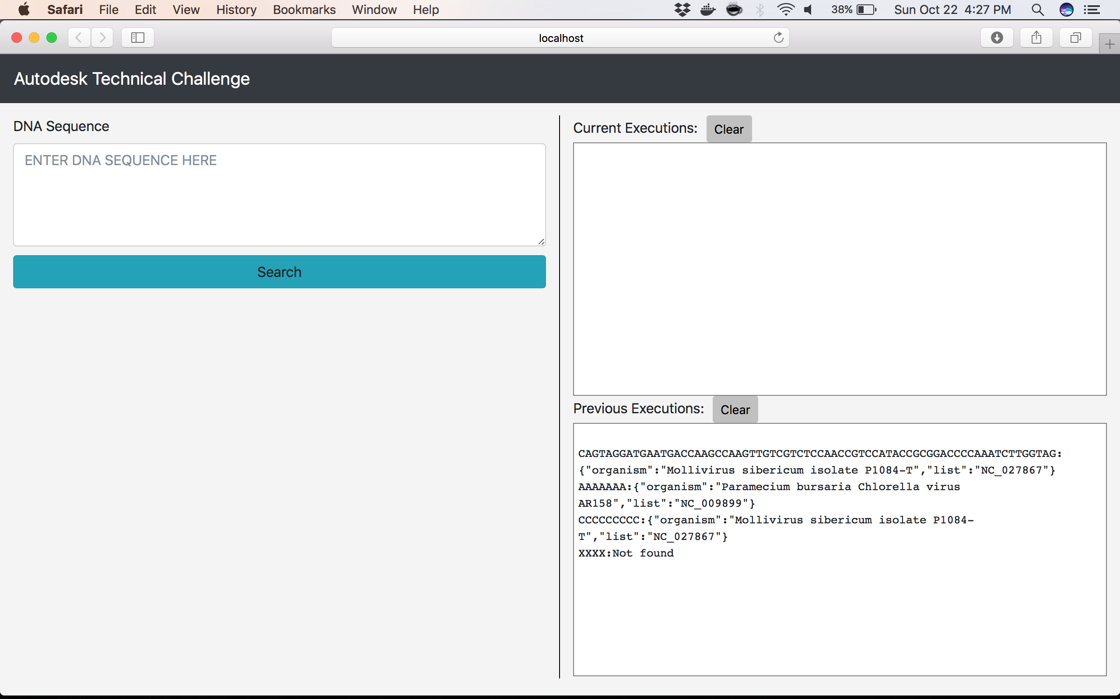

1. If the same sequence is found in multiple proteins, the list is collated

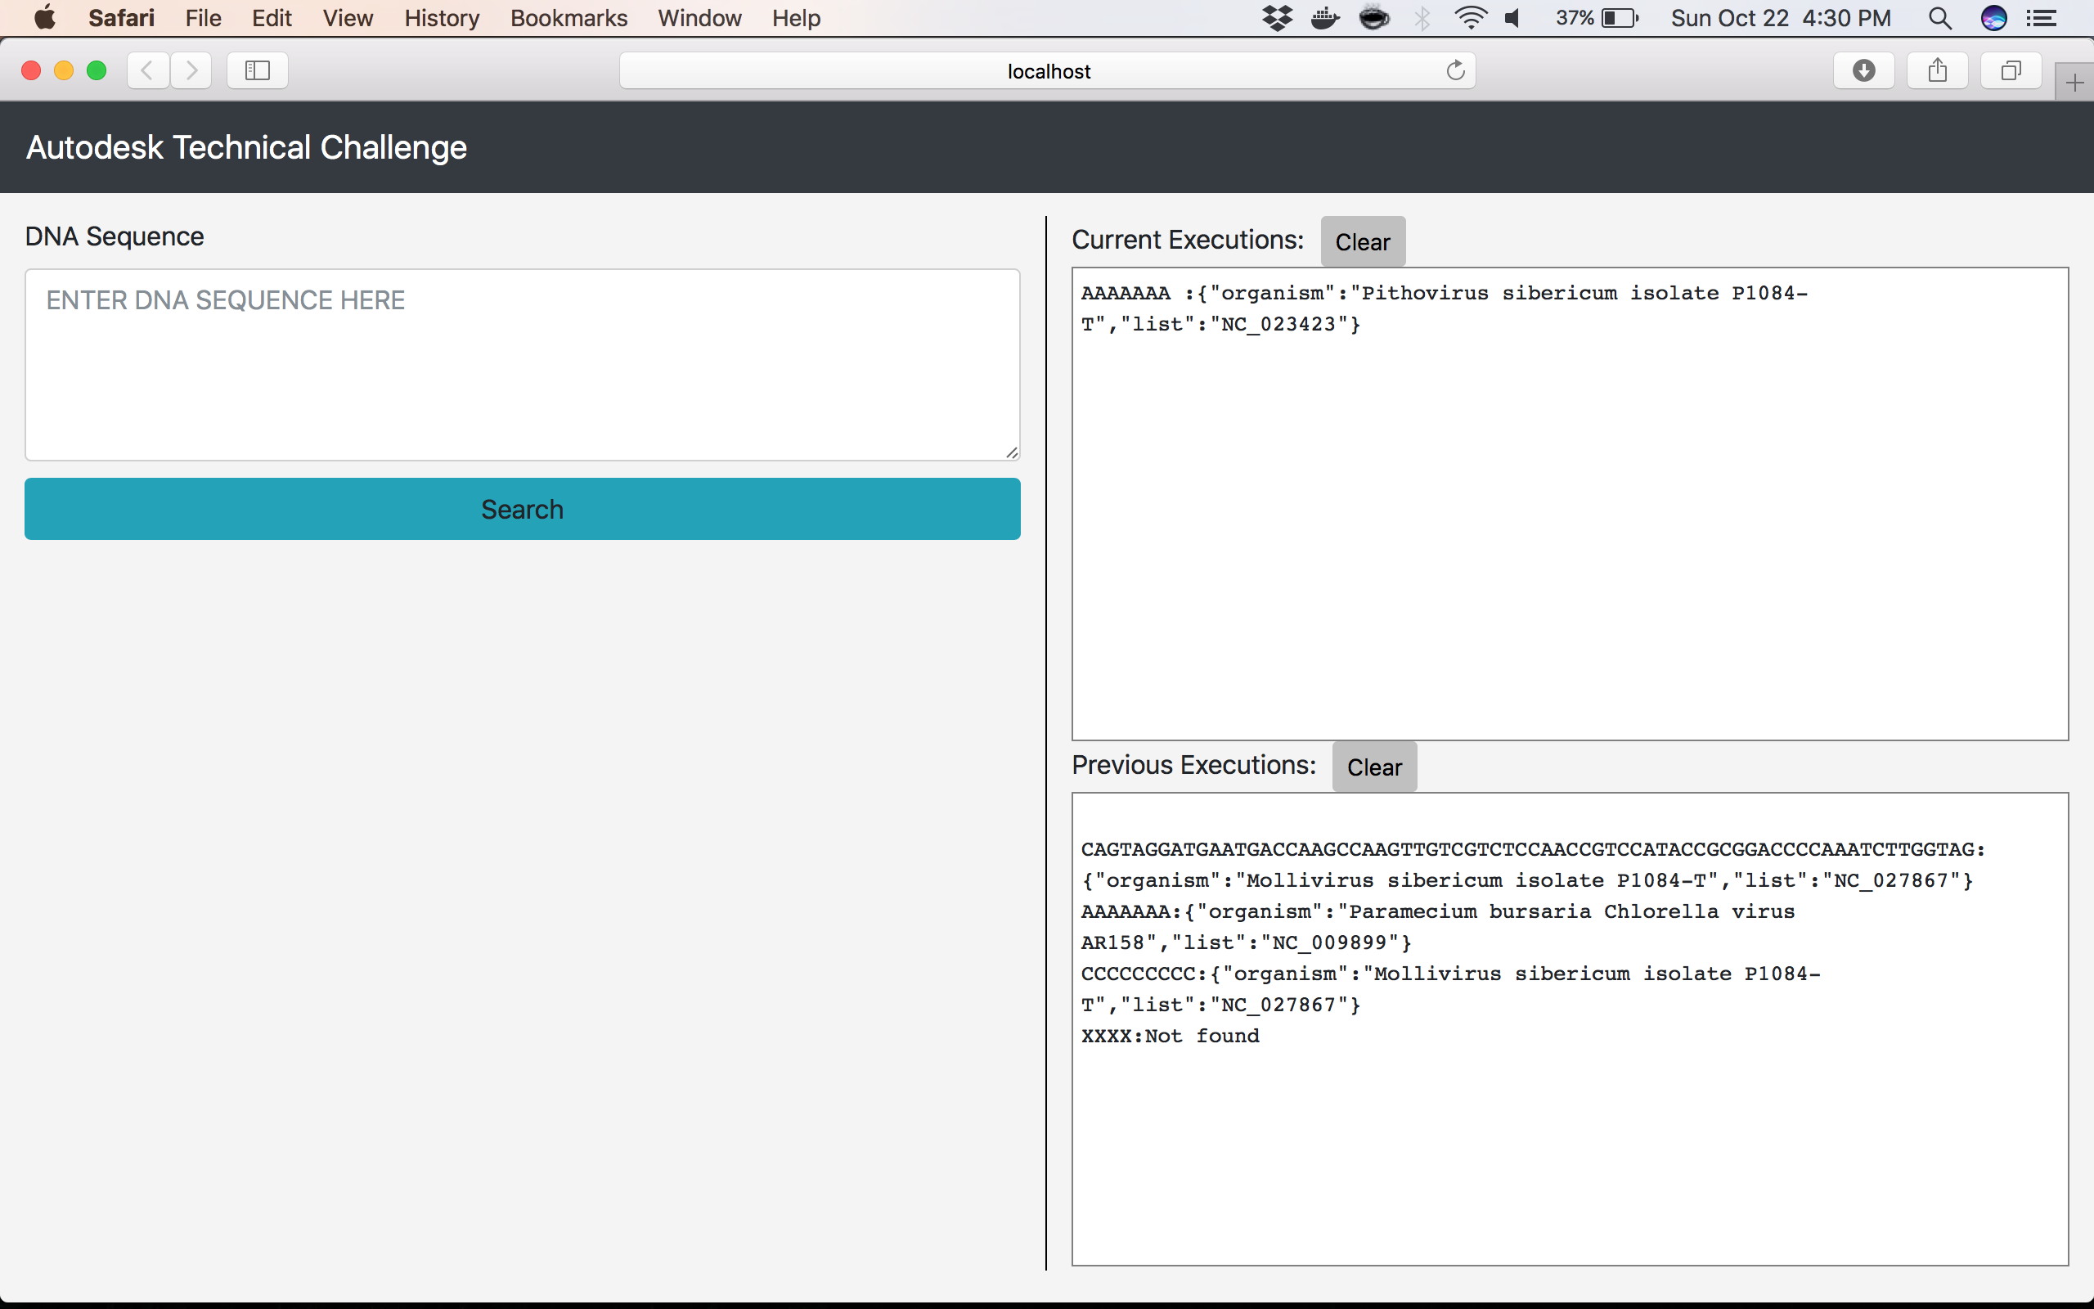

Sequence AAAAAAA is found in list NC_009899 and NC_023423. The result is therefore collated, as shown below.

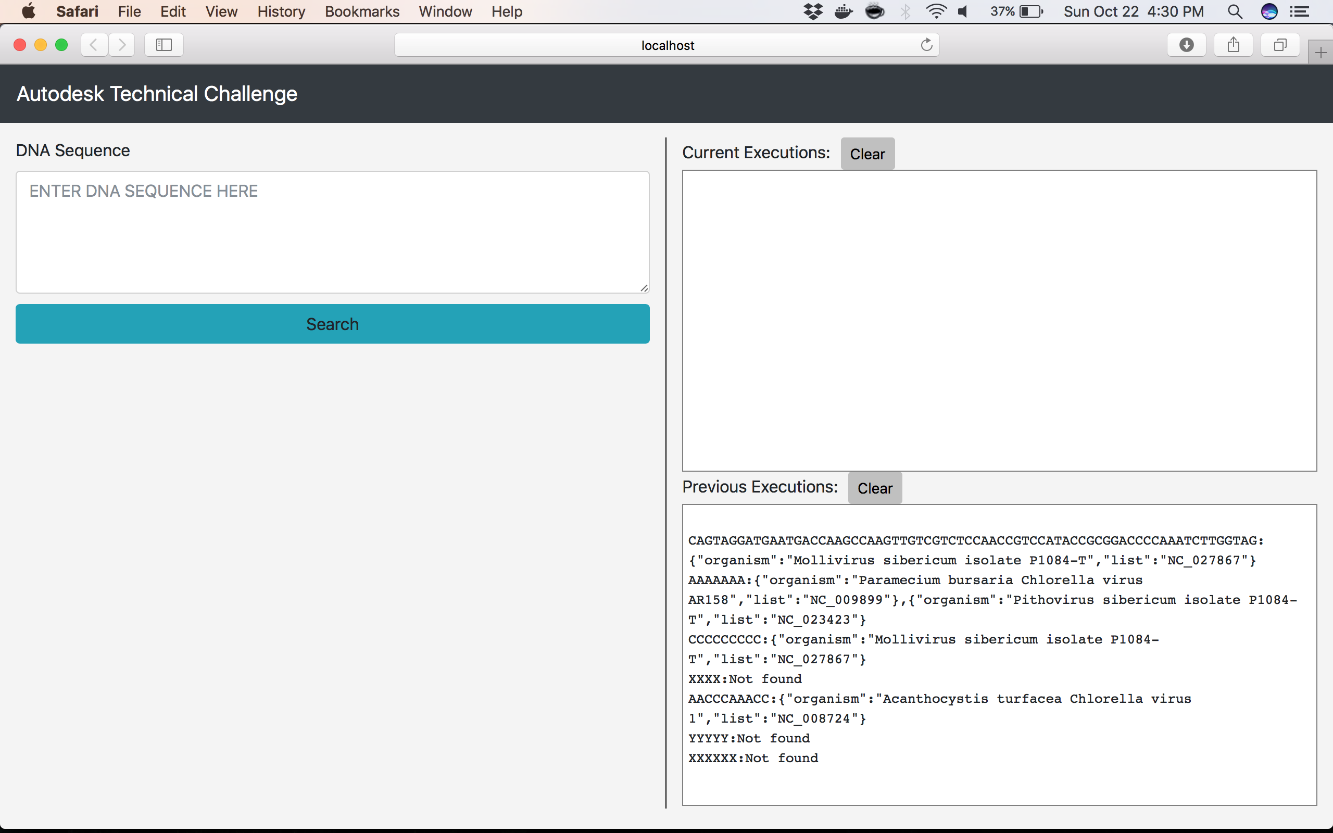

1. If a user closes the browser, when a search is still in progress, the search will resume whenever the page is re-opened.
2. Only alphabets are accepted as input.