Code for Selection Sort:

import java.util.*;

public class EXPT_01_Selection {

    public static void main(String args[]) {

        Scanner in = new Scanner(System.in);

        int n, i, j, min, temp;

        Random randomnumber = new Random();

        System.out.print("Enter the number of elements to sort: ");

        n = in.nextInt();

        int arr2[] = new int[n]; // to be sorted using Selection sort

        for (i = 0; i < n; i++) {

            // System.out.print("For index "+(i+1)+", enter value: ");

            // arr1[i] = in.nextInt();

            arr2[i] = randomnumber.nextInt(1000);

        }

        System.out.println("\n\n");

        System.out.print("The random-generated array is ");

        for (i = 0; i < n; i++) {

            System.out.print("\t" + arr2[i]);

        }

        System.out.println("");

        long start2 = System.currentTimeMillis();

        for (i = 0; i < n - 1; i++) {

            min = i;

            for (j = i + 1; j < n; j++)

                if (arr2[j] < arr2[min])

                    min = j;

            temp = arr2[min];

            arr2[min] = arr2[i];

            arr2[i] = temp;

        }

        long end2 = System.currentTimeMillis();

        long time2 = end2 - start2;

        System.out.println("");

        System.out.print("The second array after Selection sort is ");

        for (i = 0; i < n; i++) {

            System.out.print("\t" + arr2[i]);

        }

        System.out.println("\n");

        System.out.println("The number of elements are " + n);

        System.out.println("Time taken for Selection Sort is " + time2 + " milliseconds.");

    }

}

Code for Insertion Sort:

import java.util.*;

public class EXPT_01_Insertion {

    public static void main(String args[]) {

        Scanner in = new Scanner(System.in);

        int n, i, j, key;

        Random randomnumber = new Random();

        System.out.print("Enter the number of elements to sort: ");

        n = in.nextInt();

        int arr1[] = new int[n]; // to be sorted using Insertion sort

        for (i = 0; i < n; i++) {

            // System.out.print("For index "+(i+1)+", enter value: ");

            // arr1[i] = in.nextInt();

            arr1[i] = randomnumber.nextInt(1000);

        }

        System.out.print("The random-generated array is ");

        for (i = 0; i < n; i++) {

            System.out.print("\t" + arr1[i]);

        }

        System.out.println("\n\n");

        long start1 = System.currentTimeMillis();

        for (i = 0; i < n; i++) {

            key = arr1[i];

            j = i - 1;

            while (j >= 0 && key < arr1[j]) {

                arr1[j + 1] = arr1[j];

                j = j - 1;

            }

            arr1[j + 1] = key;

        }

        long end1 = System.currentTimeMillis();

        long time1 = end1 - start1;

        System.out.print("The first array after Insertion sort is ");

        for (i = 0; i < n; i++) {

            System.out.print("\t" + arr1[i]);

        }

        System.out.println("\n");

        System.out.println("The number of elements are " + n);

        System.out.println("Time taken for Insertion Sort is " + time1 + " milliseconds.");

    }

}

Case 1: When the number of elements is 1000

Insertion sort: 10 ms.

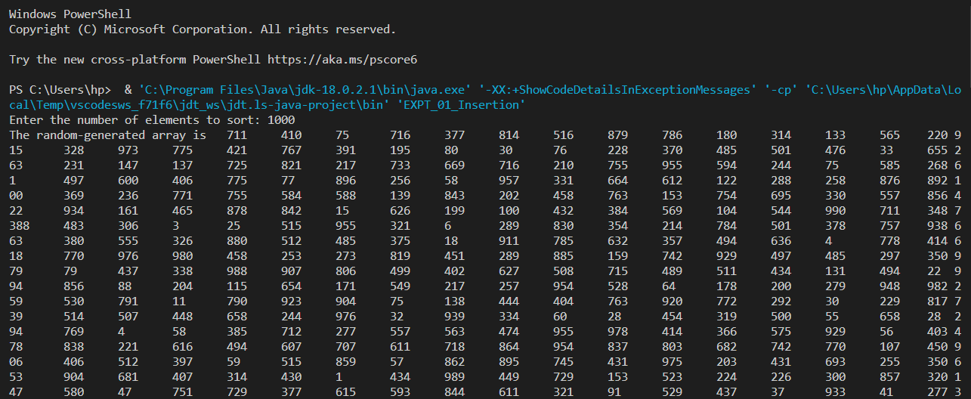

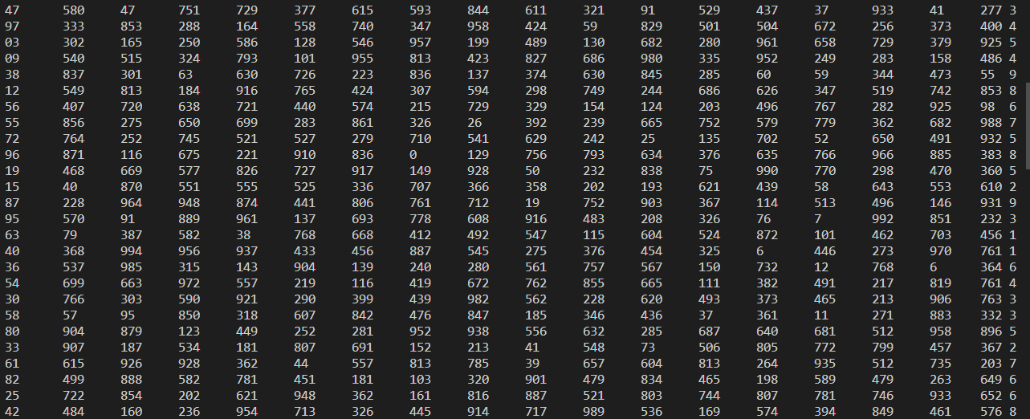

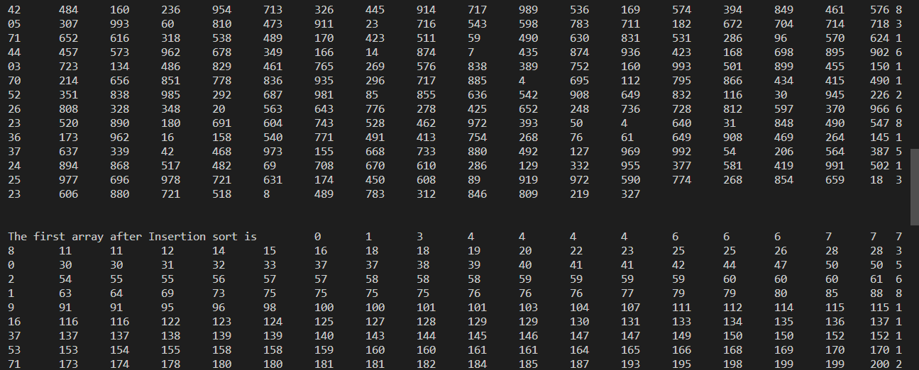

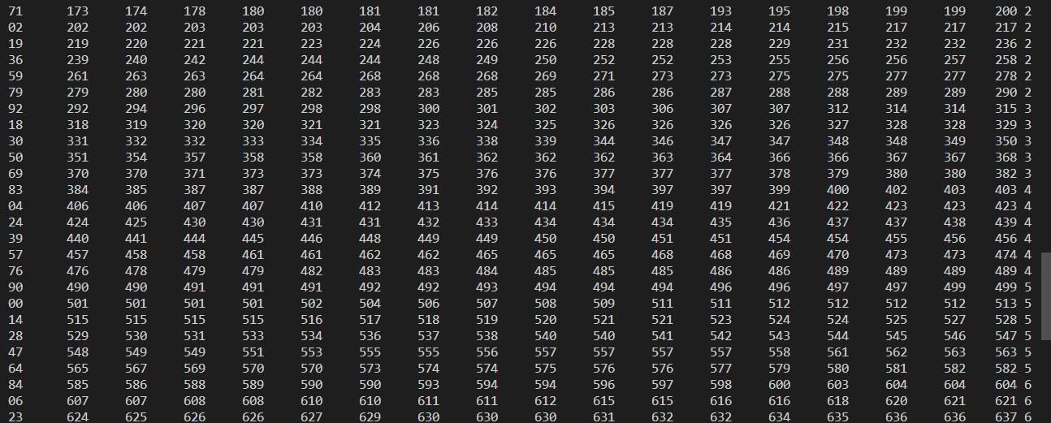

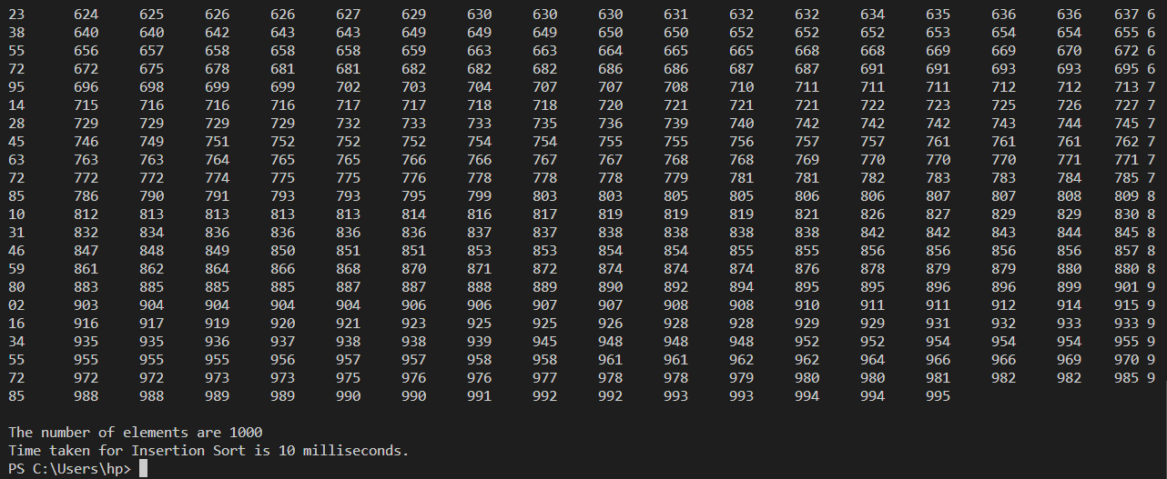

Selection sort: 14 ms.

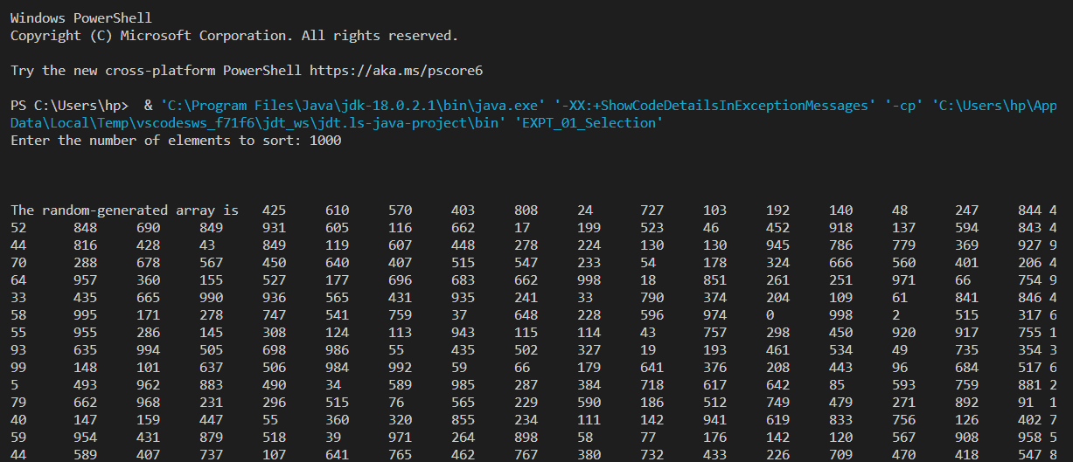

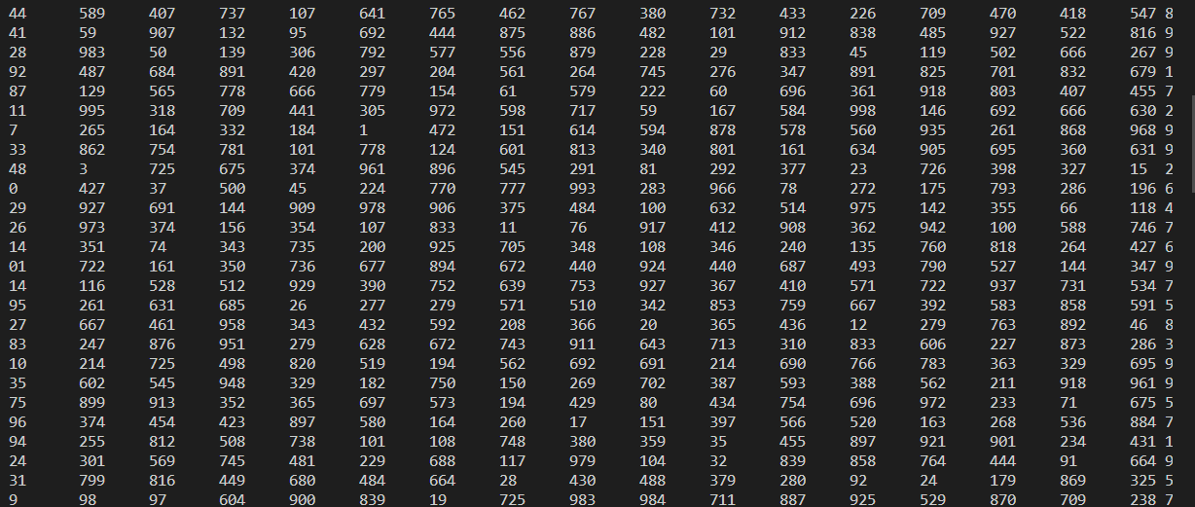

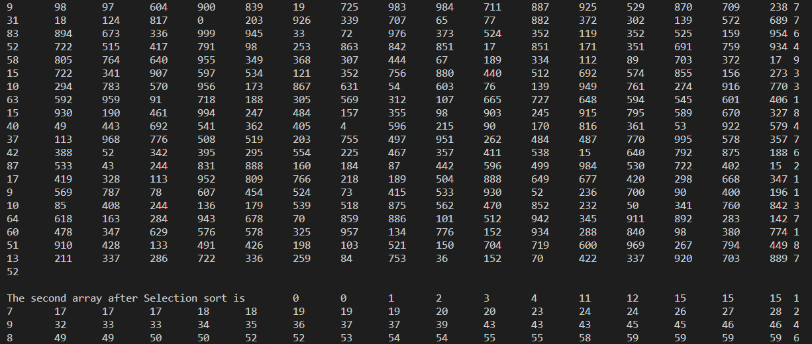

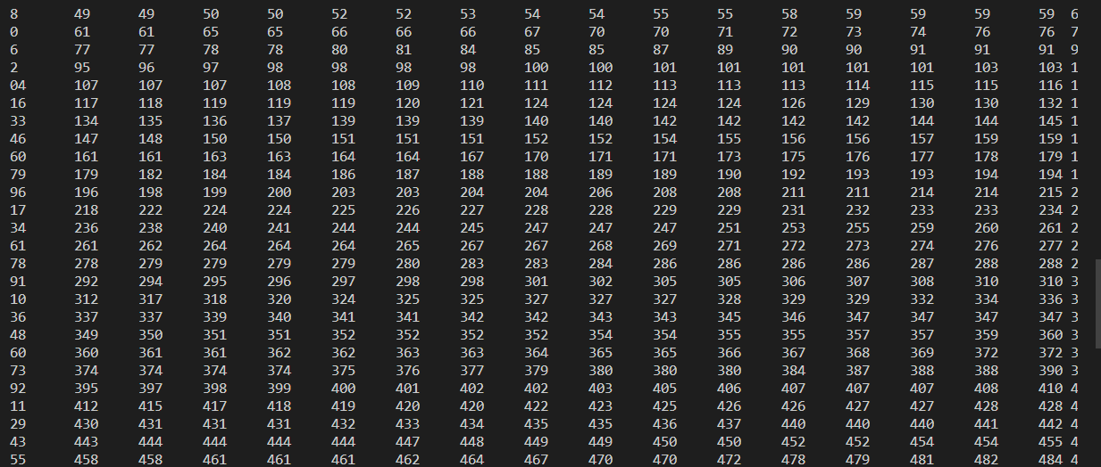

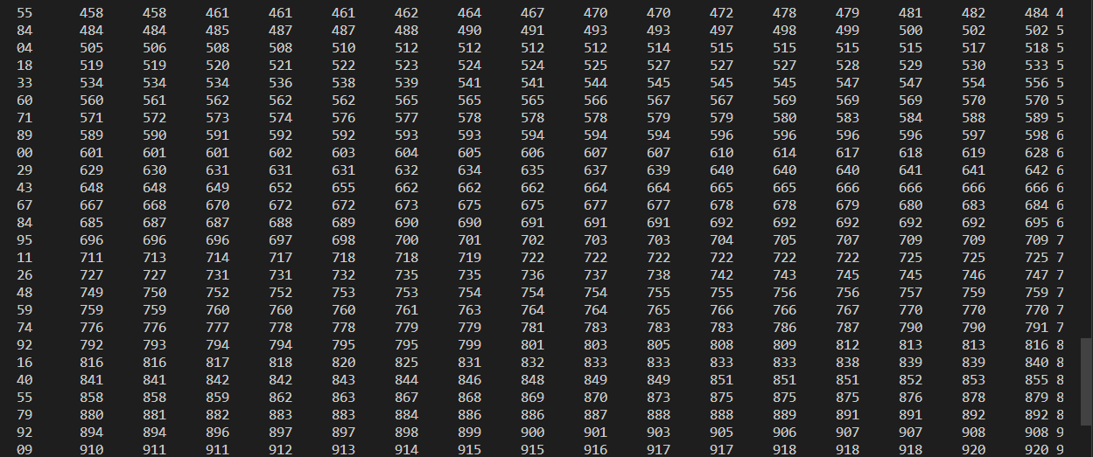

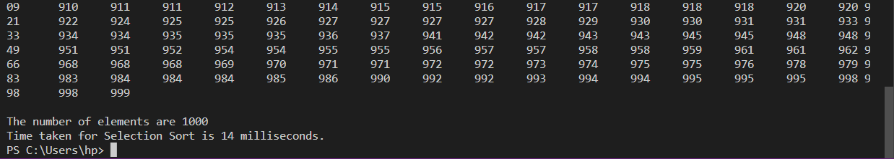

Case 2: When the number of elements is 5000

Insertion Sort: 39 ms.

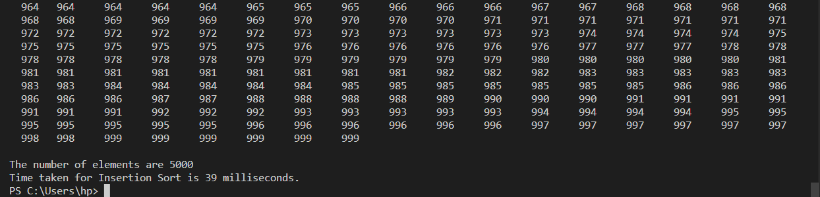

Selection Sort: 55 ms.

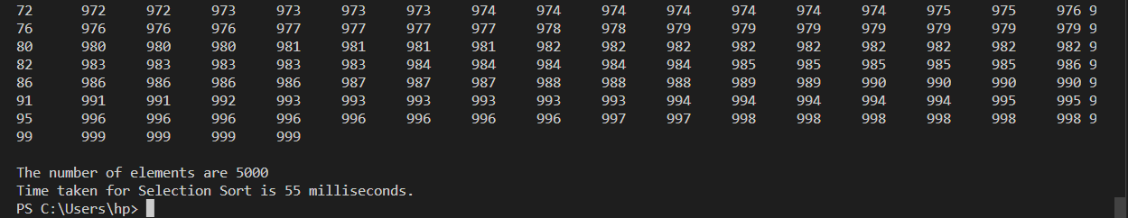

Case 3: When the number of elements is 10000

Insertion Sort: 61 ms.

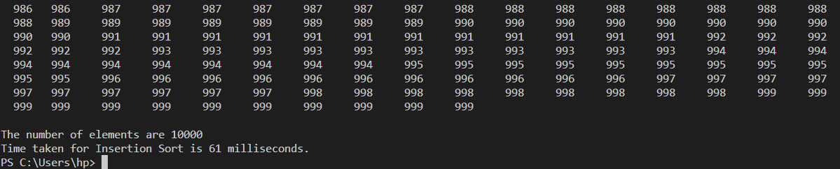

Selection Sort: 135 ms.

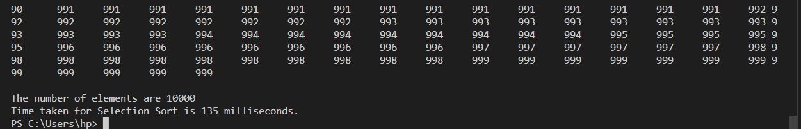

Case 4: When the number of elements is 15000

Insertion Sort: 99 ms.

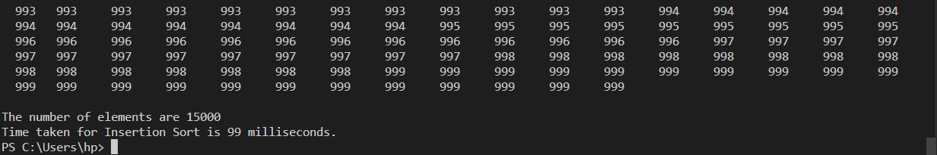

Selection Sort: 267 ms.

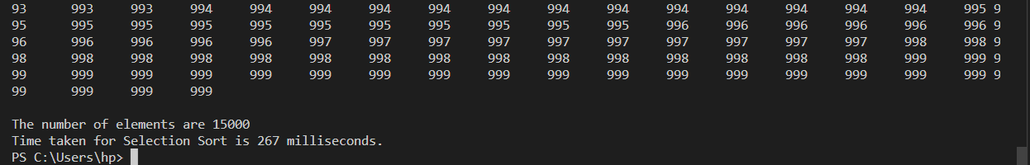

Case 5: When the number of elements is 20000

Insertion Sort: 182 ms.

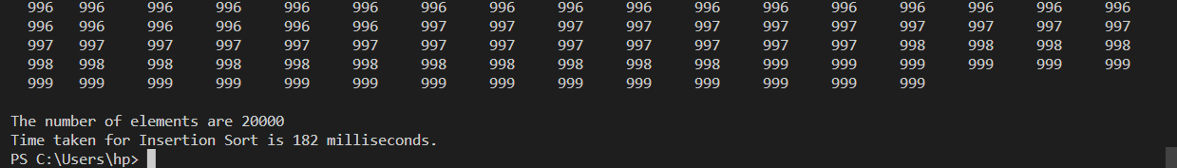

Selection Sort: 459 ms.

