**Batch: B3 Roll No.: 121**

**Experiment No.___5____**

**Grade: AA / AB / BB / BC / CC / CD /DD**

**Signature of the Staff In-charge with date**

|  |
| --- |
| **Title:** Implementation of Knapsack Problem using Greedy strategy |

**Objective:** To learn the Greedy strategy of solving the problems for different types of problems

|  |  |
| --- | --- |
| CO 2 | CO to be achieved:  Describe various algorithm design strategies to solve different problems and analyse Complexity. |

**Books/ Journals/ Websites referred:**

1. **Ellis horowitz, Sarataj Sahni, S.Rajasekaran,” Fundamentals of computer algorithm”, University Press**
2. **T.H.Cormen ,C.E.Leiserson,R.L.Rivest and C.Stein,” Introduction to algorithms”,2nd Edition ,MIT press/McGraw Hill,2001**
3. **http://lcm.csa.iisc.ernet.in/dsa/node184.htm**
4. **http://students.ceid.upatras.gr/~papagel/project/kruskal.htm**
5. [**http://www.personal.kent.edu/~rmuhamma/Algorithms/MyAlgorithms/GraphAlgor/kruskalAlgor.html**](http://www.personal.kent.edu/~rmuhamma/Algorithms/MyAlgorithms/GraphAlgor/kruskalAlgor.html)
6. **http://lcm.csa.iisc.ernet.in/dsa/node183.html**
7. **http://students.ceid.upatras.gr/~papagel/project/prim.htm**
8. **http://www.cse.ust.hk/~dekai/271/notes/L07/L07.pdf**
9. **https://www.gyaanibuddy.com/assignments/assignment-detail/job-sequencing-with-deadline-algo-greedy-strategy/**
10. **https://algodaily.com/lessons/getting-to-know-greedy-algorithms-through-examples**

**Pre Lab/ Prior Concepts:**

Data structures, Concepts of algorithm analysis

**Historical Profile:**

The knapsack problem represents constraint satisfaction optimization problems’ family. Based on the nature of constraints, the knapsack problem can be solved with various problem solving strategies. Typically, these problems represent resource optimization solutions.

Given a set of n inputs. · Find a subset, called feasible solution, of the n inputs subject to some constraints, and satisfying a given objective function. · If the objective function is maximized or minimized, the feasible solution is optimal. · It is a locally optimal method.

**New Concepts to be learned:**

Application of algorithmic design strategy to any problem, Greedy method of problem solving Vs other methods of problem solving, optimality of the solution, knapsack problem and their applications

**Knapsack Problem Algorithm**

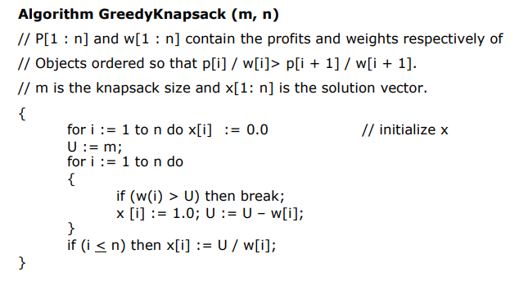

**Example: Knapsack Problem**

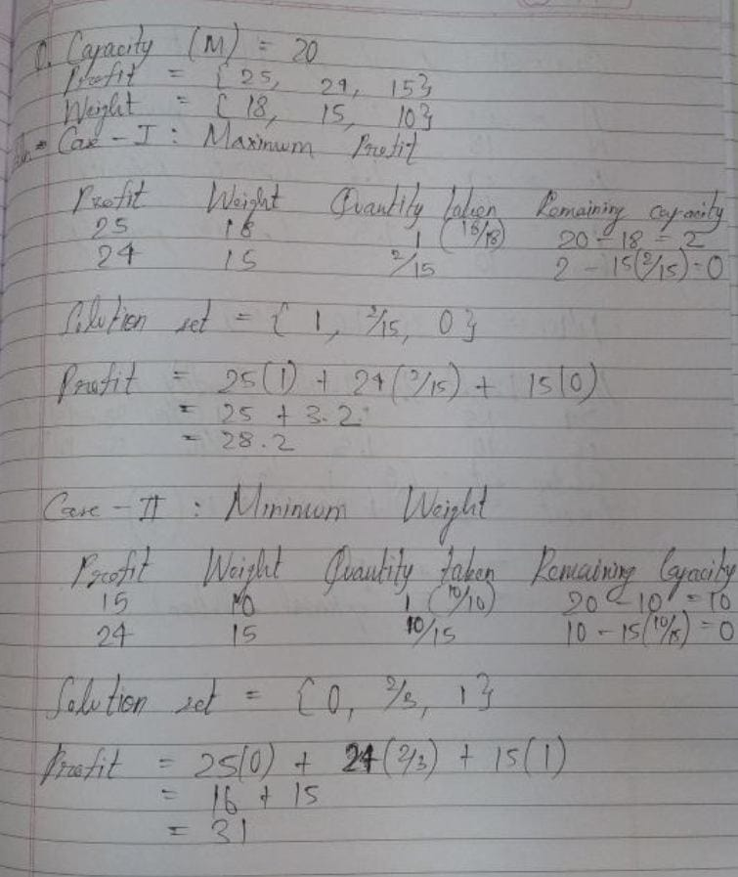

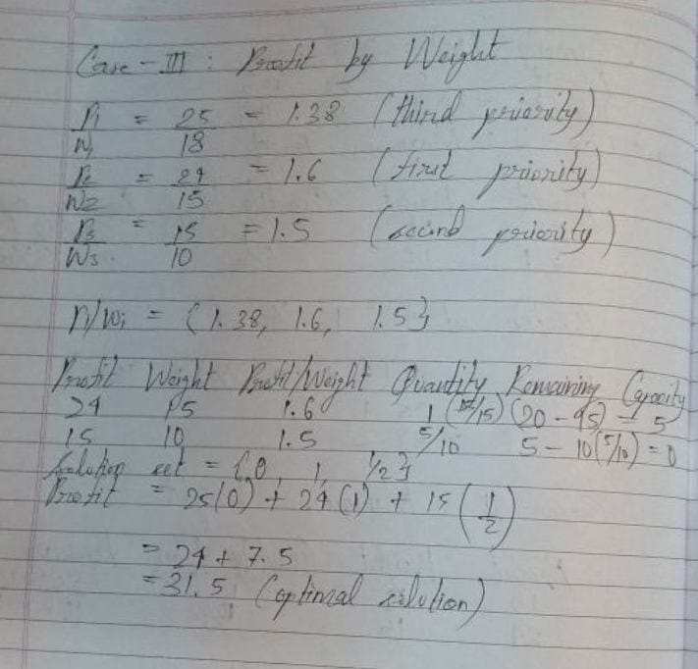

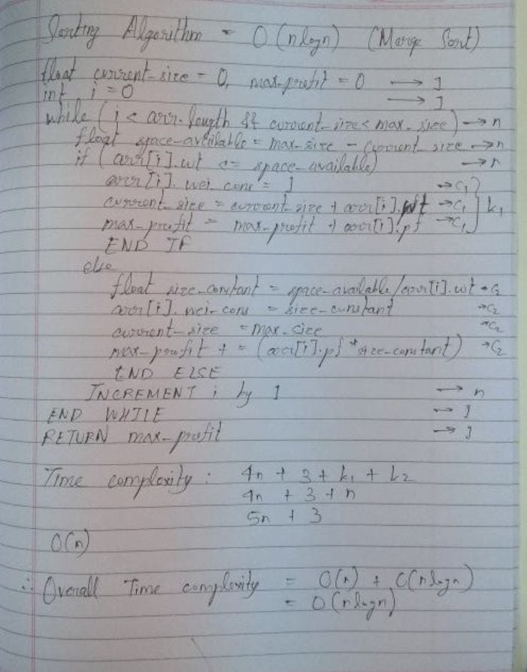**Analysis of Knapsack Problem algorithm:**

The space complexity is O(n). This is because one additional array is being user for storing pi/wi and another one for keeping the solution.

**Conclusion:**

Thus, in this experiment, the concept of Greedy Knapsack has been learnt and implemented. It shows us that in order to get maximum overall profit, the solution we might naturally think, i.e., to include all those components according to their profit, is not the best option. In fact, it is the worst option. The best option is to prioritize the choices according to Pi/Wi and then include them accordingly.