**Batch: B3 Roll No.: 121**

**Experiment No.___7___**

**Grade: AA / AB / BB / BC / CC / CD /DD**

**Signature of the Staff In-charge with date**

|  |
| --- |
| **Title: Implementation Matrix Chain Multiplication of Dynamic Programming** |

**Objective:** To learn Matrix chain multiplication using Dynamic Programming Approach

**CO to be achieved:**

|  |  |
| --- | --- |
| CO 2 | Describe various algorithm design strategies to solve different problems and analyse Complexity. |

**Books/ Journals/ Websites referred:**

1. **Ellis horowitz, Sarataj Sahni, S.Rajasekaran,” Fundamentals of computer algorithm”, University Press**
2. **T.H.Cormen ,C.E.Leiserson,R.L.Rivest and C.Stein,” Introduction to algorithms”,2nd Edition ,MIT press/McGraw Hill,2001**
3. [**http://www.lsi.upc.edu/~mjserna/docencia/algofib/P07/dynprog.pdf**](http://www.lsi.upc.edu/~mjserna/docencia/algofib/P07/dynprog.pdf)
4. [**http://www.geeksforgeeks.org/travelling-salesman-problem-set-1/**](http://www.geeksforgeeks.org/travelling-salesman-problem-set-1/)
5. [**http://www.mafy.lut.fi/study/DiscreteOpt/tspdp.pdf**](http://www.mafy.lut.fi/study/DiscreteOpt/tspdp.pdf)
6. [**https://class.coursera.org/algo2-2012-001/lecture/181**](https://class.coursera.org/algo2-2012-001/lecture/181)
7. [**http://www.quora.com/Algorithms/How-do-I-solve-the-travelling-salesman-problem-using-Dynamic-programming**](http://www.quora.com/Algorithms/How-do-I-solve-the-travelling-salesman-problem-using-Dynamic-programming)
8. [**www.cse.hcmut.edu.vn/~dtanh/download/Appendix_B_2.ppt**](http://www.cse.hcmut.edu.vn/~dtanh/download/Appendix_B_2.ppt)
9. **www.ms.unimelb.edu.au/~s620261/powerpoint/chapter9_4.ppt‎**
10. **https://www.gyaanibuddy.com/assignments/assignment-detail/dynamic-programming-matrix-chain-multiplication/**
11. **https://www.codingninjas.com/codestudio/library/matrix-chain-multiplication-679**

**Pre Lab/ Prior Concepts:**

Data structures, Concepts of algorithm analysis

**Historical Profile:** Dynamic Programming (DP) is used heavily in optimization problems (finding the maximum and the minimum of something). Applications range from financial models and operation research to biology and basic algorithm research. So the good news is that understanding DP is profitable. However, the bad news is that DP is not an algorithm or a data structure that you can memorize. It is a powerful algorithmic design technique.

**New Concepts to be learned:**

Application of algorithmic design strategy to any problem, dynamic Programming method of problem solving Vs other methods of problem solving, optimality of the solution, Optimal Binary Search Tree Problems and their applications

**Theory:**

**Problem definition:** Given a sequence of N matrices, the matrix chain multiplication problem is to find the most efficient way to [multiply these matrices](https://en.wikipedia.org/wiki/Matrix_multiplication) by minimizing the number of computations involved during multiplications.

**Optimal Substructure:** parameterization/ select the subgroup of matrices that will result in least number of computations.

For multiplication of matrix series Ai to Aj, choose Ak such that multiplication of matrices through Ai..k and Ak+1…j will incur least number of computations for any k such that i<=k<j. **Recursive Formula:****Algorithm:**

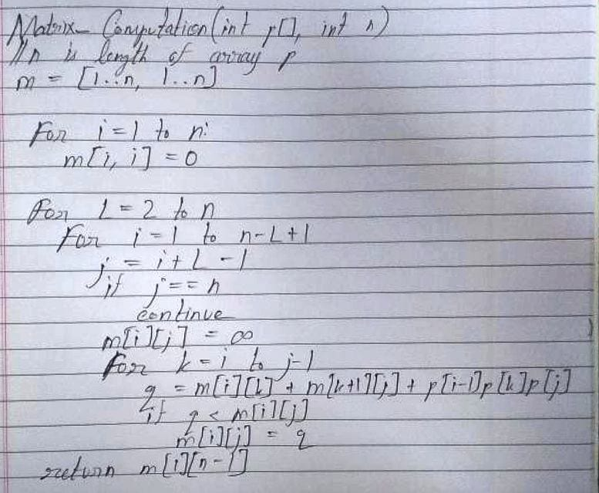

**Example:**

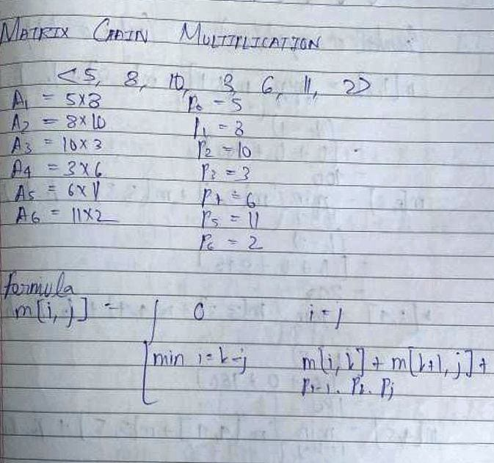

**Solution for the example:**

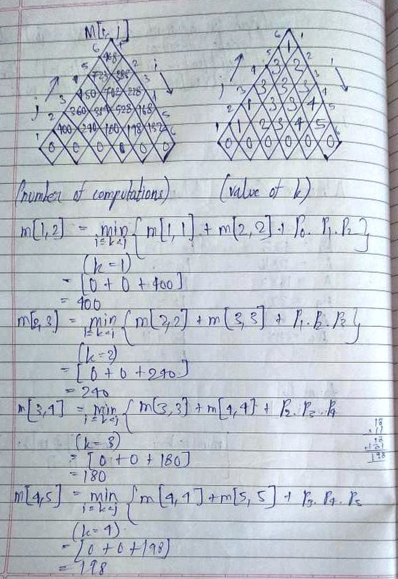

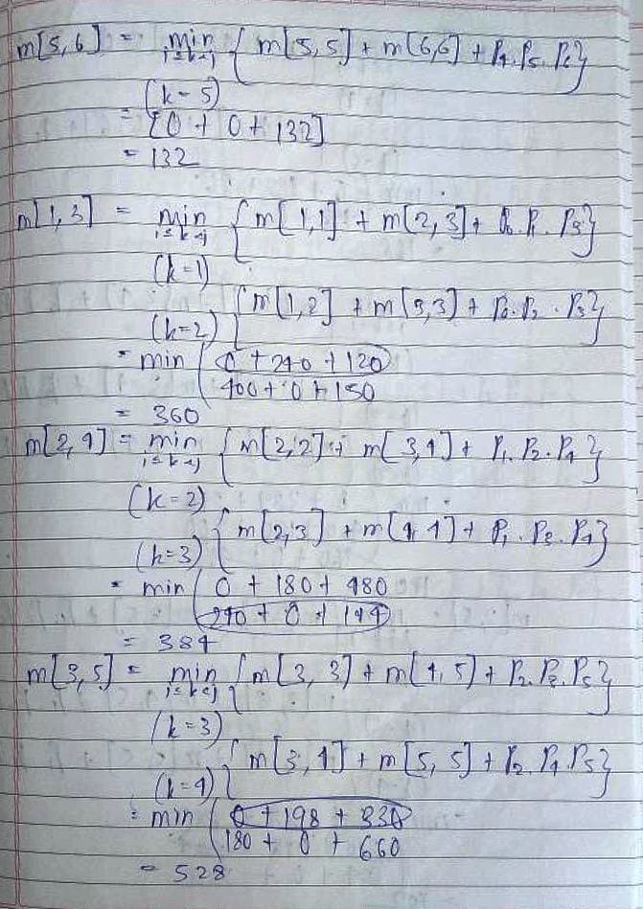

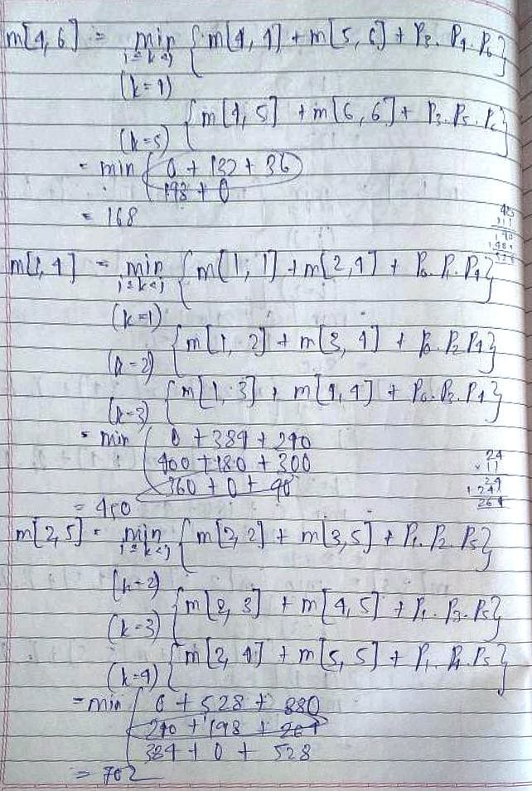

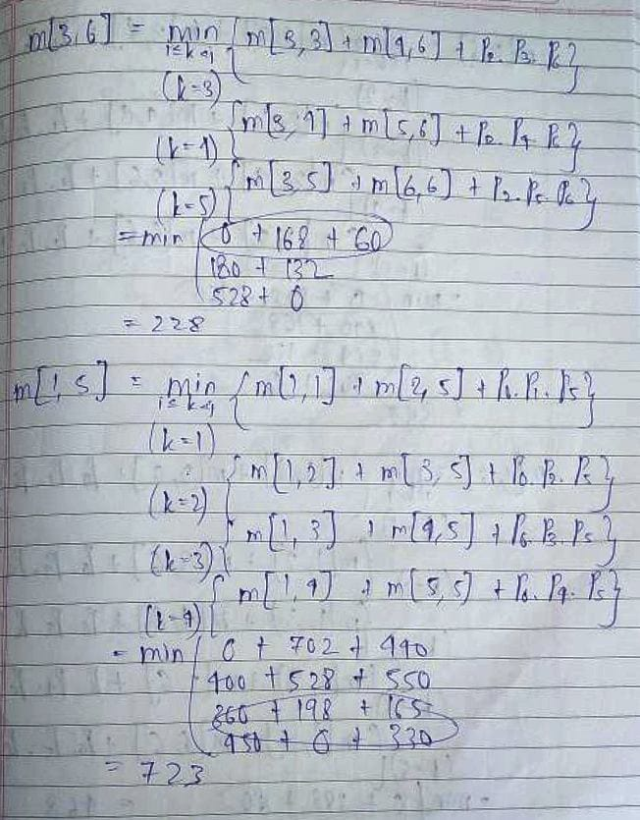

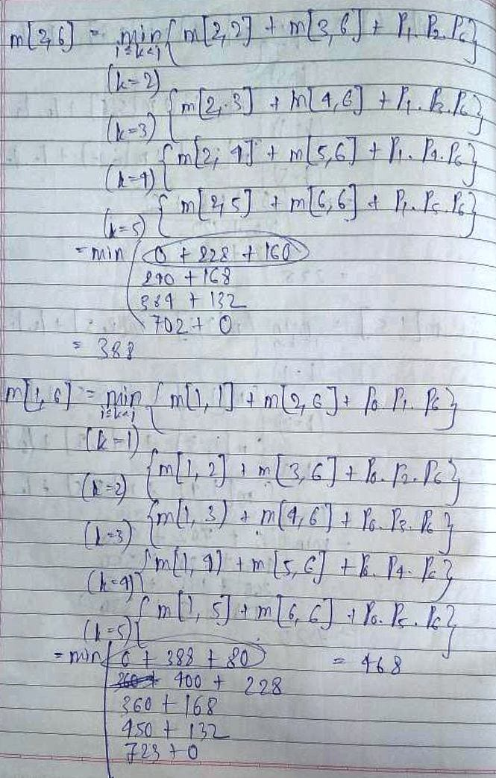

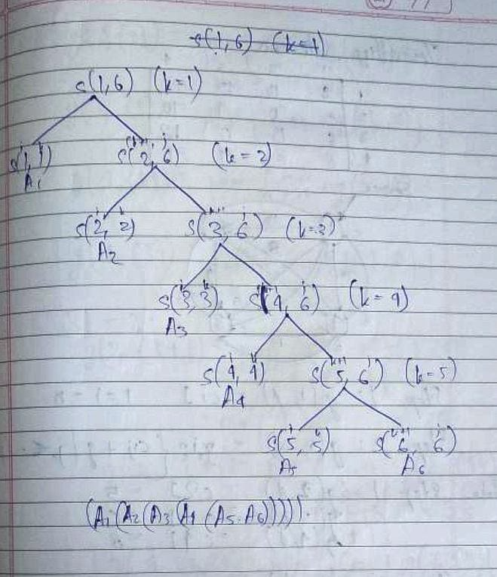

**Analysis of algorithm:**

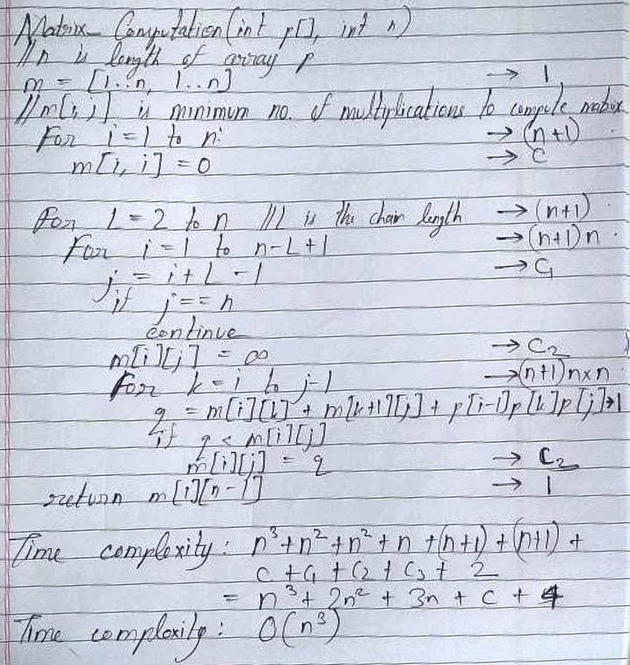

The Space Complexity is O(n2). This is because a two dimensional matrix is used to store the computations.

**CONCLUSION:**

Thus, in this experiment, the concept of Dynamic Programming was applied in order to solve the Matrix Chain Multiplication problem. It is a better approach as compared to the naïve approach, because its time complexity is O(n3) as compared to O(2n) for naïve.