**Batch: B3 Roll No.: 121**

**Experiment / assignment / tutorial No.__10__**

**Grade: AA / AB / BB / BC / CC / CD /DD**

**Signature of the Staff In-charge with date**

|  |
| --- |
| **TITLE:** Study of multiprocessor configuration concepts through Virtual lab |

**AIM:** Understanding Virtual Lab concepts

**_______________________________________________________________**

**Expected OUTCOME of Experiment:**

CO1- Describe and define the structure of a computer with buses structure and detail working of the arithmetic logic unit and its sub modules.

**__________________________________________________________________**

**Books/ Journals/ Websites referred:**

<http://vlabs.iitb.ac.in/vlab/labscse.html>

[http://vlabs.iitb.ac.in/vlab/#](http://vlabs.iitb.ac.in/vlab/)

<http://www.vlab.co.in/>

**_____________________________________________________________________**

**Pre Lab/ Prior Concepts:**

The main aim of this experiment is to provide remote-access to Labs in various disciplines of Science and Engineering. These Virtual Labs would cater to students at the undergraduate level, post graduate level as well as to research scholars. Also, to enthuse students to conduct experiments by arousing their curiosity. This would help them in learning basic and advanced concepts through remote experimentation. It also provides a complete Learning Management System around the Virtual Labs where the students can avail the various tools for learning, including additional web-resources, video-lectures, animated demonstrations and self-evaluation. We can share costly equipment and resources, which are otherwise available to limited number of users due to constraints on time and geographical distances

**Salient Features:**

. 1. Virtual Labs will provide to the students the result of an experiment by one of the following methods (or possibly a combination)

* Modeling the physical phenomenon by a set of equations and carrying out simulations to yield the result of the particular experiment. This can, at-the-best, provide an approximate version of the ‘real-world’ experiment.
* Providing measured data for virtual lab experiments corresponding to the data previously obtained by measurements on an actual system.
* Remotely triggering an experiment in an actual lab and providing the student the result of the experiment through the computer interface. This would entail carrying out the actual lab experiment remotely.

2. Virtual Labs will be made more effective and realistic by providing additional inputs to the students like accompanying audio and video streaming of an actual lab experiment and equipment.

**Observations**

**Title of Study Experiment:**

Representation of Integers and Their Arithmetic

**Brief description of experiment under study:**

The objective of this experiment is to learn about the representation of signed and unsigned integers. Specifically, the advantages of using 2’s complement representation of numbers for performing arithmetic operations over other representations will be learnt.

**Learning’s recorded:**

When the simulation was run, some test cases were considered as follows:

1. 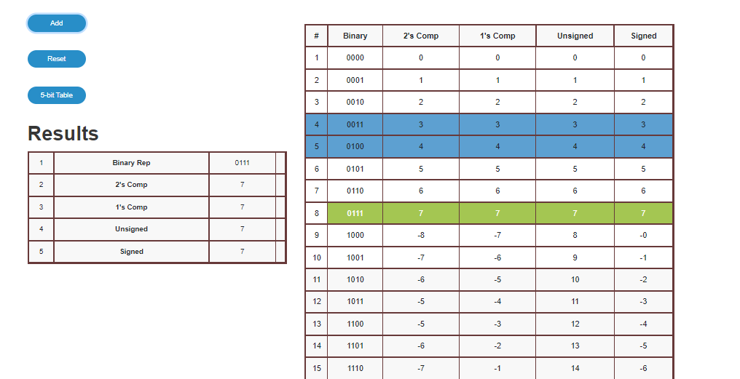Case 1: When both integers are positive and no overflow occurs
2. 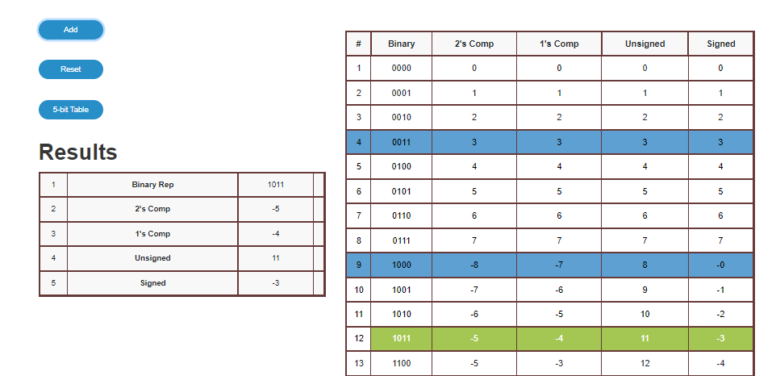Case 2: When an integer is positive and another integer is negative and no overflow occurs
3. 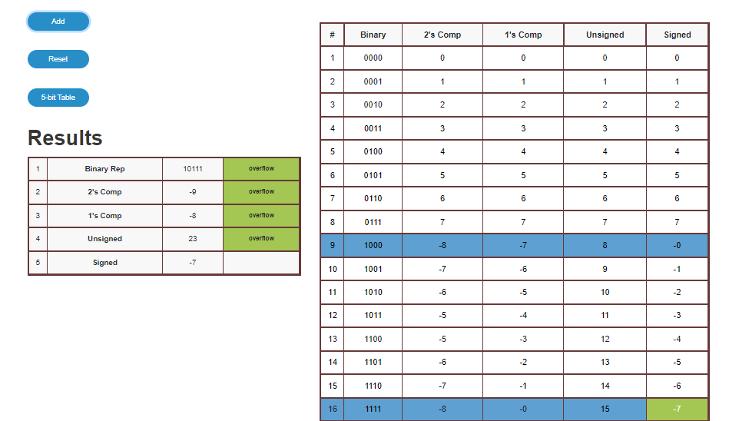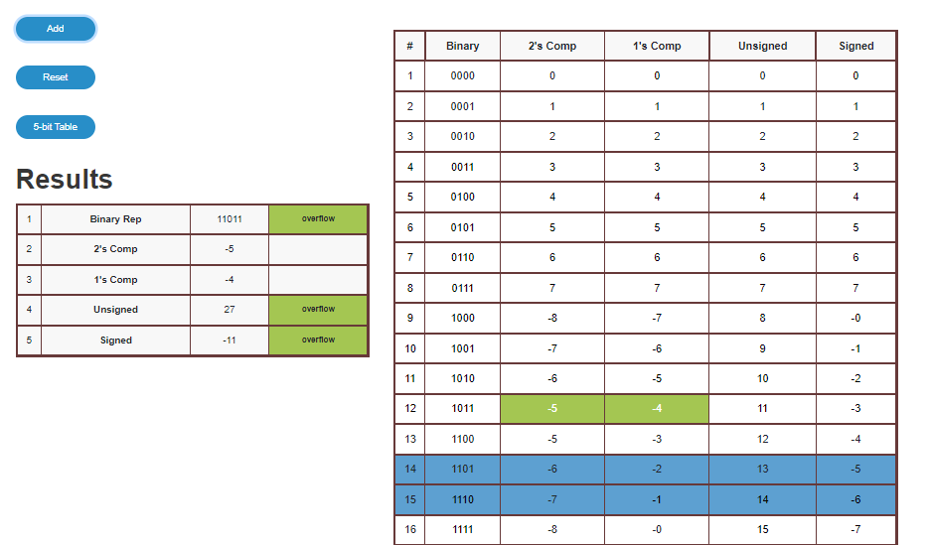Case 3: When both integers are negative and no overflow occurs
4. Case 4: When overflow occur

**Knowledge gained / Inference Obtained :**

In the 2’s complement representation, there is a single representation for zero. Thus, it enhances the efficiency of operations involving zero in the computer. Further, it is convenient to perform arithmetic, especially the subtraction operation as the negative of a number is obtained by getting the two’s complement representation for that number, which can be added to other operands to give the effect of subtraction.

Also, from the test cases above, it can be seen that Two’s Complement Representation does not suffer as much from Overflow condition as the other representations do.

**Post Lab Descriptive Questions**

1. **What are the applications of the virtual lab case study / tool reviewed by you?**

Ans. The virtual lab case study on the topic “Representation of Integers and Their Arithmetic” helps the student understand the concept of how integers are stored in a computer and the various methods for doing so, plus the best method of all viz., Two’s Complement Representation. The virtual lab helps the student visualize the words written in the book; it gives live example of addition of integers and the results obtained with various representations.

**Conclusion**

Thus, in this experiment, the concept of “Representation of Integers and Their Arithmetic” was learnt using VLabs. VLabs provides visual understanding of the concept as described in the textbooks. It helps one to practically understand how the different representations work and why the Two’s Complement Representation is the best among them.

**Date: ___07-12-22____ Signature of faculty in-charge**