**Batch: B3 Roll No.: 121**

**Experiment / assignment / tutorial No.__4__**

**Grade: AA / AB / BB / BC / CC / CD /DD**

**Signature of the Staff In-charge with date**

|  |
| --- |
| **TITLE :** To study and implement Non Restoring method of division |

**AIM :** The basis of algorithm is based on paper and pencil approach and the operation involve repetitive shifting with addition and subtraction. So the main aim is to depict the usual process in the form of an algorithm.

**______________________________________________________________________**

**Expected OUTCOME of Experiment: (Mention CO/CO’s attained here)**

CO1 – Describe and define the structure of a computer with buses structure and detail working of

the arithmetic logic unit and its sub modules.

**_____________________________________**

**Books/ Journals/ Websites referred:**

1. Carl Hamacher, Zvonko Vranesic and Safwat Zaky, “Computer Organization”, Fifth Edition, TataMcGraw-Hill.
2. William Stallings, “Computer Organization and Architecture: Designing for Performance”, Eighth Edition, Pearson.

**3**. Dr. M. Usha, T. S. Srikanth, “Computer System Architecture and Organization”, First Edition, Wiley-India.

**_____________________________________________________________________**

**Pre Lab/ Prior Concepts:**

The Non Restoring algorithm works with any combination of positive and negative numbers.

**Flowchart for Non Restoring of Division:**

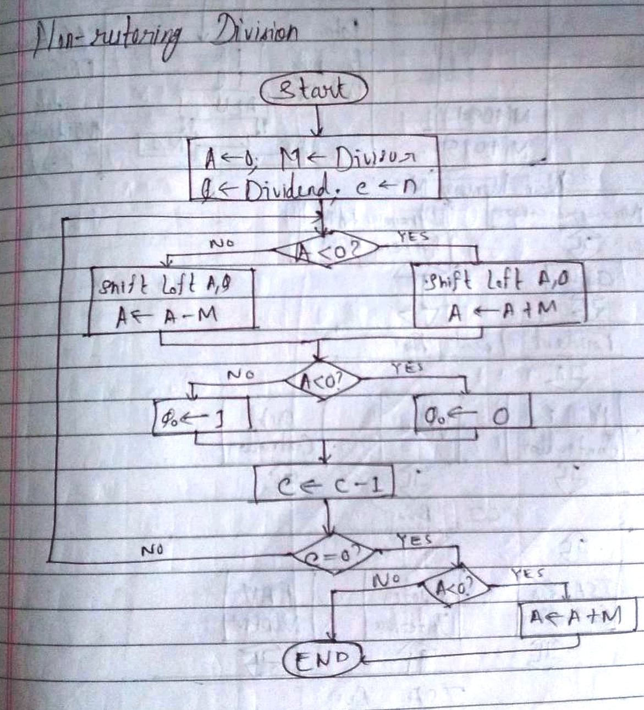

**Example: (Handwritten solved problem needs to uploaded)**

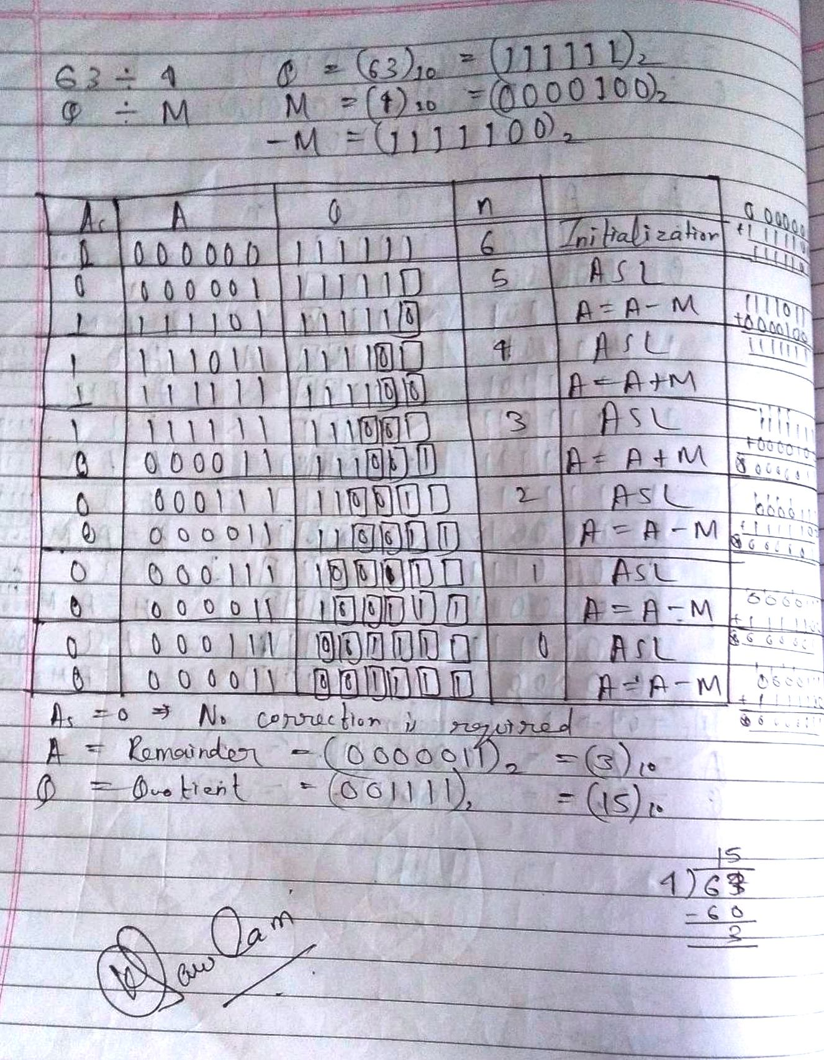

**Code:**

#include<stdio.h>

#include<conio.h>

int dec_bin(int d, int m[])

{

int b = 0, i = 0;

for(i = 0; i < 4; i++)

{

m[i] = d % 2;

d = d / 2;

}

return 0;

}

int twos(int m[], int m2[])

{

int i, m1[4];

for(i = 0; i < 4; i++)

{

if(m[i]==0)

{

m1[i] = 1;

}

else

{

m1[i] = 0;

}

}

for(i = 0; i < 4; i++)

{

m2[i] = m1[i];

}

if(m2[0] == 0)

{

m2[0] = 1;

}

else

{

m2[0] = 0;

if(m2[1] == 0)

{

m2[1] = 1;

}

else

{

m2[1] = 0;

if(m2[2] == 0)

{

m2[2] = 1;

}

else

{

m2[2] = 0;

if(m2[3] == 0)

{

m2[3] = 1;

}

else

{

m2[3] = 0;

}

}

}

}

return 0;

}

int left(int acc[], int q[])

{

int i;

for(i = 3; i > 0; i--)

{

acc[i] = acc[i-1];

}

acc[0] = q[3];

for(i = 3; i > 0; i--)

{

q[i] = q[i-1];

}

}

int add(int acc[], int m[])

{

int i, carry = 0;

for(i = 0; i < 4; i++)

{

if(acc[i]+m[i]+carry == 0)

{

acc[i] = 0;

carry = 0;

}

else if(acc[i]+m[i]+carry == 1)

{

acc[i] = 1;

carry = 0;

}

else if(acc[i]+m[i]+carry == 2)

{

acc[i] = 0;

carry = 1;

}

else if(acc[i]+m[i]+carry == 3)

{

acc[i] = 1;

carry = 1;

}

}

return 0;

}

int main()

{

int a, b, m[4] = {0, 0, 0, 0}, q[4] = {0, 0, 0, 0}, acc[4] = {0, 0, 0, 0}, m2[4], i, n = 4;

printf("\nNON-RESTORING\tDIVISION\tALGORITHM");

printf("\nNote:\nBoth Dividend as well as Divisor\nmust be less than 15");

do{

printf("\nEnter Dividend: ");

scanf("%d", &a);

printf("\nEnter Divisor: ");

scanf("%d", &b);

}while(a > 15 || b > 15);

dec_bin(a, q);

dec_bin(b, m);

twos(m, m2);

printf("\nA\tQ\tComments\n");

for(i = 3; i >= 0; i--)

{

printf("%d", acc[i]);

}

printf("\t");

for(i = 3; i >= 0; i--)

{

printf("%d", q[i]);

}

printf("\tStart\n");

while(n > 0)

{

left(acc, q);

for(i = 3; i >= 0; i--)

{

printf("%d", acc[i]);

}

printf("\t");

for(i = 3; i >= 0; i--)

{

printf("%d", q[i]);

}

printf("_\tLeft Shift A,Q\n");

if(acc[3] == 0)

{

add(acc, m2);

for(i = 3; i >= 0; i--)

{

printf("%d", acc[i]);

}

printf("\t");

for(i = 3; i >= 1; i--)

{

printf("%d", q[i]);

}

printf("_\tA=A-M\n");

}

else

{

add(acc, m);

for(i = 3; i >= 0; i--)

{

printf("%d", acc[i]);

}

printf("\t");

for(i = 3; i >= 0; i--)

{

printf("%d", q[i]);

}

printf("_\tA=A+M\n");

}

if(acc[3] == 0)

{

q[0] = 1;

for(i = 3; i >= 0; i--)

{

printf("%d", acc[i]);

}

printf("\t");

for(i = 3; i >= 0; i--)

{

printf("%d", q[i]);

}

printf("\tQo = 1\n");

}

else

{

q[0] = 0;

for(i = 3; i >= 0; i--)

{

printf("%d", acc[i]);

}

printf("\t");

for(i = 3; i >= 0; i--)

{

printf("%d", q[i]);

}

printf("\tQo = 0\n");

}

n--;

}

if(acc[3]==0)

{

printf("\nMSB is 0. No correction is required.");

}

else

{

printf("\nMSB is 1. Correction is required.\n");

add(acc, m);

for(i = 3; i >= 0; i--)

{

printf("%d", acc[i]);

}

printf("\t");

for(i = 3; i >= 0; i--)

{

printf("%d", q[i]);

}

printf("_\tA=A+M\n");

}

printf("\nQuotient = ");

for(i = 3; i >= 0; i--)

{

printf("%d", q[i]);

}

printf("\tRemainder = ");

for(i = 3; i >= 0; i--)

{

printf("%d", acc[i]);

}

printf("\n");

return 0;

}

**Output:**

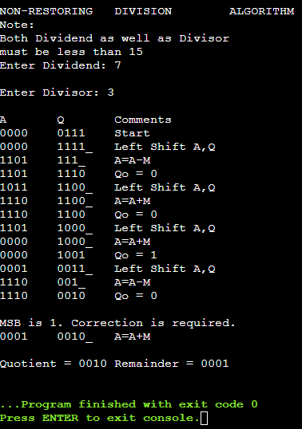

**Conclusion**

Thus, in this experiment, the concept of Non Restoring Division has been learnt and implemented in C language. This algorithm is used in the Arithmetic and Logic Unit of the CPU’s in order to compute the quotient of two numbers in an efficient manner.

**Post Lab Descriptive Questions**

1. **What are the advantages of non restoring division over restoring division?**

Ans. The advantage of using non-restoring division over restoring division is that it involves only one decision and addition/subtraction per quotient bit. In other words, the restore step is removed. Due to this, the number of operations are reduced to half. Because of the reduction in the number of operations, the execution speed and memory efficiency of the algorithm is higher.

**Date: __10-11-22___ Signature of faculty in-charge**