**Experiment / Assignment / Tutorial No. ___1___**

**Grade: AA / AB / BB / BC / CC / CD /DD**

**Signature of the Staff In-charge with date**

|  |
| --- |
| **Batch: B3 Roll No.: 121 Experiment / assignment / tutorial No.: 1** |

|  |
| --- |
| **Title:** Basic Gates & Universal Gates |

**_____________________________________________________________________________________**

**Objective:** To study the basic gates: AND, OR, NOT and universal gates: NAND, NOR, XOR, XNOR

**_____________________________________________________________________________**

**Expected Outcome of Experiment:**

**CO1:** Recall basic gates and binary, octal & hexadecimal calculations and conversions.

**_____________________________________________________________________________**

**Books/ Journals/ Websites referred:**

* Vlab Link: [http://vlabs.iitkgp.ernet.in/dec/#](http://vlabs.iitkgp.ernet.in/dec/)
* R. P. Jain, “Modern Digital Electronics”, Tata McGraw Hill
* http://www.ee.surrey.ac.uk/Projects/Labview/gatesfunc/
* http://www.electronics-tutorials.ws/boolean/bool_6.html

**Pre Lab/ Prior Concepts:**

Gate is a logic circuit with one or more inputs but only one output. Gates are digital (two state) circuit because the input & output are either low or high. Gates provide high output for certain combinations of input & for other combinations the output is low. Total number of combinations for a gate is 2^n; where n is number of input.

**Classification:** The two types of gate are:

1. **Basic or Fundamental Gates:** 
   1. AND gate
   2. OR gate
   3. NOT gate
2. **Derived Gates:** 
   1. NAND gate
   2. NOR gate
   3. X-OR gate
   4. X-NOR gate

**Symbols of gates**

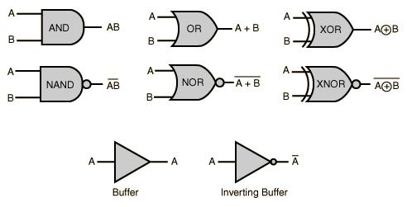

|  |  |
| --- | --- |
| **Type of IC**  IC 7400 …………………  IC 7402 ……………………  IC 7404 …………………  IC 7408 ……………………..  IC 7432 …………………..  IC 7486 …………………..  IC 74266 …………………… | **Specification**  NAND Gate  NOR Gate  NOT Gate  AND Gate  OR Gate  X-OR Gate  X-NOR Gate |

**Implementation Details:**

**Basic Gates**

1. **OR gate:** The OR gate has two or more inputs but only 1 output. If any or all the inputs are high, the output is high. If all the inputs are low, the output is low.

Y= A + B

**Symbol for OR gate** **Pin Diagram For IC 7432**

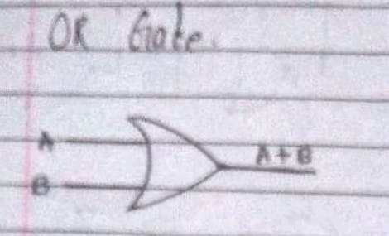 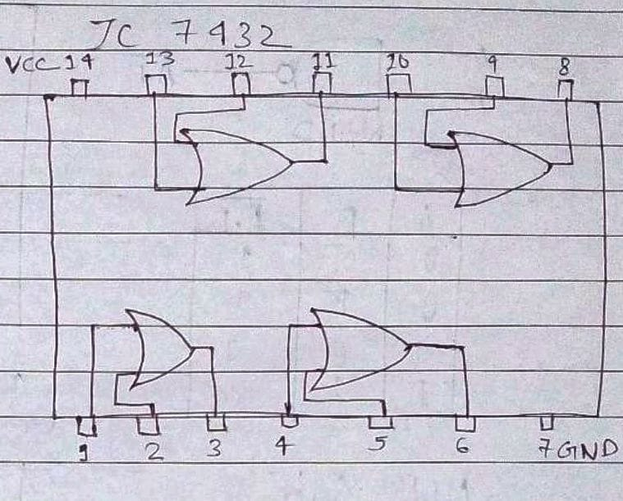

The truth table for OR operations are:

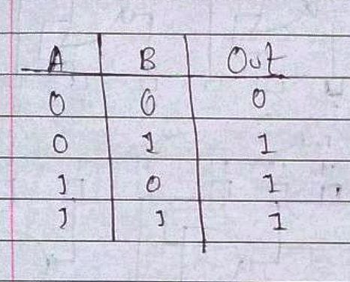

1. **AND gate:** The AND gate has two or more inputs but only one output. If all inputs are high then output is high.

Y= A.B

**Symbol for AND gate** **Pin Diagram For IC 7408**

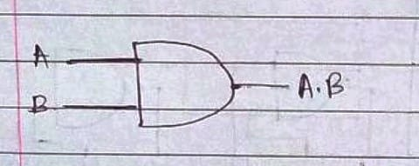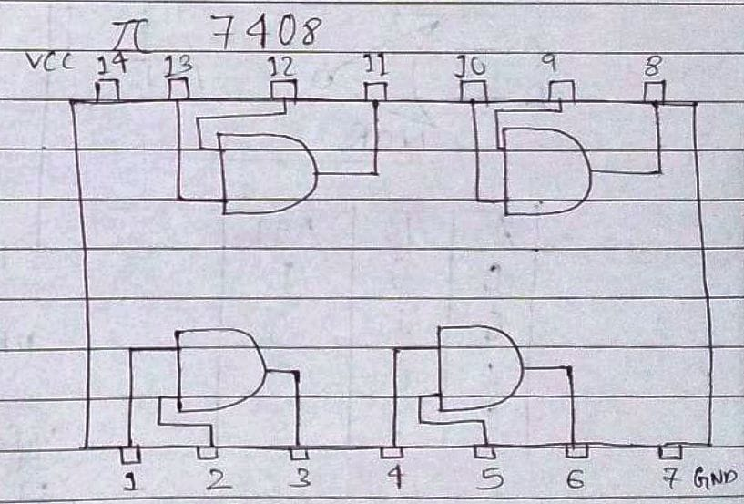

The truth table for AND operations are:

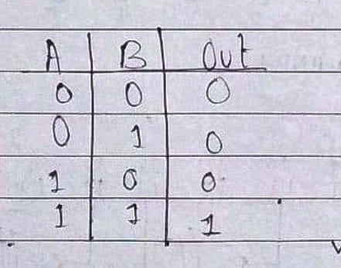

1. **NOT gate:** The Not gate is a gate with only one input and one output. The output is always in opposite state of an input. A NOT gate is also called as Inverter because it performs inversion.

Y= not A

**Symbol for NOT gate** **Pin Diagram For IC 7404**

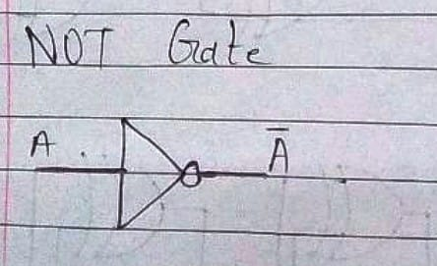

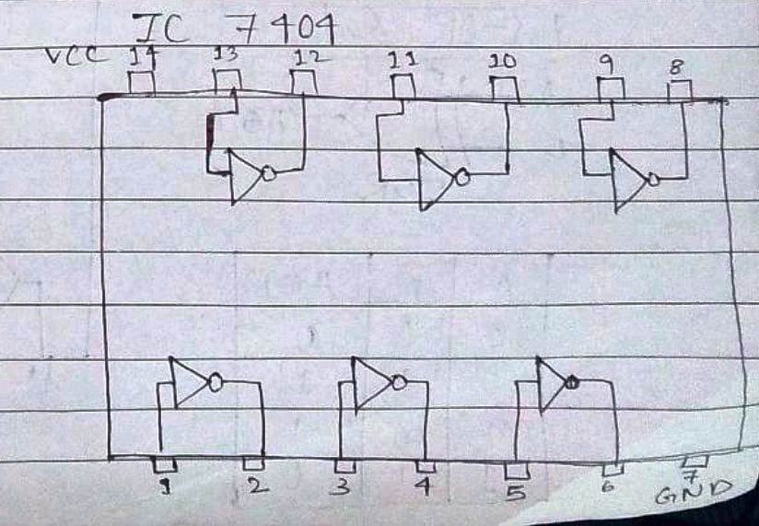

The truth table for NOT operations is:

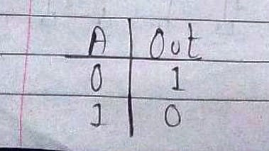

**Derived Gates/Universal Gates**

* + NAND gate
  + NOR gate
  + EX-OR gate
  + EX-NOR gate

1. **NAND gate:** This is a NOT-AND gate which is equal to an AND gate followed by a NOT gate. The outputs of all NAND gates are high if any of the inputs are low. The symbol is an AND gate with a small circle on the output. The small circle represents inversion.

Y=

**Symbol Pin Diagram for IC 7400**

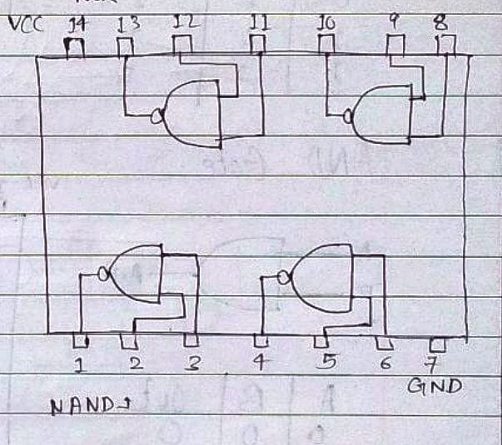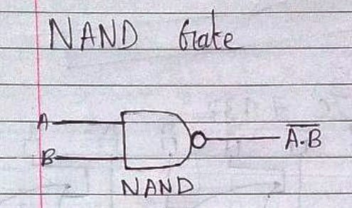

The truth table for NAND operations is: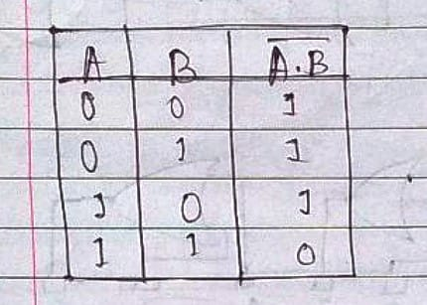

1. **NOR gate:** This is a NOT-OR gate which is equal to an OR gate followed by a NOT gate. The outputs of all NOR gates are low if any of the inputs are high. The symbol is an OR gate with a small circle on the output. The small circle represents inversion.

Y=

**Symbol for NOR gate** **Pin Diagram For IC 7402**

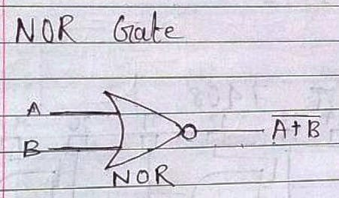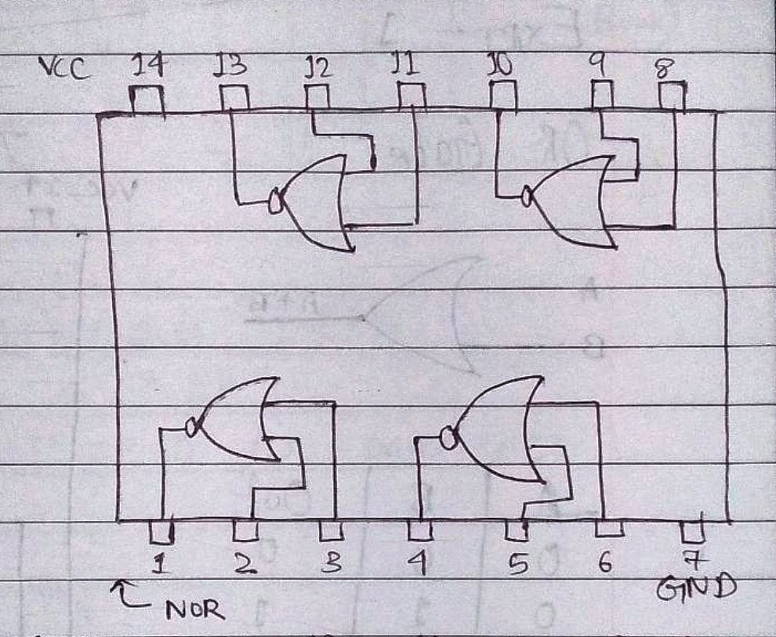

The truth table for NOR operations are: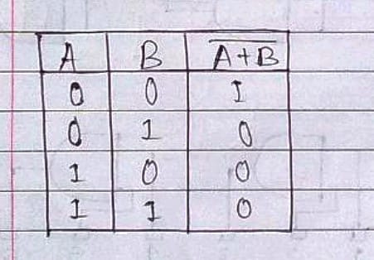



1. **EX-OR gate**: The 'Exclusive-OR' gate is a circuit which will give a high output if either, but not both, of its two inputs are high. An encircled plus sign ( ) is used to show the EX-OR operation

Y=

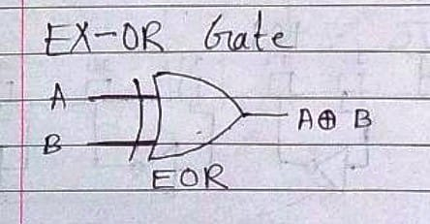**Symbol for Ex-OR gate** **Pin Diagram For IC 7486**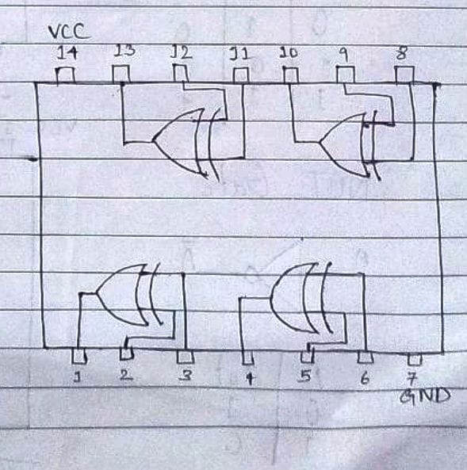

The truth table for XOR operations is: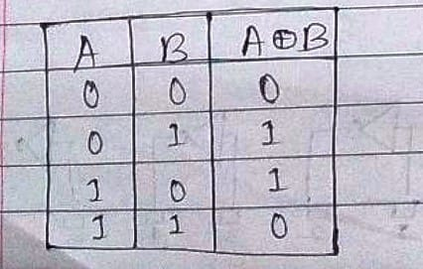

1. **EX-NOR gate**: The 'Exclusive-NOR' gate circuit does the opposite to the EOR gate. It will give a low output if either, but not both, of its two inputs are high. The symbol is an EXOR gate with a small circle on the output. The small circle represents inversion

Y=

**Symbol for Ex-NOR gate**

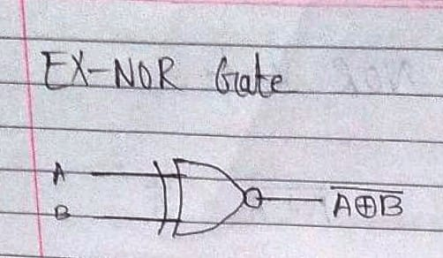

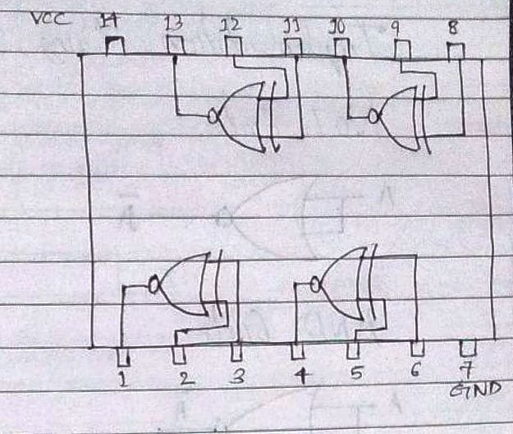

The truth table for XNOR operations is: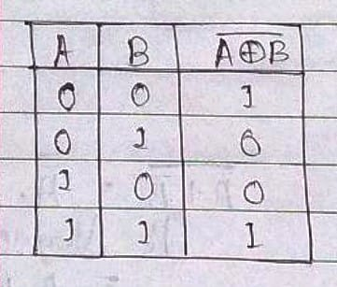

**Implementation Using NAND Gate**

**NOT GATE STEPS**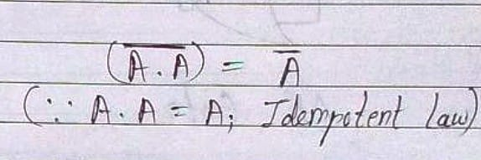

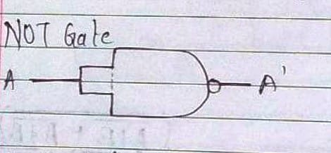

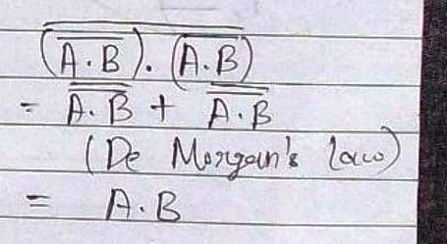**AND GATE**

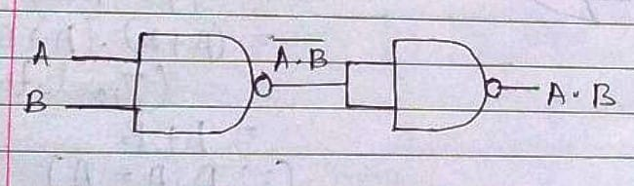

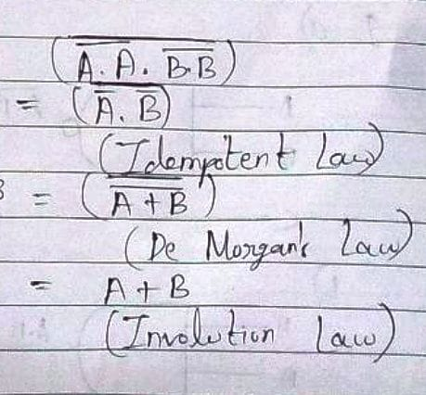**OR GATE**

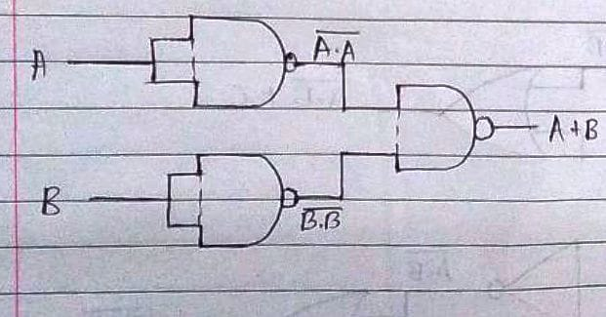

**IMPLEMENTATION USING NOR GATE**

**NOT GATE STEPS**

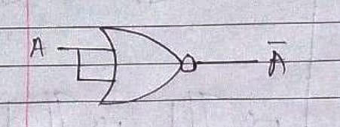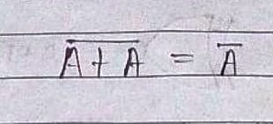

**AND GATE**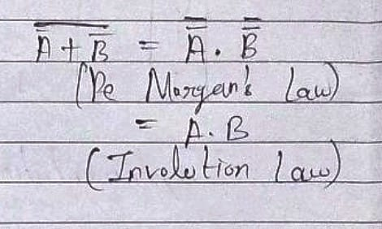

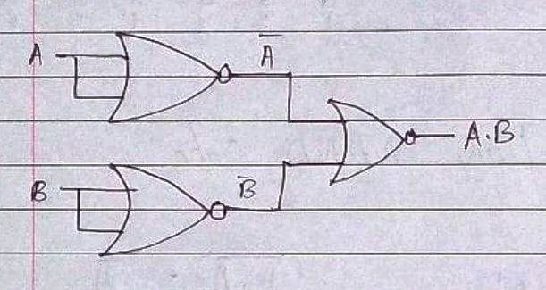

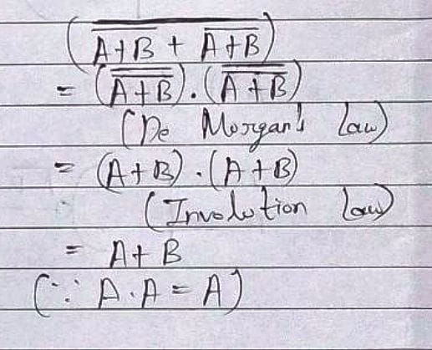**OR GATE**

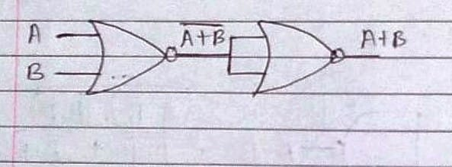

**Conclusion:**

Thus, in this experiment, the three basic and four derived logic gates have been worked with. Their symbols, truth tables and IC circuits have been shown. Using the Universal gates, i.e, the NAND and NOR gates, the basic gates can be constructed. The logic gates control the flow of signals based on the condition of one or more input signals and are thus used in electronic circuits to build computer machines.

**Post Lab Descriptive Questions**

1. Verify the expression (A∙B)' + C by:
2. Using NAND Gate directly.
3. Using AND & NOT gate consecutively.

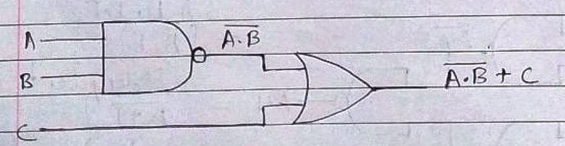

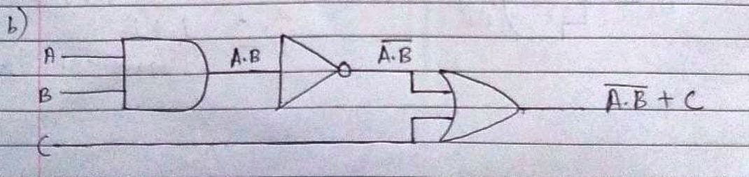

1. Implement the following expressions using combination of gates:
2. (A'+B)∙B
3. (A∙B)+A'
4. A∙ (B∙B')
5. (A'⊕B)∙A

