**Experiment / Assignment / Tutorial No. __3__**

**Grade: AA / AB / BB / BC / CC / CD /DD**

**Signature of the Staff In-charge with date**

**Experiment / Assignment / Tutorial No. _______**

**Grade: AA / AB / BB / BC / CC / CD /DD**

**Signature of the Staff In-charge with date**

|  |
| --- |
| **Batch: B3 Roll No.: 121 Experiment / assignment / tutorial No.: 3** |

|  |
| --- |
| **Title:** Design 4:1 Multiplexer and 1: 4 De-multiplexer |

**______________________________________________________________________________**

**Objective:** To design and implement a 4:1 multiplexer and 1:4 de-multiplexer using logic gates and MUX IC

**______________________________________________________________________________**

**Expected Outcome of Experiment:**

**CO2:** Use different minimization technique and solve combinational circuits, synchronous & asynchronous sequential circuits.

**______________________________________________________________________________**

**Books/ Journals/ Websites referred:**

* VLab Links: <http://vlabs.iitb.ac.in/vlabs-dev/labs/dldesignlab/experimentlist.html>
* R. P. Jain, “Modern Digital Electronics”, Tata McGraw Hill
* M .Morris Mano, “Digital Logic & computer Design”, PHI
* [https://wiki.engr.illinois.edu/download/attachments/84770821/08](https://wiki.engr.illinois.edu/download/attachments/84770821/08-Multiplexers.pdf?version=2&modificationDate=1285128827000)- [Multiplexers.pdf?version=2&modificationDate=128512882700](https://wiki.engr.illinois.edu/download/attachments/84770821/08-Multiplexers.pdf?version=2&modificationDate=1285128827000)0

**Pre Lab/ Prior Concepts:**

**Multiplexer:** Multiplexer is a special type of combinational circuit. It is a digital circuitwhich selects one of the n data inputs and routes it to the output. The selection of one of the n inputs is done by the select lines. To select n inputs we require m select lines, such that 2m=n. Depending on the digital code applied at the select inputs, one out of the n data sources is selected and transmitted to a single output . E is called as the strobe or enable input which is useful for cascading. It is generally on active low terminal that means it will perform the required operation when it is low. The multiplexer act like a digitally controlled single pole, multiple way switches. The output gets connected to only one input at a time. In most of the electronic system the digital data is available on more than one line. It is necessary to route the data over a single line, under such circumstances input at a time

**Types of Multiplexer:**

1. 2:1 Multiplexer
2. 4:1 Multiplexer
3. 8:1 Multiplexer
4. 16:1 Multiplexer
5. 32:1 Multiplexer

**De-multiplexer:** It has only one input, n output and m select lines. A demultiplexerperforms the reverse operation of a multiplexer i.e. it receives one input and distributes it over several outputs. The demultiplexer converts a serial data signal at the input to a parallel data at its output lines. The relation between the output lines and select lines is as follows: N=2m

**Types of Demultiplexers:**

1. 1:2 DEMUX
2. 1:4 DEMUX
3. 1:8 DEMUX
4. 1:16 DEMUX

**Implementation Details of 4:1 MUX**

**Block Diagram of 4:1 MUX**

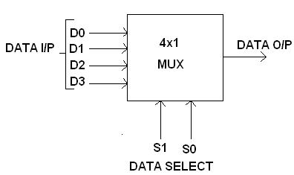

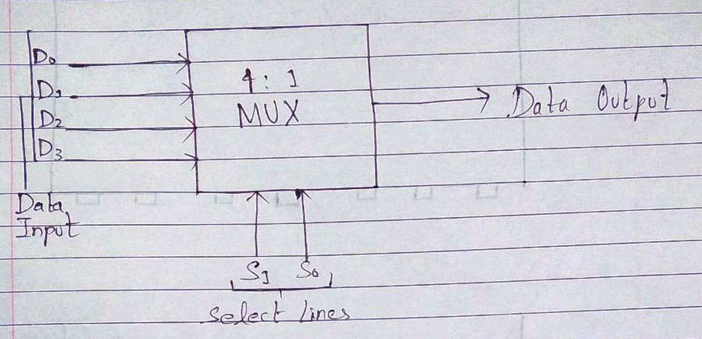

**Circuit Diagram of 4:1 MUX**

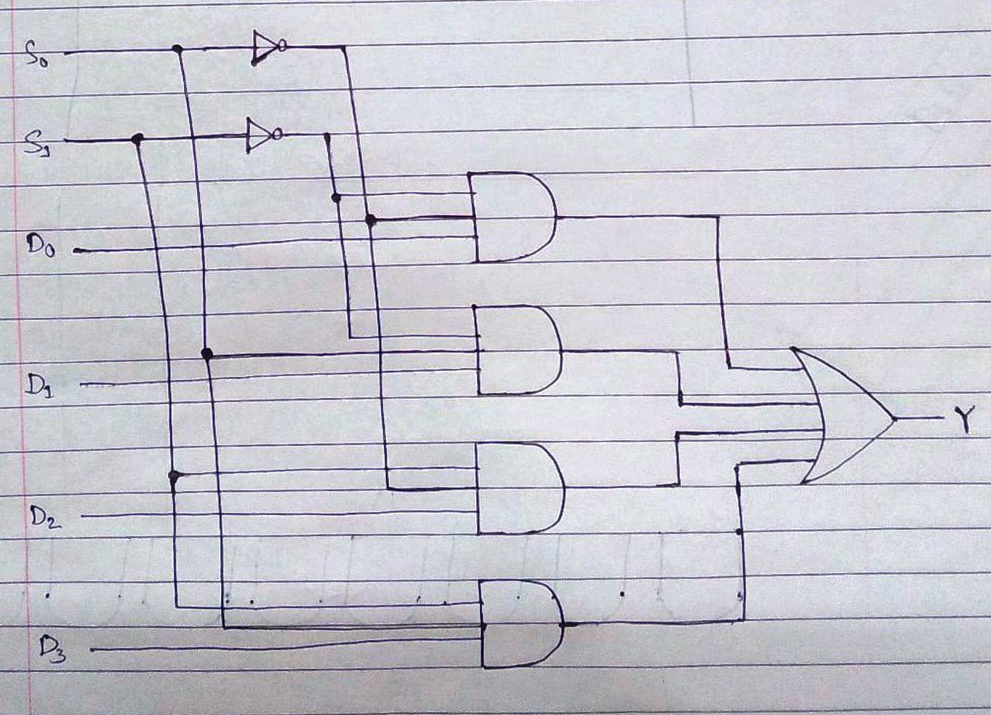

**Truth table**

|  |  |  |
| --- | --- | --- |
| **S1** | **S0** | **Y** |
|  |  |  |
| 0 | 0 | D0 |
|  |  |  |
| 0 | 1 | D1 |
|  |  |  |
| 1 | 0 | D2 |
|  |  |  |
| 1 | 1 | D3 |
|  |  |  |
|  |  |  |

**From Truth Table:**

Y = S1’S0’D0 + S1’S0D1 + S1S0’D2 + S1S0D3

**Implementation Details of 8:1 MUX**

**Circuit Diagram of 8:1 MUX**

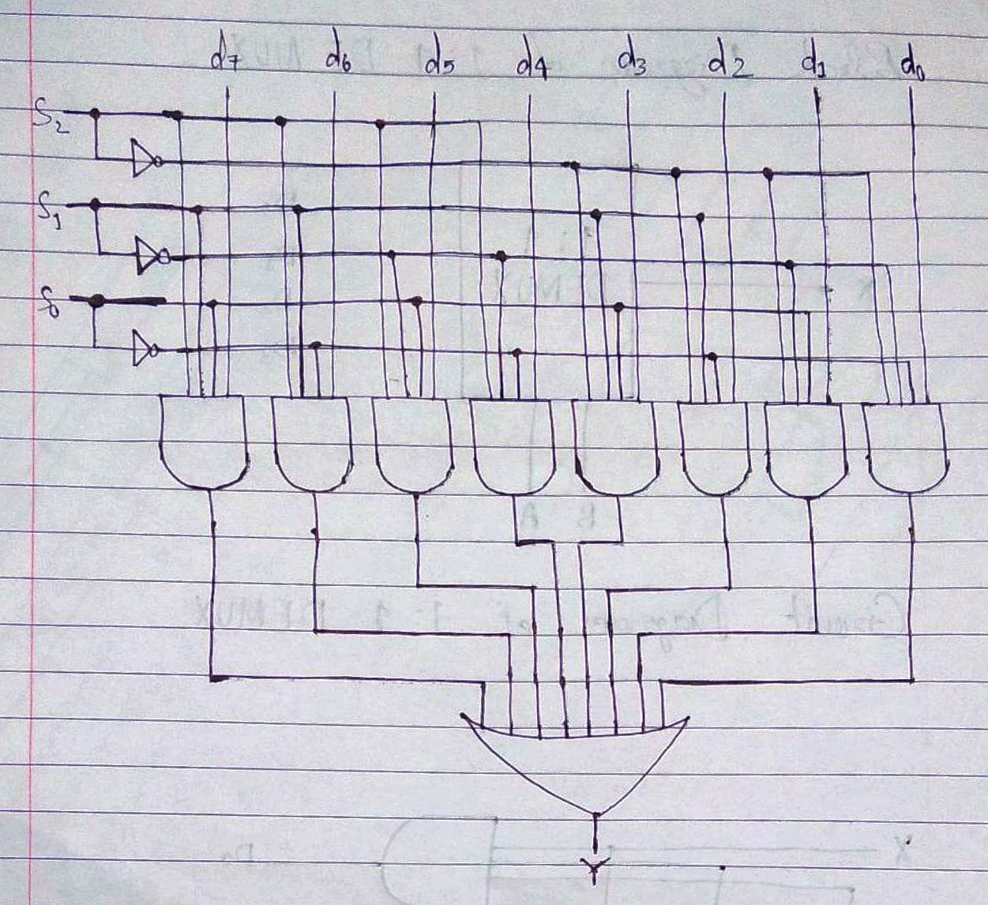

**Truth Table for 8:1 Multiplexer**

|  |  |  |  |
| --- | --- | --- | --- |
| **S2** | **S1** | **S0** | **Y** |
|  |  |  |  |
| 0 | 0 |  | d0 |
|  |  | 0 |  |
| 0 | 0 | 1 | d1 |
|  |  |  |  |
| 0 | 1 | 0 | d2 |
|  |  |  |  |
| 0 | 1 | 1 | d3 |
| 1 | 0 | 0 | d4 |
| 1 | 0 | 1 | d5 |
| 1 | 1 | 0 | d6 |
| 1 | 1 | 1 | d7 |
|  |  |  |  |
|  |  |  |  |

**From Truth Table:**

**Y =** S2’S1’S0’d0 + S2’S1’S0d1 + S2’S1S0’d2 + S2’S1S0d3 + S2S1’S0’d4 + S2S1’S0d5 + S2S1S0’d6 + S2S1S0d7

**Pin diagram: IC 74151**

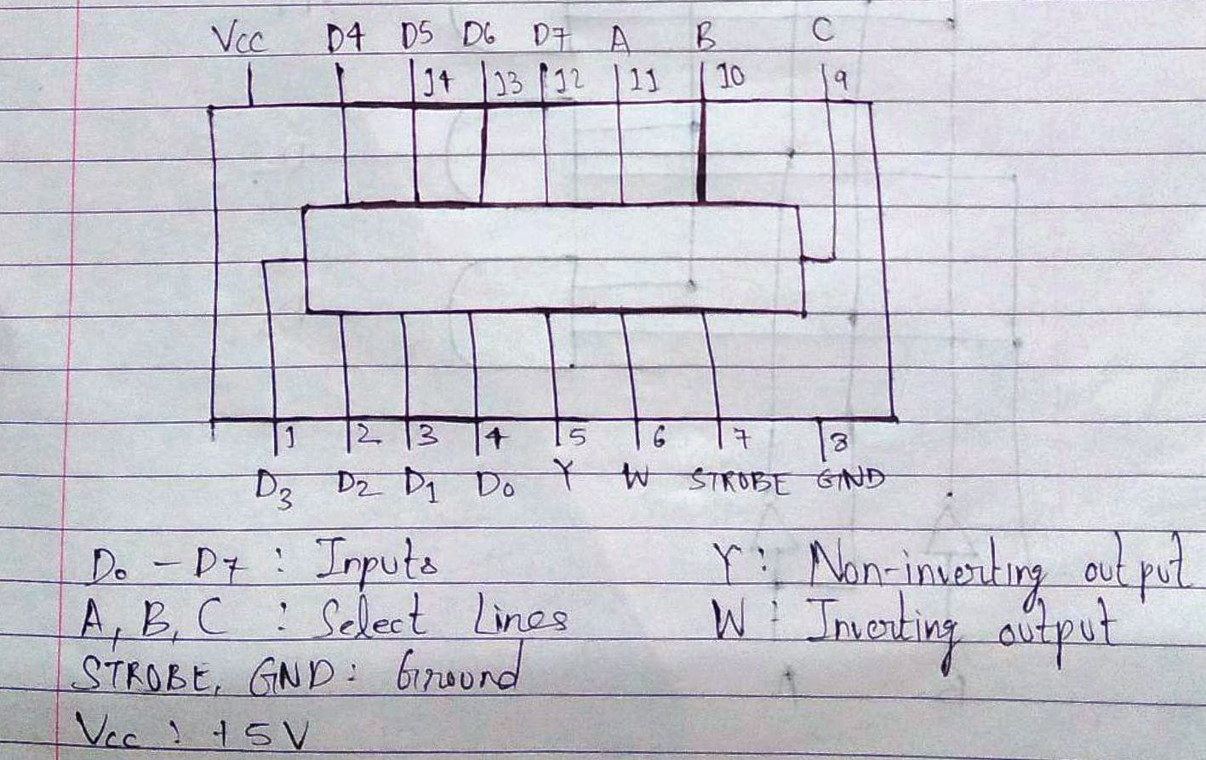

**Block Diagram of 1:4 DE MUX**

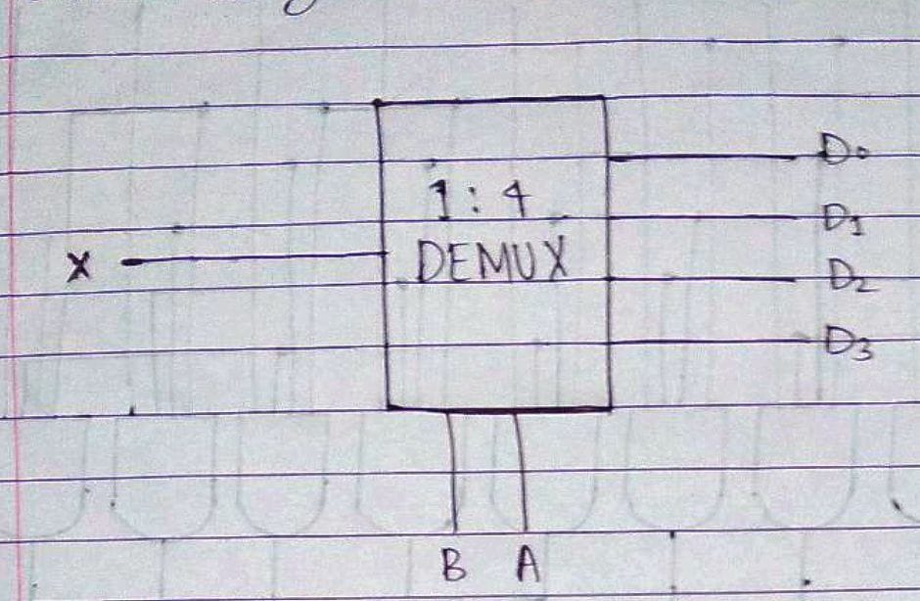

**Circuit Diagram of 1:4 DE MUX**

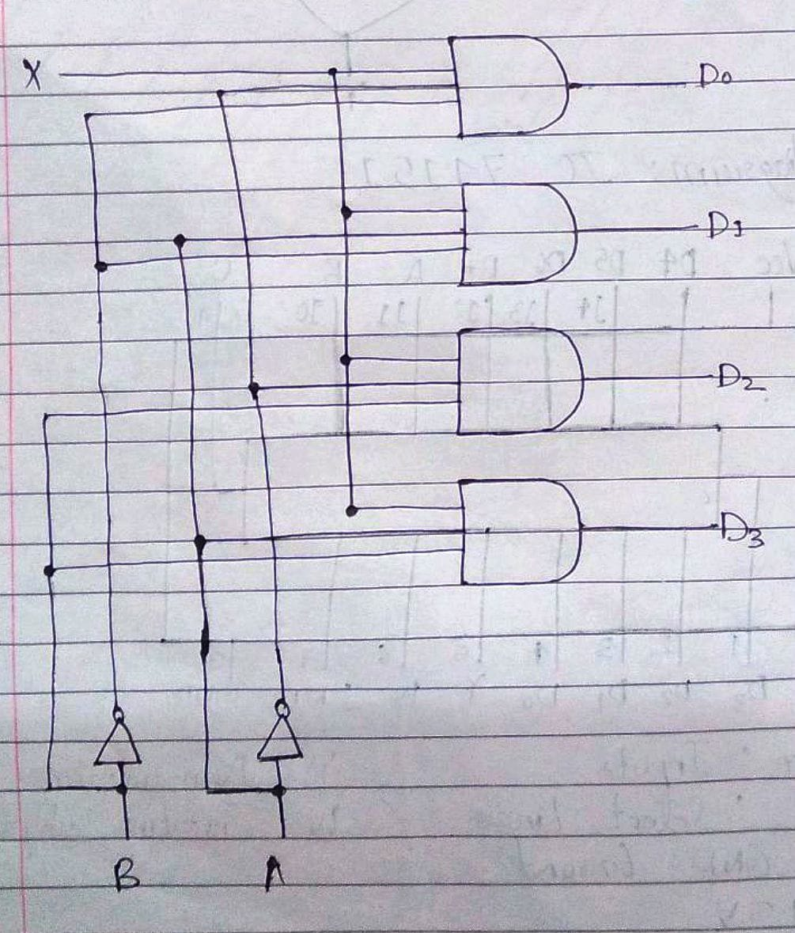

**Truth Table for 1:4 Demultiplexers**

|  |  |  |  |  |  |
| --- | --- | --- | --- | --- | --- |
| **A** | **B** | **D0** | **D1** | **D2** | **D3** |
|  |  |  |  |  |  |
| 0 | 0 | X | 0 | 0 | 0 |
|  |  |  |  |  |  |
| 0 | 1 | 0 | X | 0 | 0 |
|  |  |  |  |  |  |
| 1 | 0 | 0 | 0 | X | 0 |
|  |  |  |  |  |  |
| 1 | 1 | 0 | 0 | 0 | X |
|  |  |  |  |  |  |
|  |  |  |  |  |  |

**From Truth Table:**

D0 = A’B’X

D1 = A’BX

D2 = AB’X

D3 = ABX

**Conclusion:** Thus, in this experiment, the working of Multiplexers and Demultiplexers, their functions, types and truth tables was learnt and the same was executed using the IC Board.

**Post Lab Descriptive Questions**

1. How many select lines are required for 64:1 MUX?

Ans. Given: Number of input lines, n = 64

To find: Number of selection lines, m.

Formula for Multiplexer: 2m = n.

Hence, 6 select lines are required for 64:1 MUX.

1. State some applications of MUX and DEMUX.
   1. The applications of Multiplexer (MUX) are:
      1. Multiplexers are used in various applications where multiple data needs to be transmitted over a single line.
      2. Multiplexers are used in computer memory to maintain a huge amount of memory in computers and to reduce the number of copper lines required.
      3. In telephone networks, multiple audio signals are integrated to a single line of transmission with the help of a multiplexer.
      4. Multiplexer is used in the implementation of combinational circuits.
   2. The applications of Demultiplexer (DE MUX) are:
      1. A demultiplexer is used to divide the mutual signals back into separate streams.
      2. Demux is used as a decoder within the security system of banking sector.
      3. The output of the Arithmetic and Logic Unit (ALU) of the CPU is fed to the input of the Demux, and the output of the Demux is connected to multiple registers. Thus, the output of the ALU can be stored in multiple registers.
      4. In a communication system, a Demultiplexer receives the output signals from the Multiplexer, at the receiver’s end, and converts those signals back to original form.
2. Build a 4:1 MUX using only 2:1 MUX.

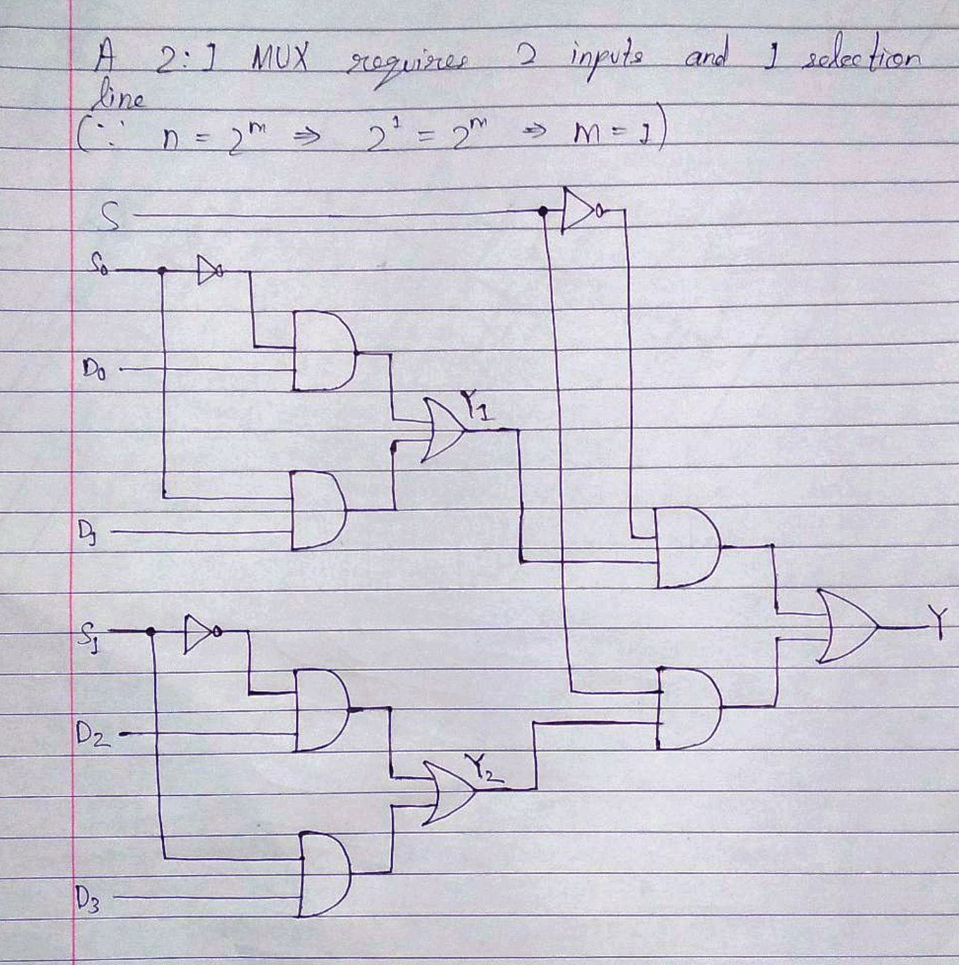Ans.