**Batch: B3 Roll No.: 121**

**Experiment / assignment / tutorial No. 02**

**Grade: AA / AB / BB / BC / CC / CD /DD**

**Signature of the Staff In-charge with date**

|  |
| --- |
| **TITLE : Control Statement** |

**AIM:** Create a class myMath. The class contains the following static methods.

i) power (x, y) – to compute x y

ii) fact (x) – to compute x!

Write a program to find the following series.

* ex = 1 +(x/1!)+ (x2/2!) + (x3/3!) + (x4/4!) + … upto n terms (n given by user).
* (1+x)n = 1 +(nx/1!)+ ((n(n-1)x2)/2!) ........ upto n terms (n given by user).

**(Do not make use of inbuilt functions. Use the functions of user defined class MyMath.)**

**_____________________________________________________________________**

**Expected OUTCOME of Experiment:**

**CO2:** Explore arrays, vectors, classes and objects in C++ and Java.

**______________________________________________________________________**

**Books/ Journals/ Websites referred:**

1. E. Balagurusamy , “Programming with Java” McGraw-Hill.
2. Sachin Malhotra, Saurabh Choudhary, “Programming in Java”, Oxford Publications.

**_____________________________________________________________________**

**Pre Lab/ Prior Concepts**

Java basic constructs (like if else statement, control structures, and data types

Programming languages provide various control structures that allow for more complicated execution paths.

A loop statement allows us to execute a statement or group of statements multiple times and following is the general form of a loop statement in most of the programming languages −

|  |  |
| --- | --- |
| **Sr.No.** | **Loop & Description** |
| 1 | [**while loop**](https://www.tutorialspoint.com/java/java_while_loop.htm)  Repeats a statement or group of statements while a given condition is true. It tests the condition before executing the loop body. |
| 2 | [**for loop**](https://www.tutorialspoint.com/java/java_for_loop.htm)  Execute a sequence of statements multiple times and abbreviates the code that manages the loop variable. |
| 3 | [**do...while loop**](https://www.tutorialspoint.com/java/java_do_while_loop.htm)  Like a while statement, except that it tests the condition at the end of the loop body. |

**Loop Control Statements**

Loop control statements change execution from its normal sequence. When execution leaves a scope, all automatic objects that were created in that scope are destroyed.

Java supports the following control statements. Click the following links to check their details.

|  |  |
| --- | --- |
| **Sr.No.** | **Control Statement & Description** |
| 1 | [**break statement**](https://www.tutorialspoint.com/java/java_break_statement.htm)  Terminates the loop or switch statement and transfers execution to the statement immediately following the loop or switch. |
| 2 | [**continue statement**](https://www.tutorialspoint.com/java/java_continue_statement.htm)  Causes the loop to skip the remainder of its body and immediately retest its condition prior to reiterating. |

**Class Diagram:**

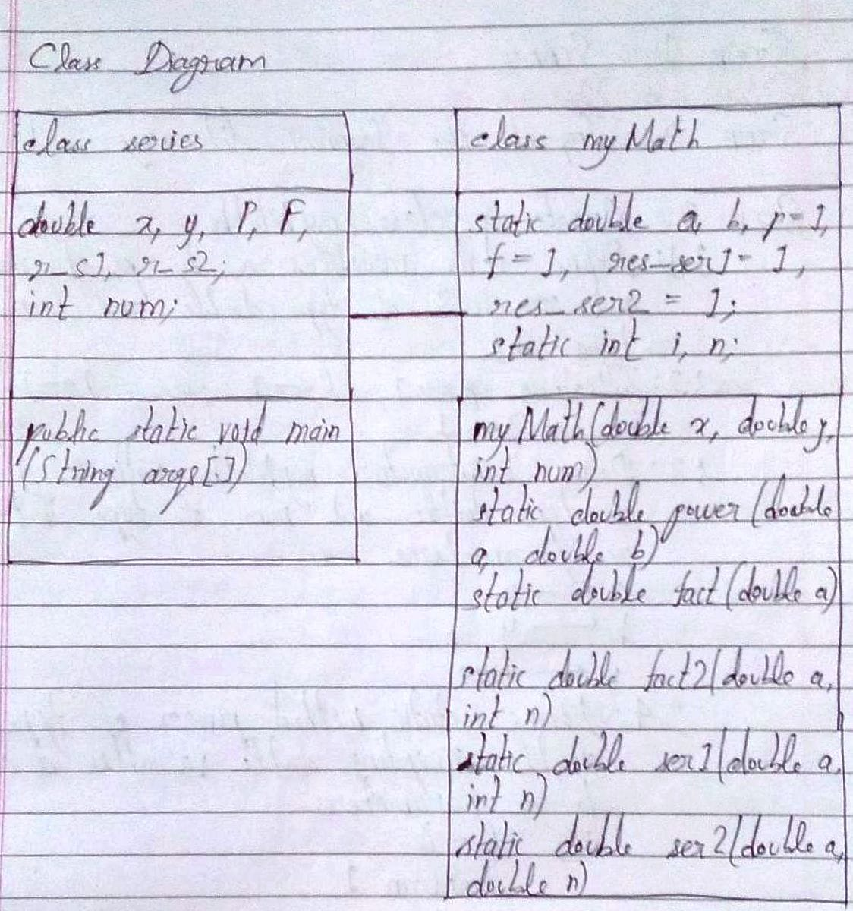

**Algorithm:**

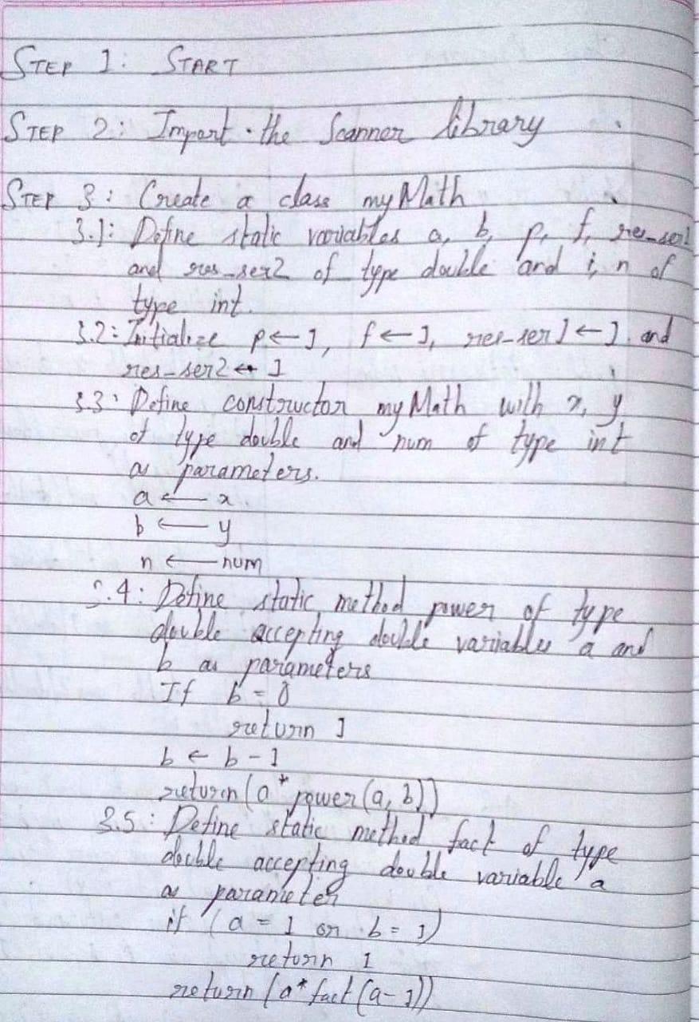

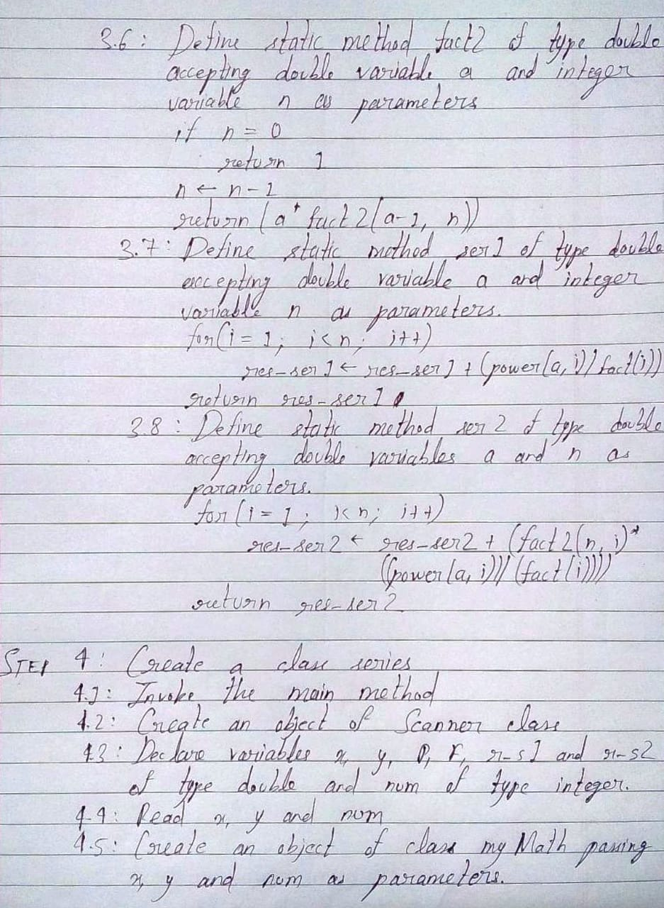

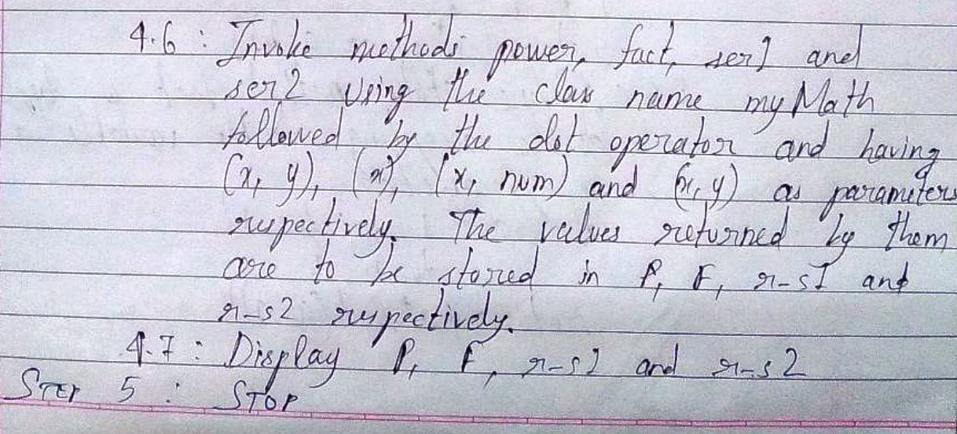

**Implementation details:**

import java.util.*;

class myMath

{

static double a, b, p = 1, f = 1, res_ser1 = 1, res_ser2 = 1;

static int i, n;

myMath(double x, double y, int num)

{

a = x;

b = y;

n = num;

}

static double power(double a, double b)

{

if(b==0)

{

return 1;

}

b--;

return(a*power(a,b));

}

static double fact(double a)

{

if(a==0||a==1)

{

return 1;

}

return(a*fact(a-1));

}

static double fact2(double a, int n)

{

if(n==0)

{

return 1;

}

n--;

return(a*fact2(a-1, n));

}

static double ser1(double a, int n)

{

for(i = 1; i < n; i++)

{

res_ser1 = res_ser1 + (power(a, i)/fact(i));

}

return res_ser1;

}

static double ser2(double a, double n)

{

for(i = 1; i < n; i++)

{

res_ser2 = res_ser2 + (fact2(n, i)*((power(a, i))/(fact(i))));

}

return res_ser2;

}

}

public class series

{

public static void main(String args[])

{

Scanner sc = new Scanner(System.in);

double x, y, P, F, r_s1, r_s2;

int num;

System.out.println("Enter the first number: ");

x = sc.nextDouble();

System.out.println("Enter the second number: ");

y = sc.nextDouble();

System.out.println("Enter the number of terms both series should have: ");

num = sc.nextInt();

myMath ob = new myMath(x, y, num);

P = myMath.power(x, y);

F = myMath.fact(x);

r_s1 = myMath.ser1(x, num);

r_s2 = myMath.ser2(x, y);

System.out.println("The result of "+x+"^"+y+" is: "+P);

System.out.println("The result of "+(int)x+"! is: "+(int)F);

System.out.println("The result of e^x upto "+num+" terms is: "+r_s1);

System.out.println("The result of (1+x)^n upto "+num+" terms is: "+r_s2);

}

}

**Output:**

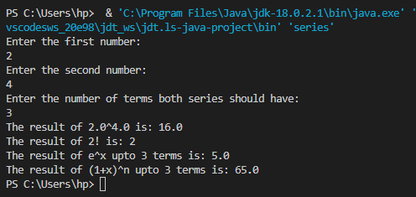

**Conclusion:**

Thus, in this experiment, there has been the application of static methods and loops. It was felt that recursive methods are more suitable to execute than iterative loops, especially in the case where multiple iteration-wise function calls are required for the calculation of sum of a series. The use of classes and objects in this program makes Java an Object Oriented Programming Language.

**Date: __28-09-22__ Signature of faculty in-charge**

**Post Lab Descriptive Questions**

Q.1 Write a program to find the largest of three numbers using the if-else construct.

Ans.

import java.util.*;

class Largest

{

public static void main(String args[])

{

Scanner in = new Scanner(System.in);

int a, b, c;

System.out.println("Enter the first element: ");

a = in.nextInt();

System.out.println("Enter the second element: ");

b = in.nextInt();

System.out.println("Enter the third element: ");

c = in.nextInt();

if(a>b)

{

if(a>c)

System.out.println(a+" is the largest.");

else

System.out.println(c+" is the largest.");

}

else

{

if(b>c)

System.out.println(b+" is the largest.");

else

System.out.println(c+" is the largest.");

}

}

}

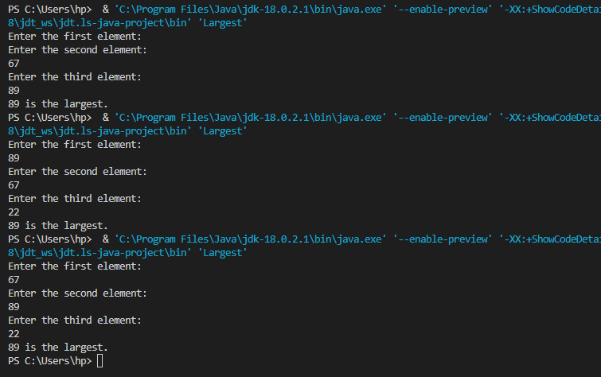

Q.2 Write a program to determine the sum of the following series for a given value of n:

1+½+⅓+....+1/n

Ans.

import java.util.*;

class calculate

{

int i, N;

double S = 0;

calculate(int N)

{

this.N = N;

}

void series()

{

for(i = 1; i <= N; i++)

{

S = S + (double)1/i;

}

System.out.println("The sum of the series is: "+S);

}

}

class EXPT_2_PLDQ_2

{

public static void main(String args[])

{

Scanner in = new Scanner(System.in);

int n;

System.out.println("Enter the number of terms in the series: ");

n = in.nextInt();

calculate ob = new calculate(n);

ob.series();

}

}

