**Batch: B3 Roll No.: 121**

**Experiment / assignment / tutorial No. 03**

**Grade: AA / AB / BB / BC / CC / CD /DD**

**Signature of the Staff In-charge with date**

|  |
| --- |
| **TITLE :Multi-dimensional Arrays (Jagged Array)** |

**AIM:** Write a program which stores information about n players in a two dimensional array. The array should contain the number of rows equal to the number of players. Each row will have a number of columns equal to the number of matches played by that player which may vary from player to player. The program should display player number (index +1), runs scored in all matches and its batting average as output. (It is expected to assign columns to each row dynamically after getting value from the user.

**_____________________________________________________________________**

**Expected OUTCOME of Experiment:**

**CO2:** Explore arrays, vectors, classes and objects in C++ and Java.

**______________________________________________________________________**

**Books/ Journals/ Websites referred:**

1. E. Balagurusamy , “Programming with Java” McGraw-Hill.
2. Sachin Malhotra, Saurabh Choudhary, “Programming in Java”, Oxford Publications.

**_____________________________________________________________________**

**Pre Lab/ Prior Concepts:**

Arrays

**Multi-Dimensional Array**:

10 12 43 11 22

20 45 56 1 33

30 67 32 14 44

40 12 87 14 55

50 86 66 13 66

60 53 44 12 11

A multi-dimensional array is one that can hold all the values above. You set them up like this:

**int[ ][ ] numbers = new int[**6**][**5**];**

The first set of square brackets is for the rows and the second set of square brackets is for the columns. In the above line of code, we're telling Java to set up an array with 6 rows and 5 columns.

aryNumbers[0][0] = 10;  
aryNumbers[0][1] = 12;  
aryNumbers[0][2] = 43;  
aryNumbers[0][3] = 11;  
aryNumbers[0][4] = 22;

So the first row is row 0. The columns then go from 0 to 4, which is 5 items.

**Class Diagram:**

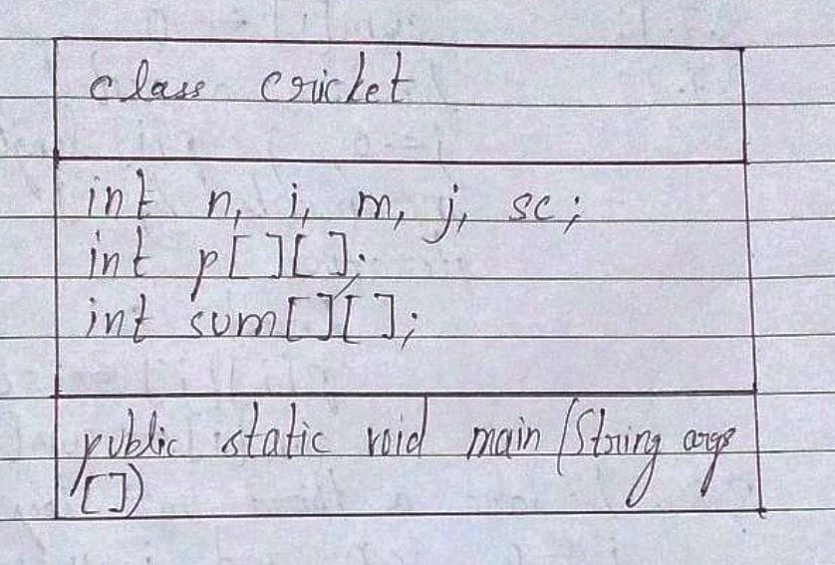

**Algorithm:**

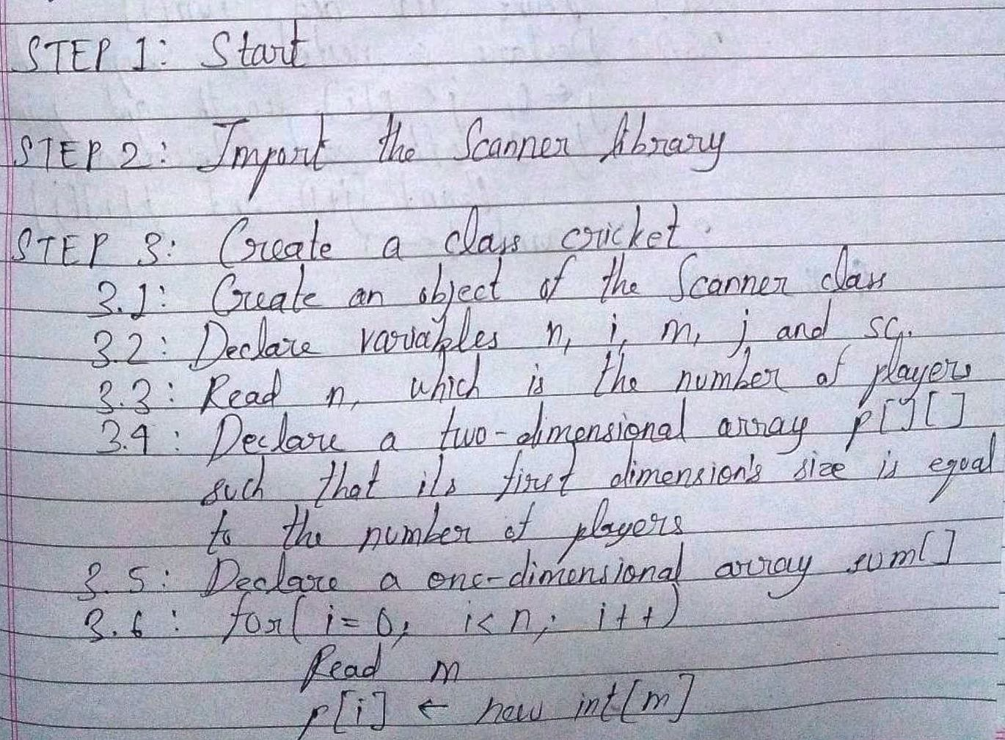

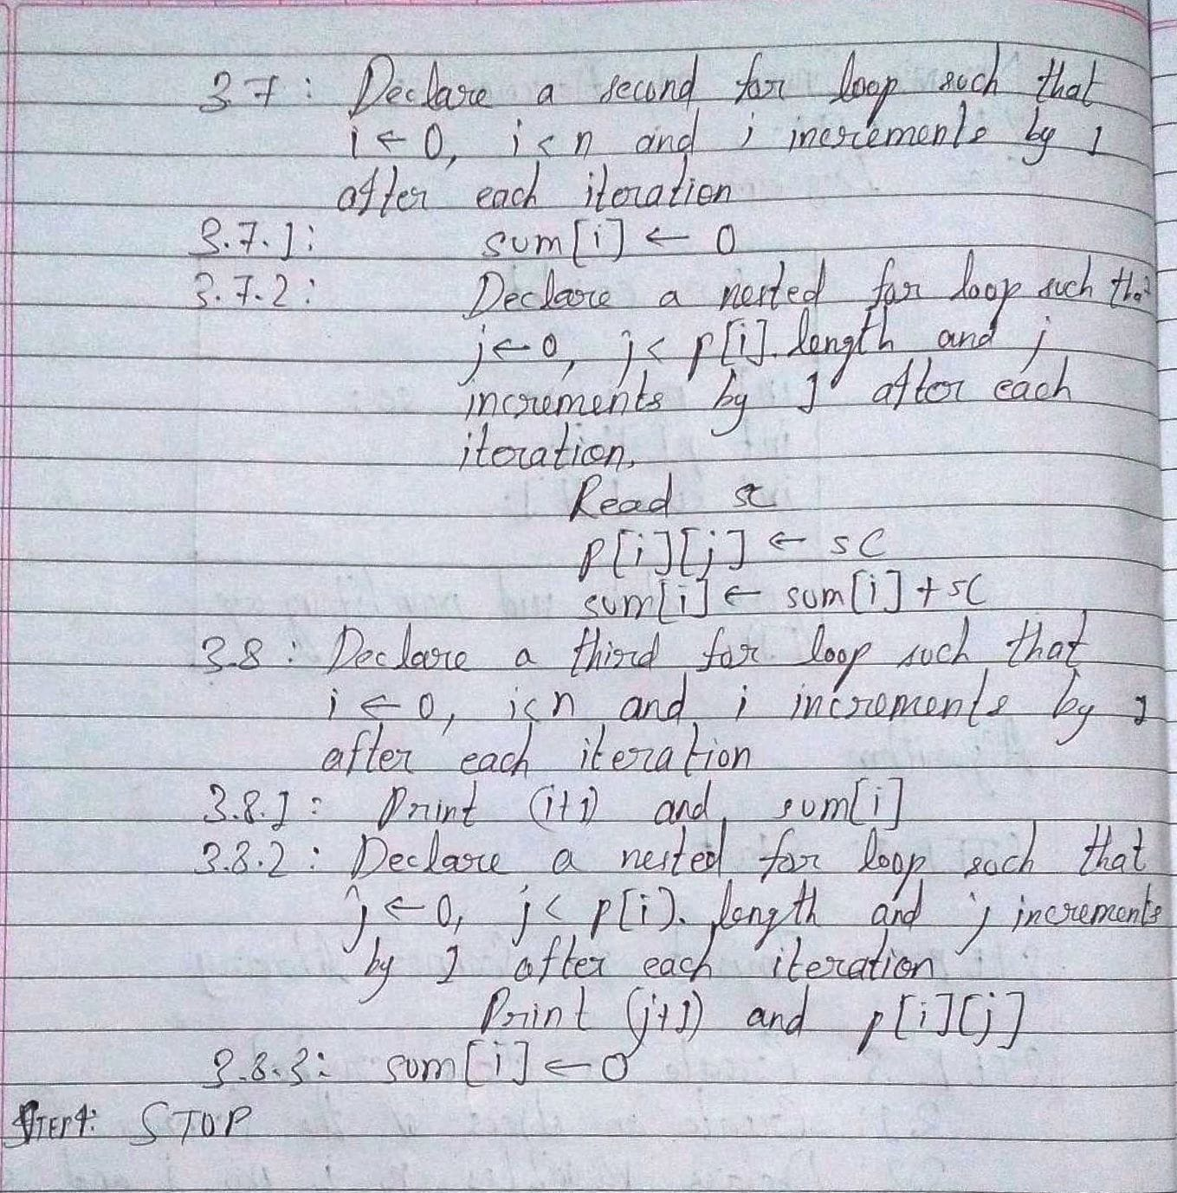

**Implementation details:**

import java.util.*\**;

class cricket

{

    public static *void* main(String *args*[])

    {

        Scanner in = **new** Scanner(System.in);

*int* n, i, m, j, sc;

        System.out.println("Enter the number of players: ");

        n = in.nextInt();

*int* p[][] = **new** *int*[n][];

*int* sum[] = **new** *int*[n];

        for(i = 0; i < n; i++) //the length of array p is n

        {

            System.out.println("Enter the number of matches played by player "+(i+1)+": ");

            m = in.nextInt();

            p[i] = **new** *int*[m];

        }

        for(i = 0; i < n; i++)

        {

            sum[i] = 0;

            for(j = 0; j < p[i].length; j++)

            {

                System.out.println("For match "+(j+1)+" played by player "+(i+1)+", enter the score: ");

                sc = in.nextInt();

                p[i][j] = sc;//ith player, jth match

                sum[i] = sum[i] + sc;//sum of scores scored by ith player

            }

        }

        System.out.println("The entered details are being displayed now: ");

        for(i = 0; i < n; i++)

        {

            System.out.println("Player No.: "+(i+1)+"\tBatting Average: "+sum[i]);

            System.out.println("Runs scored in individual matches are:\nMatch no.\tRuns Scored");

            for(j = 0; j < p[i].length; j++)

            {

                System.out.println((j+1)+"\t\t"+p[i][j]);

            }

            sum[i] = 0;

        }

    }

}

**Output:**

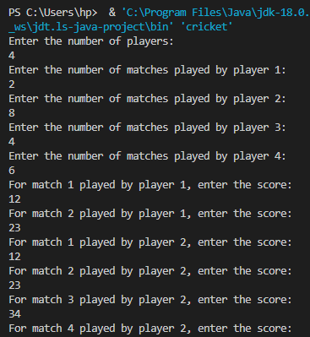

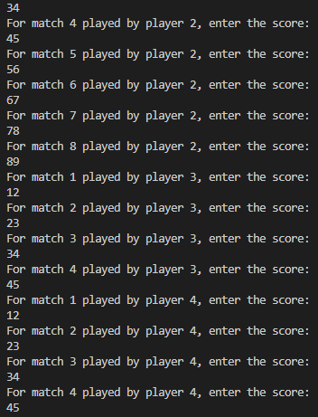

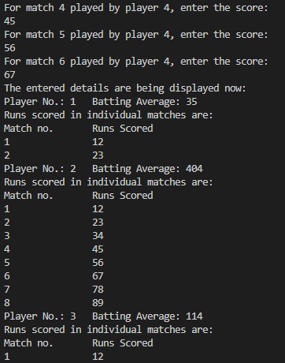

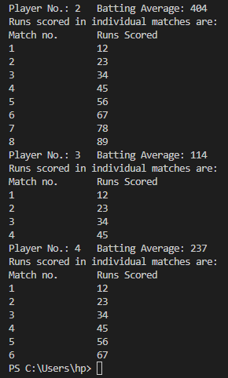

**Conclusion:**

Thus, in this experiment, the concept of jagged arrays have been learnt. Jagged arrays provide flexibility as the size of the arrays can be changed dynamically. Further, jagged arrays provide more operations that can be performed on arrays.

**Date: __04-10-22__ Signature of faculty in-charge**

**Post Lab Descriptive Questions**

**Q.1 Create a jagged array of integers. This array should consist of two 2-D arrays. First 2-D array should contain 3 rows having length of 4,3,and 2 respectively. Second 2-D array should contain 2 rows with length 3 and 4 respectively.**

**Ans.** int A[][][] = new int[2][][];

//first 2D array

A[0][0] = new int[4];

A[0][1] = new int[3];

A[0][2] = new int[2];

//second 2D array

A[1][0] = new int[3];

A[1][1] = new int[4];

**Q.2 Consider the following code**

int number[] = new int[5];

After execution of this statement, which of the following are true?

(A) number[0] is undefined

(B) number[5] is undefined

(C) number[4] is null

(D) number[2] is 0

(E) number.length() is 5

(i) (C) & (E)

(ii) (A) & (E)

(iii) (E)

(iv) (B), (D) & (E)

**Ans:**

(ii) (B), (D) & (E)

**Q.3 Write a program to create an array where ith row has i columns.**

**Ans.**

import java.util.*\**;

class jaggedarray

{

    public static *void* main(String *args*[])

    {

        Scanner in = **new** Scanner(System.in);

*int* i, n, j;

        System.out.println("Enter the value of n: ");

        n = in.nextInt();

*int* ar[][] = **new** *int*[n][];

        for(i = 0; i < n; i++)

        {

            ar[i] = **new** *int*[i];

        }

        for(i = 0; i < n; i++)

        {

            for(j = 0; j < ar[i].length j++)

            {

                ar[i][j] = j;

            }

        }

        for(i = 0; i < n; i++)

        {

            for(j = 0; j < ar[i].length; j++)

            {

                System.out.print("\t"+ar[i][j]);

            }

            System.out.print("\n");

        }

    }

}