**Batch: B3 Roll No.: 121**

**Experiment / assignment / tutorial No. 04**

**Grade: AA / AB / BB / BC / CC / CD /DD**

**Signature of the Staff In-charge with date**

|  |
| --- |
| **TITLE :An Array of Objects** |

**AIM:** Write a program which accepts information about n no of customers from user .Create an array of objects to store account_id ,name,balance.

Your program should provide following functionalities

1. To add account
2. To delete any account detail
3. To display account details.

**_____________________________________________________________________**

**Expected OUTCOME of Experiment:**

**CO1:** Understand the features of object oriented programming compared with procedural approach with C++ and Java

**CO2:** Explore arrays, vectors, classes and objects in C++ and Java.

**______________________________________________________________________**

**Books/ Journals/ Websites referred:**

1. Ralph Bravaco , Shai Simoson , “Java Programing From the Group Up” Tata McGraw-Hill.
2. Grady Booch, Object Oriented Analysis and Design .

**_____________________________________________________________________**

**Pre Lab/ Prior Concepts:**

**Arrays of Objects:**

Unlike traditional array which store values like string, integer, boolean, etc. array of objects stores objects. The array elements store the location of reference variables of the object.

**For example:**

class Student

{  
   int rno;

String name;

float avg;  
}

Student(int r, String name, float average)

{

rno=r;

this.name=name;

avg=average;

}

Student studentArray[] = new Student[n];

* The above statement creates the array which can hold references to n number of Student objects. It doesn't create the Student objects themselves. They have to be created separately using the constructor of the Student class. The studentArray contains n number of memory spaces in which the address of n Student objects may be stored.

for ( int i=0; i<studentArray.length; i++)

{  
studentArray[i]=new Student(r,name,average);

}

* The above for loop creates n Student objects and assigns their reference to the array elements. Now, a statement like the following would be valid.

studentArray[i].r=1001;

.

**Class Diagram:**

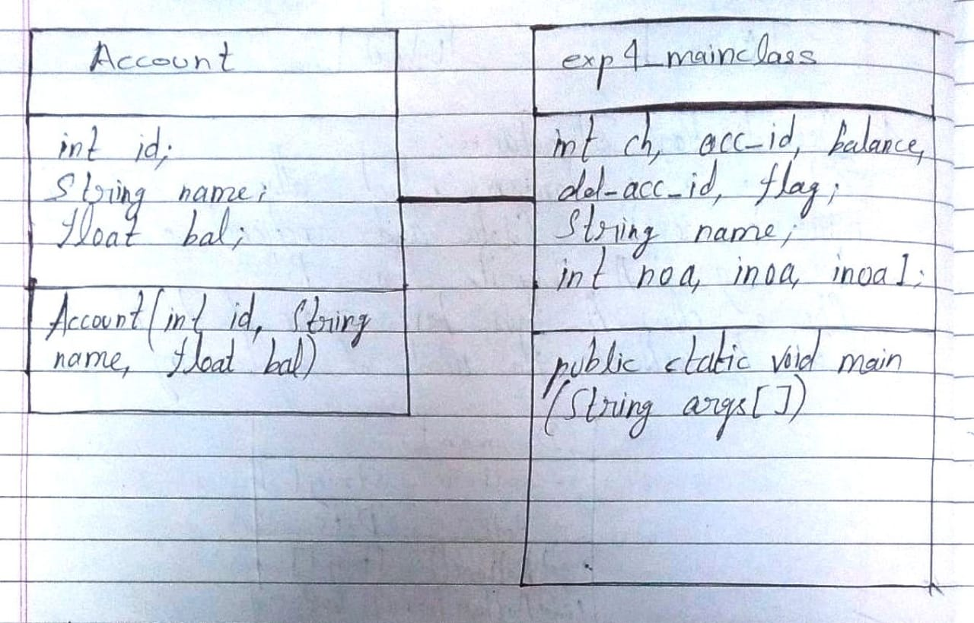

**Algorithm:**

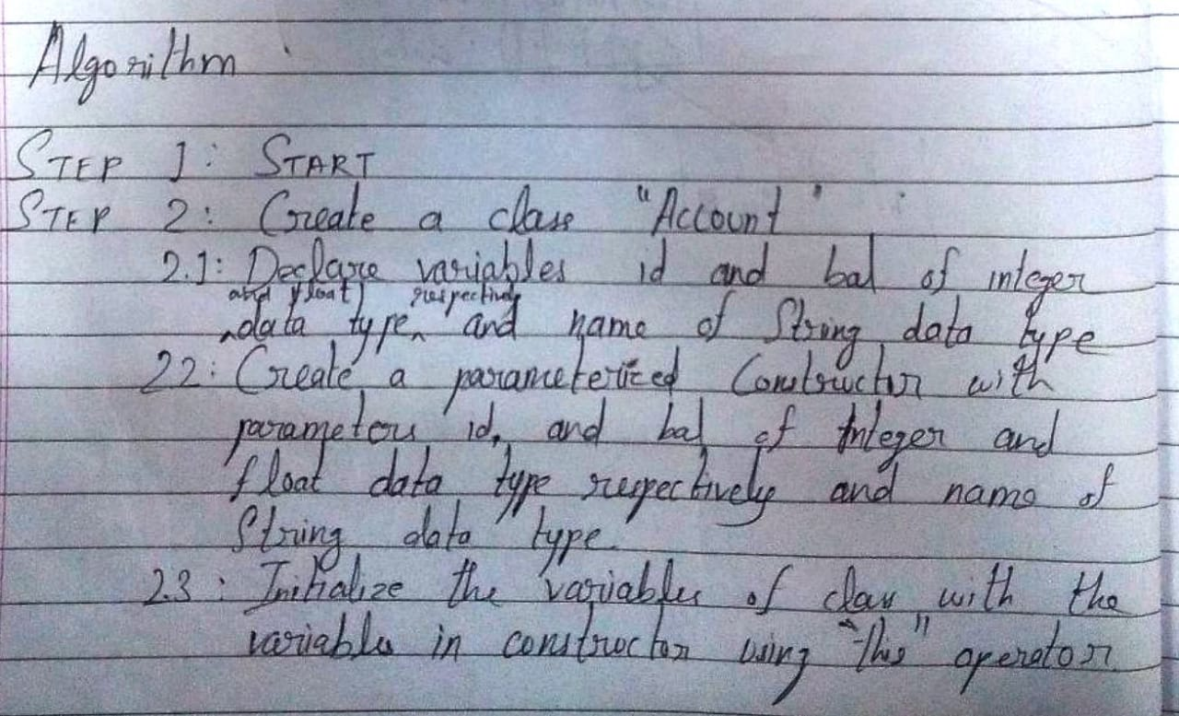

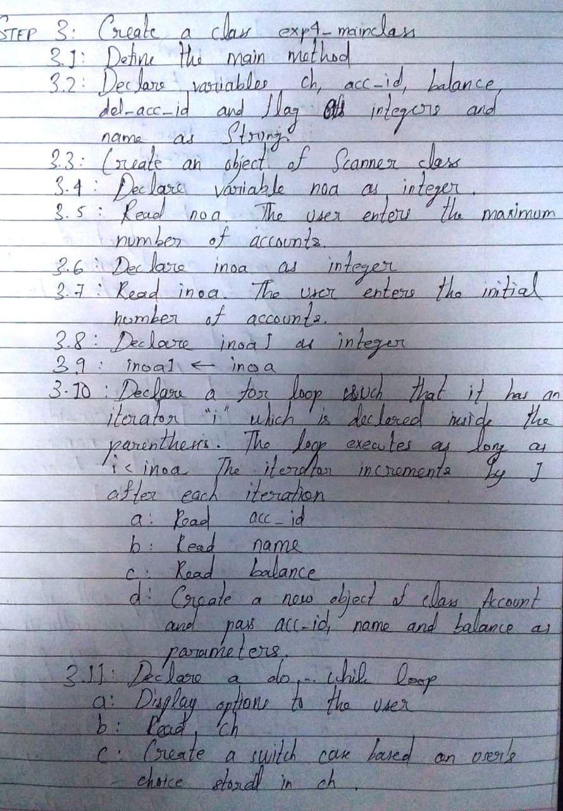

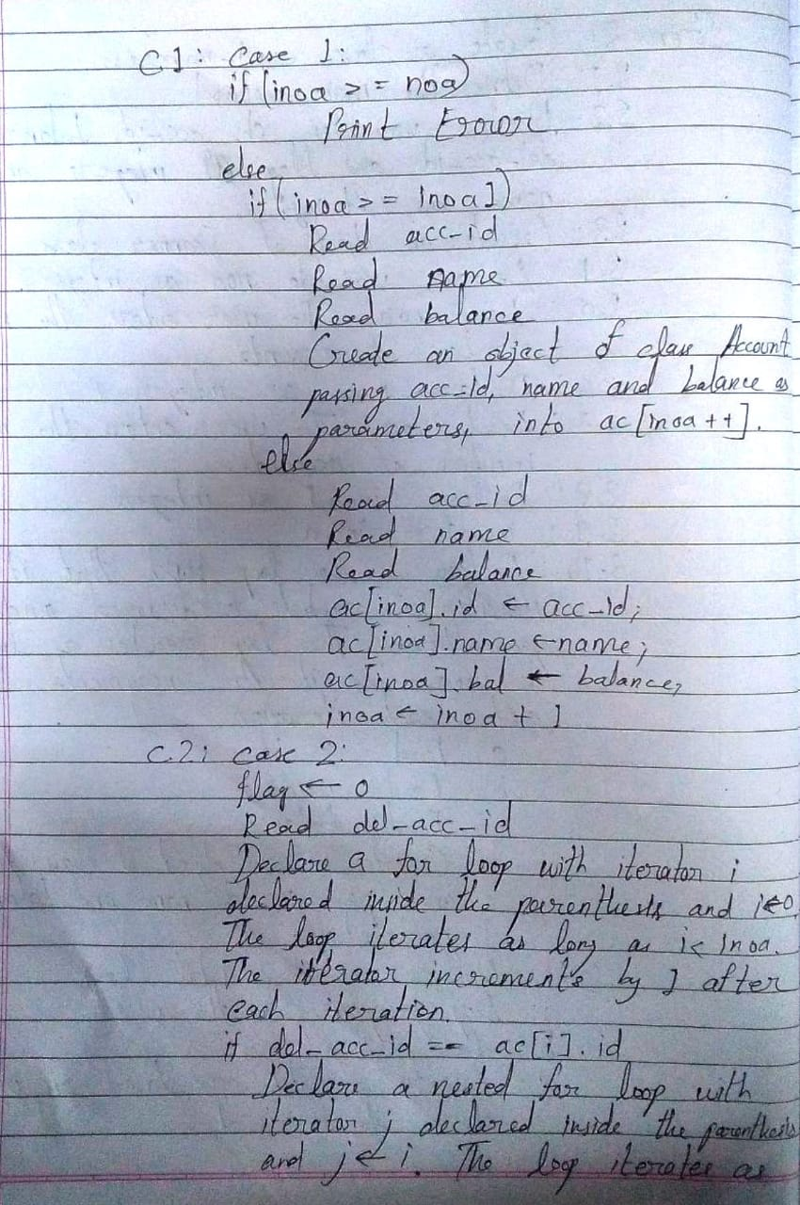

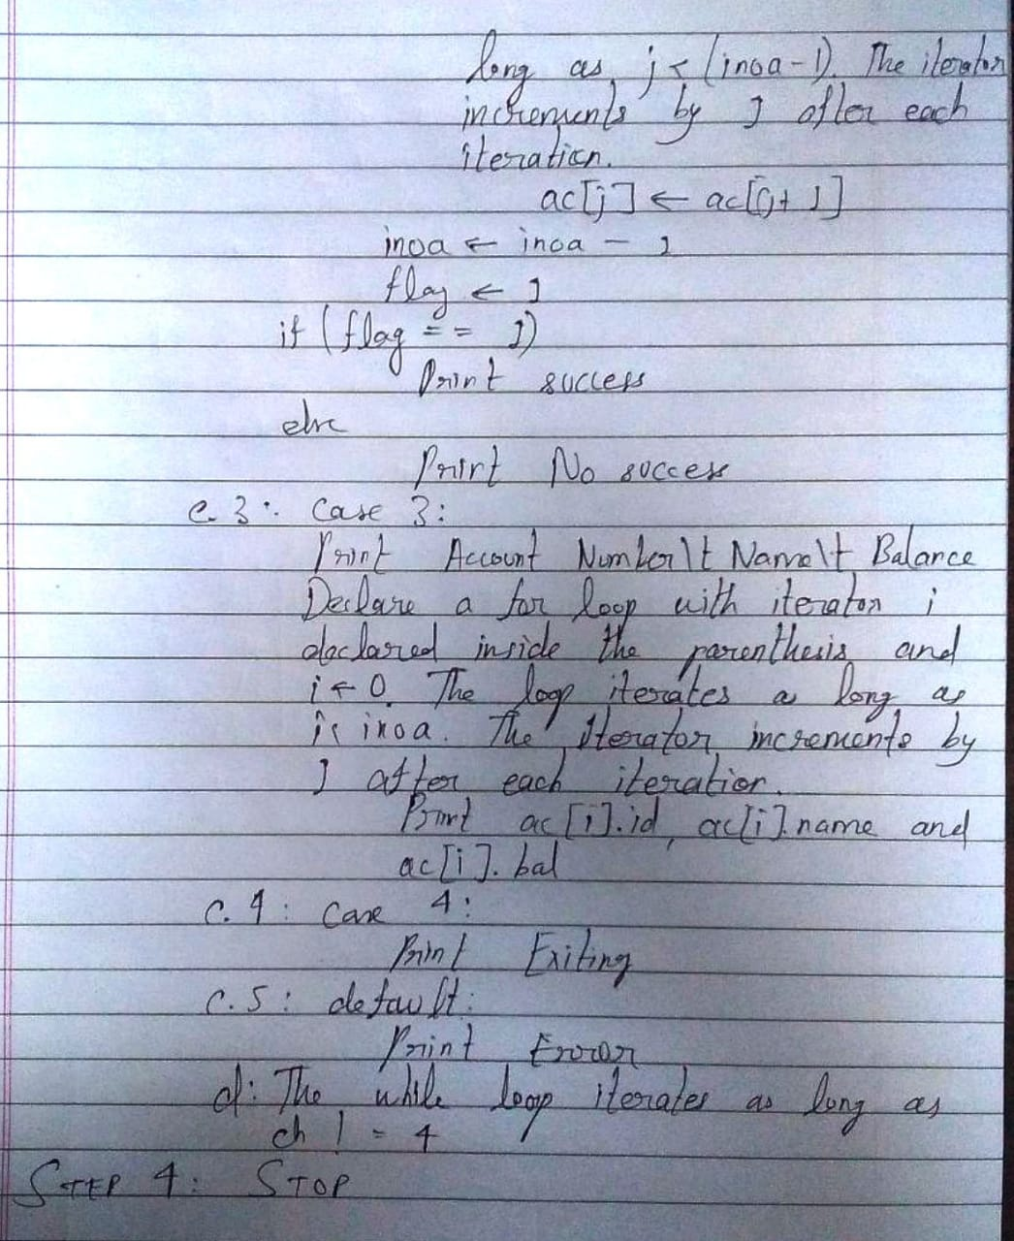

**Implementation details:**

Code:

import java.util.*;

class Account

{

    int id;

    String name;

    float bal;

    Account(int id, String name,float bal)

    {

        this.id= id;

        this.name=name;

        this.bal=bal;

    }

}

class exp4_mainclass

{

    public static void main(String[] args)

     {

        int ch, acc_id, balance, del_acc_id, flag;

        String name;

        Scanner sc = new Scanner(System.in);

        System.out.println("Enter the number of accounts:");

        int noa = sc.nextInt();

        Account[] ac = new Account[noa];

        System.out.println("Enter the intial number of accounts to be added:");

        int inoa = sc.nextInt();

        int inoa1 = inoa;

        if(inoa<=noa)

        {

            for(int i=0;i<inoa;i++)

            {

                System.out.println("For Record "+(i+1)+", enter the Account Number: ");

                acc_id = sc.nextInt();

                System.out.println("For Account Number "+acc_id+", enter Name: ");

                name = sc.next();

                System.out.println("For "+name+", enter the Balance: ");

                balance = sc.nextInt();

                ac[i] = new Account(acc_id, name, balance);

            }

            do

            {

                System.out.println("Enter:\n'1' to add an account.\n'2' to delete an account.\n'3' to display the entire record.\n'4' to exit.\nEnter your choice: ");

                ch = sc.nextInt();

                switch(ch)

                {

                    case 1:

                    if(inoa>= noa)

                    {

                        System.out.println("Sorry! The number of accounts exceeds the initial number of accounts.");

                        System.out.println("In order to add more, delete one record first.");

                    }

                    else

                    {

                        if(inoa>=inoa1)

                        {

                            System.out.println("For Record, enter the Account Number: ");

                            acc_id = sc.nextInt();

                            System.out.println("For Account Number "+acc_id+", enter Name: ");

                            name = sc.next();

                            System.out.println("For "+name+", enter the Balance: ");

                            balance = sc.nextInt();

                            ac[inoa++]= new Account(acc_id, name, balance);

                        }

                        else

                        {

                            System.out.println("For Record, enter the Account Number: ");

                            acc_id = sc.nextInt();

                            System.out.println("For Account Number "+acc_id+", enter Name: ");

                            name = sc.next();

                            System.out.println("For "+name+", enter the Balance: ");

                            balance = sc.nextInt();

                            ac[inoa].id = acc_id;

                            ac[inoa].name= name;

                            ac[inoa].bal= balance;

                            inoa++;

                        }

                    }

                    break;

                    case 2:

                    flag = 0;

                    System.out.println("Enter the Account Number of the account to delete:");

                    del_acc_id = sc.nextInt();

                    for(int i=0;i<inoa;i++)

                    {

                        if(del_acc_id==ac[i].id)

                        {

                            for(int j =i;j<(inoa-1);j++)

                            {

                                ac[j]= ac[j+1];

                            }

                            inoa--;

                            flag = 1;

                        }

                    }

                    if(flag==1)

                        System.out.println("Record found.");

                    else

                        System.out.println("Record not found.");

                    break;

                    case 3:

                    System.out.println("Account Number\tName\t Balance");

                    for(int i=0;i<inoa;i++)

                    {

                        System.out.println(ac[i].id+"\t\t"+ac[i].name+"\t"+ac[i].bal);

                    }

                    break;

                    case 4:

                    System.out.println("E\tX\tI\tT\tI\tN\tG\t.\t.\t.");

                    break;

                    default:

                    System.out.println("Enter '1', '2', '3' or '4' only. Please try again.");

                    break;

                 }

            }while(ch!=4);

        }

        else

        {

            System.out.println("Sorry! The initial number of accounts cannot exceed the number of accounts.");

        }

    }

}

**Output:**

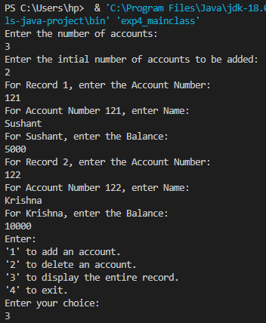

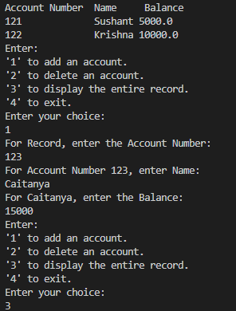

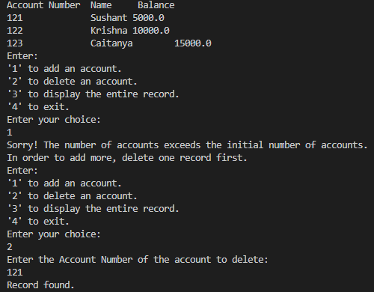

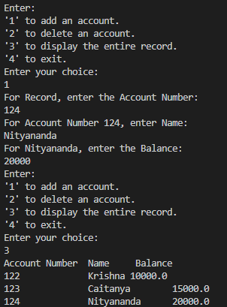

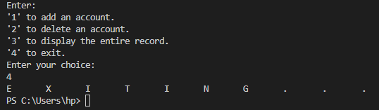

**Conclusion:**

Thus, in this experiment, the concept of array of objects has been practically implemented. Just like there are arrays of integers, strings, etc., there is the existence of array of objects in Java. This makes Java an Object Oriented Programming Language and Array of Objects is an Object Oriented Programming Method.

**Date: __17-10-2022__ Signature of faculty in-charge**

**Post Lab Descriptive Questions**

**Q.1**  If an array of objects is of size 10 and a data value have to be retrieved from 5th object then ________________ syntax should be used.

a)Array_Name[4].data_variable_name;  
b)Data_Type Array_Name[4].data_variable_name;  
c)Array_Name[4].data_variable_name.value;  
d) Array_Name[4].data_variable_name(value);

**Ans: a)**

 Q.2)The Object array is created in _____________________  
a)Heap memory  
b) Stack memory  
c) HDD  
d) ROM

1. Heap memory