**Batch: B3 Roll No.: 121**

**Experiment / assignment / tutorial No. 9**

**Grade: AA / AB / BB / BC / CC / CD /DD**

**Signature of the Staff In-charge with date**

|  |
| --- |
| **TITLE :Java Packages** |

**AIM:** Create a **Package Engineering** which has two classes as **Student and Marks**. Accept (n) student details like roll_no, Subject_name, Student_name,calculate total marks in the class Student Write **display () method** to display details and **sort () method** to sort the students records as per increasing order of the total marks. The function **sort must be statically defined to invoke it without referring to any object**. Both the functions are written in the Marks class.

Create a main class which will use a package to display all the records of the student in the increasing order of their total marks.

**_____________________________________________________________________**

**Expected OUTCOME of Experiment:**

**CO4:** Explore the interface, exceptions, multithreading, packages.

**Books/ Journals/ Websites referred:**

1. Ralph Bravaco , Shai Simoson , “Java Programming From the Group Up” Tata McGraw-Hill.

2.Grady Booch, Object Oriented Analysis and Design .

**Pre Lab/ Prior Concepts:**

**Java Packages:**

A package in Java is a group of similar types of classes, interfaces, and sub-packages. They can be categorized into two categories, the built-in package ( java, lang, util, awt, javax, swing, net, io, sql et), and user-defined package.

They are used for the following tasks –

* To prevent the naming conflicts which can occur between the classes.
* Make the searching and locating of classes or enumerations or annotations much easier.
* Provide access control to the classes.
* Used for data encapsulation.

**Advantages of Java Package:**

* A Java package is mainly used for the categorization of classes and interfaces so that we can maintain them easily.
* They always provide access protection
* Used to bundle classes and interfaces.
* With the help of packages, we can reuse the existing code
* By using the package, we can easily locate the classes related to it.
* Also, remove the naming collision.

**Built-in Packages in Java**

Built-in is a part of Java API and it offers a variety of packages are –

lang – Automatically imported and it contains language support classes.

io – Contains classes for input and output operations.

util – Contains utility classes for implementing data structures.

applet – This package contains classes that create applets.

awt – Contain classes that implement compounds for GUI.

net – This package contains classes that support networking operations.

**User-defined Packages in Java**

1. package First;
2. public class MyClass
3. {
4. public void **getNames**(String name)
5. {
6. System.out.**println**(name);
7. }
8. }
9. package First;
10. import First.MyClass;
11. public class MyClass1 {
12. public static void **main**(String args[])
13. {
14. // Initializing the String variable with a value
15. String name = "Welcome";
16. // Creating an instance of class MyClass in the package.
17. MyClass obj = new **MyClass**();
18. obj.**getNames**(name);
19. }
20. }

.

**Class Diagram:**

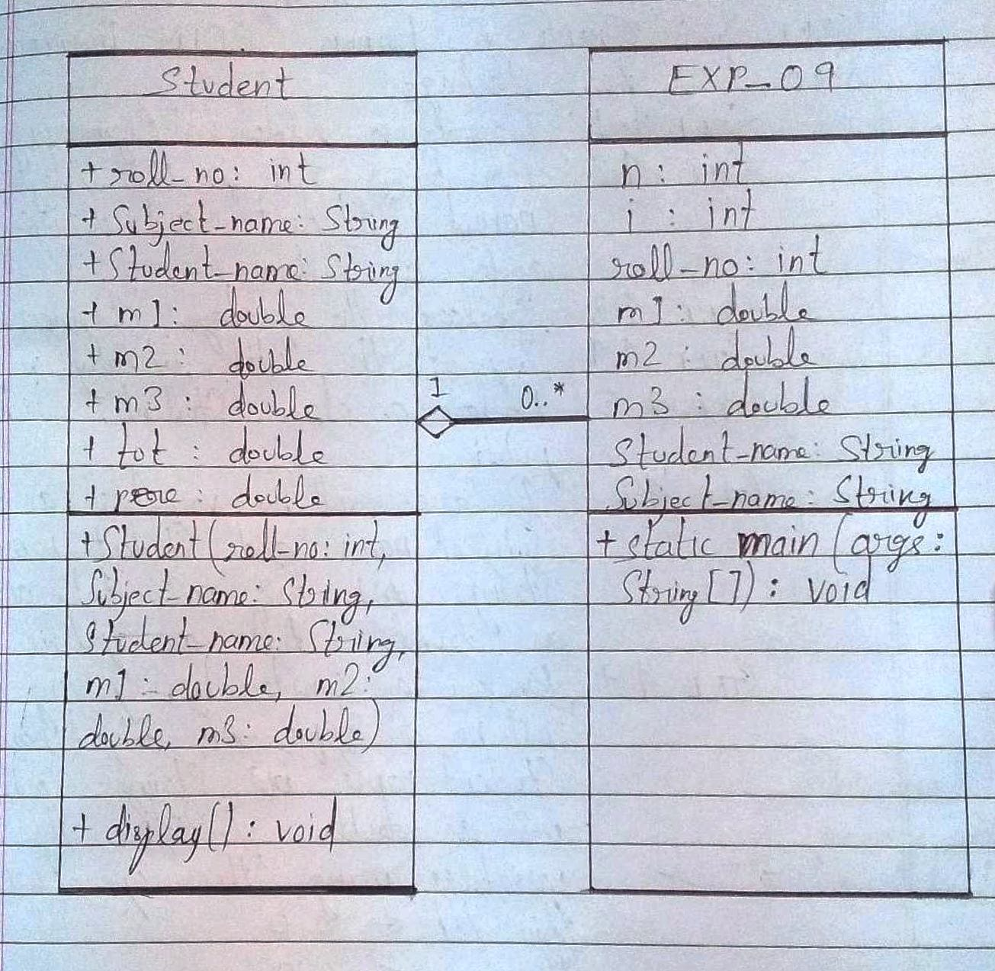

**Algorithm:**

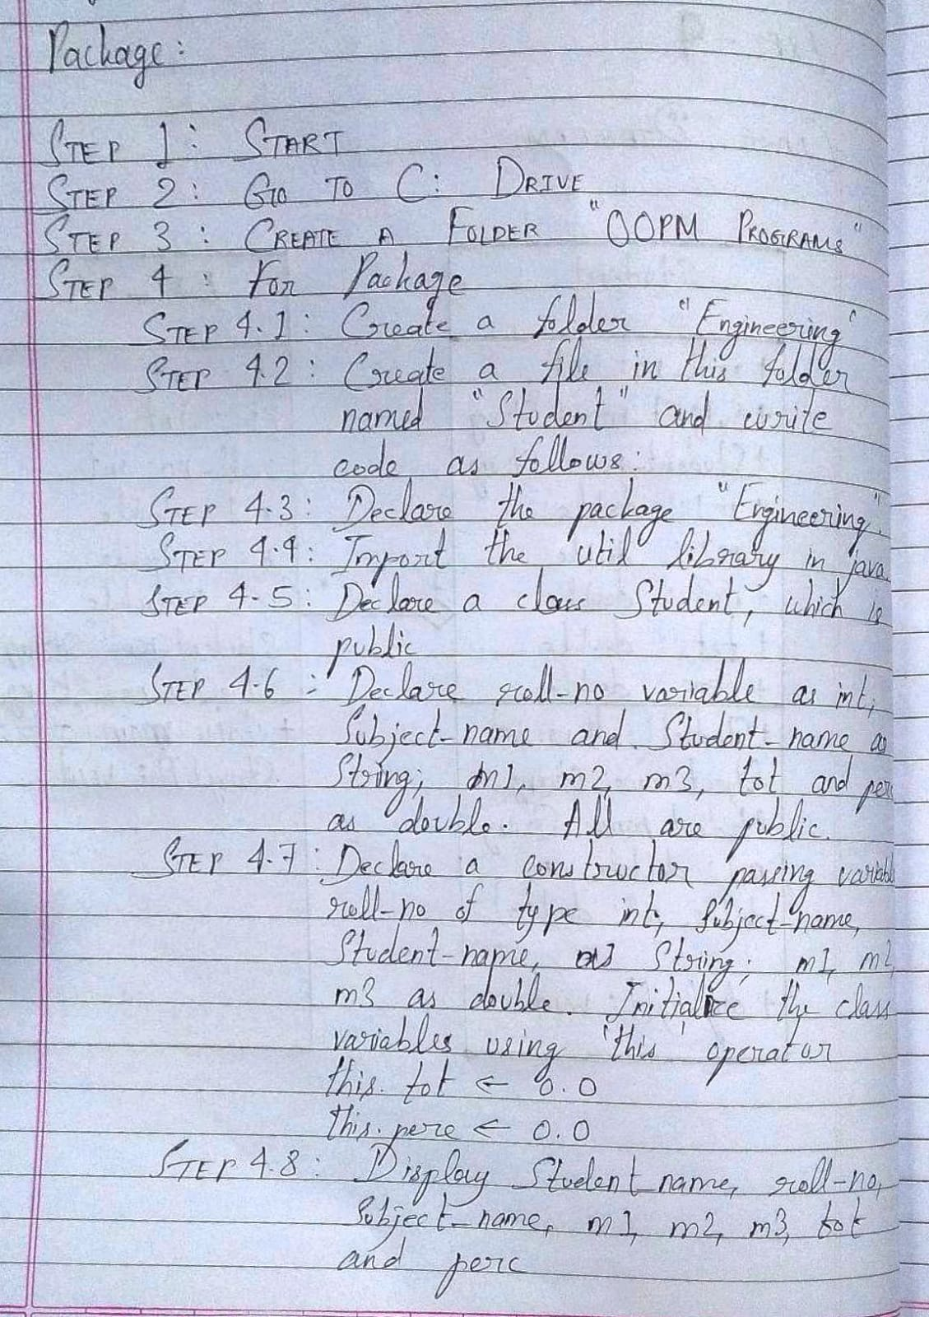

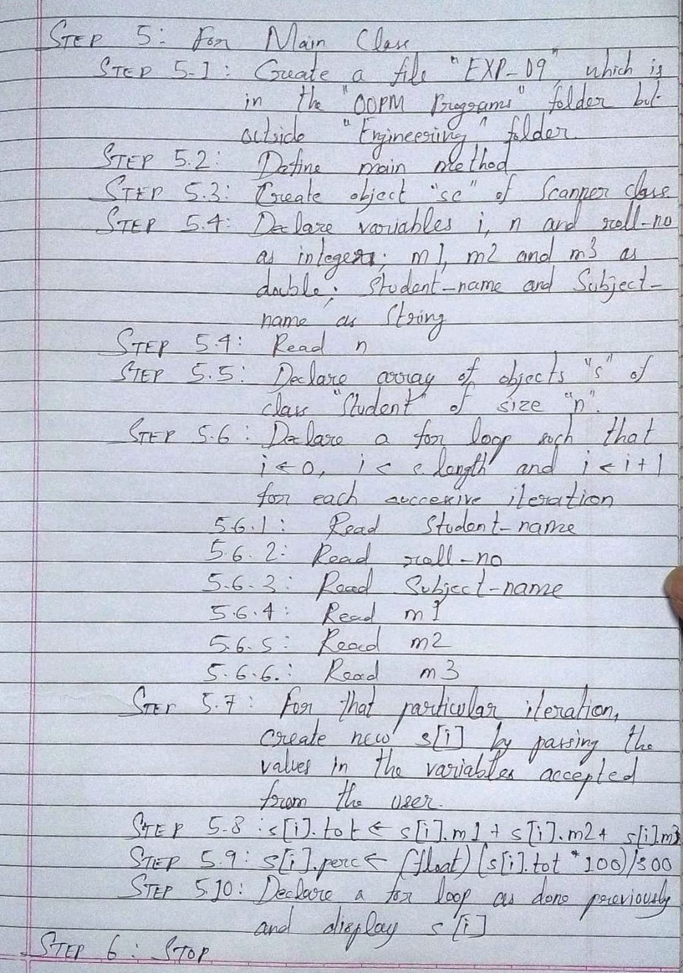

**Implementation details:**

Code for Package (which is saved with the name “Student” inside a folder called “Engineering”)

package Engineering;  
import java.util.*;  
public class Student  
{  
    public int roll_no;  
    public String Subject_name, Student_name;  
    public double m1, m2, m3, tot, perc;  
    public Student(int roll_no, String Subject_name, String Student_name, double m1, double m2, double m3)  
    {  
        this.roll_no = roll_no;  
        this.Subject_name = Subject_name;  
        this.Student_name = Student_name;  
        this.m1 = m1;  
        this.m2 = m2;  
        this.m3 = m3;  
        this.tot = 0.0;  
        this.perc = 0.0;  
    }  
    public void display()  
    {  
        System.out.println(Student_name+"\t"+roll_no+"\t"+Subject_name+"\t"+m1+"\t"+m2+"\t"+m3+"\t"+tot+"\t"+perc);  
    }  
}

Code for Main Method (which is saved with the name “EXP_09” outside the folder “Engineering”. Both codes are in the same directory, i.e., C: drive or D: drive)

import Engineering.*;  
  
import java.util.*;  
class EXP_09  
{  
    public static void main(String[] args)  
    {  
        Scanner sc = new Scanner(System.in);  
        int n, i, roll_no;  
        double m1, m2, m3;  
        String Student_name, Subject_name;  
        System.out.println("Enter no. of students");  
        n = sc.nextInt();  
        Student s[] = new Student[n];  
        for (i = 0; i < s.length; i++)  
        {  
            System.out.println("For row "+(i+1)+", enter Name: ");  
            Student_name = sc.next();  
            sc.nextLine();  
            System.out.println("For "+Student_name+", enter Roll Number: ");  
            roll_no = sc.nextInt();  
            System.out.println("For "+Student_name+", enter Course Name: ");  
            Subject_name = sc.next();  
            sc.nextLine();  
            System.out.println("For "+Student_name+", enter marks in Subject 1: ");  
            m1 = sc.nextDouble();  
            System.out.println("For "+Student_name+", enter marks in Subject 2: ");  
            m2 = sc.nextDouble();  
            System.out.println("For "+Student_name+", enter marks in Subject 3: ");  
            m3 = sc.nextDouble();  
            s[i] = new Student(roll_no, Subject_name, Student_name, m1, m2, m3);  
            s[i].tot = s[i].m1 + s[i].m2 + s[i].m3;  
            s[i].perc = (float) (s[i].tot * 100) / 300;  
        }  
        for (i = 0; i < s.length; i++)  
        {  
            s[i].display();  
        }  
    }  
}

**Output:**

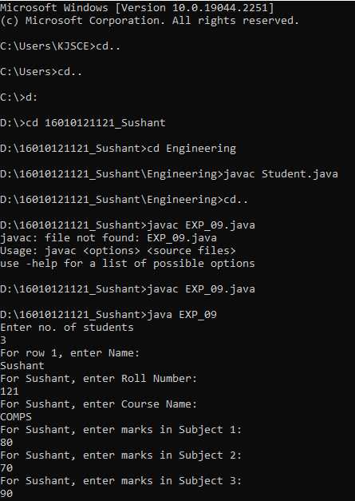

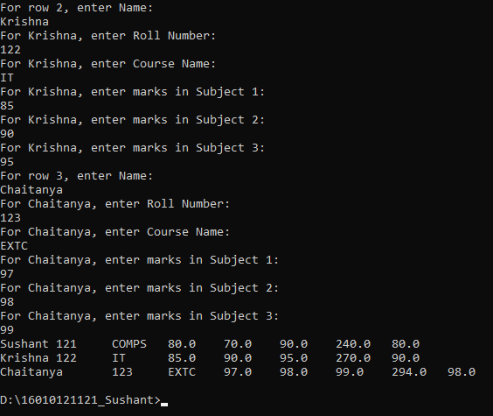

**Conclusion:**

Thus, in this experiment, the concept of packages has been learnt and implemented in java. Packages enable the programmer to combine multiple classes into a single file which can be invoked again and again in various different codes. Thus, the concept of code reusability is an important component for Packages. This improves the efficiency of programming, memory efficiency of CPU and running speed of programs.

**Date: __02-12-22__ Signature of faculty in-charge**

**Post Lab Descriptive Questions**

Q.1   What are Java Packages? What's the significance of packages?

Ans. A Java Package is a group of similar classes, interfaces and sub-packages. Package in java can be categorized into two types, built-in and user-defined. There are many built-in packages such as lang, awt, javax, swing, net, io, util, sql, etc.

Programmers can implement user-defined packages by bundling a group of classes or interfaces. It is a good practice to group related classes so that it can easily be determined that those classes or interfaces are related.

Since the package creates a new namespace, there won’t be any name conflicts with names in other packages. Using packages, it is easier to provide access control and it is also easier to locate the related classes.

 Q.2 Does importing a package imports its sub-packages as well in Java?

Ans. No, importing a package in Java does not mean that the sub-packages of that package also get imported automatically.