**Batch: B2 Roll No.: 121**

**Experiment / assignment / tutorial No. 2**

**Grade: AA / AB / BB / BC / CC / CD /DD**

**Signature of the Staff In-charge with date**

|  |
| --- |
| **TITLE:** Write a program to accept 3 numbers from the user and find the largest of the 3 numbers using                    If - else if-else                    Ternary operator |

**AIM:** Write a program to accept 3 numbers from the user and find the largest of the 3 numbers using

                  If - else if-else

                  Ternary operator

**______________________________________________________________________**

**Expected OUTCOME of Experiment:**

|  |
| --- |
| CO2: Apply basic concepts of C programming for problem solving |

**__________________________________________________**

**Books/ Journals/ Websites referred:**

1. Programming in ANSI C, E. Balagurusamy, 7 th Edition, 2016, McGraw-Hill Education, India.
2. Structured Programming Approach, Pradeep Dey and Manas Ghosh, 1 st Edition, 2016, Oxford University Press, India.
3. Let Us C, Yashwant Kanetkar, 15th Edition, 2016, BPB Publications, India.

**_____________________________________________________________________**

**Problem Definition:**

Ask user to input three numbers. Compare three numbers to find the largest of them using

1. Nested if else statement
2. Using ternary operator

**Algorithm:**

**To find the largest of three input numbers using Nested if else statement**

Step 1: Start

Step 2: Declare variables num1, num2 and num3

Step 3: Read values num1, num2 and num3

Step 4: if num1>num2 and num1>num3

Display num1 is greatest

else if num2>num1 and num2>num3

Display num2 is greatest

else

Display num3 is greatest

Step 5: Stop

**To find the largest of three input numbers using ternary operator**

Step 1: Start

Step 2: Declare variables num1, num2 and num3

Step 3: Read values num1, num2 and num3

Step 4: Using Ternary operator, compare the values of num1, num2 and num3

if num1>num2 and num1>num3 is true

display num1 is the largest

otherwise

if num2>num3 is true

display num2 is the largest

otherwise

display num3 is largest

Step 5: Stop

**Implementation details:**

/* Largest of three numbers using if - else if - else

Name: Sushant M Nair; Roll no: 121 Div: B,B2 */

#include<stdio.h>

int main()

{

int num1, num2, num3;

printf("Enter first number: \n");

scanf("%d", &num1);

printf("\nEnter second number: \n");

scanf("%d", &num2);

printf("\nEnter third number: \n");

scanf("%d", &num3);

if(num1>num2 && num1>num3)

printf("The number %d is the largest of the three.", num1);

else if(num2>num1 && num2>num3)

printf("The number %d is the largest of the three.", num2);

else

printf("The number %d is the largest of the three.", num3);

}

/* Largest of three numbers using Ternary operator

Name: Sushant M Nair; Roll no: 121 Div: B,B2 */

#include<stdio.h>

int main()

{

int num1, num2, num3, max = 0;

printf("Enter first number: \n");

scanf("%d", &num1);

printf("\nEnter second number: \n");

scanf("%d", &num2);

printf("\nEnter third number: \n");

scanf("%d", &num3);

max = (num1>num2 && num1>num3) ? printf("The number %d is largest", num1) : (num2>num3) ? printf("The number %d is largest", num2) : printf("The number %d is largest", num3);

}

**Output(s):**

If – else if – else program

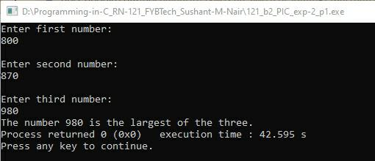

Ternary Operator program

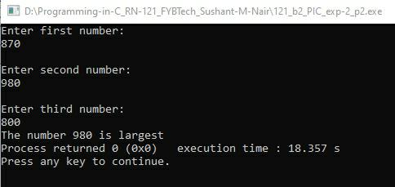

**Conclusion:**

In this experiment, I have learnt how to apply the basic concepts of C programming for problem solving in the matter of comparison of three numbers in order to print the largest among them. I learnt two methods for doing the same, i.e., by using if – else if – else statement and by using Ternary operator. The algorithm has been written, the input code has been written and the output screen screenshots have also been included.

**Post Lab Descriptive Questions**

**1. Explain bitwise operators with examples**

Ans. A bitwise operator is an operator which is used to perform bitwise operations on binary numerals or bit patterns which require the modification of individual bits.

Examples of Bitwise operators:

AND (&): The result is true if both the operands are true.

OR (|): The result is true if any one or both of the operands are true.

XOR (^): The result is true if exactly any one of the two operands are true, but not both simultaneously.

NOT (~): It inverts the value of the operand.

Right-Shift (>>) and Left-Shift (<<): It moves the bits by the number of positions indicated by the second character of the operand in the right or left direction.

**2. Write associative rules and precedence table of various operators.**

|  |  |  |
| --- | --- | --- |
| **Category** | **Operator** | **Associativity** |
| Postfix | (), [] | Left to Right |
| Unary | +, - | Right to Left |
| Multiplicative | *, /, % | Left to Right |
| Additive | +, - | Left to Right |
| Shift | <<, >> | Left to Right |
| Relational | <, <=, >, >= | Left to Right |
| Equality | ==, != | Left to Right |
| Bitwise AND | & | Left to Right |
| Bitwise XOR | ^ | Left to Right |
| Bitwise OR | | | Left to Right |
| Logical AND | && | Left to Right |
| Logical OR | || | Left to Right |
| Conditional | ?: | Right to Left |
| Assignment | = | Right to Left |
| Comma | , | Left to Right |

**Date: ___28-11-2021___ Signature of faculty in-charge**