**Batch: B2 Roll No.: 121**

**Experiment / assignment / tutorial No. 10**

**Grade: AA / AB / BB / BC / CC / CD /DD**

**Signature of the Staff In-charge with date**

|  |
| --- |
| **TITLE:**  Application Oriented Program |

**AIM:** To develop any application based program.

**______________________________________________________________________**

**Expected OUTCOME of Experiment:**

CO 1: Formulate a problem statement and develop the logic (algorithm/flowchart) for its solution.

CO 2: Apply basic concepts of C programming for problem solving.

CO 3: Illustrate the use of derived and structured data types such as arrays, strings, structures and unions.

CO 4: Design modular programs using functions and demonstrate the concept of pointers and file handling.

**_____________________________________________________________________**

**Books/ Journals/ Websites referred:**

1. Programming in C, second edition, Pradeep Dey and Manas Ghosh, Oxford University Press.
2. Programming in ANSI C, fifth edition, E Balagurusamy, Tata McGraw Hill.
3. Introduction to programming and problem solving , G. Michael Schneider ,Wiley India edition.
4. [**http://cse.iitkgp.ac.in/~rkumar/pds-vlab/**](http://cse.iitkgp.ac.in/~rkumar/pds-vlab/)

**_____________________________________________________________________**

**Problem Definition:**

Consider the marble rolling toy as shown in figure:

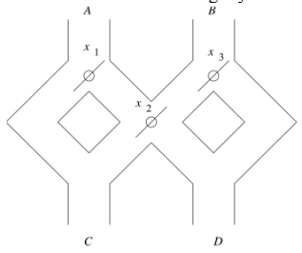

A marble is dropped at A or B. Levers x1, x2 and x3 cause the marble to fall either to the left or to the right. Whenever a marble encounters a lever, it causes the lever to reverse the direction after the marble passes, so the next marble will take the opposite branch.

**Write a C program to accept an input sequence and generate the appropriate output sequence. Example: input: “BAA” Its equivalent output sequence is “CCD” i.e. three marbles are dropped sequentially at B, A and A. First marble will find its way through C, second through C and third through D.**

**Flowchart:**

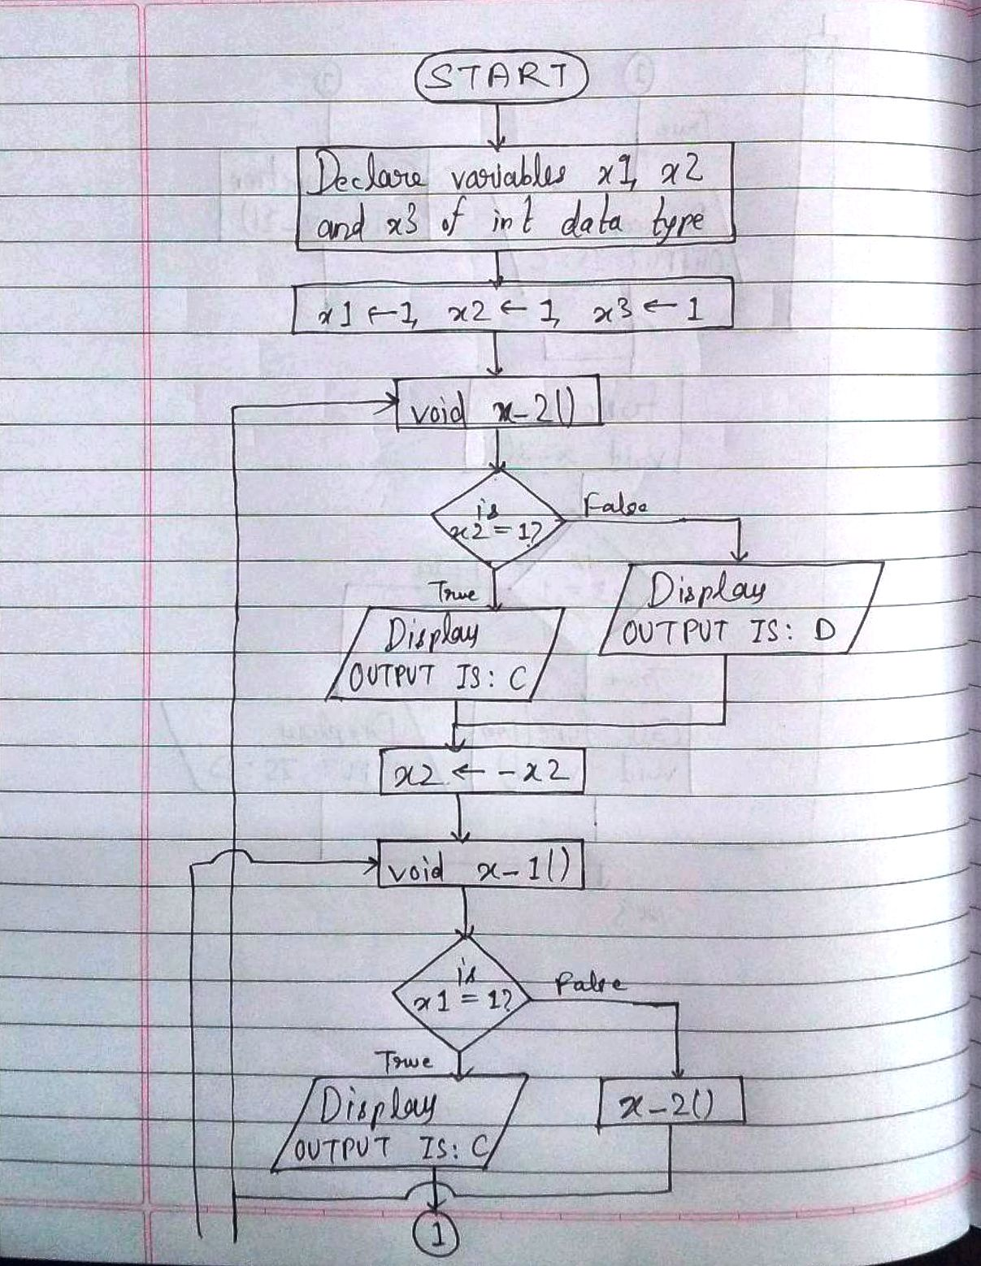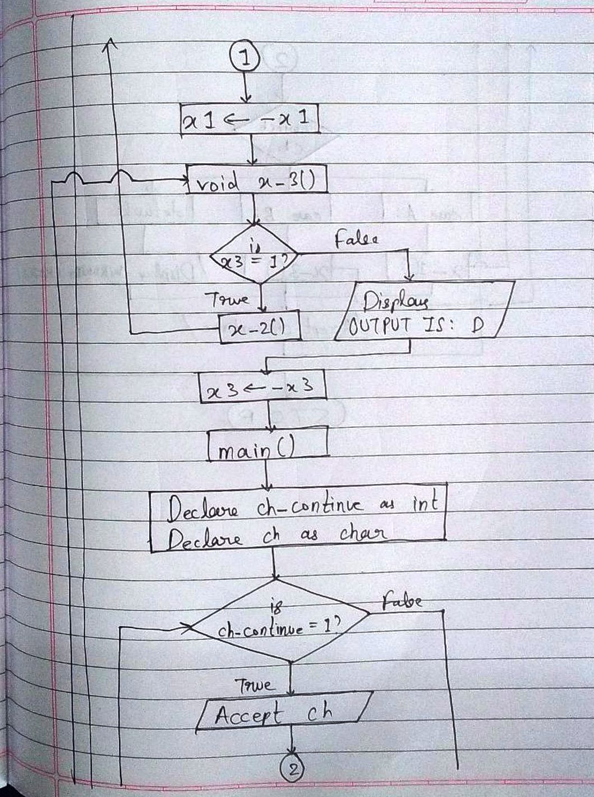

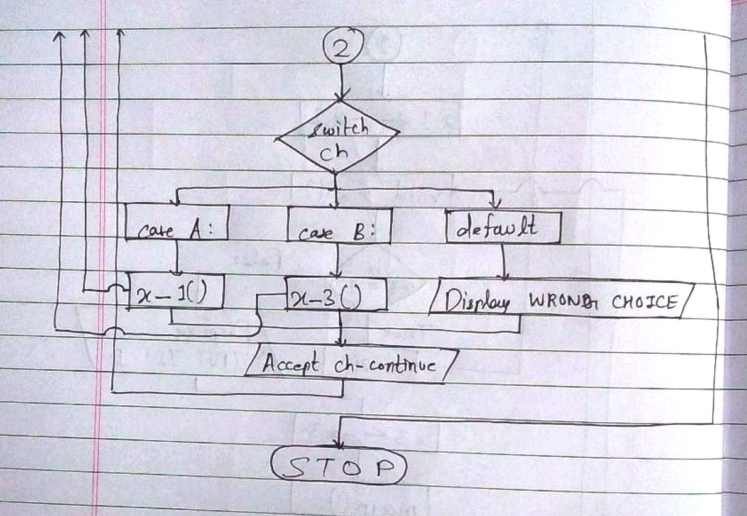

**Implementation details:**

#include<stdio.h>

int x1 = 1, x2 = 1, x3 = 1;

void x_2 ()

{

if (x2 == 1)

printf ("\n\nOUTPUT IS: C\n\n");

else

printf ("\n\nOUTPUT IS: D\n\n");

x2 = -x2;

}

void x_1 ()

{

if (x1 == 1)

printf ("\n\nOUTPUT IS: C\n\n");

else

x_2 ();

x1 = -x1;

}

void x_3 ()

{

if (x3 == 1)

x_2 ();

else

printf ("\n\nOUTPUT IS: D\n\n");

x3 = -x3;

}

int main ()

{

int ch_continue;

char ch;

do

{

fflush (stdin);

printf ("\nEnter a character - A or B: ");

scanf (" %c", &ch); //lesson: put a space between the opening of quotes and the delimiter.

switch (ch)

{

case 'A':

x_1 ();

break;

case 'B':

x_3 ();

break;

default:

printf

("\nAn incorrect input has been entered. Enter 'A' or 'B' only.");

}

fflush (stdin);

printf

("\nDo you want to enter one more character? Press '1'. Otherwise, press '2'.\nEnter your choice: ");

scanf ("%d", &ch_continue);

}

while (ch_continue == 1);

return 0;

}

**Output(s):**

**Conclusion:**

Thus, in this program, an input sequence is accepted from the user and the logically appropriate output sequence is displayed as output. The program is the logical equivalent of a marble toy. The program uses three functions and three variables to represent the three levers X1, X2 and X3 which were present in the marble toy. Thus, this program helped to improve my (the student programmer’s) logical skills. It certainly challenged me because it involved out-of-the-box thinking. Among the wide range of choices available, I chose the functions method. Thus, this program includes void return type non-parameterized functions. It also includes if-else statement within the functions. Further, switch case is used in the main() function. Also, the program runs on an infinite do-while loop so that the user can keep entering more characters to get logically appropriate output, provided that, the choice inputted, whenever prompted, is 1. If the choice is not 1, then the program ends.

**Date: __04-02-2022__ Signature of faculty in-charge**