+

**Batch: B2 Roll No.: 121**

**Experiment / assignment / tutorial No. 3**

**Grade: AA / AB / BB / BC / CC / CD /DD**

**Signature of the Staff In-charge with date**

|  |
| --- |
| **TITLE:**  Menu driven program. |

**AIM:** Write a menu driven program for following option

a. To find whether a number is palindrome or not. (e.g. 1221 is palindrome)

b. To calculate the sum of the Fibonacci series up to ‘n’ terms(use do-while loop only)

c. To find the numbers and sum of all integer between 100 and 200 which are divisible by both 3 & 5.(use for loop only)

______**________________________________________________________________**

**Expected OUTCOME of Experiment:**

CO2: Apply basic concepts of C programming for problem solving.

**_____________________________________________________________________**

**Books/ Journals/ Websites referred:**

1. Programming in C, second edition, Pradeep Dey and Manas Ghosh, Oxford University Press.
2. Programming in ANSI C, fifth edition, E Balagurusamy, Tata McGraw Hill.
3. Introduction to programming and problem solving , G. Michael Schneider ,Wiley India edition.
4. [**http://cse.iitkgp.ac.in/~rkumar/pds-vlab/**](http://cse.iitkgp.ac.in/~rkumar/pds-vlab/)

**_____________________________________________________________________**

**Problem Definition:**

The program accepts a choice from the user using a switch case statement and generates output accordingly.

**Choice a**: The program checks whether a given numbered by user is palindrome or not.If a number remains same, even if we reverse its digits then the number is known as palindrome number. For example, 12321 is a palindrome number because it remains same if we reverse its digits.

**Choice b:** Sum of Fibonacci series up to n terms will be generated. Fibonacci series is a series in which each number is the sum of the last two preceding numbers. The first two terms of a Fibonacci series are 0 and 1.(use while loop only)

**Example:**

Input: n = 5

Output: 7

Explanation: 0 + 1 + 1 + 2 + 3 = 7

**Choice c:** To find the numbers and sum of all integer between 100 and 200 which are divisible by both 3 & 5.(use for loop only)

**Algorithm:**

**Implementation details:**

/* Exp no 3 - Menu driven program - palindrome,

fibonacci, divisibility by 3 or 5.

Name: Sushant M Nair Roll No: 121 Div: B, B2 */

#include<stdio.h>

int main()

{

char ch;

int num, rev_num = 0, orig_num = 0;

int a = 0, b = 1, c, n, sum = 0, n1 = 0;

int i, s = 0;

printf("Press 'a' to find whether a number is palindrome or not.\n");

printf("Press 'b' to calculate the sum of the Fibonacci series up to ‘n’ terms.\n");

printf("Press 'c' to find the numbers and sum of all integer between 100 and 200 which are divisible by both 3 & 5.\n");

printf("Enter your choice: ");

scanf("%c", &ch);

switch(ch)

{

case 'a':

printf("\nEnter a number: ");

scanf("%d", &num);

orig_num = num;

while(num!=0)

{

rev_num = rev_num*10 + num%10;

num = num/10;

}

if(rev_num == orig_num)

printf("\nThe number %d is Palindrome number.", orig_num);

else

printf("\nThe number %d is not a Palindrome number.", orig_num);

break;

case 'b':

printf("\nEnter the number of terms up to which the Fibonacci series has to be printed: ");

scanf("%d", &n);

printf(" %d %d", a, b);

n1 = n-2;

do

{

c = a + b;

a = b;

b = c;

sum = sum + c;

printf(" %d", c);

n1--;

} while(n1!=0);

sum++;

printf("\nThe sum of %d terms of Fibonacci series is %d.", n, sum);

break;

case 'c':

for(i = 100; i < 200; i++)

{

if(i%3==0 && i%5==0)

{

printf("\nThe number %d is divisible by both 3 and 5.", i);

s = s + i;

}

else

continue;

}

printf("\nThe sum of the numbers, between 100 and 200, which divisible by both 3 and 5 is %d.", s);

break;

default:

printf("Please enter only 'a', 'b' or 'c'. Other inputs are invalid.");

}

}

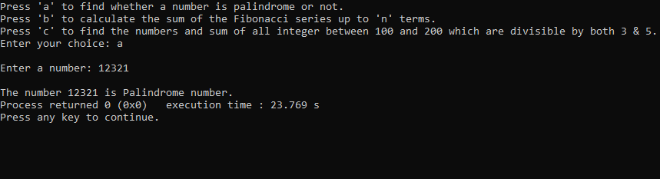**Output(s):**

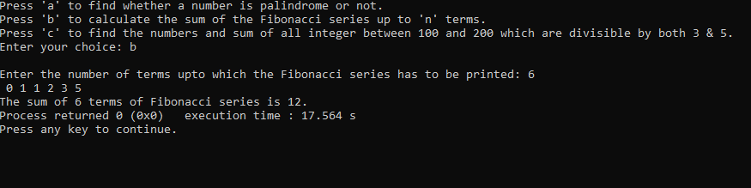

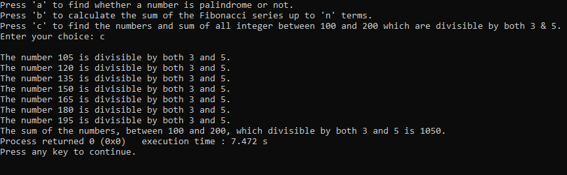

**Conclusion:**

In this experiment, the application of basic concept of C programming for problem solving was performed. The concept was about menu driven program. Using switch case, a program can be developed wherein the user has a choice to make. The user can choose between multiple options as per requirement. In this case, three options are there for the user to choose from – to enter a number and check whether the entered number is palindrome or not, to enter the number of terms to print for Fibonacci series, and to print all integers between 100 and 200 which are divisible by both 3 and 5 and to display the sum of those integers. In case the choice (which can be an integer or a character) entered by the user does not match with any of the defined cases, then the appropriate error message is displayed. Thus, a switch case statement is a convenient way to code in a scenario where there are multiple choices to choose from.

**Post Lab Descriptive Questions**

**Write menu driven code for the following:**

The program allows a user to enter five numbers and then asks the user to select a choice from a menu. The menu should offer the following options –

1. Display the smallest number entered

2. Display the largest number entered

3. Display the sum of the five numbers entered

4. Display the average of the five numbers entered.

5. Exit

Ans: The code is as follows:

/*Name: Sushant M Nair; Div: B, B2; Roll no: 121

Menu driven program: 1 --> smallest, 2 --> largest

3 --> sum, 4 --> average, 5 --> exit*/

#include<stdio.h>

int main()

{

int n1, n2, n3, n4, n5, ch;

int min = 0, max = 0, avg = 0, sum = 0;

printf("Enter number 1: ");

scanf("%d", &n1);

printf("\nEnter number 2: ");

scanf("%d", &n2);

printf("\nEnter number 3: ");

scanf("%d", &n3);

printf("\nEnter number 4: ");

scanf("%d", &n4);

printf("\nEnter number 5: ");

scanf("%d", &n5);

printf("\nEnter '1' to display the smallest number entered.");

printf("\nEnter '2' to display the largest number entered.");

printf("\nEnter '3' to display the sum of the five numbers entered.");

printf("\nEnter '4' to display the average of the five numbers entered.");

printf("\nEnter '5' to exit from the program.");

printf("\nEnter your choice: ");

scanf("%d", &ch);

switch(ch)

{

case 1:

min = (n1<n2 && n1<n3 && n1<n4 && n1<n5) ? printf("\n%d is the smallest.", n1) : (n2<n3 && n2<n4 && n2<n5) ? printf("\n%d is the smallest.", n2) : (n3<n4 && n3<n5) ? printf("\n%d is the smallest.", n3) : (n4<n5) ? printf("\n%d is the smallest.", n4) : printf("\n%d is the smallest.", n5);

break;

case 2:

max = (n1>n2 && n1>n3 && n1>n4 && n1>n5) ? printf("\n%d is the largest.", n1) : (n2>n3 && n2>n4 && n2>n5) ? printf("\n%d is the largest.", n2) : (n3>n4 && n3>n5) ? printf("\n%d is the largest.", n3) : (n4>n5) ? printf("\n%d is the largest.", n4) : printf("\n%d is the largest.", n5);

break;

case 3:

sum = n1 + n2 + n3 + n4 + n5;

printf("\nThe sum of the five numbers entered is: %d", sum);

break;

case 4:

avg = (n1 + n2 + n3 + n4 + n5)/5;

printf("\nThe average of the five numbers entered is: %d", avg);

break;

case 5:

void exit();

break;

default:

printf("\nThe wrong choice has been entered.");

}

return 0;

}

**Date: __04-12-2021___ Signature of faculty in-charge**