Batch: B2 Roll No.: 121

Experiment / assignment / tutorial No.

Grade: AA / AB / BB / BC / CC / CD /DD

Signature of the Staff In-charge with date

TITLE: Polymorphism and Abstract Class

AIM:
Write a program that defines an abstract class called Vehicle containing an abstract method speed (). Derive from it two classes - FourWheeler and TwoWheeler. Create objects of derived classes and call the speed () method using these objects, passing to it the name of vehicle and speed of vehicle. In the speed () method print the vehicle name and the speed of vehicle to which speed () belongs.
______________________________________________________________________
Expected OUTCOME of Experiment:
CO1: Use basic data structures in Python
CO2: Use different Decision Making statements and Functions in Python.
CO3: Apply Object oriented programming concepts in Python
_____________________________________________________________________
Resource Needed: Python IDE
_____________________________________________________________________

Theory:
Polymorphism:
Polymorphism is taken from the Greek words Poly (many) and morphism (forms). It means that the same function name can be used for different types. This makes programming more intuitive and easier.

Polymorphism in Python:
A child class inherits all the methods from the parent class. However, in some situations, the method inherited from the parent class doesn’t quite fit into the child class. In such cases, you will have to re-implement method in the child class.
There are different methods to use polymorphism in Python. You can use different function, class methods or objects to define polymorphism.

Polymorphism with Function and Objects:
You can create a function that can take any object, allowing for polymorphism.

Example:
Create a function called “func()” which will take an object which we will name “obj”. and let give the function something to do that uses the ‘obj’ object which is passed to it. Now, call the methods type() and color(), each of which is defined in the two classes ‘Tomato’ and ‘Apple’ by creating instances of both the ‘Tomato’ and ‘Apple’ classes if they do not exist:

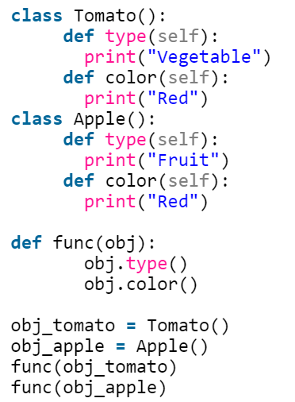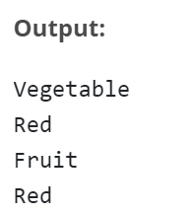

Polymorphism with Class Methods:
Python uses two different class types in the same way. Here, you have to create a for loop that iterates through a tuple of objects. Next, you have to call the methods without being concerned about which class type each object is. We assume that these methods actually exist in each class

Example:

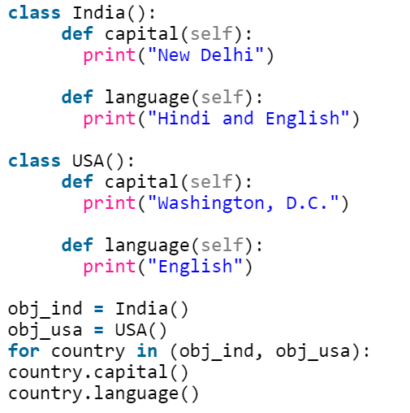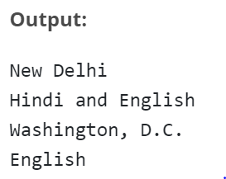

Polymorphism with Inheritance:
Polymorphism in python defines methods in the child class that have the same name as the methods in the parent class. In inheritance, the child class inherits the methods from the parent class. Also, it is possible to modify a method in a child class that it has inherited from the parent class.
This is mostly used in cases where the method inherited from the parent class doesn’t fit the child class. This process of re-implementing a method in the child class is known as Method Overriding.

Example:

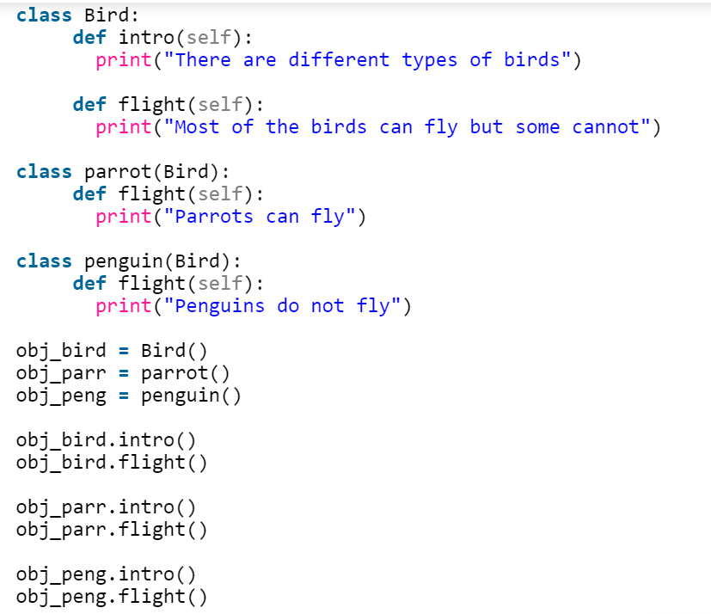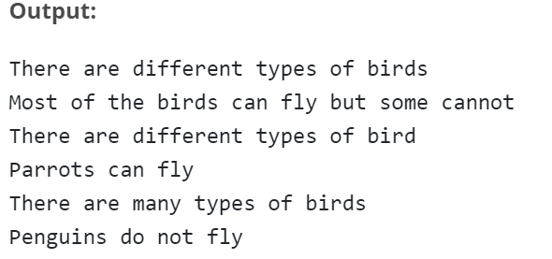

Abstract Class:
Abstract Class is concept of object-oriented programming based on DRY (Don’t Repeat Yourself) principle. In a large project, code duplication is approximately equal to bug reuse and one developer is impossible to remember all classes’ details. Therefore, it’s very helpful to use an abstract class to define a common interface for different implementations.
An abstract class has some features, as follows:-
- An abstract class doesn’t contain all of the method implementations required to work completely, which means it contains one or more abstract methods. An abstract method is a method that just has a declaration but does not have a detail implementation.
- An abstract class cannot be instantiated. It just provides an interface for subclasses to avoid code duplication. It makes no sense to instantiate an abstract class.
- A derived subclass must implement the abstract methods to create a concrete class that fits the interface defined by the abstract class. Therefore it cannot be instantiated unless all of its abstract methods are overridden.

Define Abstract Class in Python:
Python comes with a module called abc which provides methods for abstract class.
Define a class as an abstract class by abc.ABC and define a method as an abstract method by abc.abstractmethod. ABC is the abbreviation of abstract base class.

Example:
from abc import ABC, abstractmethod

class Animal(ABC):
@abstractmethod
def move(self):
pass
a = Animal() # TypeError: Can't instantiate abstract class Animal with abstract methods move

class Animal():
@abstractmethod
def move(self):
pass
a = Animal() # No errors

Invoke Methods from Abstract Classes:
An abstract method is not needed to be “totally abstract” in Python. We can define some content in an abstract method and use super() to invoke it in subclasses.

Example:

from abc import ABC, abstractmethod

class Animal(ABC):
@abstractmethod
def move(self):
print('Animal moves')

class Cat(Animal):
def move(self):
super().move()
print('Cat moves')

c = Cat()
c.move()

Output:
Animal moves
Cat moves

Problem Definition:
- For given program find output

Sr.No | Program | Output
1 | class Bank:  def getroi(self):  return 10  class SBI:  def getroi(self):  return 7  class ICICI:  def getroi(self):  return 8  b1=Bank()  b2=SBI()  b3=ICICI()  print("Bank rate of interest:",b1.getroi())  print("SBI rate of interest:",b2.getroi())  print("ICICI rate of interest:",b3.getroi()) | Bank rate of interest: 10  SBI rate of interest: 7  ICICI rate of interest: 8
2. | from abc import ABC, abstractmethod  class Employee(ABC):  @abstractmethod  def calculate_salary(self,sal):  pass  class Developer(Employee):  def calculate_salary(self,sal):  finalsalary=sal*1.10  return finalsalary  emp_1=Developer()  print(emp_1.calculate_salary(10000)) | 11000.0

- Write a program that defines an abstract class called Vehicle containing an abstract method speed (). Derive from it two classes - FourWheeler and TwoWheeler. Create objects of derived classes and call the speed () method using these objects, passing to it the name of vehicle and speed of vehicle. In the speed () method print the vehicle name and the speed of vehicle to which speed () belongs.

Books/ Journals/ Websites referred:

  - Reema Thareja , “Python Programming: Using Problem Solving Approach”, Oxford University Press, First Edition 2017, India
  - Sheetal Taneja and Naveen Kumar,” Python Programing: A Modular Approach”, Pearson India, Second Edition 2018, India
  - https://www.edureka.co/blog/polymorphism-in-python/
  - https://www.geeksforgeeks.org/inheritance-in-python/

Implementation details:

from abc import ABC, abstractmethod
from operator import methodcaller
class Vehicle(ABC):
@abstractmethod
def speed(self, name, spd):
pass
class FourWheeler(Vehicle):
def speed(self, name, spd):
self.name = name
self.spd = spd
print(self.name, self.spd)
class TwoWheeler(Vehicle):
def speed(self, name, spd):
self.name = name
self.spd = spd
print(self.name, self.spd)
f_w = FourWheeler()
t_w = TwoWheeler()
f_w.speed("Maruti Suzuki Alto 800\t", 100)
t_w.speed("TVS\t", 150)

Output(s):

Conclusion:

Thus, the concept of Polymorphism and Abstract Classes in Python has been practically demonstrated in this experiment. In polymorphism, the same operator or function can take multiple forms. It is useful in creating different classes which will have class methods with the same name. That helps in reusing a lot of code and helps in reducing code complexity. A class in an Abstract Class if it contains one or more methods (functions) which is abstract. An abstract method is one which is declared but has no implementation. The abstract methods must be implemented by its subclasses. Thus, an abstract class acts as a blueprint for other classes. It allows the programmer to create a set of abstract methods which must be implemented in any child class derived from the abstract class. Thus, the proper application of these tools make code lighter, faster, more efficient and economically viable.

Post Lab Questions

1. What will be the output of the following Python code?

class A:
def __init__(self):
self.multiply(15)
print(self.i)

def multiply(self, i):
self.i = 4 * i;
class B(A):
def __init__(self):
super().__init__()

def multiply(self, i):
self.i = 2 * i;
obj = B()
Options
a) 15
b) 60
c) An exception is thrown
d) 30
Ans. d) 30

- A class in which one or more methods are only implemented to raise an exception is called an abstract class.

a) True
b) False
Ans. b) False
Correct Statement: A class in which one or more methods are not implemented to raise an exception is called an abstract class.

Date: __07-07-2022___ Signature of faculty in-charge

