**Batch: B2 Roll No.: 121**

**Experiment / assignment / tutorial No.**

**Grade: AA / AB / BB / BC / CC / CD /DD**

**Signature of the Staff In-charge with date**

|  |
| --- |
| **TITLE:**  Regular expression in Python |

**AIM:** **Program to demonstrate use of regular expressions in pattern matching.**

**______________________________________________________________________**

**Expected OUTCOME of Experiment:** Use of basic data structure in Python.

**_____________________________________________________________________**

**Resource Needed: Python IDE**

**_____________________________________________________________________**

**Theory:**

A RegEx, or Regular Expression, is a sequence of characters that forms a search pattern.

RegEx can be used to check if a string contains the specified search pattern.

## RegEx Module

Python has a built-in package called re, which can be used to work with Regular Expressions. Import the re module: import re

## RegEx in Python

When you have imported the re module, you can start using regular expressions:

### Example

Search the string to see if it starts with "The" and ends with "Spain":

import re  
txt = "The rain in Spain"  
x = re.search("^The.*Spain$", txt)

## RegEx Functions

The re module offers a set of functions that allows us to search a string for a match:

|  |  |
| --- | --- |
| **Function** | **Description** |
| findall | Returns a list containing all matches |
| search | Returns a Match object if there is a match anywhere in the string |
| split | Returns a list where the string has been split at each match |
| sub | Replaces one or many matches with a string |

## Metacharacters

Metacharacters are characters with a special meaning:

|  |  |  |
| --- | --- | --- |
| **Character** | **Description** | **Example** |
| [] | A set of characters | "[a-m]" |
| \ | Signals a special sequence (can also be used to escape special characters) | "\d" |
| . | Any character (except newline character) | "he..o" |
| ^ | Starts with | "^hello" |
| $ | Ends with | "world$" |
| * | Zero or more occurrences | "aix*" |
| + | One or more occurrences | "aix+" |
| {} | Exactly the specified number of occurrences | "al{2}" |
| | | Either or | "falls|stays" |
| () | Capture and group |  |

## Special Sequences

A special sequence is a \ followed by one of the characters in the list below, and has a special meaning:

|  |  |  |
| --- | --- | --- |
| **Character** | **Description** | **Example** |
| \A | Returns a match if the specified characters are at the beginning of the string | "\AThe" |
| \b | Returns a match where the specified characters are at the beginning or at the end of a word (the "r" in the beginning is making sure that the string is being treated as a "raw string") | r"\bain" r"ain\b" |
| \B | Returns a match where the specified characters are present, but NOT at the beginning (or at the end) of a word (the "r" in the beginning is making sure that the string is being treated as a "raw string") | r"\Bain" r"ain\B" |
| \d | Returns a match where the string contains digits (numbers from 0-9) | "\d" |
| \D | Returns a match where the string DOES NOT contain digits | "\D" |
| \s | Returns a match where the string contains a white space character | "\s" |
| \S | Returns a match where the string DOES NOT contain a white space character | "\S" |
| \w | Returns a match where the string contains any word characters (characters from a to Z, digits from 0-9, and the underscore _ character) | "\w" |
| \W | Returns a match where the string DOES NOT contain any word characters | "\W" |
| \Z | Returns a match if the specified characters are at the end of the string | "Spain\Z" |

## Sets

A set is a set of characters inside a pair of square brackets [] with a special meaning:

|  |  |
| --- | --- |
| **Set** | **Description** |
| [arn] | Returns a match where one of the specified characters (a, r, or n) are present |
| [a-n] | Returns a match for any lower case character, alphabetically between a and n |
| [^arn] | Returns a match for any character EXCEPT a, r, and n |
| [0123] | Returns a match where any of the specified digits (0, 1, 2, or 3) are present |
| [0-9] | Returns a match for any digit between 0 and 9 |
| [[0-5][0-9] | Returns a match for any two-digit numbers from 00 and 59 |
| [a-zA-Z] | Returns a match for any character alphabetically between a and z, lower case OR upper case |
| [+] | In sets, +, *, ., |, (), $,{} has no special meaning, so [+] means: return a match for any + character in the string |

**Problem Definition:**

1. For given program find output

|  |  |  |
| --- | --- | --- |
| Sr. No. | Program | Output |
| 1 | import re  txt = "The rain in Spain"  x = re.findall("ai", txt)  print(x) | [‘ai’, ‘ai’] |
| 2 | import re  txt = "The rain in Spain"  x = re.findall("Portugal", txt)  print(x) | [] |
| 3 | import re  txt = "The rain in Spain"  x = re.search("\s", txt)  print("The first white-space character is located in position:", x.start()) | The first white-space character is located in position: 3 |
| 4 | import re  txt = "The rain in Spain"  x = re.search("Portugal", txt)  print(x) | None |
| 5 | import re  txt = "The rain in Spain"  x = re.split("\s", txt)  print(x) | [‘The’, ‘rain’, ‘in’, ‘Spain’] |
| 6 | import re  txt = "The rain in Spain"  x = re.split("\s", txt, 1)  print(x) | [‘The’, ‘rain in Spain’] |
| 7 | import re  txt = "The rain in Spain"  x = re.sub("\s", "9", txt)  print(x) | The9rain9in9Spain |
| 8 | import re  txt = "The rain in Spain"  x = re.sub("\s", "9", txt, 2)  print(x) | The9rain9in Spain |
| 9 | import re  txt = "The rain in Spain"  x = re.search("ai", txt)  print(x) #this will print an object | <re.Match object; span = (5, 7), match=’ai’> |
| 10 | import re  txt = "The rain in Spain"  x = re.search(r"\bS\w+", txt)  print(x.span()) | (12, 17) |

2. WAP to verify whether his credit card numbers are valid or not.  A valid credit card

from ABC Bank has the following characteristics:

* It must start with a 4,5  or 6 .
* It must contain exactly 16 digits.
* It must only consist of digits (0-9).
* It may have digits in groups of 4, separated by one hyphen ‘-’

3. From given string extract phone numbers only and save it into list.

Txt = “Dave Martin

615-555-7164

173 Main St., Springfield RI 55924

davemartin@bogusemail.com

Charles Harris

800-555-5669

969 High St., Atlantis VA 34075

charlesharris@bogusemail.com

Eric Williams

560-555-5153

806 1st St., Faketown AK 86847

laurawilliams@bogusemail.com

Corey Jefferson

900-555-9340

826 Elm St., Epicburg NE 10671

coreyjefferson@bogusemail.com”

**Books/ Journals/ Websites referred:**

1. Reema Thareja, *Python Programming: Using Problem Solving Approach*, Oxford University Press, First Edition 2017, India
2. Sheetal Taneja and Naveen Kumar, *Python Programming: A modular Approach*, Pearson India, Second Edition 2018,India

**Implementation details:**

Code for Q.2:

import re

c = 0

num = input("Enter your credit card number: ")

x = re.search("\A[456]", num)

if x:

print("Success, as num starts from ", x)

z = re.search("[a-zA-Z_]", num)

if z==None:

print("Success, as the number contains only digits.")

y = re.findall("\d", num)

if len(y)==16:

print("Success, as number contains ", len(y), " digits.")

y1 = re.findall("[-]", num)

if len(y1) == 3:

print("Success, as there are exactly three hyphens.")

w = re.split("[-]", num)

print(w)

for i in w:

v = len(i)

if v == 4:

c = c+1

if c==4:

print("Success, as the digits are grouped in pairs of four.")

print("Success! Your Credit Card Number is valid.")

else:

print("Failure, as the digits are not in groups of four.")

else:

print("Failure, as there are not exactly three hyphens.")

else:

print("Failure, as the number does not contain exactly 16 digits.")

else:

print("Failure, as the number contains characters which are not digits")

else:

print("Failure, as the number does not start from 4, 5 or 6.")

**Output(s):**

For Q1:

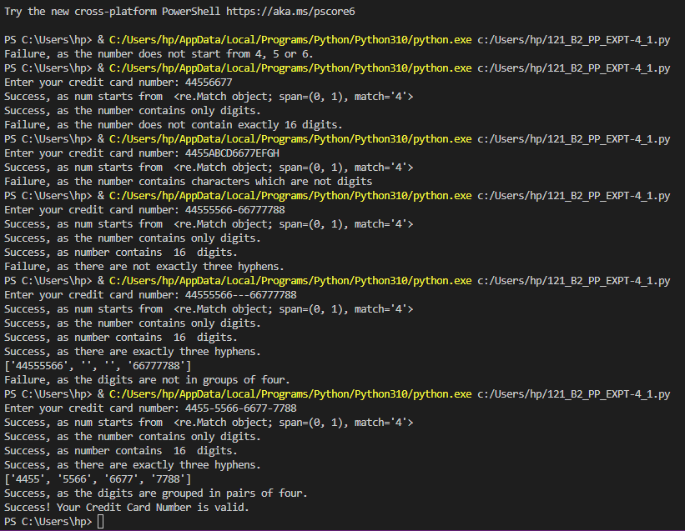

**Conclusion:**

Thus, in this experiment, the demonstration of use of regular expressions for pattern matching has been done. Regex is a sequence of characters that defines a search pattern. It is used in search algorithms, input validation (as in Q.2, where the input Credit Card Number was verified for validity). In order to use regex expressions in Python, we need to import the re module using the ‘import re’ instruction. It includes a vast library of functions, metacharacters, special sequences and sets. Thus, regex in Python is a very versatile tool and offers several functionalities that allows the programmer to test several types of strings. Thus, it is an easy and ideal way to check for patterns and validity and can be used in commercial applications like website log-in, search engine, etc.

**Post Lab Descriptive Questions**

What is difference in match and search function? explain with suitable example.

**Ans.** The re.match() and re.search() functions are regex functions. Both of them search for a substring within a string and return an object if a substring is found, else they return “None”. However, there is a difference between the two: although both return the first match found in a string, but re.match() searches only from the beginning of the string and returns an object if a match is found. But if the match is in the beginning of the string, even then it returns “None”. On the other hand, re.search() scans the entire string, even in the case of multiline strings, throughout the entire length and returns an object if a match is found.

Example:

**import re**

**str1 = ("Python Programming")**

**str2 = ("Welcome to Python Programming")**

**match = re.match(str1, str2) #str1 is substring**

**print(match) #substring is at the end of the string**

**search = re.search(str1, str2)**

**print(search)**

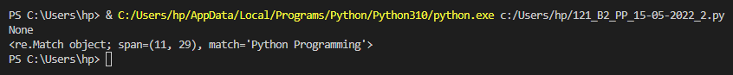

**Date: __15-05-2022__ Signature of faculty in-charge**