JUET Portal (with Online Outpass Service)


Developed By :- Sushant Singh
Enrollment No. :- 161B301
Batch :- B9 (BZ)
Contact :- +91-7088799810
Email :- sushant@sushantsoftwares.121wh.in , sushantr134@gmail.com

About The Project

This is a Online Based Desktop Application Which sends Requests to main website of this
Portal i.e https://sushantsoftwares.121wh.in/op and helps student of JUET College to get
their Leave Outpass issued through Online Digital Three Step Verification Process.

Step 1 :- Student Verification

Here Student itself verify its Personal Details that he or she submit for the outpass
by Verification Link which will be send automatically to the Student Registered
Email-id and After the verification Step 2 will takes place.

Step 2 :- Parent's Verification

Here After the Step 1 , SMS OTP and OTP Verification Link will be Send to their
Parent's Phone Number and Email-id Respectively.
All the Details will be Shared or Send to their Parents about the Reason of taking
Leave from the College and If Parents have No Objection in taking their Ward's
Responsibility then they will click the verfication link and then after OTP Submition
the Message will be displayed to the Parents that "Outpass Verification Completed ,
Please Inform Your Ward for The Outpass ."

And Finally, The PDF format of Outpass Will be Send to the Student Respective
Email-id .

Step 3 :- QR-Code Verification (Digital Signature)

Hostel Warden will have the Right to Scan the QR-Code to Verify the Outpass is
Genuine or Not ( QR-Code Will be Printed along with the Outpass ).

After all These three Verification , Student Can go outside the College Campus Without
Any inconvenience .

Conclusion :- This Online Outpass System Will Make the Present Running System More Effective,
Smart , More Secure and Less Time Consuming .
(**Paperless Work) ----- All The Information Will be Stored in Online Database.

Desktop Application Screenshots
(Beta Version)

1) Main Window

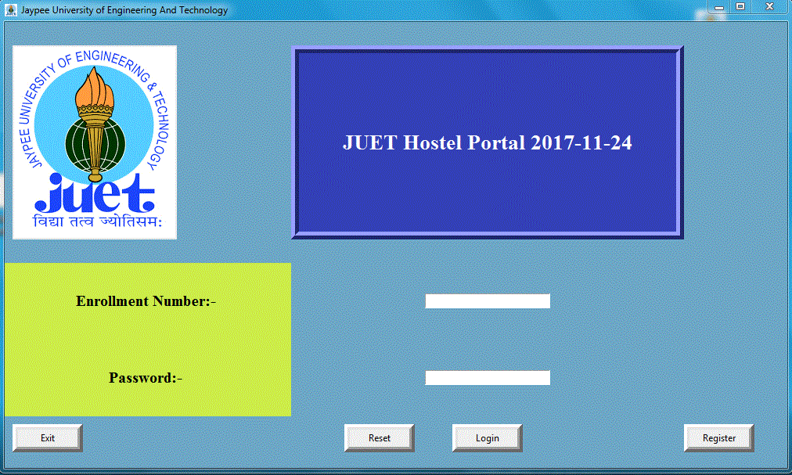

2) Registartion Form

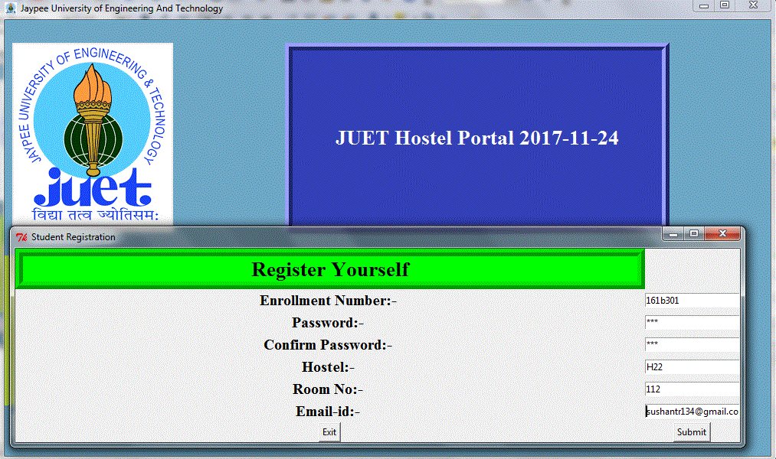
3) After Registration Completion , Email will be send to the user having OTP .

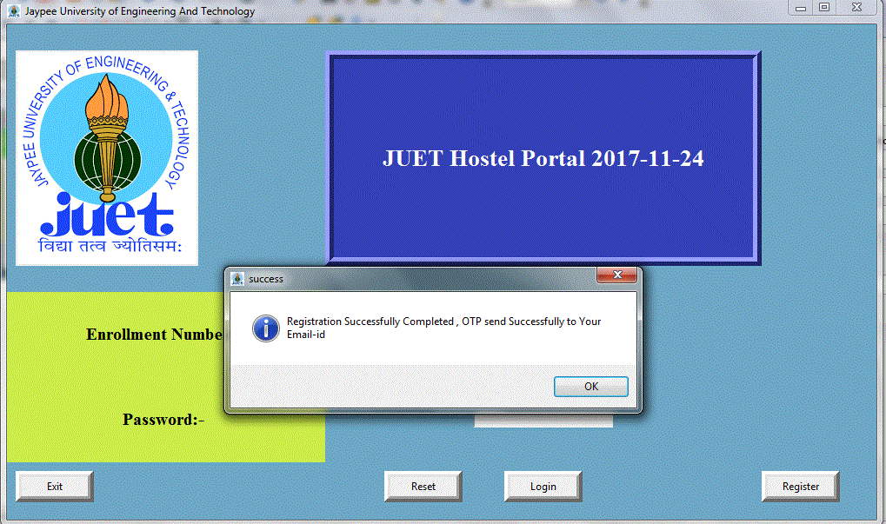

4) First Login Account Verification By Entering Received OTP via Email.

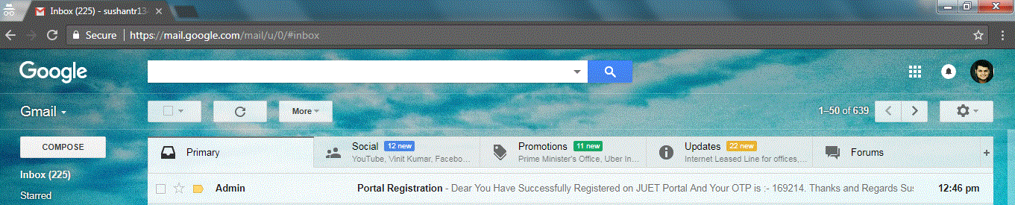
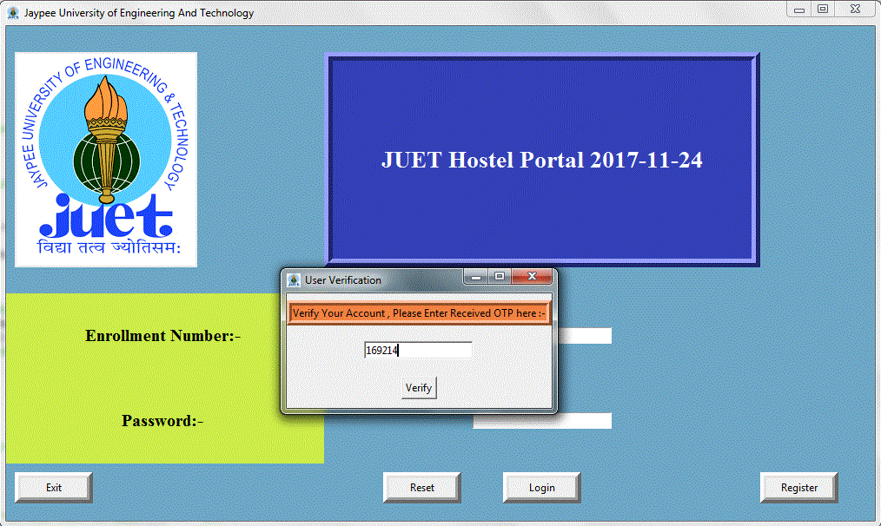

5) User Dashboard Panel

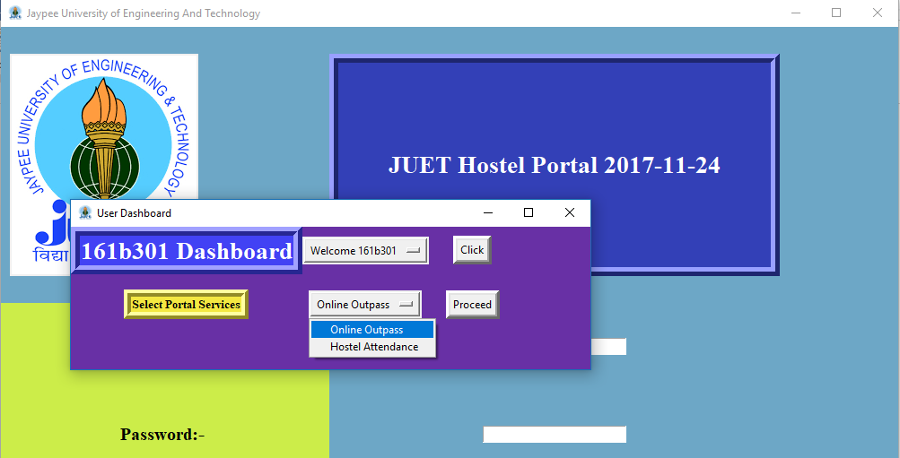

6) Outpass Form

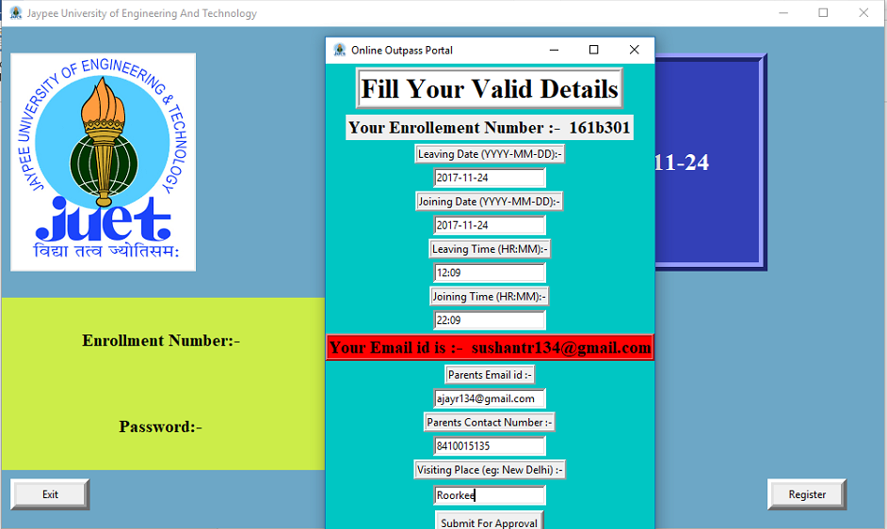

7)

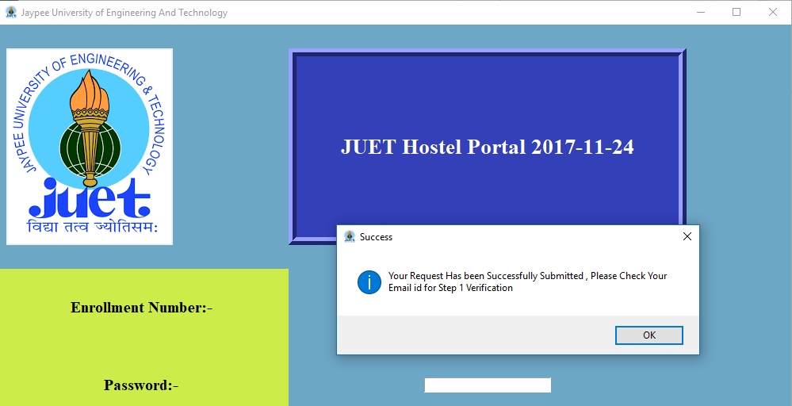

8)

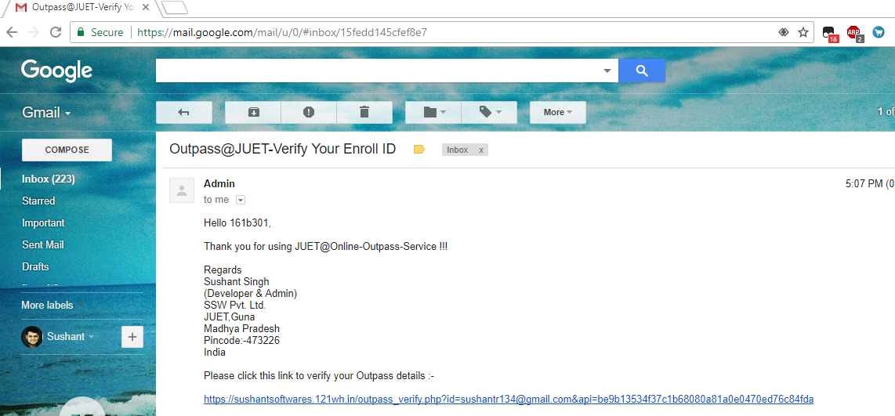

*After Completing this Above Step , Clicking on the Verification Link the request and all the Outpass Details and SMS OTP will be send to their Parents and then Step 2 and Step 3 Verification Takes Place.

Important Steps to Run Python Script :-

- PIL Library , Requests , PyDNS and validate_Email , all these Library Must be Installed to
Successfully Compile Python Script.

- And .Exe Program File also there (if you don’t want to Compile *.py file )

Thank You !!!

For More Info Visit the Website :- http://bit.ly/2iNXP2P (New JUET Website Design)

