PORTFOLIO
CA ASSIGNMENT OF CSE111
(ORIENTATION TO COMPUTING-1)
COMPUTER SCIENCE AND ENGINEERING
Submitted by:
Name:
Registration number:
Roll No.:
Section:

Submitted to:


LOVELY PROFESSIONAL UNIVERSITY

DECLARATION
I, ……………………..., a student of Bachelor of Technology under CSE discipline at Lovely Professional University, Punjab, hereby declare that all the information furnished in this project report is based on my own work and is genuine.

Name:
Registration No:

Platforms for profile creation | Link to student profile | Page number
Figma
Leet code
Stack overflow
Hacker Rank
Hacker Earth
Geeks for Geeks
Github
LinkedIn
Figma Logo
CV
Technical mooc registration proof
MOOCS Certificates

Paste screen shots of all given in the table as proof:
Eg:
Figma:

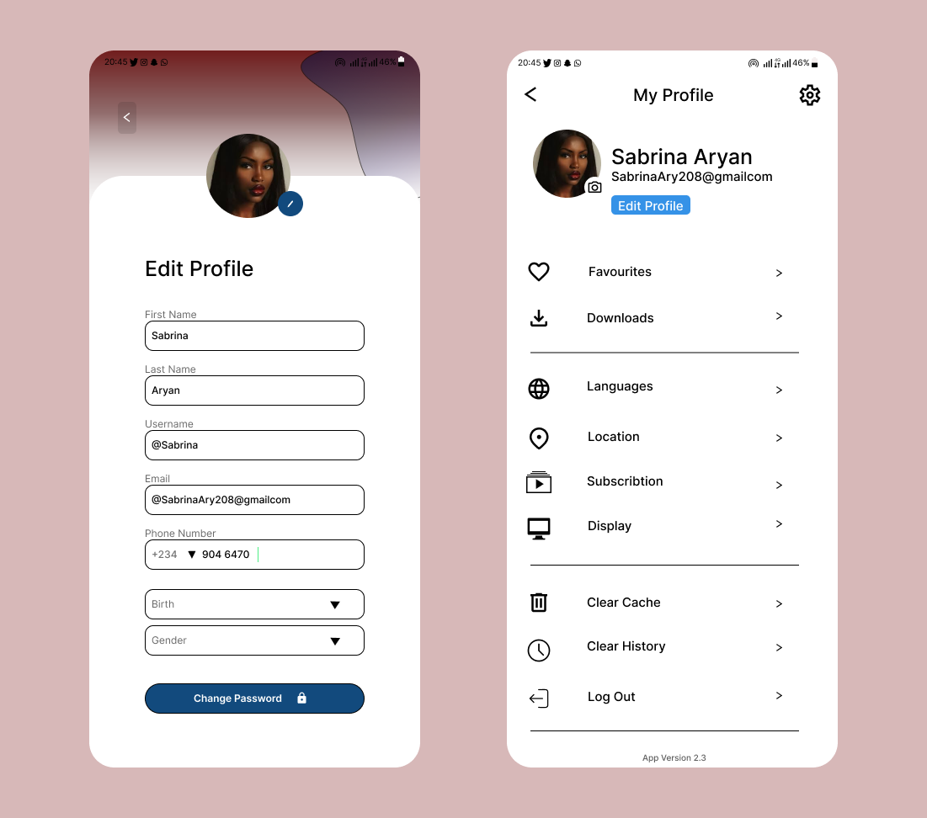

Leetcode
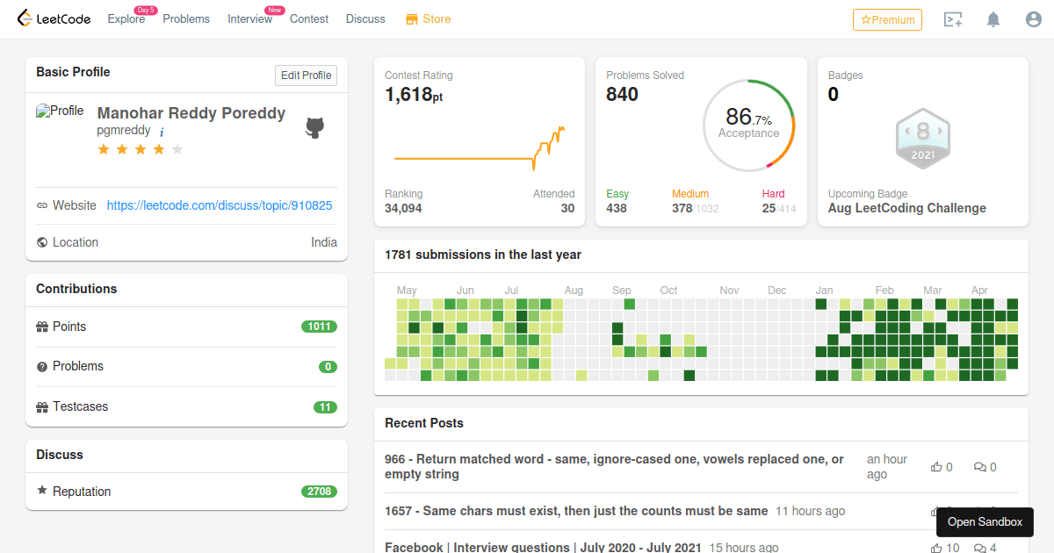

Hacker Earth…

