* Create folders like instance-1,instance-2 etc. These will be our different instances of tomcat.

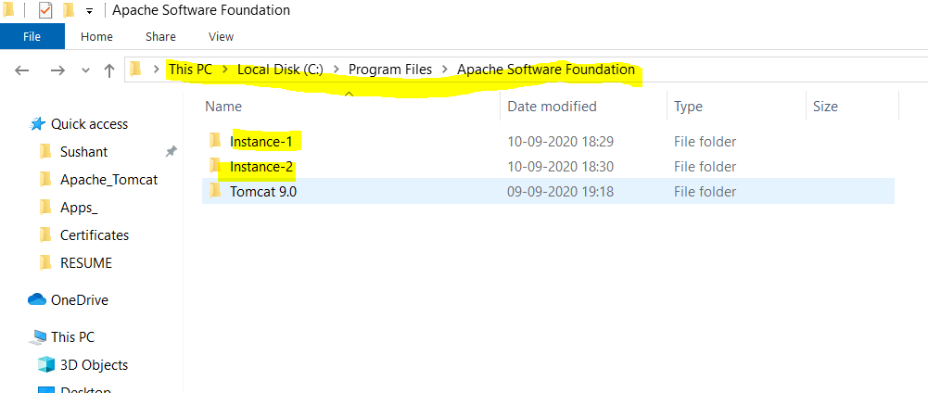

* Copy all folder from tomcat installation directory ‘C:\Program Files\Apache Software Foundation\Tomcat 9.0’ except ‘bin’ and ‘lib’. These folders will be common for all instances.

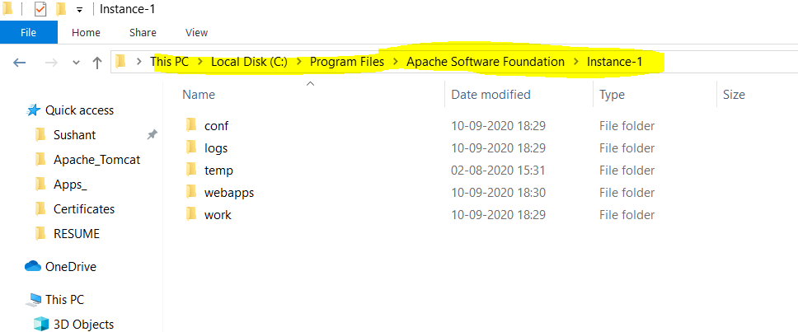

* You need to change port number for each of the instances in server.xml of ‘conf’ folder. I changed port numbers for shutdown, connector port. AJP connector block was commented. Hence I did not touch that.

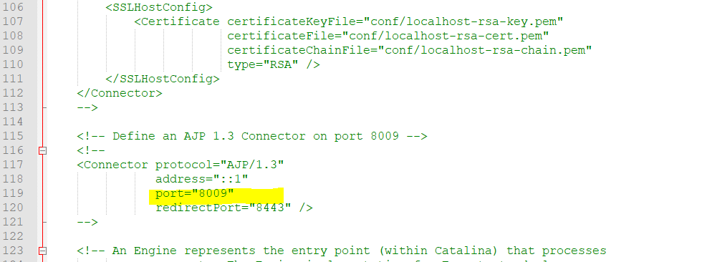

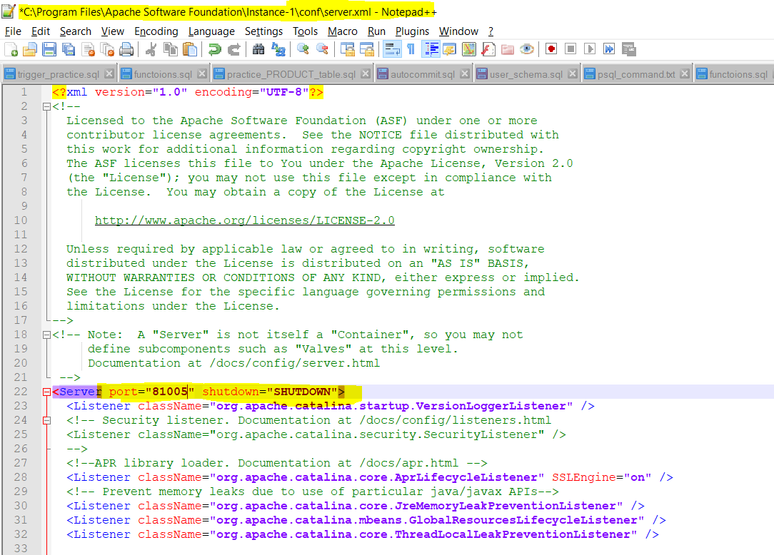

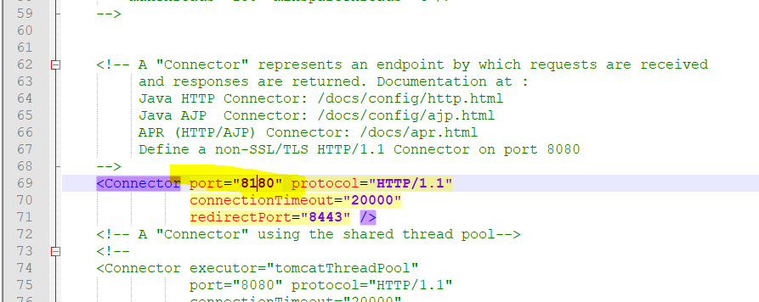

* Now, we need to have startup and shutdown scripts for these instances.

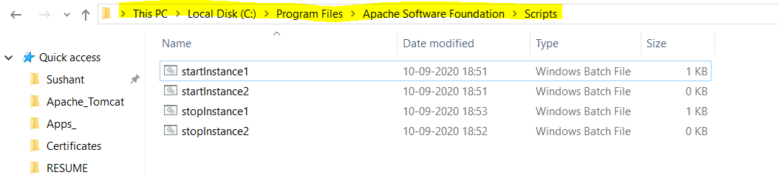

* Create a startInstance1.bat file and stopInstance1.bat file

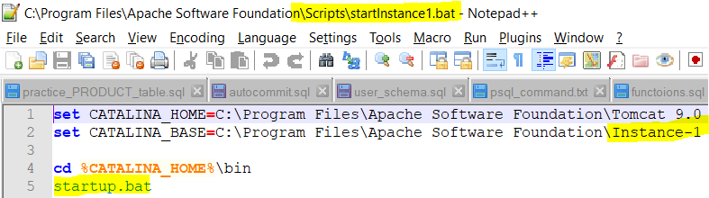

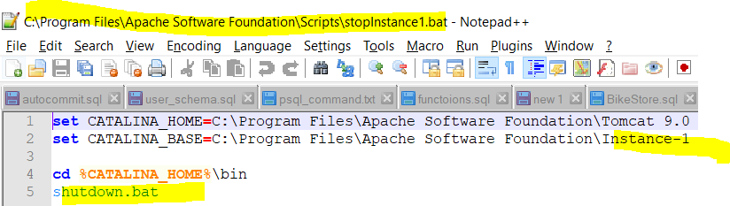

* **CATALINA_HOME**: Represents the root of your Tomcat installation, for example /home/tomcat/apache-tomcat-9.0.10 or C:\Program Files\apache-tomcat-9.0.10.
* **CATALINA_BASE**: Represents the root of a runtime configuration of a specific Tomcat instance. If you want to have multiple Tomcat instances on one machine, use the CATALINA_BASE property.

For instance 2, change these parameters accordingly. Only CATALINA_BASE will change