* Need to define JNDI context in context.xml

Configure data source in tomcat by adding declaration to context.xml

(<https://tomcat.apache.org/tomcat-9.0-doc/jndi-datasource-examples-howto.html>) – Datasource tag

(<https://docs.oracle.com/cd/E19509-01/820-3497/agqka/index.html>) - For driver name for postgresql

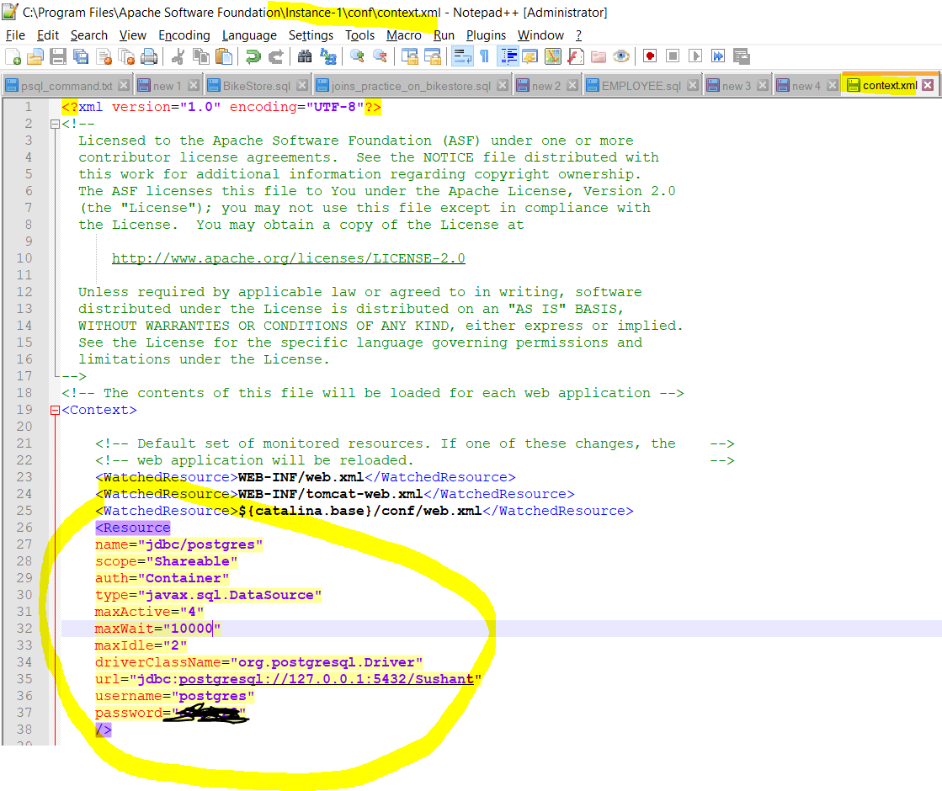

* To access this JNDI, we need parameter inside WEB-INF, web.xml, parameter is resource-ref. (Insode our application)

(<https://tomcat.apache.org/tomcat-9.0-doc/jndi-datasource-examples-howto.html>) – this web.xml file

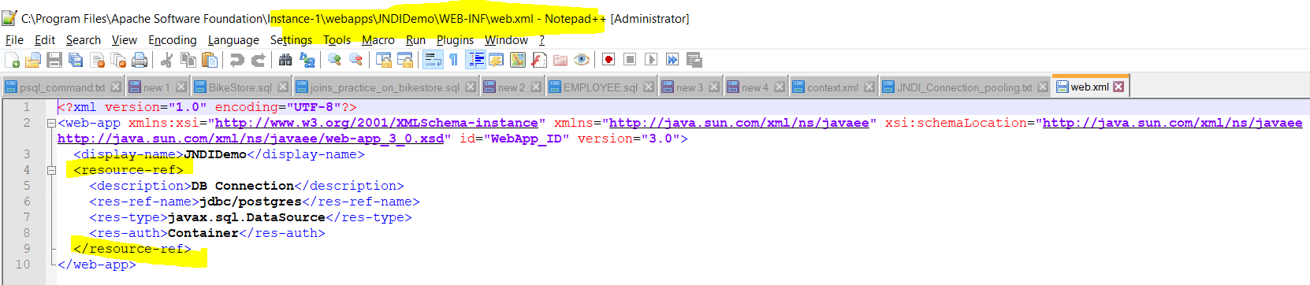

* We have to create simple JSP page

(<https://tomcat.apache.org/tomcat-9.0-doc/jndi-datasource-examples-howto.html>) – this JSP file

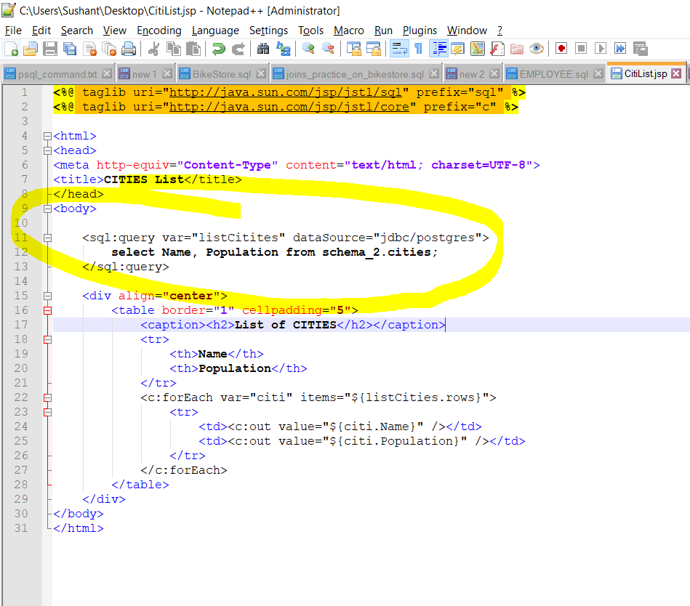

* We also need JDBC driver for postgreSQL

(<https://jdbc.postgresql.org/download.html>) – get JDBC driver form here.

And we need to place this inside /WEB-INF/lib of application.

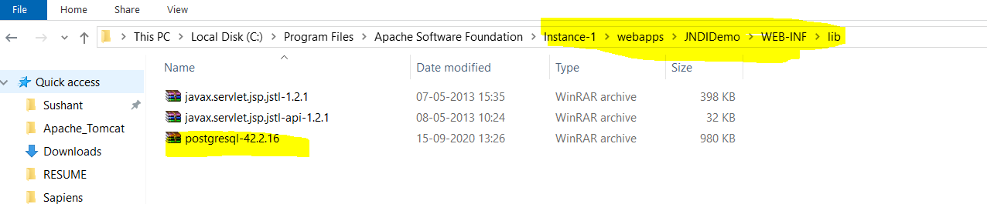

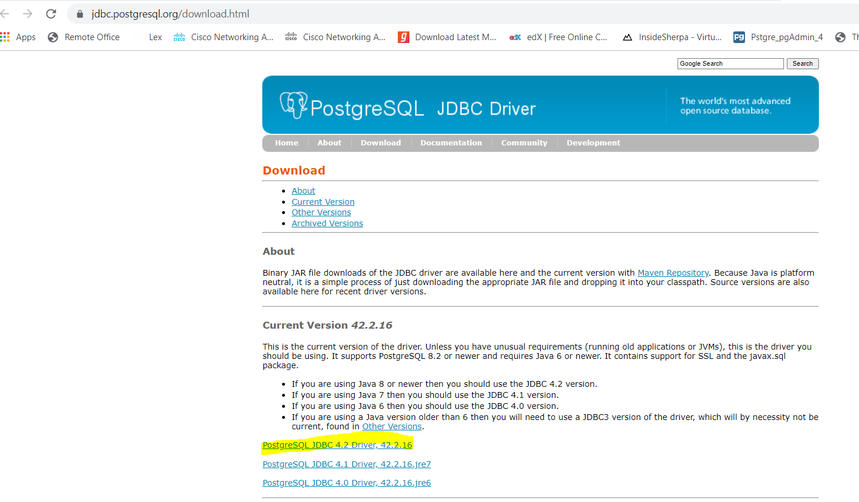

* Hit the URL

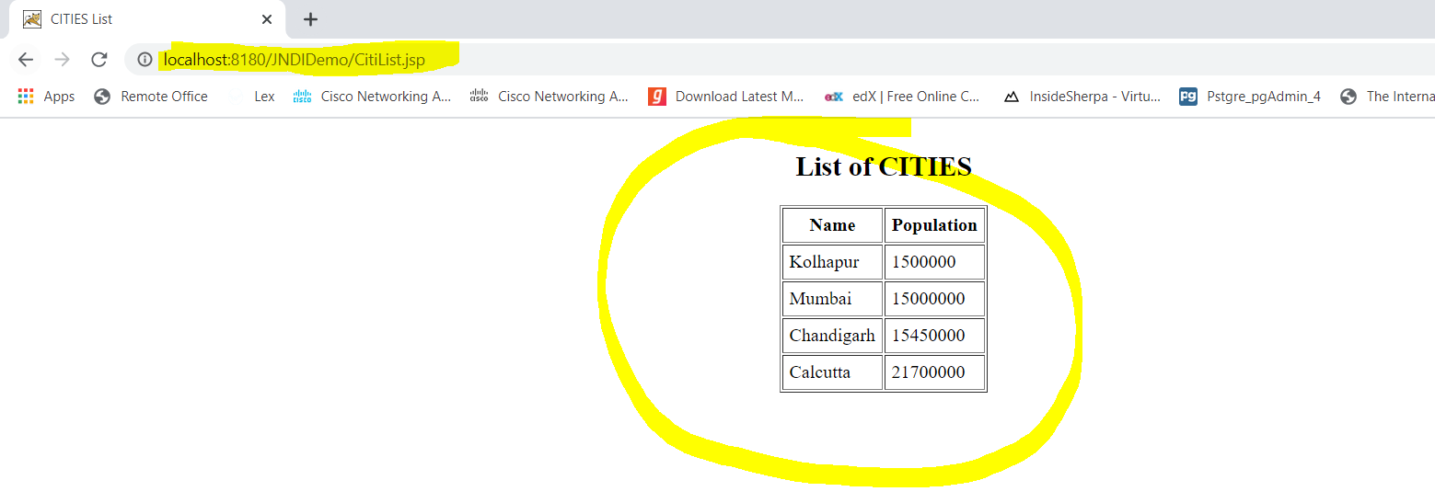

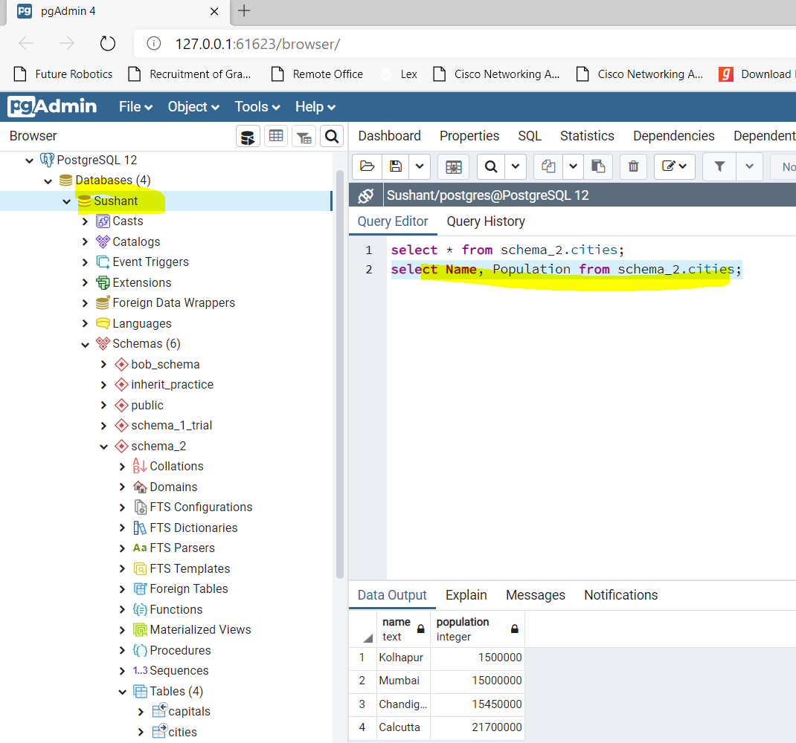

* ERROR:: 1

Stacktrace:

org.apache.jasper.servlet.JspServletWrapper.handleJspException(JspServletWrapper.java:626)

org.apache.jasper.servlet.JspServletWrapper.service(JspServletWrapper.java:500)

org.apache.jasper.servlet.JspServlet.serviceJspFile(JspServlet.java:385)

org.apache.jasper.servlet.JspServlet.service(JspServlet.java:329)

javax.servlet.http.HttpServlet.service(HttpServlet.java:733)

org.apache.tomcat.websocket.server.WsFilter.doFilter(WsFilter.java:53)

Root Cause

javax.servlet.ServletException: javax.servlet.jsp.JspException: Unable to get connection, DataSource invalid: "java.sql.SQLException: Cannot create JDBC driver of class '' for connect URL 'null'"

org.apache.jasper.runtime.PageContextImpl.handlePageException(PageContextImpl.java:666)

org.apache.jsp.UsersList_jsp._jspService(UsersList_jsp.java:175)

org.apache.jasper.runtime.HttpJspBase.service(HttpJspBase.java:71)

javax.servlet.http.HttpServlet.service(HttpServlet.java:733)

org.apache.jasper.servlet.JspServletWrapper.service(JspServletWrapper.java:477)

org.apache.jasper.servlet.JspServlet.serviceJspFile(JspServlet.java:385)

org.apache.jasper.servlet.JspServlet.service(JspServlet.java:329)

javax.servlet.http.HttpServlet.service(HttpServlet.java:733)

org.apache.tomcat.websocket.server.WsFilter.doFilter(WsFilter.java:53)

Root Cause

javax.servlet.jsp.JspException: Unable to get connection, DataSource invalid: "java.sql.SQLException: Cannot create JDBC driver of class '' for connect URL 'null'"

org.apache.taglibs.standard.tag.common.sql.QueryTagSupport.getConnection(QueryTagSupport.java:318)

org.apache.taglibs.standard.tag.common.sql.QueryTagSupport.doStartTag(QueryTagSupport.java:201)

org.apache.jsp.UsersList_jsp._jspx_meth_sql_005fquery_005f0(UsersList_jsp.java:199)

org.apache.jsp.UsersList_jsp._jspService(UsersList_jsp.java:137)

org.apache.jasper.runtime.HttpJspBase.service(HttpJspBase.java:71)

javax.servlet.http.HttpServlet.service(HttpServlet.java:733)

org.apache.jasper.servlet.JspServletWrapper.service(JspServletWrapper.java:477)

org.apache.jasper.servlet.JspServlet.serviceJspFile(JspServlet.java:385)

org.apache.jasper.servlet.JspServlet.service(JspServlet.java:329)

javax.servlet.http.HttpServlet.service(HttpServlet.java:733)

org.apache.tomcat.websocket.server.WsFilter.doFilter(WsFilter.java:53)

Note The full stack trace of the root cause is available in the server logs.

**Solution- You should modify right context.xml file. Accidently, I was placing contex.xml file in some other application’s META-INF directory. Later I changed context.xml placed in** $CATALINA_BASE/conf/

**Solution- https://tomcat.apache.org/tomcat-9.0-doc/config/context.html**

* ERROR:: 2

avax.servlet.ServletException: javax.servlet.jsp.JspException: Unable to get connection, DataSource invalid: "java.sql.SQLException: Cannot create PoolableConnectionFactory (FATAL: no pg_hba.conf entry for host "192.168.43.63", user "postgres", database "Sushant", SSL off)"

org.apache.jasper.runtime.PageContextImpl.handlePageException(PageContextImpl.java:666)

org.apache.jsp.UsersList_jsp._jspService(UsersList_jsp.java:177)

org.apache.jasper.runtime.HttpJspBase.service(HttpJspBase.java:71)

javax.servlet.http.HttpServlet.service(HttpServlet.java:733)

org.apache.jasper.servlet.JspServletWrapper.service(JspServletWrapper.java:477)

org.apache.jasper.servlet.JspServlet.serviceJspFile(JspServlet.java:385)

org.apache.jasper.servlet.JspServlet.service(JspServlet.java:329)

javax.servlet.http.HttpServlet.service(HttpServlet.java:733)

org.apache.tomcat.websocket.server.WsFilter.doFilter(WsFilter.java:53)

Root Cause

javax.servlet.jsp.JspException: Unable to get connection, DataSource invalid: "java.sql.SQLException: Cannot create PoolableConnectionFactory (FATAL: no pg_hba.conf entry for host "192.168.43.63", user "postgres", database "Sushant", SSL off)"

org.apache.taglibs.standard.tag.common.sql.QueryTagSupport.getConnection(QueryTagSupport.java:318)

org.apache.taglibs.standard.tag.common.sql.QueryTagSupport.doStartTag(QueryTagSupport.java:201)

org.apache.jsp.UsersList_jsp._jspx_meth_sql_005fquery_005f0(UsersList_jsp.java:201)

org.apache.jsp.UsersList_jsp._jspService(UsersList_jsp.java:147)

org.apache.jasper.runtime.HttpJspBase.service(HttpJspBase.java:71)

javax.servlet.http.HttpServlet.service(HttpServlet.java:733)

org.apache.jasper.servlet.JspServletWrapper.service(JspServletWrapper.java:477)

org.apache.jasper.servlet.JspServlet.serviceJspFile(JspServlet.java:385)

org.apache.jasper.servlet.JspServlet.service(JspServlet.java:329)

javax.servlet.http.HttpServlet.service(HttpServlet.java:733)

org.apache.tomcat.websocket.server.WsFilter.doFilter(WsFilter.java:53)

Note The full stack trace of the root cause is available in the server logs.

**Solution- Connection error. Googled, and found below. I was mentioning IP address of system in contet.xml. I had to change it to 127.0.0.1**

