*Dedicated Host

Dedicated physical erver you have. Like at my workplace, like in my project, our application has dedicated hosts when TOMCAR APACHE runs

*Virtual Host

Server resource are shared. Cheap to host namy applications. Multiple websites reside in same machine/serever. Shared hardware resources(CPU, Memory etc). Ex. www.website1.com, www.website2.com, www.website3.com...we get response for these requests from same server...same tomcat container.

*Requiremrnt::

Want to host www.website1.com, www.website1.com, www.website1.com on my windows machine on tomcat.

As we know, web application resides into webapps folder. So let's create website1-webapps, website2-webapps, website3-webapps folders that contain web application for given websites inside ROOT.

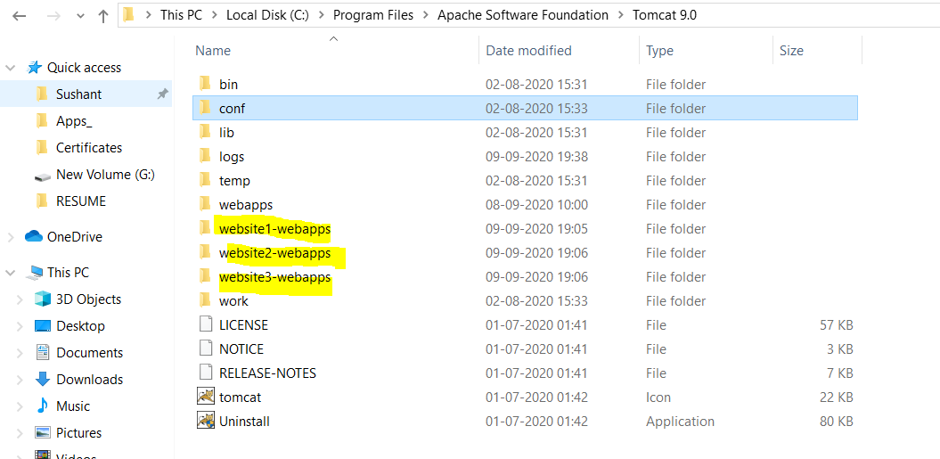

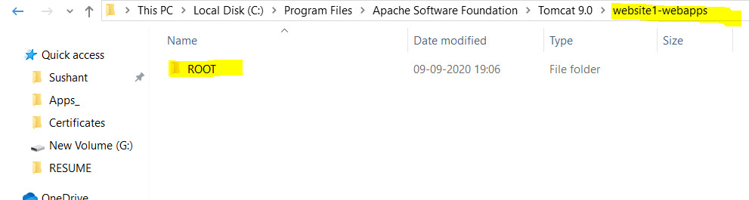

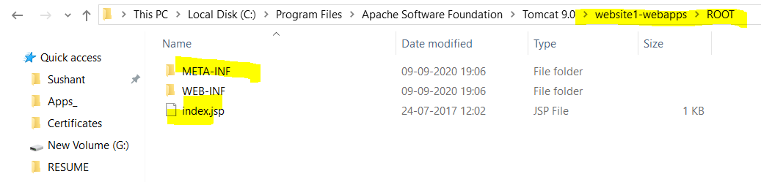

Now we have to make certain changes in server.xml to point to these new deploy folder.

Note, below configuration in server.xml

<Host name="localhost" appBase="webapps"

unpackWARs="true" autoDeploy="true">

</Host>

*localhost- IP address appBase- where web application resides.

*So we will create three virtual hosts like below

<Host name="www.website1.com" appBase="website1-webapps"

unpackWARs="true" autoDeploy="true">

</Host>

<Host name="www.website2.com" appBase="website2-webapps"

unpackWARs="true" autoDeploy="true">

</Host>

<Host name="www.website3.com" appBase="website3-webapps"

unpackWARs="true" autoDeploy="true">

</Host>

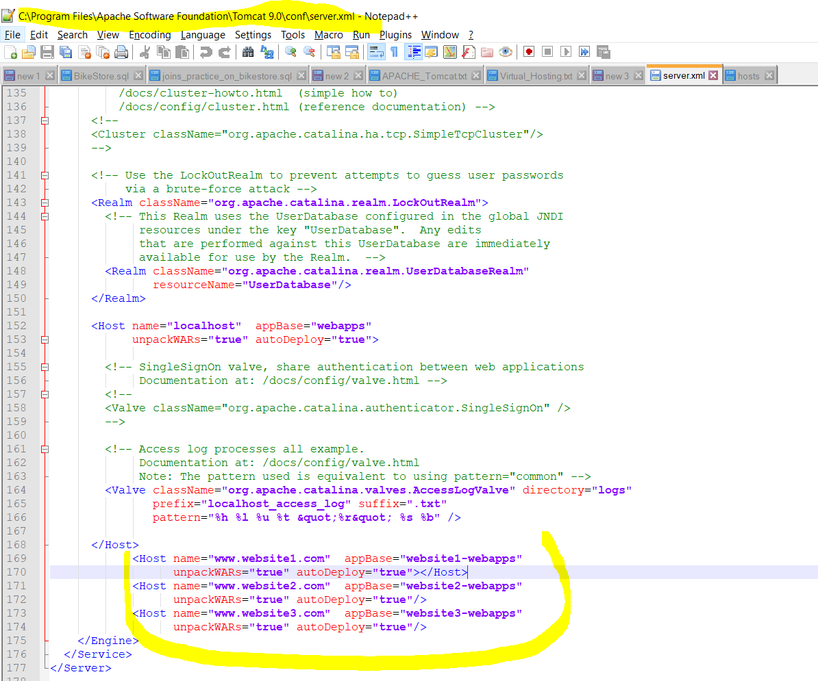

That means, www.website3.com will refer to website3-webapps containts.

**Also, www.website1.com, www.website1.com, www.website1.com these hostnames does not exist in reaity. So we will somehow make them to point to our own local machines IP adress. And this well be done by adding entries in DNS Files.

window+R --> drivers --> etc --> hosts file

127.0.0.1 www.website1.com

127.0.0.1 www.website2.com

127.0.0.1 www.website3.com

Add above entries to hosts file and make sure you are doing this as administrator.

Re-start the apache-tomcat and hit URLs

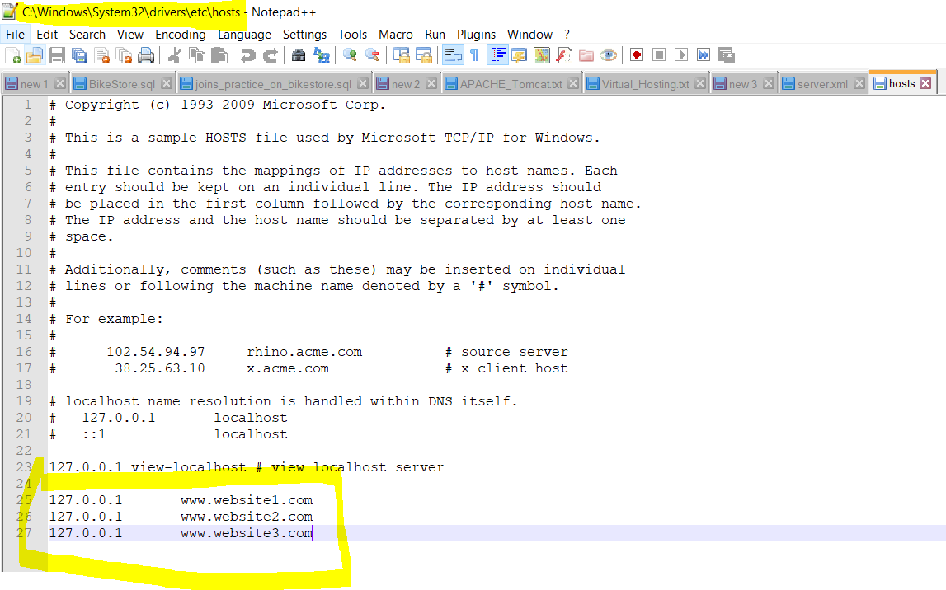

www.website1.com:8080

www.website2.com:8080

www.website3.com:8080

Different contain will be flashed depending upon web contains in respective webapps folder.

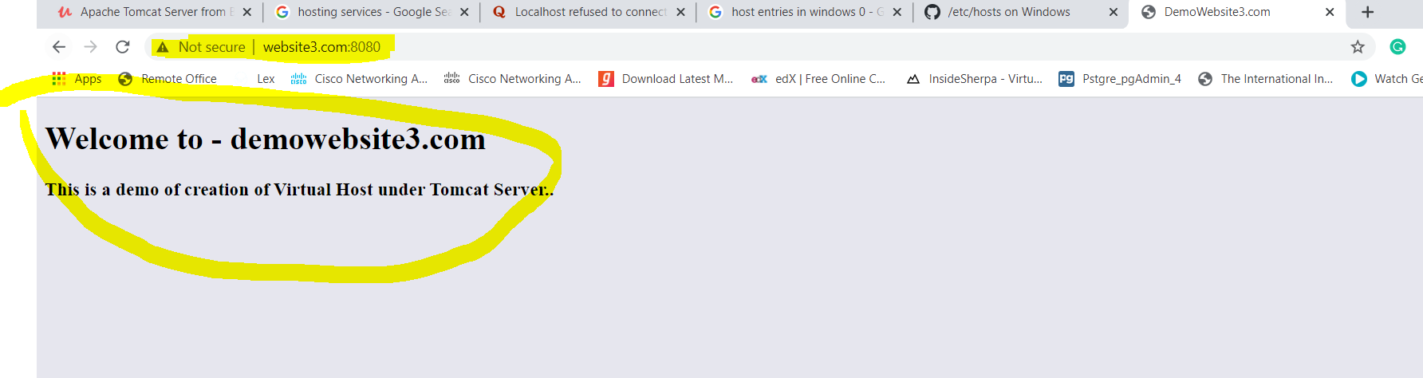

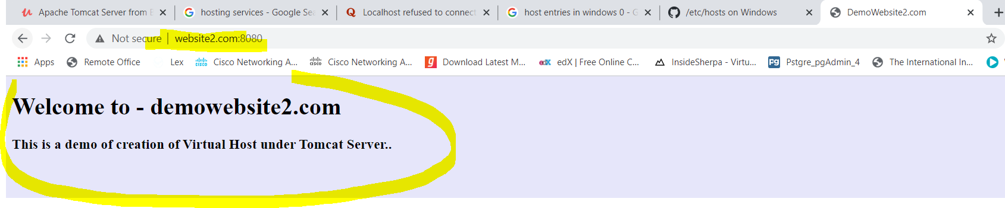

**Errors I received while doing these things**

Using CATALINA_BASE: "C:\Program Files\Apache Software Foundation\Tomcat 9.0"

Using CATALINA_HOME: "C:\Program Files\Apache Software Foundation\Tomcat 9.0"

Using CATALINA_TMPDIR: "C:\Program Files\Apache Software Foundation\Tomcat 9.0\temp"

Using JRE_HOME: "C:\Program Files\Java\jdk"

Using CLASSPATH: "C:\Program Files\Apache Software Foundation\Tomcat 9.0\bin\bootstrap.jar;C:\Program Files\Apache Software Foundation\Tomcat 9.0\bin\tomcat-juli.jar"

NOTE: Picked up JDK_JAVA_OPTIONS: --add-opens=java.base/java.lang=ALL-UNNAMED --add-opens=java.base/java.io=ALL-UNNAMED --add-opens=java.rmi/sun.rmi.transport=ALL-UNNAMED

09-Sep-2020 19:35:05.673 SEVERE [main] org.apache.tomcat.util.digester.Digester.fatalError Parse fatal error at line [177] column [7]

org.xml.sax.SAXParseException; systemId: file:/C:/Program%20Files/Apache%20Software%20Foundation/Tomcat%209.0/conf/server.xml; lineNumber: 177; columnNumber: 7; The element type "Host" must be terminated by the matching end-tag "</Host>".

at java.xml/com.sun.org.apache.xerces.internal.util.ErrorHandlerWrapper.createSAXParseException(ErrorHandlerWrapper.java:204)

at java.xml/com.sun.org.apache.xerces.internal.util.ErrorHandlerWrapper.fatalError(ErrorHandlerWrapper.java:178)

at java.xml/com.sun.org.apache.xerces.internal.impl.XMLErrorReporter.reportError(XMLErrorReporter.java:400)

at java.xml/com.sun.org.apache.xerces.internal.impl.XMLErrorReporter.reportError(XMLErrorReporter.java:327)

at java.xml/com.sun.org.apache.xerces.internal.impl.XMLScanner.reportFatalError(XMLScanner.java:1471)

at java.xml/com.sun.org.apache.xerces.internal.impl.XMLDocumentFragmentScannerImpl.scanEndElement(XMLDocumentFragmentScannerImpl.java:1681)

at java.xml/com.sun.org.apache.xerces.internal.impl.XMLDocumentFragmentScannerImpl$FragmentContentDriver.next(XMLDocumentFragmentScannerImpl.java:2879)

at java.xml/com.sun.org.apache.xerces.internal.impl.XMLDocumentScannerImpl.next(XMLDocumentScannerImpl.java:602)

at java.xml/com.sun.org.apache.xerces.internal.impl.XMLDocumentFragmentScannerImpl.scanDocument(XMLDocumentFragmentScannerImpl.java:532)

at java.xml/com.sun.org.

**I forgot to add closing tag for <Host> tag**

Can be done in following way as well.

<Host name="www.website1.com" appBase="website1-webapps"

unpackWARs="true" autoDeploy="true"/>

<Host name="www.website2.com" appBase="website2-webapps"

unpackWARs="true" autoDeploy="true"/>

<Host name="www.website3.com" appBase="website3-webapps"

unpackWARs="true" autoDeploy="true"/>