* To create .war file

jar cvf web_demo_app.war *

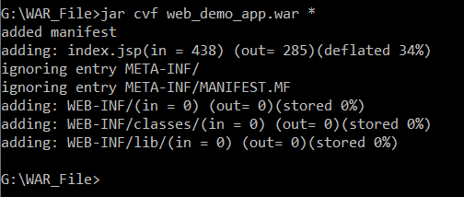

* Add ‘Deploy’ Plug in to JENKINS

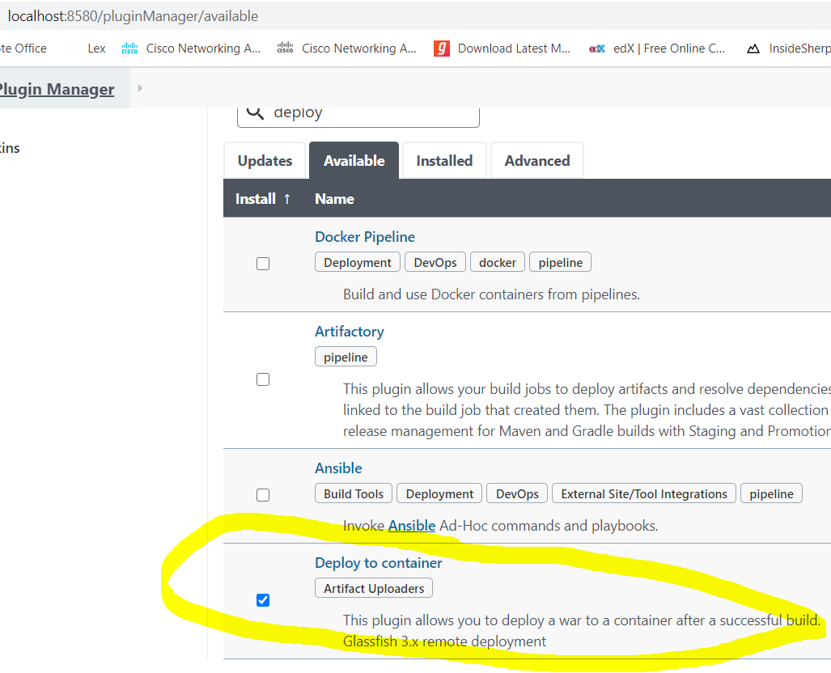

* Create JENKINS JOB

In POST-build actions, you will get an option for war deployment only if above plug-in is installed. Click on question mark and it will give you more info about parameters.

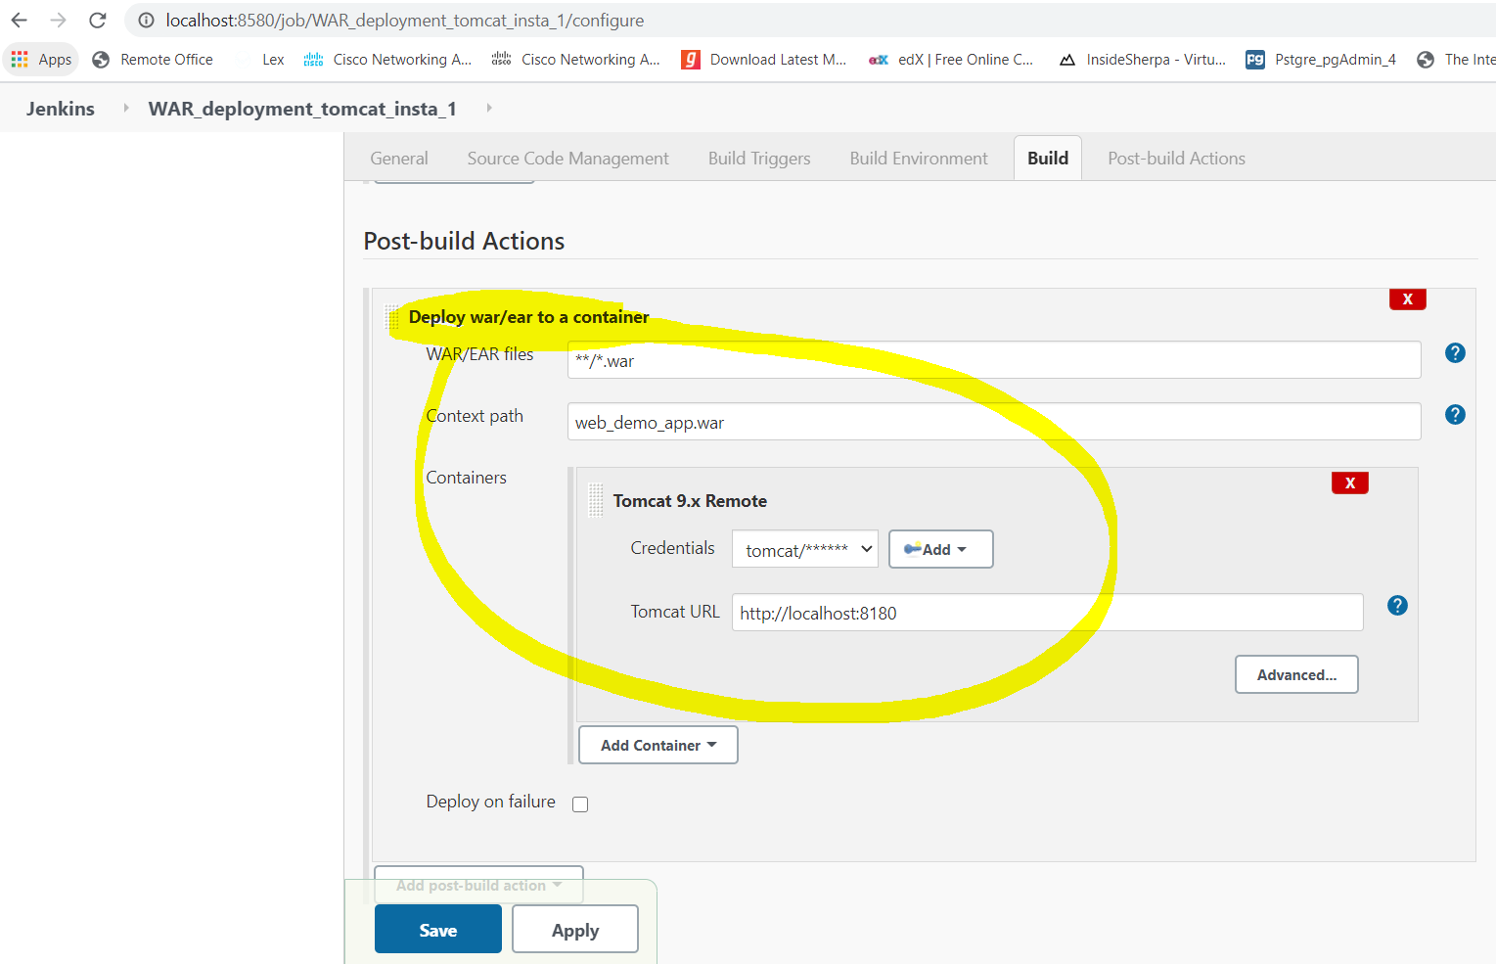

* Build the job

At first it threw error: error 403 is related to permission/access issues. On checking tomcat user .xml file, manager-script role was not defined and it was not granted to ‘tomcat’ user.

‘‘org.codehaus.cargo.container.tomcat.internal.TomcatManagerException: The username you provided is not allowed to use the text-based Tomcat Manager (error 403)’’

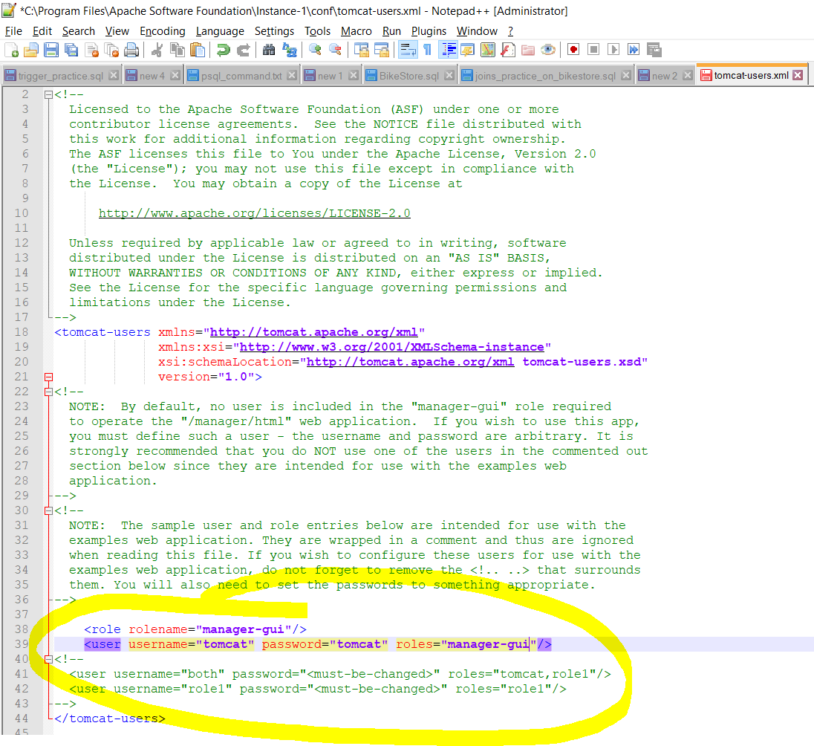

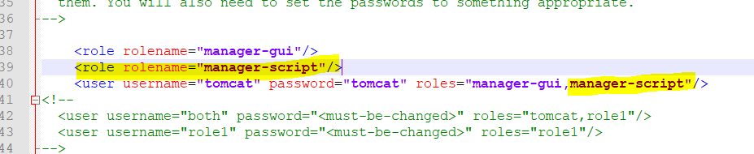

* After this build the job. ‘.war’ file was deployed.

