gcloud auth login 🡪 to set LOGIN ID

gcloud config set project <project_id> 🡪 to set default project

bq show 🡪 To list all projects, when used with option shows info about that option.

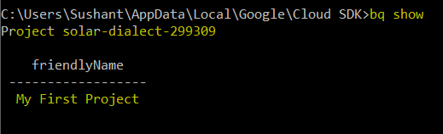

bq show --dataset <project_id>:<dataset_name> 🡪 Info about dataset name given

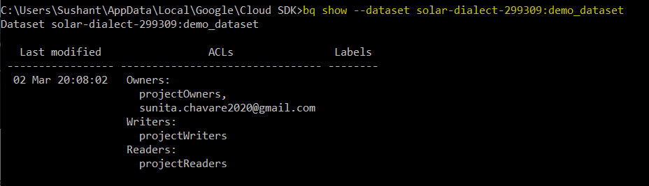

bq show --schema project_id>:<dataset_name>.<table_name> 🡪 Info about schema(table)



bq shell 🡪 go into bq shell mode, so do not have to explicitly write bq in each command above

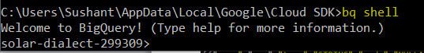

**Querying Commands**

bq query --use_legacy_sql=false select * from solar-dialect-299309.demo_dataset.demo_table

Flag –use_legacy_sql is to switch between standard SL and legacy SLQ. By default, this option is true. To switch to standard SQL, we set this flag to False.

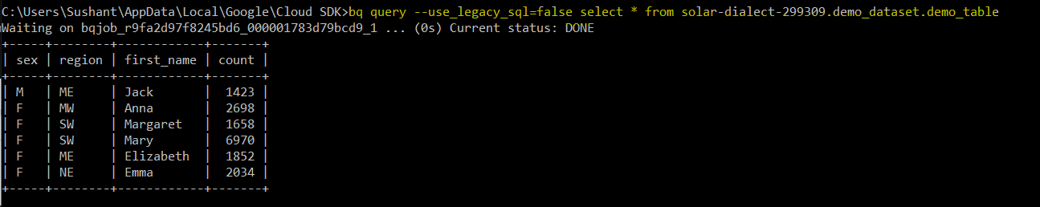

**Creating dataset**

bq mk --dataset solar-dialect-299309:new_dataset_from_cli

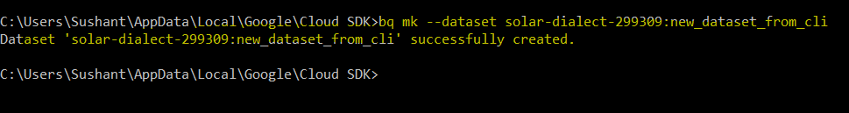

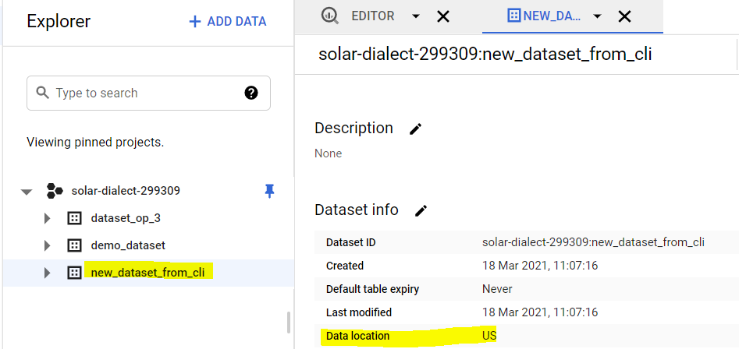

All other parameters, it set to default values. We can mention these parameters in command to set values to different.

**Creating table**

bq mk --table --description "table created from CLI" --schema customer_name:string,gender:string,count:integer solar-dialect-299309:new_dataset_from_cli.table_from_cli



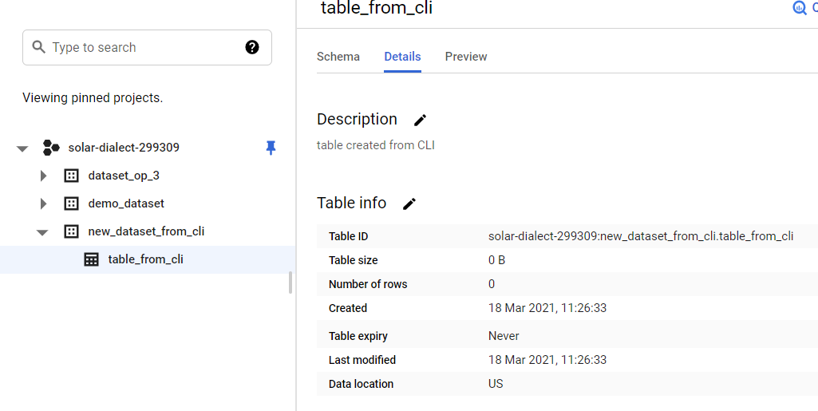

Instead of providing schema in command line, you can create a JSON file and give path to JSON file after --schema



‘bq load’ is command to load data into table