**Dataset operations 🡪 Copying dataset**

Create a dataset in different regions

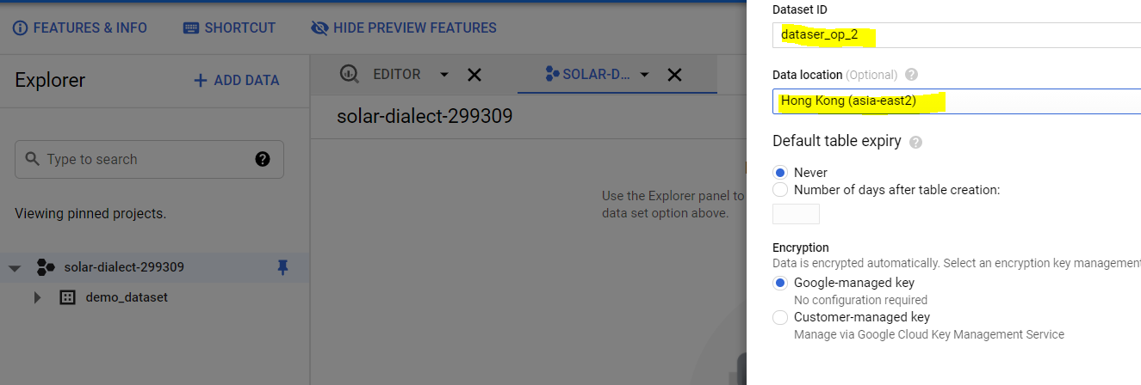

Now, I want to copy existing dataset ‘demo_dataset’ to newly created dataset.

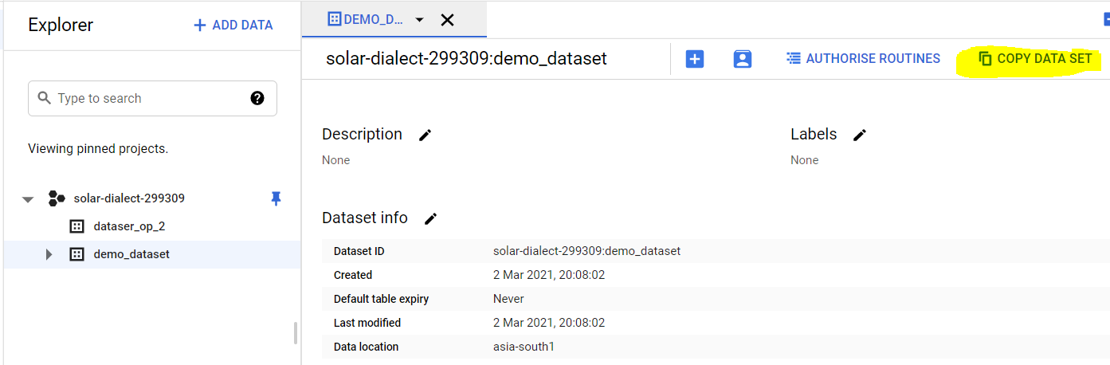

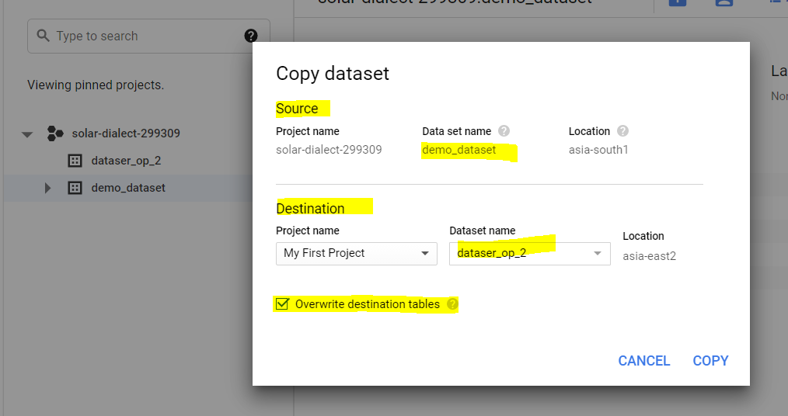

Source is automatically populated. You can specify destination dataset name. If tables with same name exists in datasets, you can overwrite them.

You can also set a job, that will run at given time to copy dataset. You must enable BQ data transfer API for this.

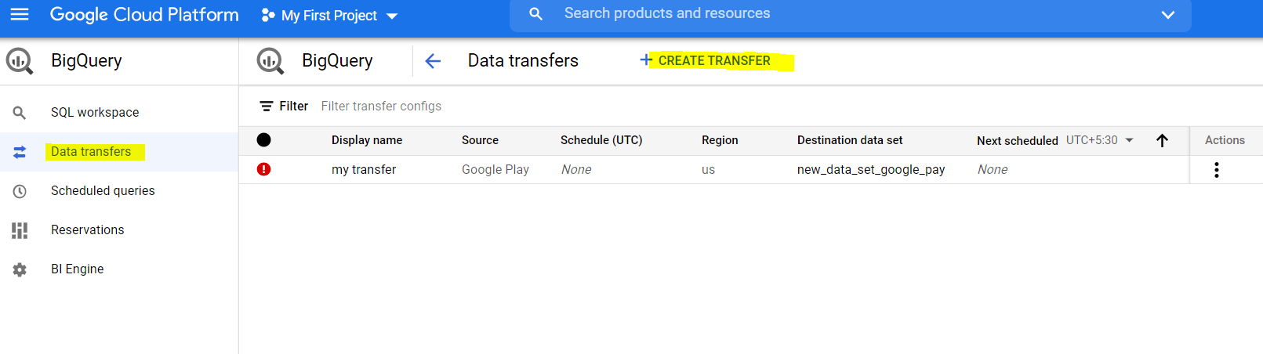

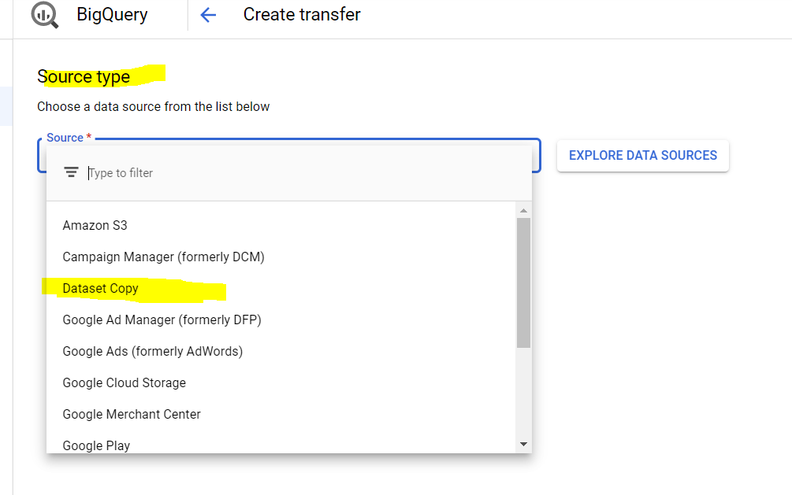

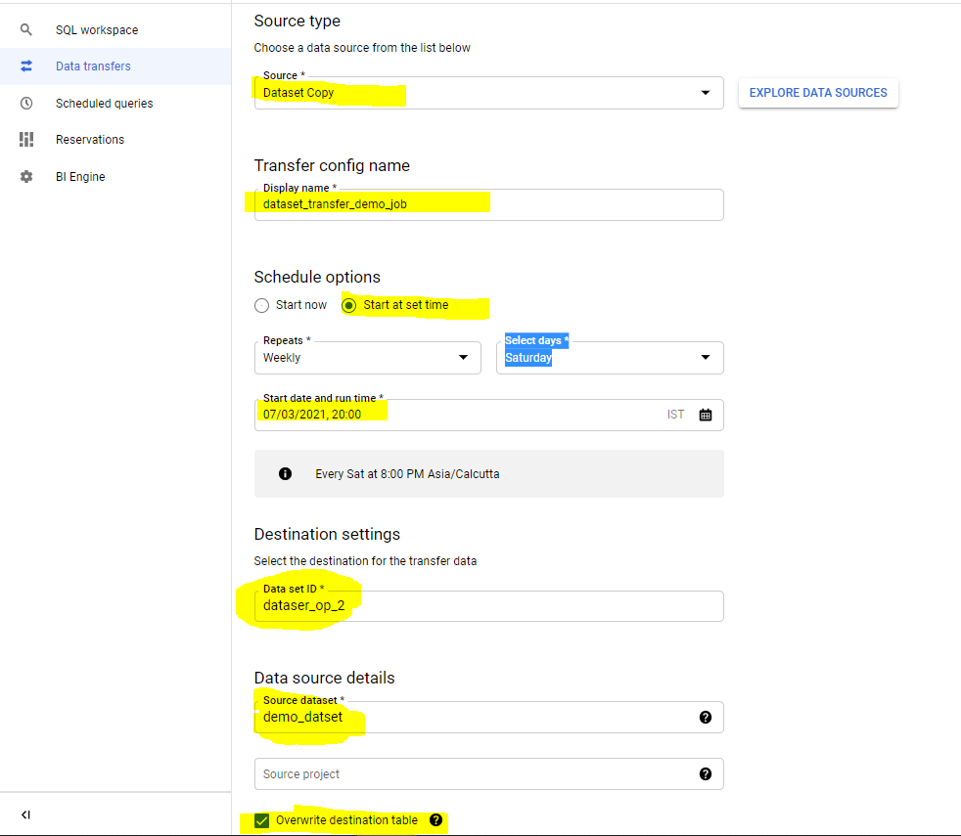

**Table operations**

Copying a table

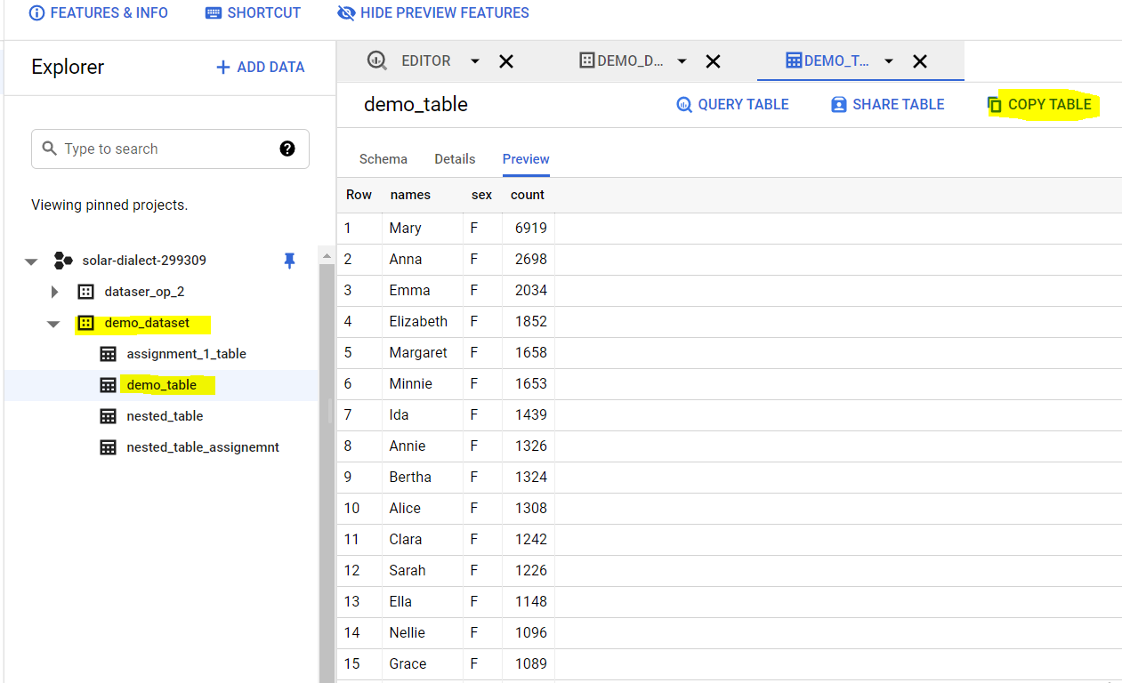

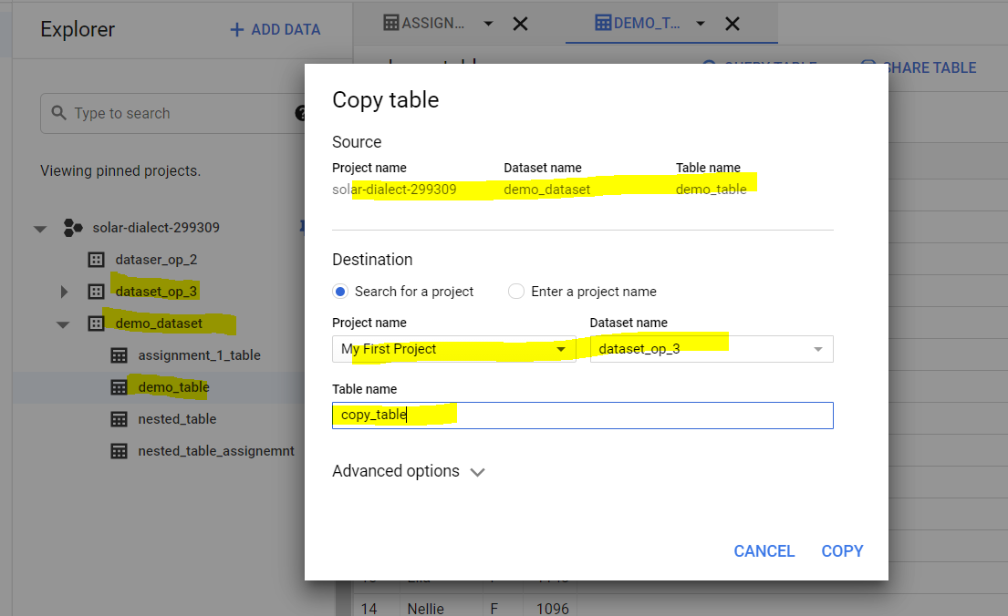

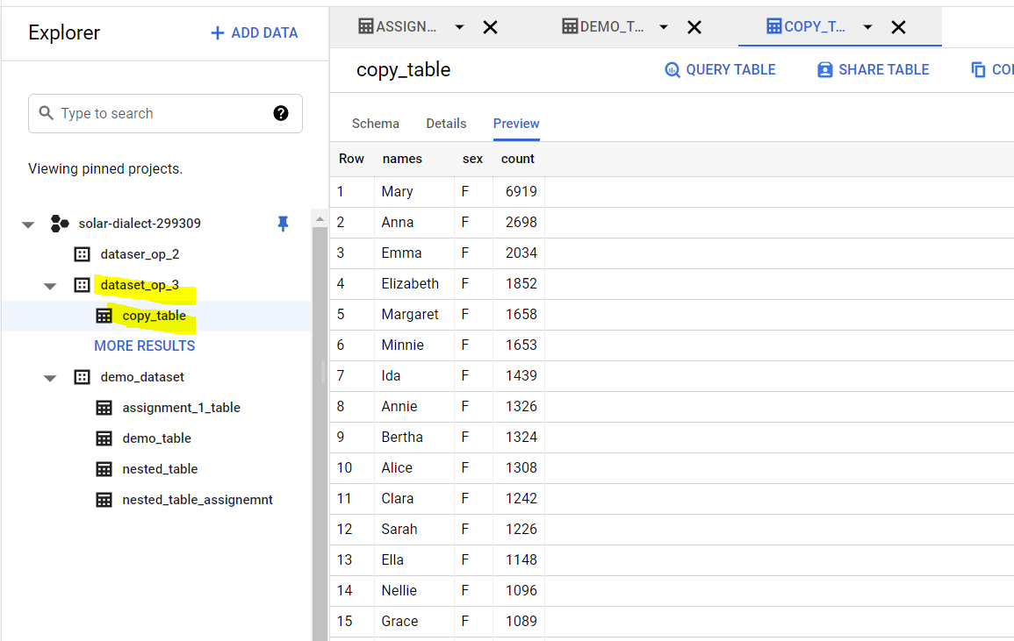

**Important note 🡪 Both dataset should be in same region if we are copying Table/schema.**

Demo_dataset and Dataset_op_3 both are in same region (Mumbai).

Table/Schema change 🡪

1. Native schema changes
   1. Adding a column
   2. Required to Nullable
2. Manual schema changes

**1 a. Adding Column**

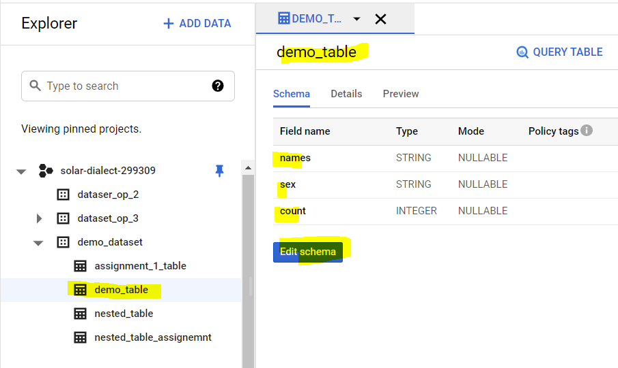

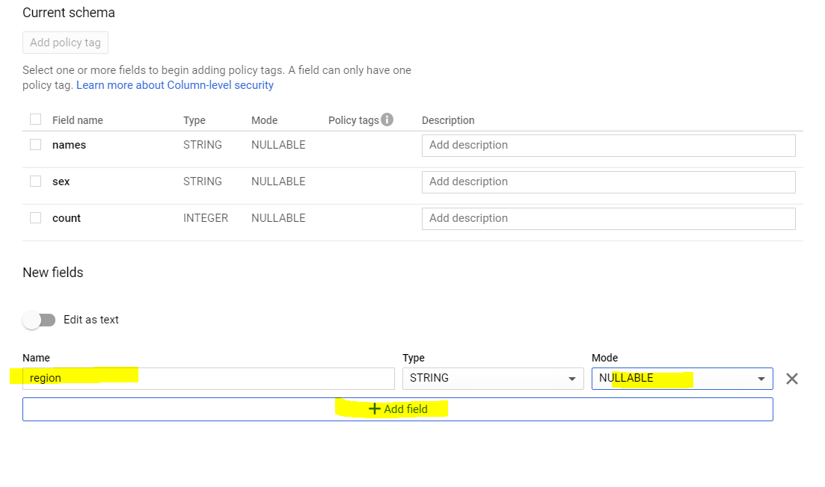

You can add new column as ‘Nullable’ or ‘Repeated’. ‘REQUIRED’ mode can not be for ne column to existing through UI. From CLI, you can do it.

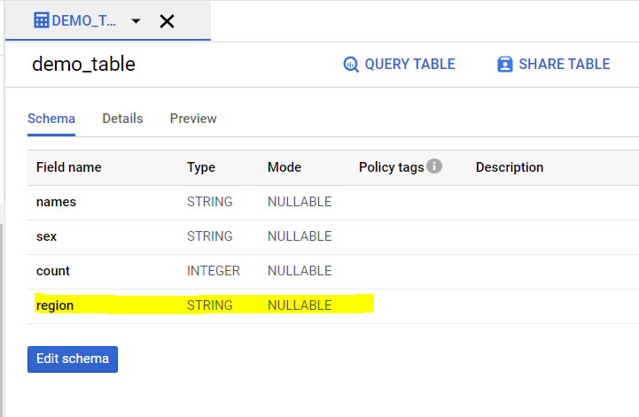

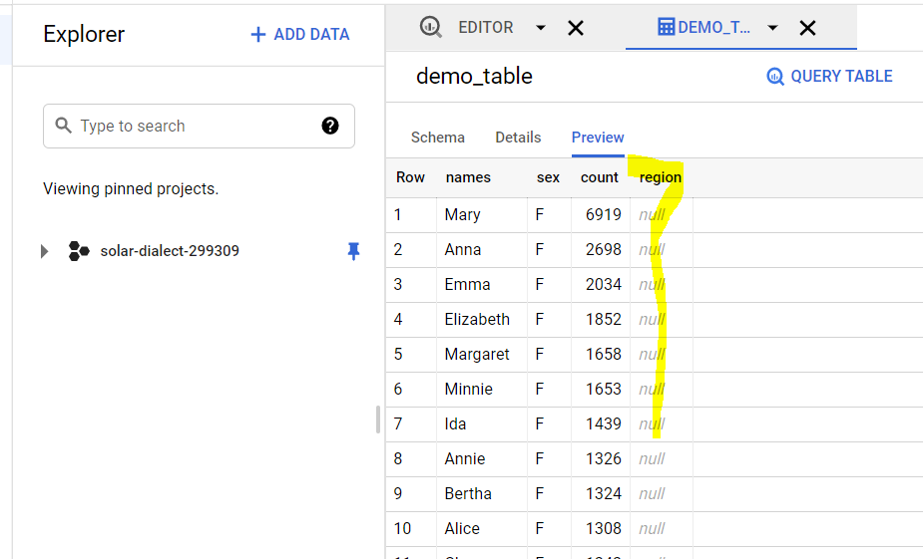

‘NULL’ values are populated to new column created.

If you want to UPDATE table, you can create table with same name and choose ‘overwrite’ option. This will update all table content.

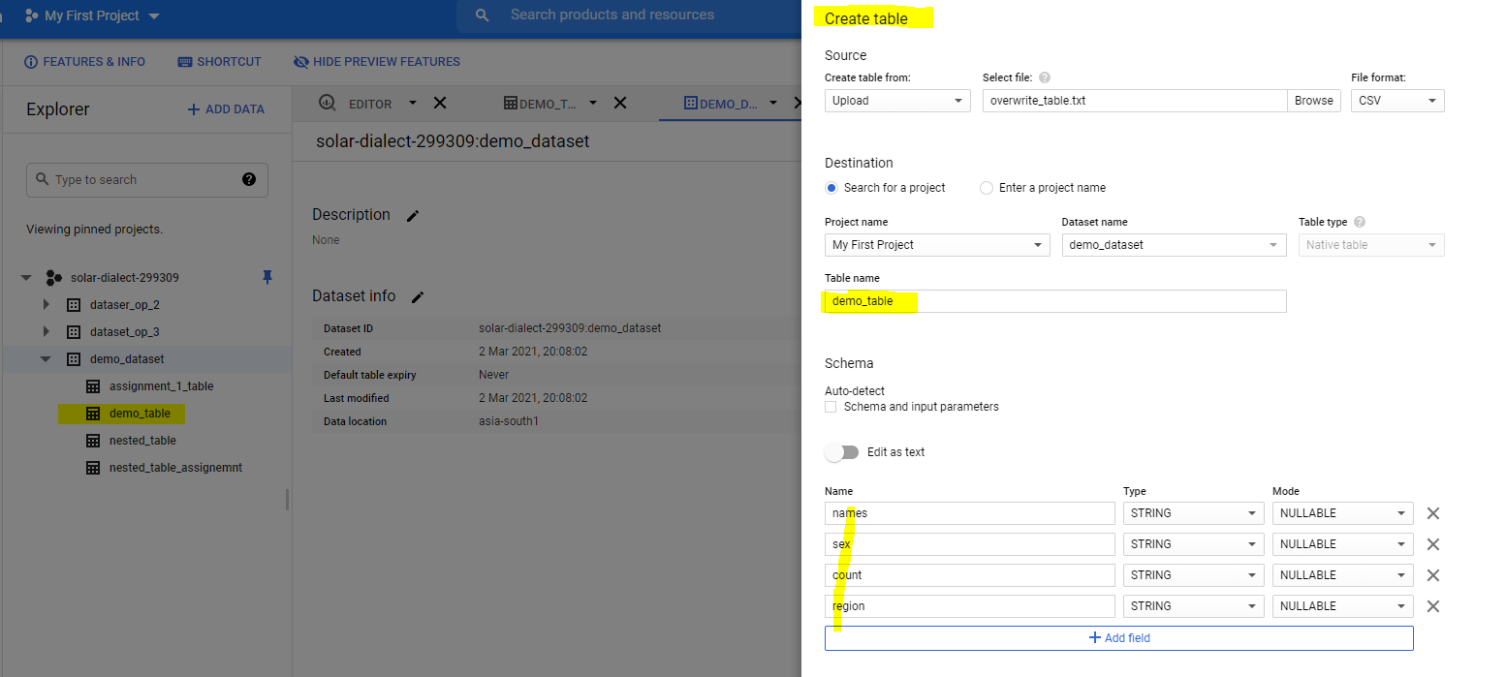

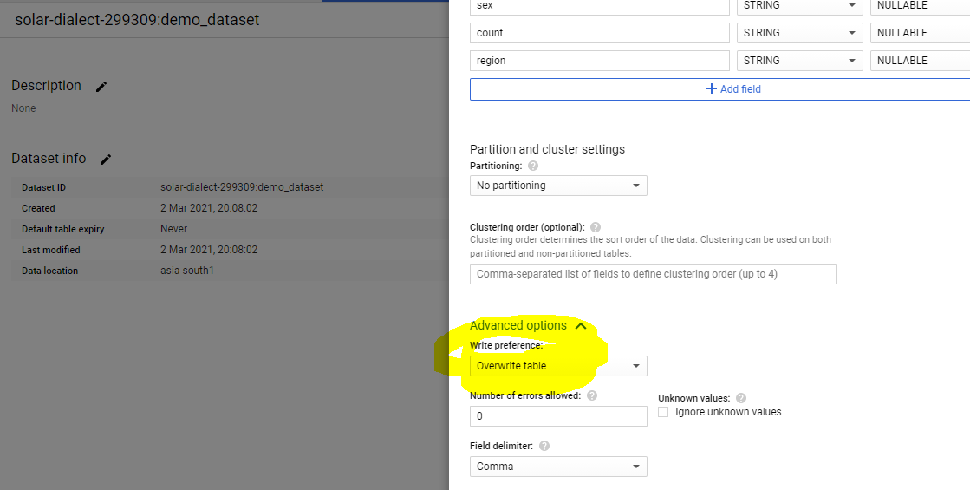

Existing table is overwritten

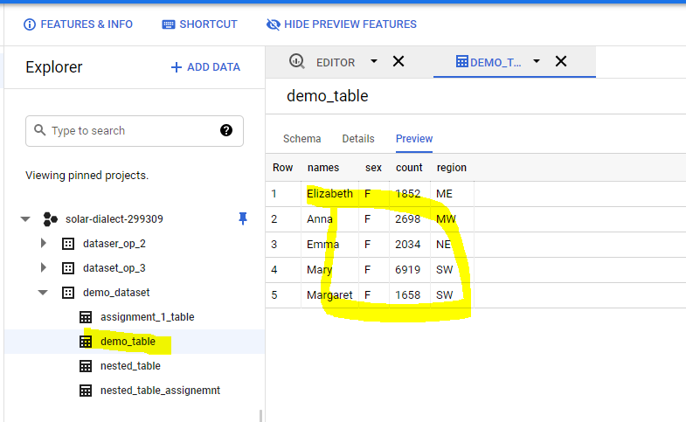

You get option like – overwrite or append. In append, new values will be added to existing table.

**2. Manual schema change-**

a. Column name change:

Renaming column name is not supported through UI or CLI.

Write a SQL query, provide alias name as new column name to intended column and overwrite existing table. Save result of this SQL query to destination table with table name same as existing table.

Want to change column names ‘names’ to ‘first_names’

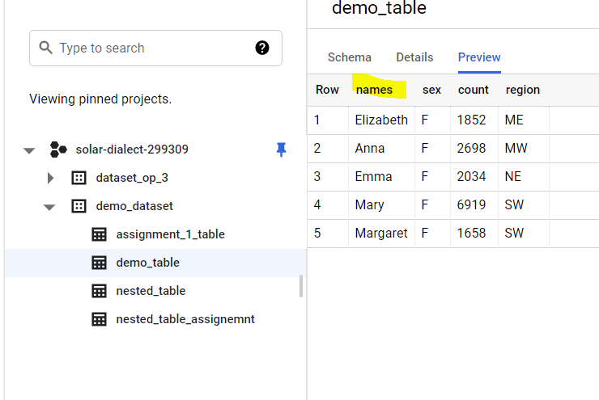

So the SQL query will be like

SELECT * except(names), names as first_name FROM `solar-dialect-299309.demo_dataset.demo_table`

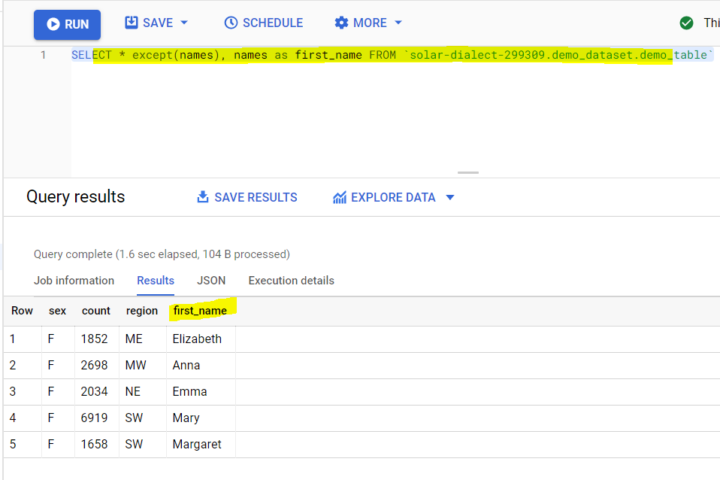

In query setting, select ‘set destination table for query result’. And give same dataset and same table name and choose option ‘OVERWRITE TABLE’.

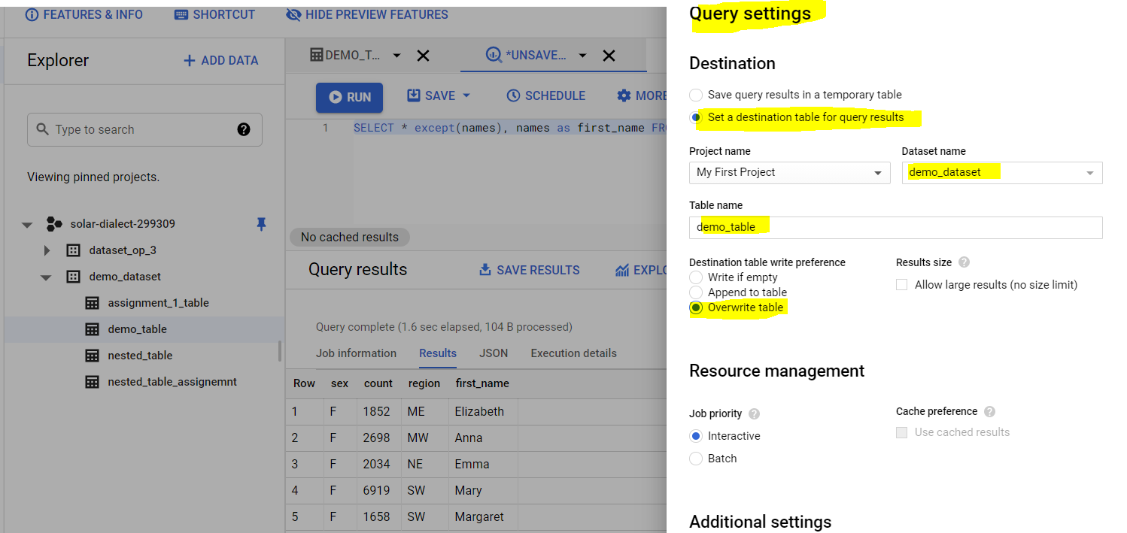

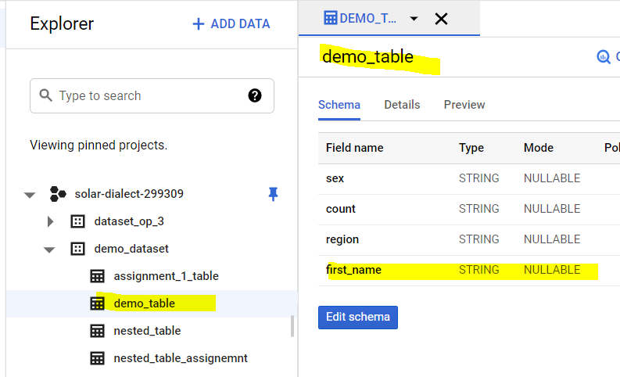

b. Column datatype change-

We can cast column with different datatype and then save query result to same table as destination table (same as above)

Column name ‘count’ datatype need to change from STRING to NUMERIC.

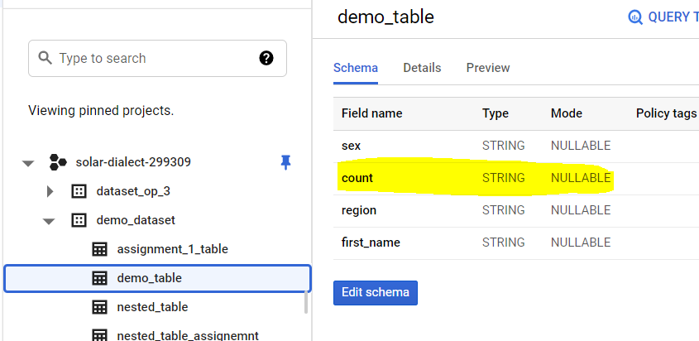

SELECT * EXCEPT(count), CAST(count as NUMERIC) as count FROM `solar-dialect-299309.demo_dataset.demo_table`

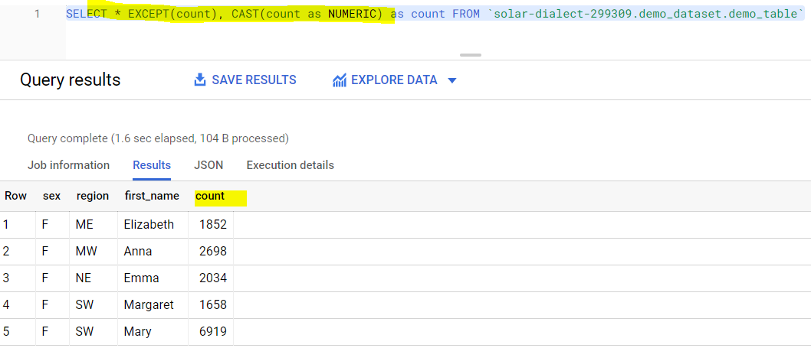

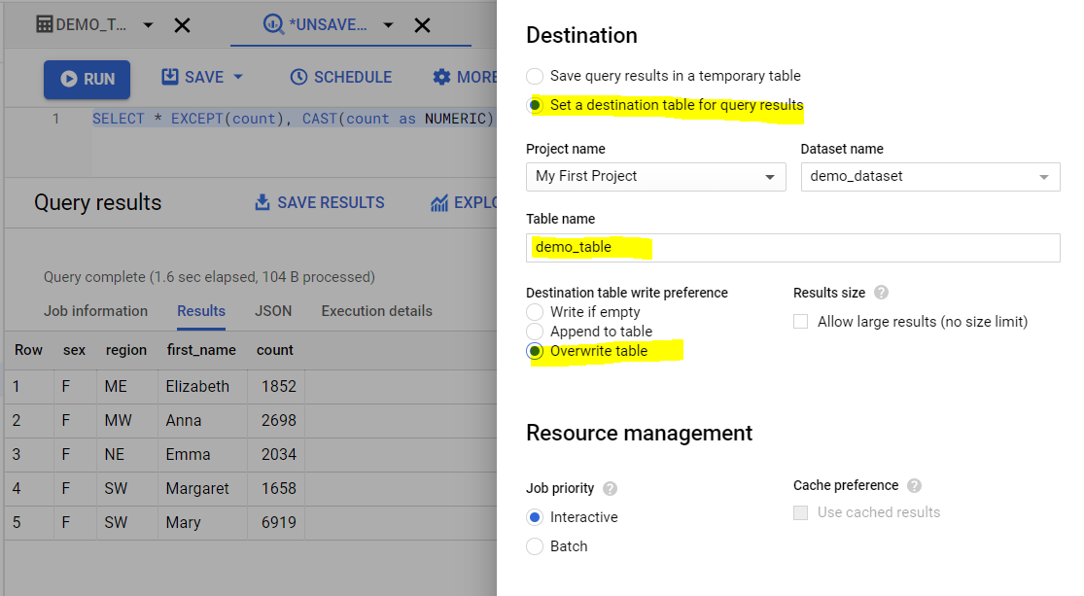

We can save query result to destination table with same name as existing table.

b. Dropping a column

SELECT * except(region) FROM `solar-dialect-299309.demo_dataset.demo_table`

Save above query result to destination table name same as orginal table name.

