Querying table is easy

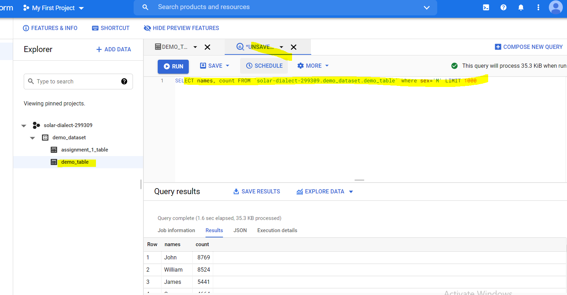

You must give table name in following format only

`<project_name>.<dataset_name>.<table_name>` (in back quote)

SELECT names, count FROM `solar-dialect-299309.demo_dataset.demo_table` where sex='M' LIMIT 1000

**Query Settings**

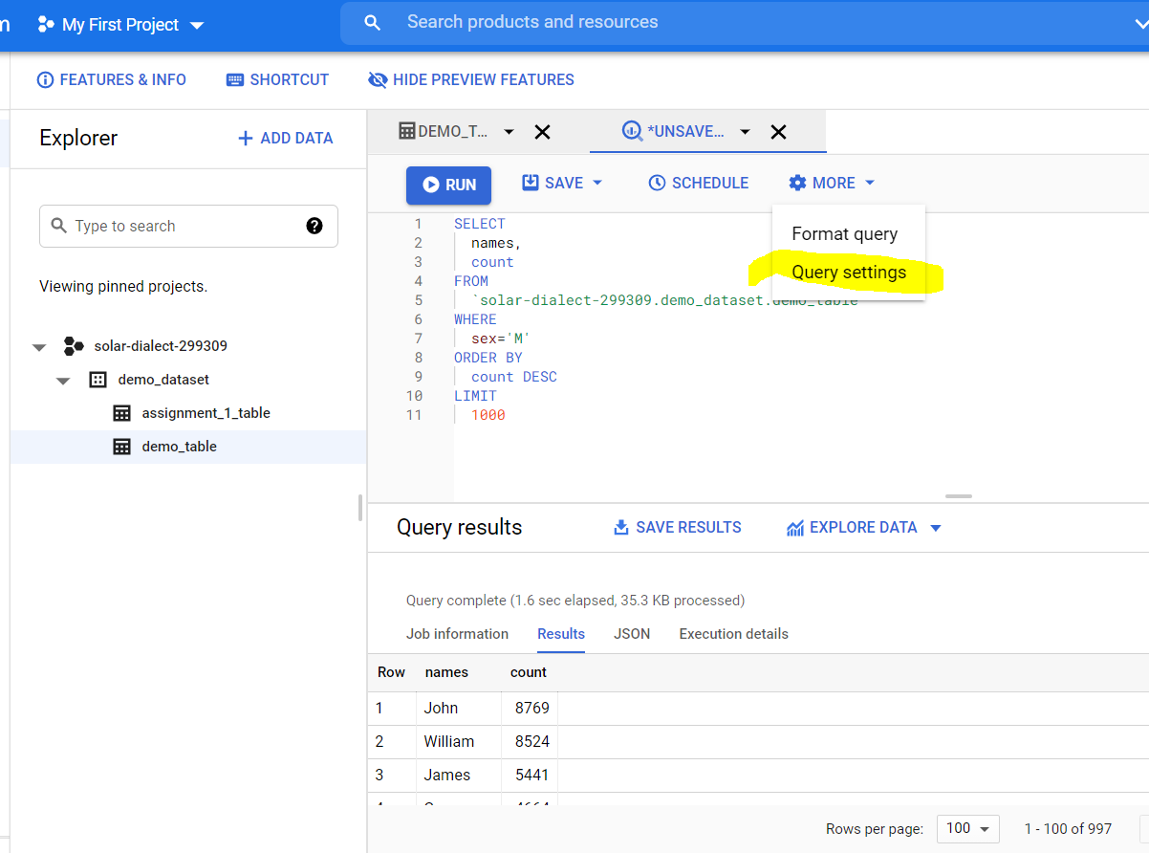

By default, every query result is saved in temporary table. These tables are not visible to users. We can save result of query to destination table, we have to specift destination table in that case.

Remember, storing data and querying table costs in GCP. Each time you query table, it will cost you in money. But if you run excat the same query again, result will be fetched from cache and this will not cost any money. So by default ‘Cache preference’ is ticked.

Caching feature and limitations-

1. To retirve data from cache, query should be **exact** same as previous query
2. Query results are not stored in cache when query results are stored in destination table
3. If table data is changed after firing a query, next time if you run same query, results will not be fetched from cache as tables have changed and query will go to database for results.
4. If table is populating with live data such as ingestion from pubsub, table data changes each seconds, hence query data is not stored in cache.
5. If query has time, timestamp, date function, results are not cached as these queries rerurn dirretent value each time you run.

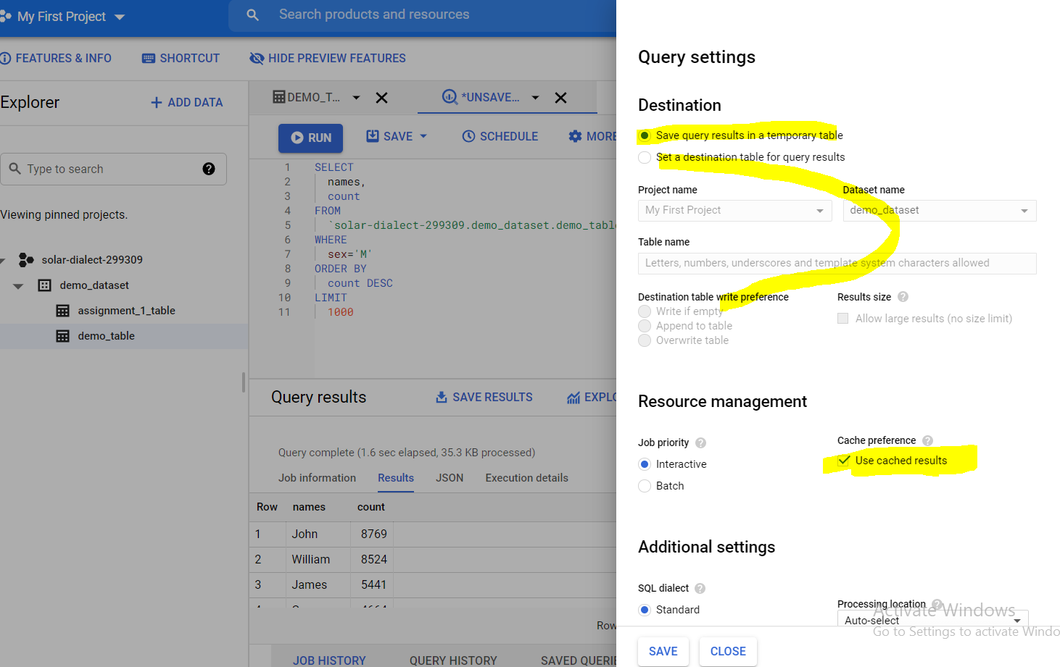

You can set limit to bytes the query gives o/p and accordingly you will be charged. If o/p of query exceeds given bytes, query will not be processed and you will not be charged any money. It will show message as below in screenshot.

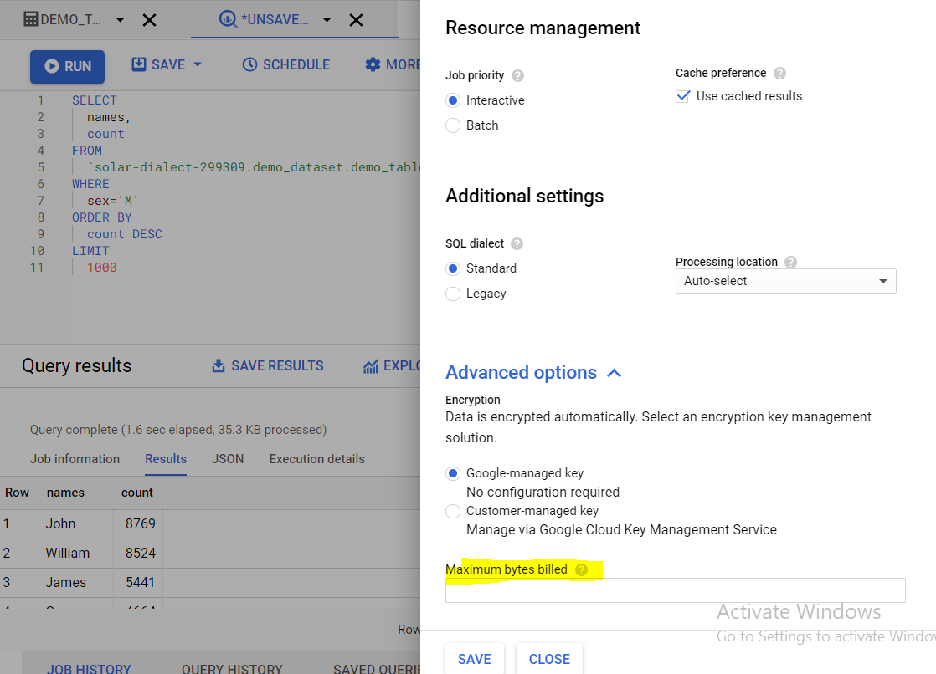

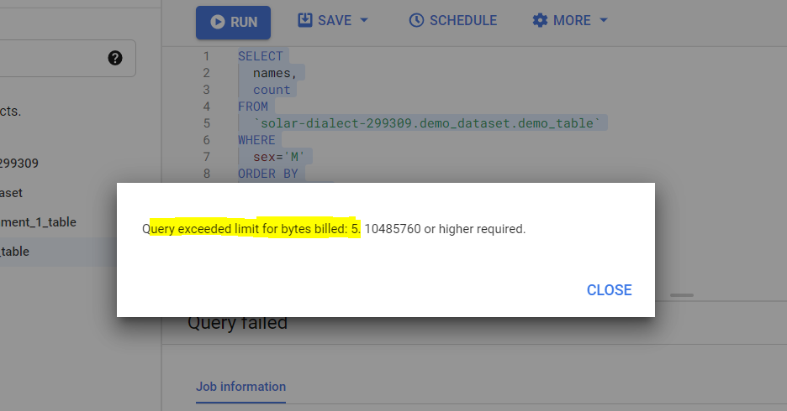

**Wildcard tables**

We can query all the tables that matches pattern

table_1* 🡪 all the tables with starting name table_1

For more information🡪 https://cloud.google.com/bigquery/docs/querying-wildcard-tables

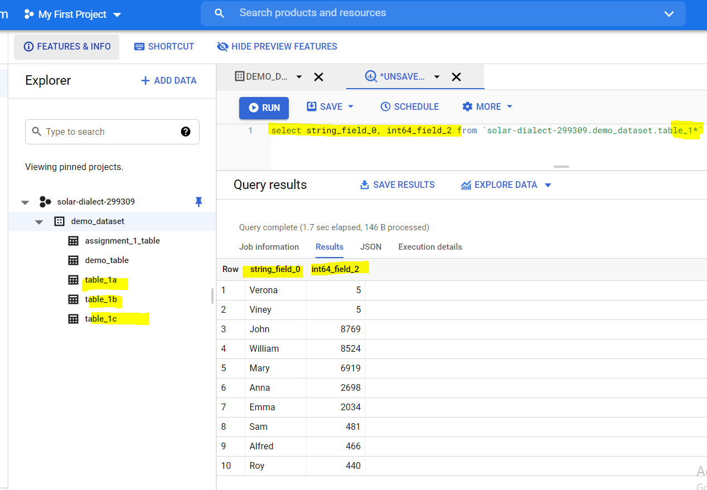

_table_suffix='a' or _table_suffix='b' 🡪Table names ending with ‘a’ or ‘b’

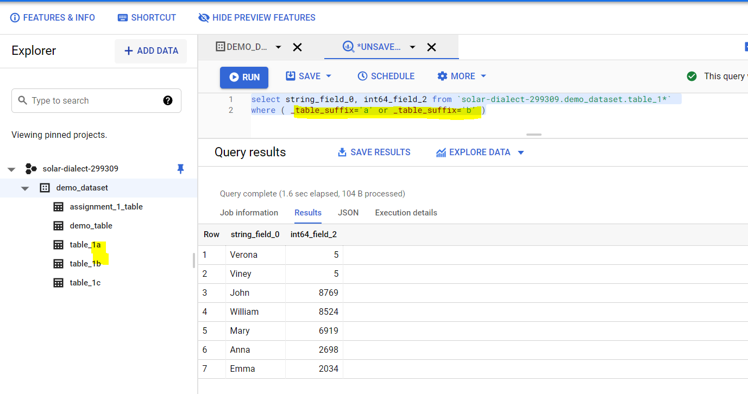

**Scheduling a query-**

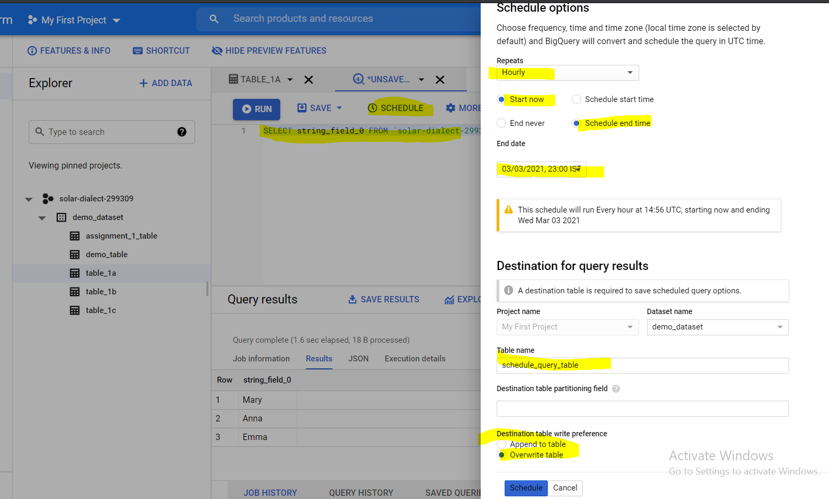

You can save queries and then share with project members

