After running a query, in ‘SAVE’ tab, you will get option to save as VIEW.

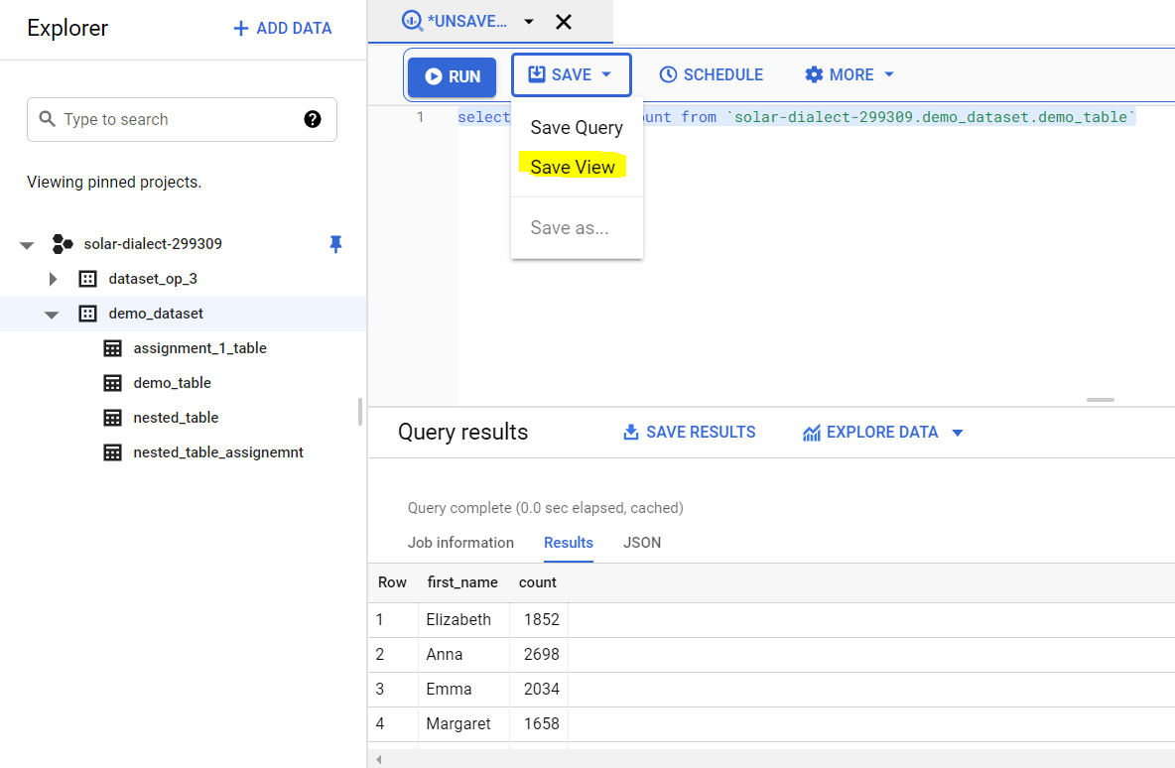

You can save VIEW in any other dataset provide source and destination dataset must have same region.

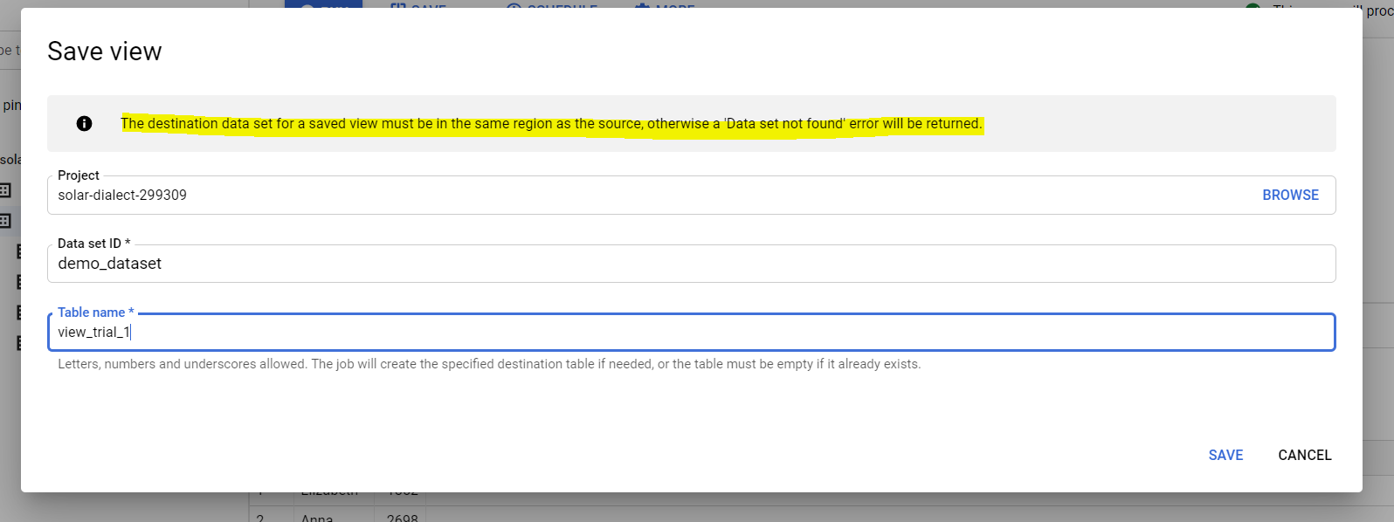

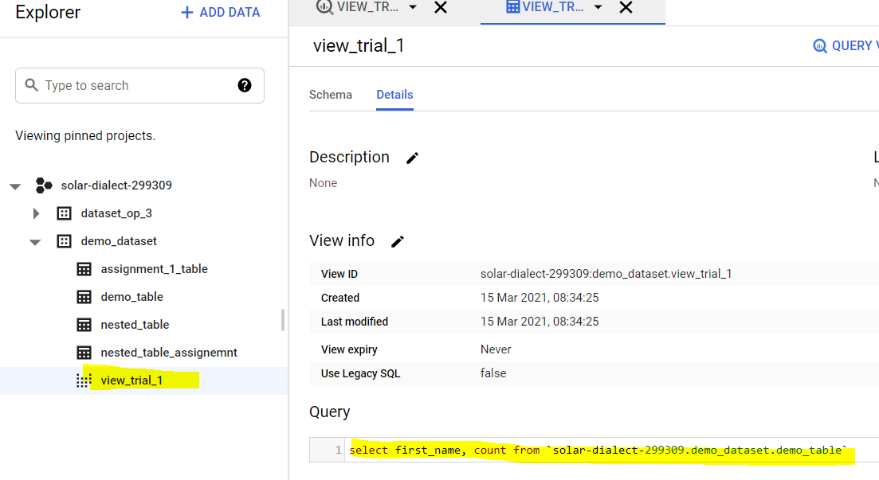

You can query the VIEW.

IAM for views/table

Access or restrictions is managed at Dataset level. You provide role to entity at Dataset level. Taking this point into consideration, VIEWS must be created in different dataset, because VIEWS are nothing but tables, and if user has access/roles on dataset, naturally, he will have same access on VIEWS in same dataset. So we create views in different dataset than the table dataset.

select session_user() 🡪 current user

Limitations of view 🡪

View dataset and source table dataset must be in same region.

Data can’t be exported from View.

You can’t reference a VIEW in wildcard table query.

**Materialized Views-**

New database object is created physically in Materialized view.

Pseudo object is created in simple View statement.

Materialized view **must be in same dataset as table**.

**Materialized view 🡪** for optimization

**View 🡪** for security purposes

GUI is not supported to create materialized view. We have to write query.

‘create materialized view as select col_1,col_2 ….. from table_name <consitions if any>’