**pg_dump** is utility to take backup of database. It can be consider as hot backup and it will literally write sql statements in text file.

-d : Database name

-U : Uername (should have permissions on datanae/schema/tables/objects)

-n : take backup of only mentioned schema

-N : all schema except schema mentioned

-t : take backup of only mentioned table

-T : all tables except mentioned table

-s: Takes backup of only objects and NO DATA (like, it will have create schema, create table statement but NO DATA insertion)

-p : Port number to connect.

-f : location of dump file (you can also wright output redirection symbol ‘>’)

--insert : data in insert statement (if not mentioned, by default COPY statements)

-v : information on screen

**pgsql** is restore utility if pg_dump is in simple text format.

Example:

pg_dump -U postgres -d bikestore -n production --inserts > F:\DB_BACKUP\bikestore_production_%date%.sql

**Periodic backup strategy**

Let schedule a job to do the requirement in JENKINS

1. Create a free style job with Build trigger periodically. Give timings.

50 11 * * 3 🡪 runs on every Wednesday at 11:50 AM

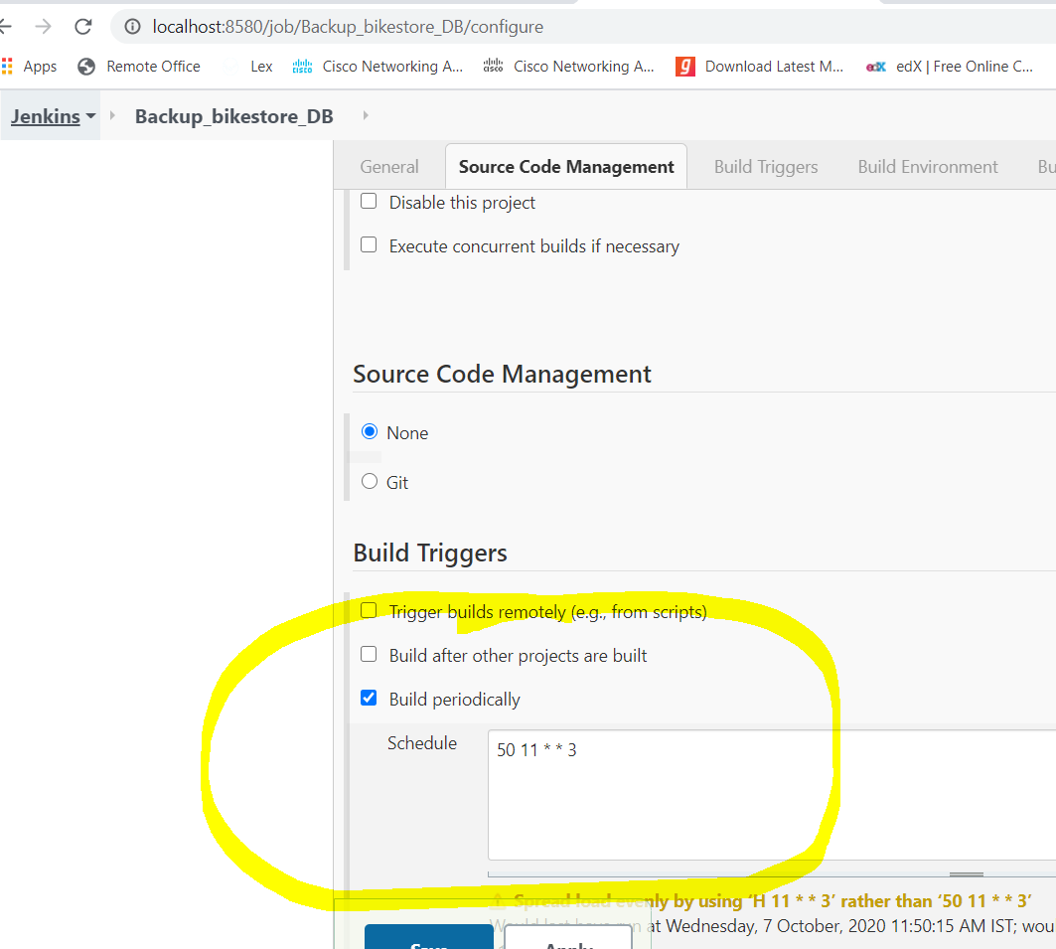

1. Script/command lines

Simply write pd_dump statements.

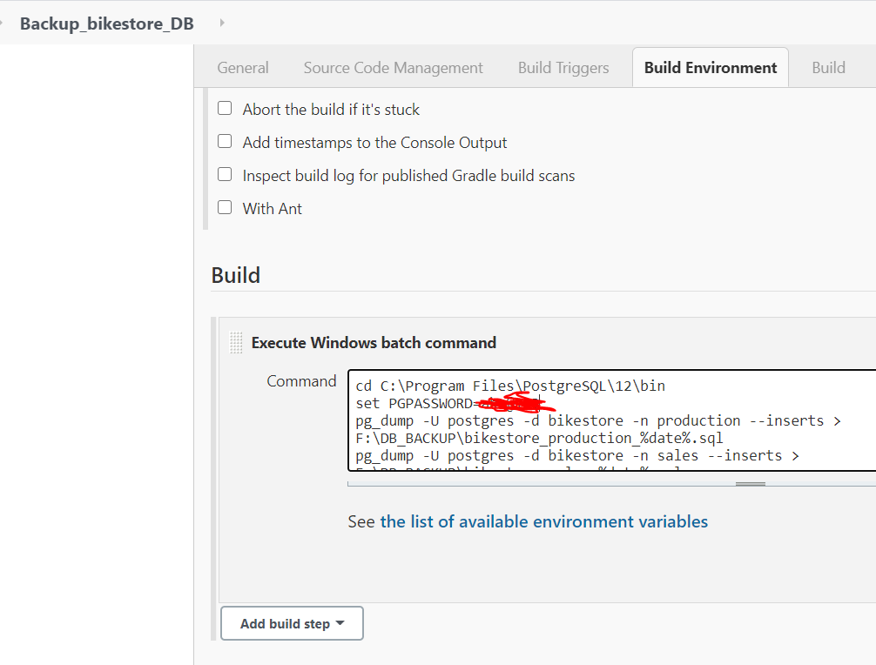

1. Successfully ran of job

