To set IP address, file important is **/etc/sysconfig/network-scripts/eth0**

**(/etc/sysconfig/network-scripts/ifcfg-<interface-nam>)**

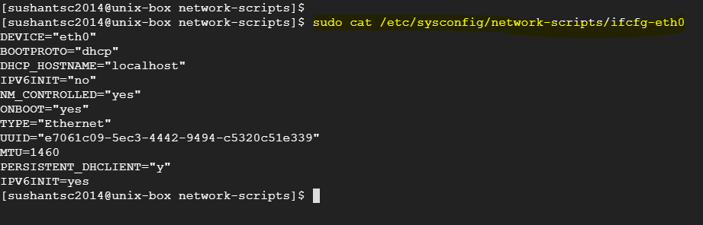

**BOOTPROTO="dhcp"** means, IP address is obtained dynamically

**Check IP address**

**ifconfig** is network interface configuration command.

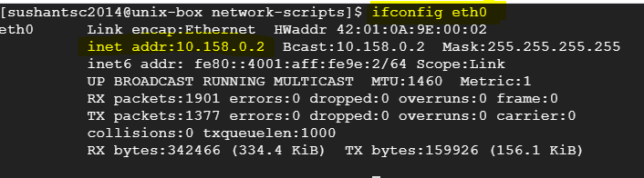

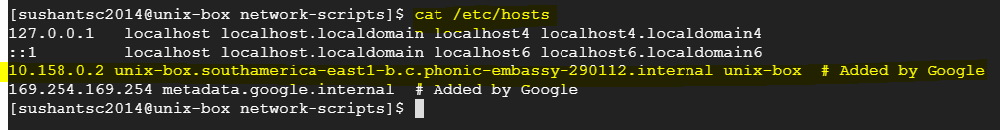

To be able to communicate with server by using name, you need to set **‘hostname’.**

You can set this in ‘etc/hosts’ (RHEL 6). Process of telling the server that it can be accessed using both the IP address and hostname is called **name resolution.**