A process is a program or part of a program in execution. Every process in the Linux system is identified by a process ID. There are two types of processes in a Linux system:

* **Foreground Process**: A foreground process is initiated and controlled by a user who has logged in to a terminal session. A foreground process will require inputs from the user.
* **Background Process**: A background process is a non-interactive process and does not require human interaction. Most of the processes initiated by the system are background processes.

As shown in screenshot, ‘top’ command waits for user i/p

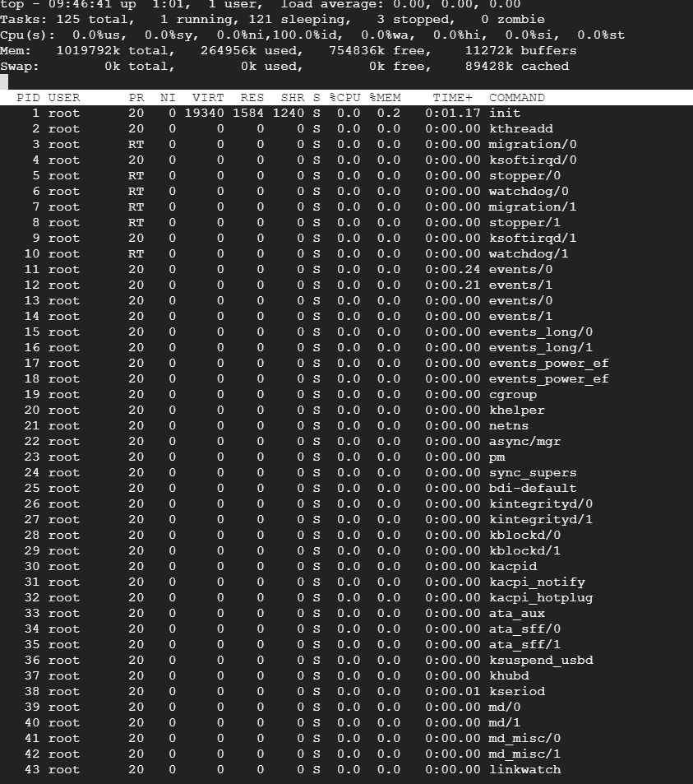

Now, when I run this ‘top’ command in background

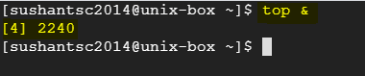

[4] 🡪 Job ID

2240 🡪 Process ID

To bring background process to foregroud, use below ( *fg* command)

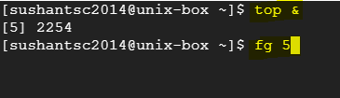

**Types of processes**

* **Running State**: A process which is currently assigned a CPU for execution or which is waiting to be assigned a CPU is said to be in the running state.
* **Waiting State**: A process which is waiting for an event to occur or for a system resource is said to be in the waiting state.
* **Stopped State**: A process which has been stopped after it has received a signal is said to be in the stopped state
* **Zombie State**: A process which is dead, but the entry for which has not been removed from the process table is said to be in the zombie state

**‘nice’ values**

Range from -20 to 19

-20 :: Highest priority

19 :: Lowest priority

**Process Scheduling**

Two type of process or job scheduler available-

1. One time job execution OR ‘at’ scheduler : Job executes one time only
2. Recurring job scheduler OR ‘cron’ job : occur again and again
3. **Using ‘at’ : Specify date and time**

‘atq’ command : All the jobs

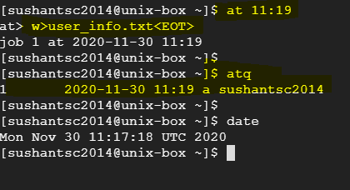

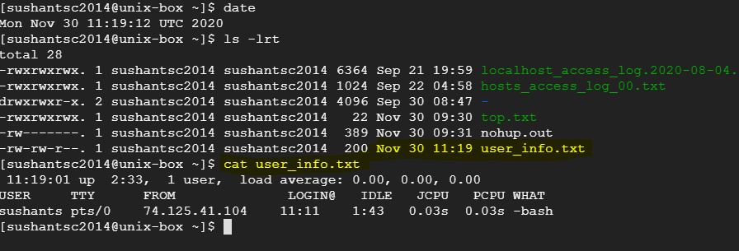

‘atrm <job_number>’ : use to remove jobs

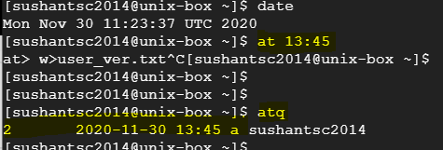

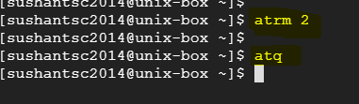

Scheduling on specific date

You can specify a time on particular date. Date format should be MMDDYY or YYYY-MM-DD

‘at <time> <date>’

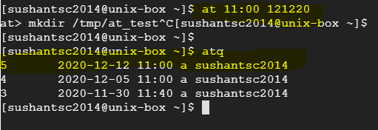

1. ‘cron’ schedule:

‘crontab –e’ : to elit cron file and make entries

‘crontab –l’ :to list all scheduled jobs

‘crontab –e –u <username>’ : for different user

**Restricting access to ‘at’ and ‘crontab’**

There exists files ‘/etc/at.deny’ and ‘/etc/cron.deny’, we can make entries of user names who we want to restrict access to commands ‘at’ and ‘crontab’ respectively. (By default,no entries in these files, means everyone is allowed to use)

By default, ‘/etc/at.allow’ and ‘/etc/cron/allow’ are not present on RHEL, that means everyone has access on these two commands.

‘root’ we have access irrespective of these files.

If we have entries in ‘/etc/at.allow’ , only those users+root is allowed to use ‘at’ command.