**USERS**

**/etc/passwd file**

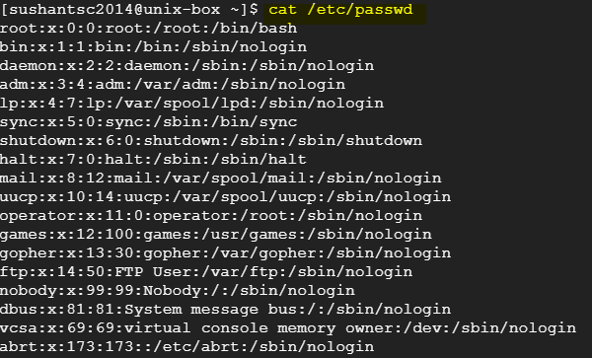

1st field: USER name

2nd filed: link to /etx/shadow file where passwords are stored.

3rd filed: User ID

4th filed: Primary Group ID

5th filed: Comments

6th filed: Home directory

7th filed: log in shell.

**/etc/shadow file**

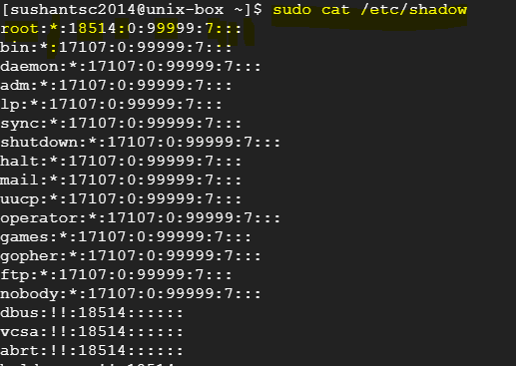

1st field: USER name

2nd filed: Password in encrypted format

3rd filed: Days since 1 Jan, 1970 (epoch date) that password changed.

4th filed: The minimum number of days that must pass before the password can be changed.

5th filed: Max number of days password can be used

6th filed: No of days before expiry of password, user will get prompts

7th filed: The number of days after a password expires before the account will be disabled.

8th filed: The date (stored as the number of days since the epoch) since the user account has been disabled.

9th filed: reserved filed.

‘**chage’** command to set password parameters.

chage –l : to list

chage <username> : to set

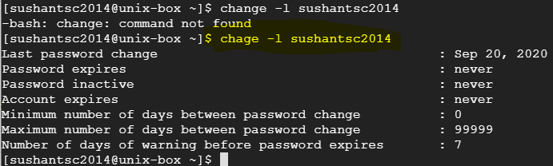

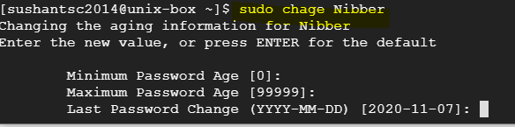

**Locking/Unlocking user**

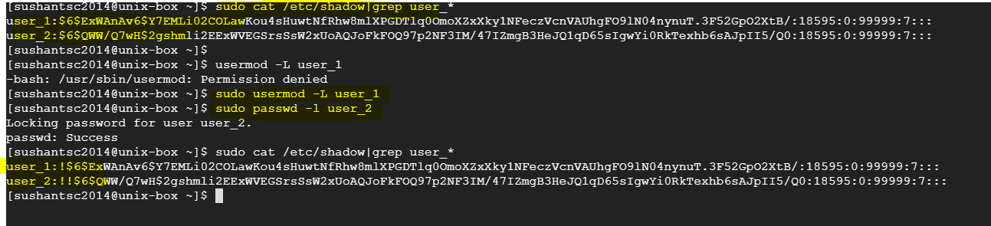

1. ‘usermod –L <user_name> : Locks account and single exclamation sign (!) is added before password in /etc/shadow file
2. ‘passwd –l <user_name> : Locks account and double exclamation sign (!!) is added before password in /etc/shadow file

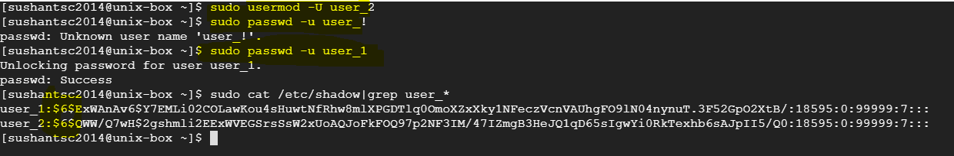

1. ‘usermod –U <user_name> : Unlocks account
2. ‘passwd –u <user_name> : Unlocks account