**Issue**

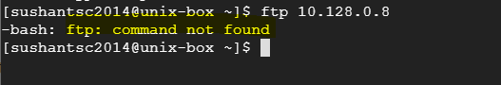

That means FTP service is not installed.

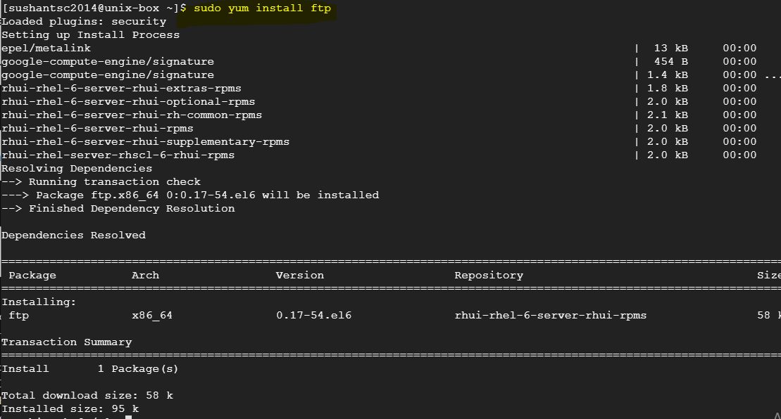

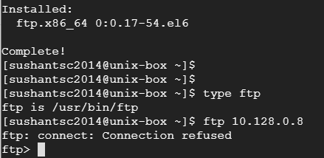

**YUM** (Yellow Gog Updater, Modified) vs **RPM** (RehHat Package Management)

**YUM** performs dependency resolution when installing, updating, and removing software packages

**RPM** it cannot manage dependency resolution like YUM (RPM can’t resolve dependencies even if other packages are installed.)

Can’t use short names of packages while using RPM.

elinks utility is alsi not there.

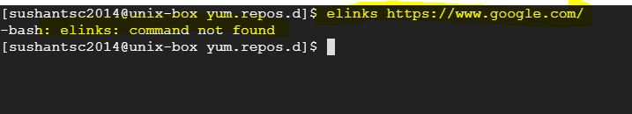

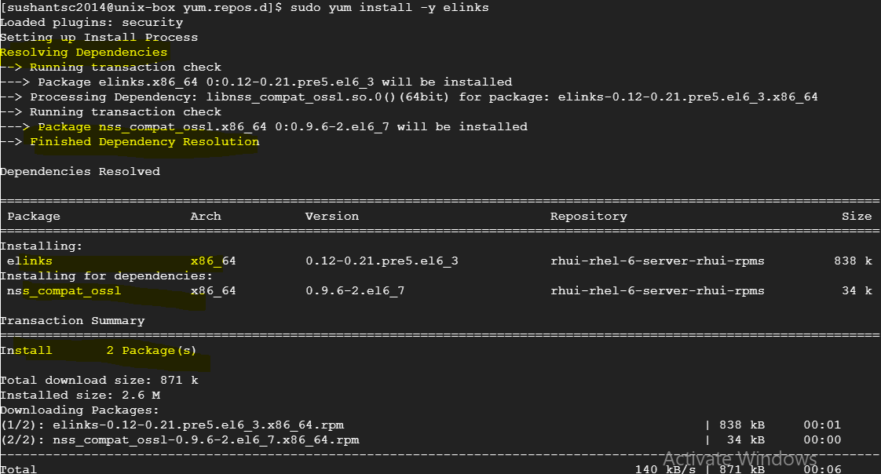

After installing elink package, google page on linux screen.

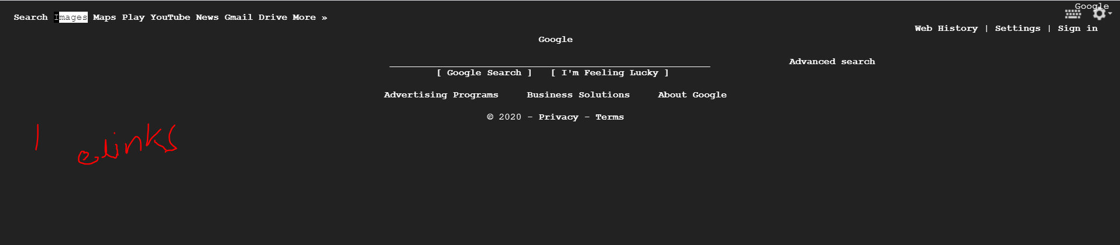

**Important directories/files for YUM command**

Important files under ‘/etc/yum.repos.d’ directory point YUM command to the location of package and information about dependencies (to resolve them). Files under this location must end with ‘**.repo’** extension.

