Systemd system and Service Manager system is used to manage startup and server processes.

‘systemctl’ command for RHEL 7

(‘systemctl start httpd’)

‘service’ command for RHEL 6

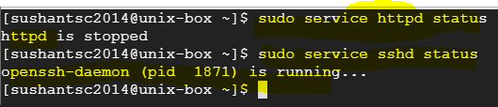

You can stop/start these services with ‘service’ command

