**COCHIN UNIVERSITY OF SCIENCE AND TECHNOLOGY**

**COCHIN UNIVERSITY COLLEGE OF ENGINEERING KUTTANADU PULINCUNNOO, ALAPPUZHA Dist.**

**KERALA-688504**

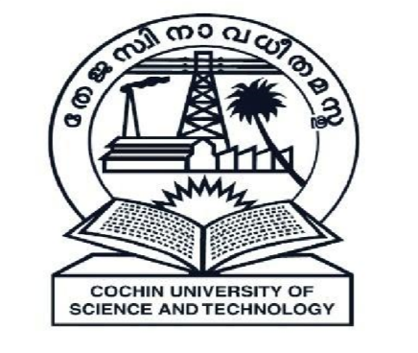

DECEMBER 2018

PROJECT REPORT ON

***PHONE_BOOK***

Submitted on partial fulfilment of the requirement for the award of the degree in Master of Computer Applications from Cochin University of Science and Technology

**Submitted by**

Sushant Sinha (Reg No: 38118235)

Prashant Kumar Singh (Reg No: 38118224)

Juhi Kumari (Reg No:38118217)

**DEPARTMENT OF MASTER OF COMPUTER APPLICATIONS**

**2018-2021**

**COCHIN UNIVERSITY OF SCIENCE AND TECHNOLOGY**

**COCHIN UNIVERSITY COLLEGE OF ENGINEERING KUTTANADU**

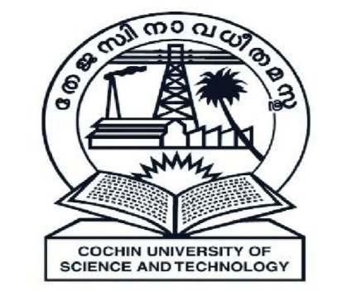

**CERTIFICATE**

This is to certify that this project report entitled “***PHONE_BOOK***” is a bona fide record on partial fulfilment for the degree of the Master of Computer Applications to the Cochin University of Science and Technology through Department of Computer Applications, Cochin University College of Engineering Kuttanadu, Alappuzha done by *Sushant Sinha(Reg.NO:38118235),Prashant Kumar Singh(Reg.NO:38118224),Juhi Kumari (Reg.NO:38118217)* in the year 2018

**Project Guide Head of the department**

**Internal Examiner**

**DECLARATION**

We hereby declare that the project entitled “***PHONE_BOOK***” submitted to the Department of Computer Applications Cochin University College Of Engineering Kuttanadu in the partial fulfilment of the requirements for the award of Degree in Master Of Computer Applications is a record of original work done by us under the guidance of ***Mrs.Deepa Nair*, Mrs.Akshaya k** Assistant Professor during my period of study in Cochin University College Of Engineering Kuttanadu.

Place: CUCEK *Sushant Sinha*

Date: 19/12/2018 *Prashant Kumar Singh*

*Juhi Kumari*

**ACKNOWLEDGEMENT**

We are thankful to god almighty for the blessings in the successful completion of our mini project “***PHONE_BOOK***”. We would like to record my profound gratitude to ***Dr. Sunilkumar N***, Principal Cochin University College of Engineering Kuttanadu who has deeply inspired. I would also like to convey our sincere thanks to ***Mrs.Jayaprabha P*** Head of the Department of Master of Computer Application for her great support.

It’s grateful to express our thanks to ***Mrs.Deepa Nair*, *Mrs.Akshaya K*** Assistant Professor in MCA Department our Project guide, Cochin University College of Engineering Kuttanadu because her effective guidance ,constructive criticism and innovative and useful stream of suggestions that helped us to complete our project.

We are thankful to various resources that provide requirements for our projects, because requirements are back bone of every project.

We are also thankful to our teachers, friends, family members, for their support and prayer for us to complete our project.

**SYNOPSIS**

* **What is PHONE_BOOK?**

PHONE_BOOK is a type of application, in which the user create a contact record to save detail of some persons. It is an application to provide basic feature of phonebook in android phones.

* **About the PHONEBOOK Mini Project in C:**

The PHONE_BOOK allows you to perform simple Phonebook operations like in your mobile. You can add, list, modify, search and delete phonebook related records. File handling and data structure concepts has been extensively used for almost all functions in this mini project.

**CONTENTS**

**1. INTRODUCTION……………………………………………………………………..1**

1.1 About the Project

1.2 Objective & Scope of Project

1.3 Definition of Problem

**2. SYSTEM ANALYSIS………...……………………………………………………….4**

2.1 Existing System

2.2 Proposed system

2.3 Feasibility Study

**3. SYSTEM REQUIREMENTS AND SPECIFICATIONS………...…………………7**

3.1 Hardware Configurations

3.2 Software Configurations

3.3 Technology Used

3.4 Platform Used

**4. SYSTEM DESIGN……………………………………………………….…………...9**

4.1 Flow Chart

4.2 Data Flow Diagram(DFD)

**5. SYSTEM IMPLEMENTATION, TESTING & MAINTENANCE……………….13**

5.1 System Implementation

5.2 System Testing

(Methodologies used for testing is required according to the project)

5.2.1 White Box Testing

5.2.2 Black Box Testing

5.2.3 Grey Box Testing

5.3 System Maintenance

**6. CONCLUSION……………………………………………………………………….19**

6.1 Drawbacks

6.2 Future Scope

**7. SCREENSHOTS……………………………………………………………………..21**

**8. BIBLIOGRAPHY…………………………………………………………………….30**