**Performance Investigation of Radio over Free Space Optics under Fog Weather Conditions**

**Paper ID**- "850”

**Objective**-

1. To study literature on ML techniques better suited for RoFSO.
2. Understanding how to work with Opti System software.
3. Designing Ro-FSO link for fog weather conditions.
4. Doing comparative analysis of different ML techniques.
5. Compilation of the report and drafting of the research paper.

**What is RoFSO?**

RoFSO (Radio over Free Space Optics) is a wireless communication technology that combines radio frequency and optical transmission to achieve high-speed data transfer over long distances. It utilizes lasers to transmit data optically through the atmosphere, providing a reliable and secure wireless connectivity solution for various applications, including telecommunications and networking.

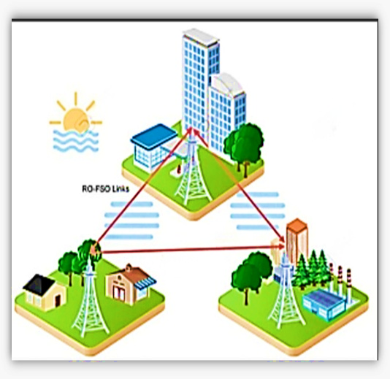

**RoFSO link**

**How weather effects performance of RoFSO?**

Weather conditions such as rain, fog, and atmospheric disturbances can negatively impact the performance of RoFSO. These weather elements can cause signal attenuation, scattering, and absorption, leading to reduced signal strength, increased error rates, and decreased link range. Adverse weather conditions can significantly degrade the reliability and availability of RoFSO communication links.

**How Machine Learning Algorithms can help improve performance of RoFSO**.

Machine learning algorithms can enhance the performance of RoFSO (Radio Frequency over Free Space Optics) by optimizing various aspects. They can analyze historical weather data and predict future weather patterns, allowing proactive adjustment of RoFSO parameters to mitigate adverse effects. Machine learning models can also identify patterns in link performance data and recommend optimal configurations for different weather conditions.

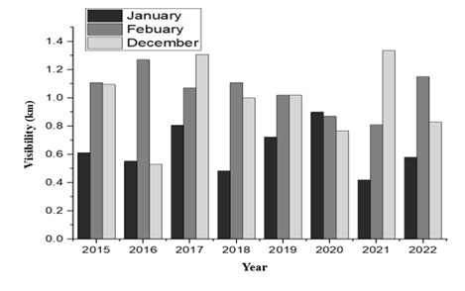

**Year wise visibility**

Fog can significantly impact the performance of RoFSO links by causing signal attenuation. Attenuation refers to the weakening or loss of signal strength as it passes through the fog, resulting in reduced signal quality and shorter transmission distances.