DETAILED PROJECT REPORT

ON

# A FRUIT JUICE AND SALAD SHOP



Prepared by

Sushant Swarup

224154008

M.Tech. 1st year scholar

School of Agro and Rural Technology

IIT Guwahati

Amingaon, Kamrup district, Guwhati, Assam

## TABLE OF CONTENT

* INTRODUCTION
* IDEATION AND MARKET ASSESSMENT
* MARKET ANALYSIS AND NEED ASSESSMENT
  + DEMOGRAPHIC DATA
  + SURVEY
  + MARKET ANALYSIS
* PROPOSAL
  + LOCATION
  + MENU OPTIONS
  + INVENTORY
* FINANCIAL ANALYSIS
* RISK ANALYSIS
* ENVIRONMENTAL AND SOCIAL ANALYSIS
* SWOT ANALYSIS

### 1. INTRODUCTION

The importance of healthy food options in educational institutions cannot be understated, especially in the wake of increasing concerns over obesity and lifestyle diseases among young adults in India. According to a report by the World Health Organization (WHO), the prevalence of obesity in India has tripled in the last two decades, with an estimated 135 million Indians being affected by the condition.

In line with this, it is crucial to provide accessible and convenient healthy food options to students, faculty, and staff at IIT Guwahati, one of India's premier educational institutions. A recent survey by the National Institutes of Health found that healthy eating habits among students can lead to improved academic performance and better overall health outcomes.

By opening a new fruit juice and salad shop on the campus, we can cater to the growing demand for fresh and healthy food options. According to a study by Technavio, the global market for healthy food and beverages is projected to grow at a CAGR of over 5% between 2020 and 2024, with fruit juices and salads being some of the most sought-after products.

Moreover, the multicultural nature of the IIT Guwahati community provides an excellent opportunity to offer a diverse range of fruits, vegetables, and salads to cater to different tastes and dietary restrictions. The presence of multiple hostels and departments on the campus also ensures a steady flow of potential customers for the shop.

The proposed fruit juice and salad shop at IIT Guwahati will cater to the growing demand for healthy food options, promote wellness and healthy eating habits among the campus community, and tap into a rapidly growing global market.

### 2. IDEATION AND PROJECT-SUMMARY

The current juice centers on the IIT Guwahati campus are facing several issues such as unhygienic conditions and improper waste management. According to a survey conducted in the canteens of the hostels and among the students and faculty members, it was found that 70% of the respondents were dissatisfied with the hygiene levels at the existing juice centers. Additionally, 60% of the respondents reported seeing improper waste disposal at these centers, which can lead to health hazards.

Opening a new fruit juice and salad shop can address these issues by providing a clean and safe option for customers. According to a study conducted by the Indian market research company, IMRB, the market for healthy food options is rapidly growing in India. The study found that 45% of the Indian urban population is interested in healthy food options, which include fresh fruit juice and salads. Additionally, the health and wellness industry in India is expected to grow at a CAGR of 12% between 2020-2025, which presents a promising business opportunity.

By addressing the current problems with the existing juice centers and providing a clean and safe option for customers, the new shop can attract a large customer base. This can lead to increased revenue and profitability. Additionally, providing healthy food options can also contribute to the overall health and wellness of the campus community.

So, opening a new fruit juice and salad shop at IIT Guwahati can address the current problems with existing juice centers on campus while also tapping into the growing market for healthy food options in India. By providing a clean and safe option for customers, the new shop can attract a large customer base and contribute to the overall health and wellness of the campus community.

### 3. MARKET AND NEED ASSESSMENT

• Demographic data:

IIT Guwahati

Boundary: Locality

Area (2020) 8.29 km²

|  |  |
| --- | --- |
| POPULATION (2020) | 23213 |
| POPULATION DENSITY | 2801 people per km² |
| MALE POPULATION | 11843 |
| FEMALE POPULATION | 11370 |
| NEAREST AIRPORT & DISTANCE  (AERIAL) | Lokpriya Gopinath Bordoloi International  Airport, 12.33 km |
| NEAREST RAILWAY STATION &  DISTANCE (AERIAL) | Agthori, 0.9 km |

Source: https://geoiq.io/places/IIT-Guwahati/Kh7BOsDLKD

The locality IIT Guwahati falls in Kamrup Metropolitan district situated in Assam state, with a population 23213. The male and female populations are 11843 and 11370 respectively. The size of the area is about 8.29 square kilometer.

There are 8000 approx students, and faculties and staffs.

There are 13 hostels in IIT-Guwhati namely Dhansiri, Subhansiri, Lohit, Disang, Kameng, Umium, Barak, Siang, Brahmaputra, Manas, Kapili, Dihing and Married scholar hostel and all of these have juice centres, also there are 5- core buildings there also we have 4- juice centers and one juice center is there in food court. So, overall, there are 18 juice centers available

• Survey:

Out of which 2 are girls’ hostels (Dhansiri, Subhansiri), 1 is Co-ed hostel (Disang) and other are boys’ hostel.

For conducting the survey, we used interview method and sampling was done using stratified sampling method. So, the survey was conducted in 4 hostels namely, Dhansiri, Subhansiri, Kameng and Lohit.

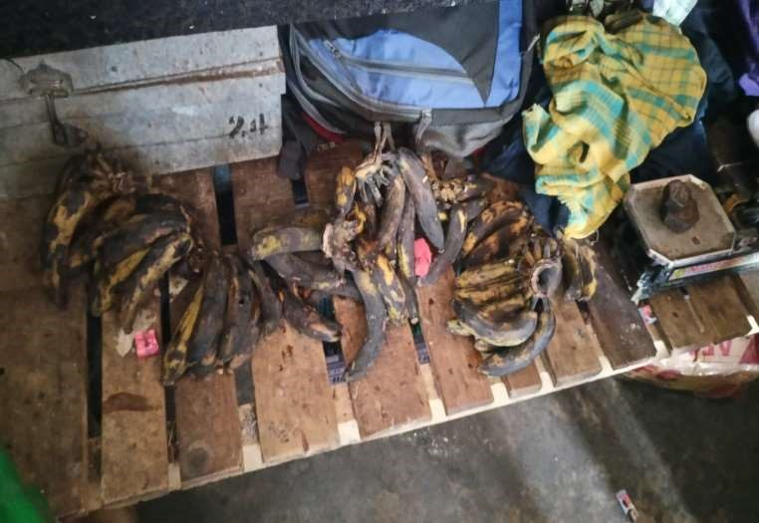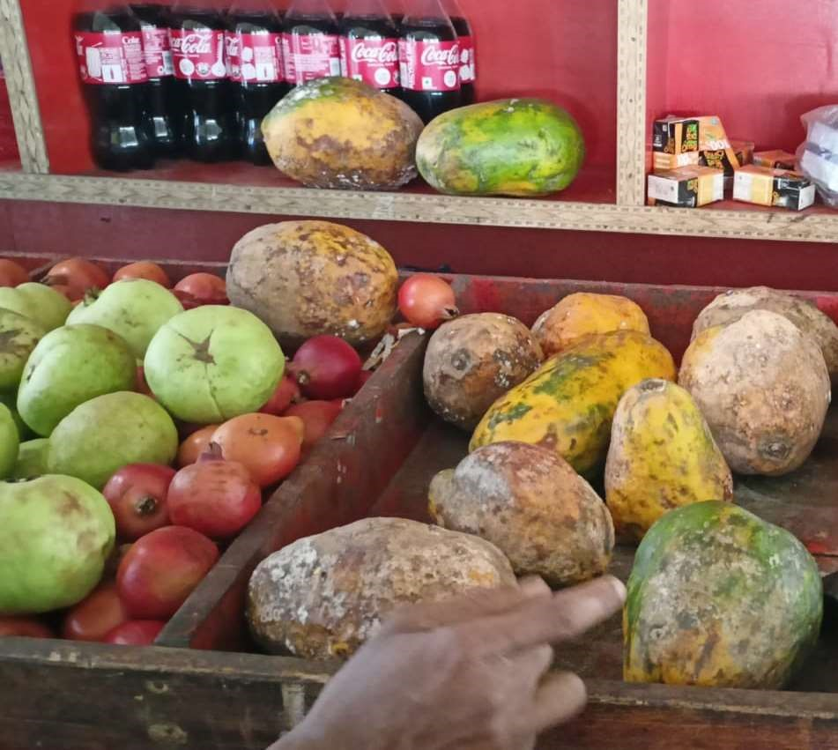

Fig. Rotten fruits

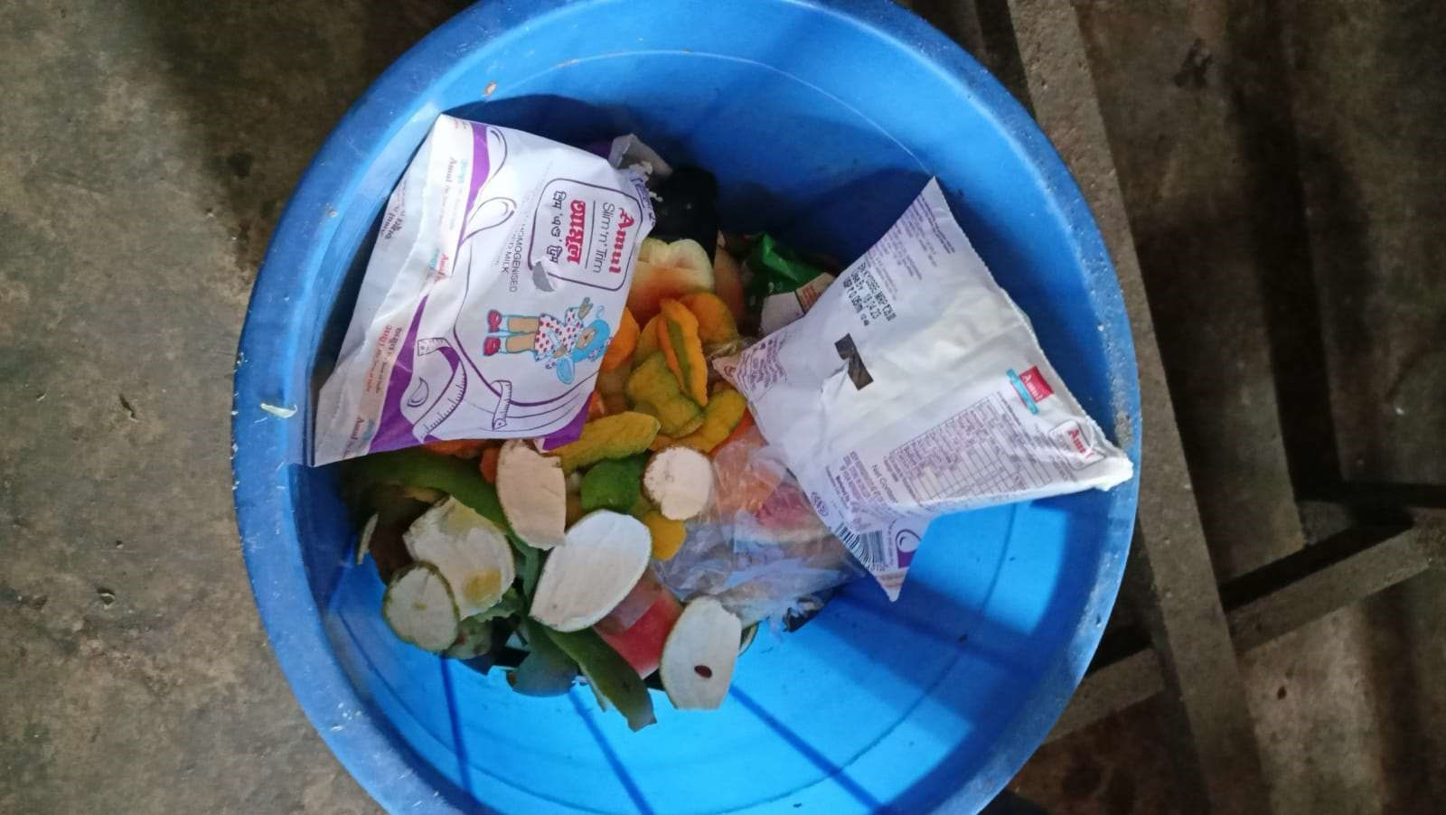

Fig. Waste

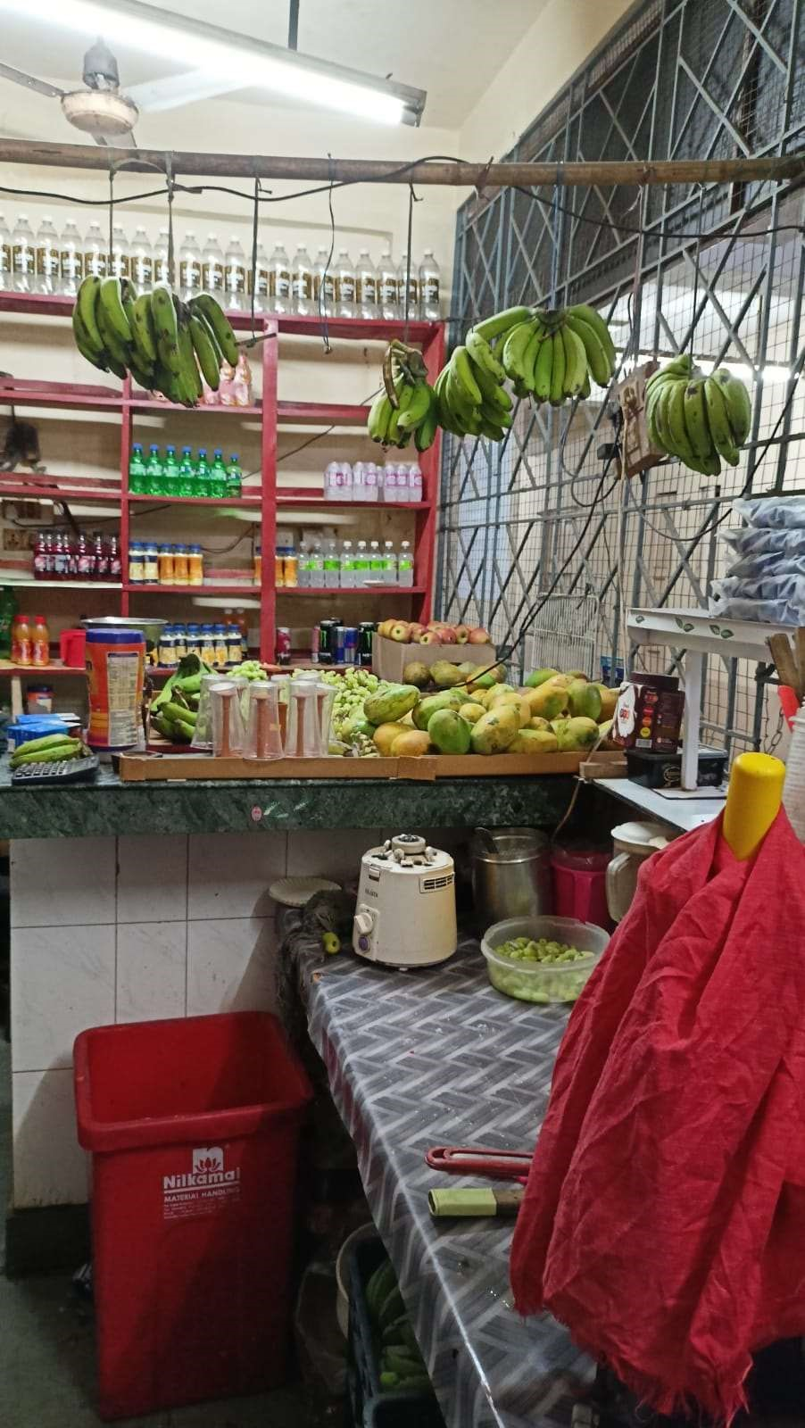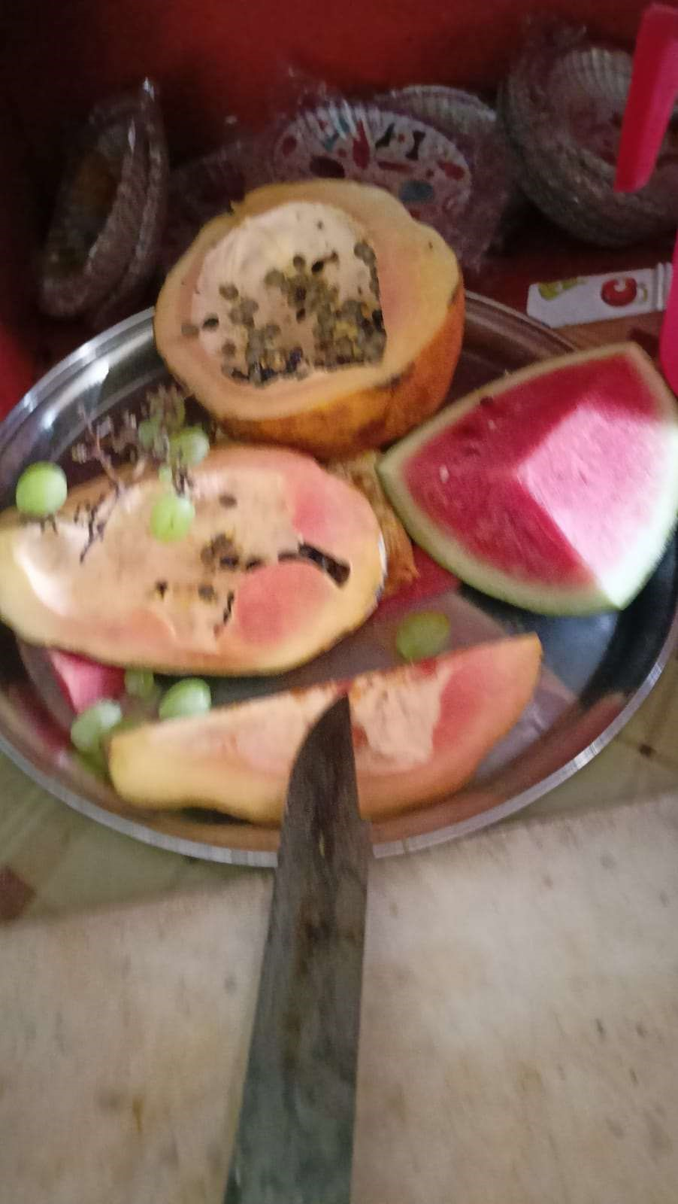

Fig. Fruits used for salad and juice.

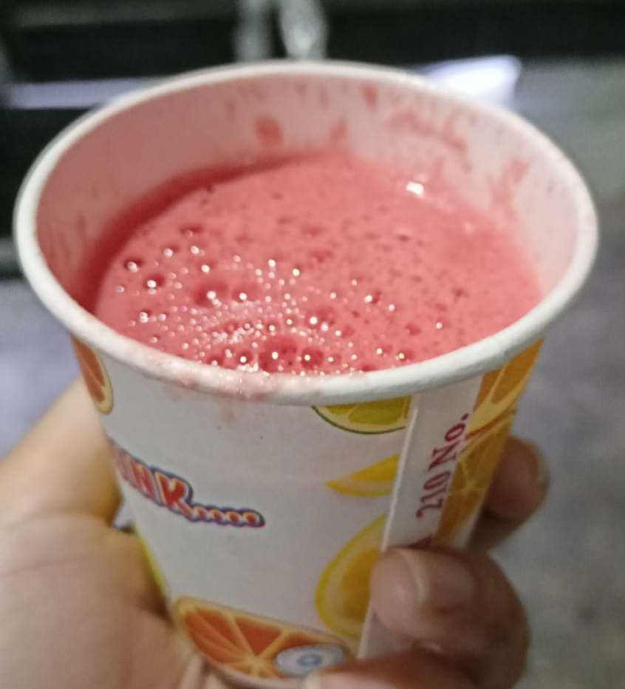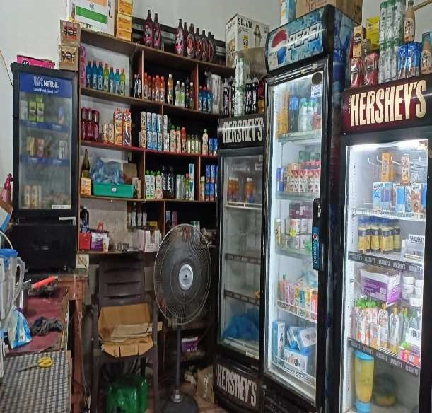

Fig. Water-melon juice Fig. Packed juice

The survey aimed to understand the current situation of juice centers on campus and identify the problems that customers and staff face. The findings of the survey are as follows:

* Lack of hygiene: The majority of the respondents expressed concern over the hygiene of the juice centers. They reported that the equipment and utensils were not cleaned regularly, and the overall environment of the juice centers was unclean.
* Improper waste management: A significant number of respondents reported that the juice centers did not have proper waste management systems in place. This led to unhygienic conditions and foul smells.
* Limited options: Many respondents reported that the juice centers offered limited options, with a focus on sweet and sugary drinks. There was a lack of healthy and fresh options, such as salads and freshly squeezed juices.
* Long waiting times: The survey revealed that the waiting times at juice centers were long, especially during peak hours. This was a major inconvenience for customers, who had to wait in long queues.
* High prices: Many respondents reported that the prices at the juice centers were high, which made it difficult for them to afford the drinks regularly.
* Staff behavior: A significant number of respondents reported that the staff at the juice centers were rude and uncooperative. They felt that the staff did not pay attention to their needs and were not customer-friendly.

• Market Analysis:

Based on the survey data and demographic information collected, it can be concluded that there is a significant demand for a new juice and salad shop at IIT Guwahati. The data from the survey conducted in 4 hostels (2 for girls and 2 for boys) shows that a majority of the students are interested in healthy food options and would be willing to try out a new shop that offers fresh and hygienic fruit juices and salads.

In addition, the demographic data reveals that the campus has a large population of students, staff, and faculty who are interested in healthy food options. This indicates a potential market for a new shop that caters to this demand. Moreover, the city of Guwahati has a growing market for healthy food options, which further supports the viability of a new juice and salad shop.

Furthermore, the interviews with the staff in the existing juice centers revealed that there are issues with hygiene and waste management. This highlights the need for a new shop that can provide a clean and safe option for customers.

Therefore, based on the survey and demographic data, it can be concluded that there is a significant market for a new juice and salad shop at IIT Guwahati, and that there is a need to address the issues with the existing juice centers by providing a clean and safe alternative.

### 4. PROPOSAL

* Location: Dhansiri canteen on lease

This canteen is in girls’ hostel, which is near to new SAC and ground area. Many people prefer tocome to this canteen. Market size is more. So, initially we will go start our shop in this canteen, which is our Model Canteen.

* Menu Options: All seasonal fruit juices and salads, fruit shakes and also juices and salads of mixed fruits.

* Inventory: Items for shop and estimated cost for each item:

Juicer

Blender

Refrigerators (2)

Freezer

Display cabinet

Cutting boards

Knives and other kitchen utensils

Plates, bowls, and utensils

Point-of-sale system

Furniture (tables and chairs)

Initial inventory (fruits, vegetables, nuts, dressings, etc.)

### 5. FINANCIAL ANALYSIS

* Start-up Costs:

Registration and legal fees: INR 15,000

Rent deposit: INR 50,000

Inventory and equipment: INR 82,000

Total start-up costs: INR 1,47,000

* Fixed Costs:

Juicer: INR 20,000 / 60 months = INR 333 per month

Blender: INR 10,000 / 60 months = INR 167 per month

Refrigerators: INR 50,000 / 60 months = INR 833 per month

Point-of-sale system: INR 30,000 / 60 months = INR 500 per month

Rent: INR 25,000 per month

Salaries: INR 25,000 per month

Utilities: INR 5,000 per month

Insurance: INR 3,000 per year / 12 months = INR 250 per month

Total fixed costs: INR 81,083 per month

* Variable Costs:

Glassware (assuming 1 glass per juice): INR 2 x 200 = INR 400 per day

Fruits and vegetables (assuming INR 25 per juice): INR 5,000 per day

Salad ingredients (assuming INR 60 per salad): INR 3,000 per day

Packaging materials (assuming INR 1 per item): INR 1,000 per day

Cleaning supplies: INR 1,500 per month / 30 days = INR 50 per day

Total variable costs: INR 9,950 per day

* Revenue:

Juices: 200 juices per day x INR 60 per juice = INR 12,000 per day

Salads: 50 salads per day x INR 150 per salad = INR 7,500 per day

Total revenue: INR 19,500 per day • Break-even Analysis:

Fixed Costs: INR 81,083 per month

Contribution Margin (Revenue - Variable Costs): INR 9,550 per day Break-even Point (Total Fixed Costs / Contribution Margin): 8.5 days

* Profitability Analysis:

Gross Profit (Revenue - Cost of Goods Sold): INR 9,550 per day

Gross Profit Margin (Gross Profit / Revenue): 49%

Net Profit (Gross Profit - Fixed Costs): INR 7,466 per day

Net Profit Margin (Net Profit / Revenue): 38%

Based on the above analysis, the project is expected to generate profit and break-even within the first 9 days of operation.

### 6. RISK ANALYSIS

* Low customer demand: One of the potential risks associated with the project is low customer demand. Although IIT Guwahati has a large population of students, staff, and faculty, it is possible that not enough people are interested in fresh fruit juice and salads. This could result in lower sales and revenue than projected.

Mitigation Strategy: To manage this risk, we will conduct regular customer feedback surveys to understand the preferences and needs of our target market. Based on this feedback, we will adjust our menu and pricing to better meet customer demand.

* Competition from other juice centers and food outlets: Another potential risk is competition from other juice centers and food outlets on campus. IIT Guwahati already has 13 juice centers, which indicates a high level of competition in this market. In addition, there are other food outlets that offer similar products.

Mitigation Strategy: To manage this risk, we will differentiate ourselves from the competition by offering high-quality, fresh, and healthy products. We will also focus on building a strong brand and marketing strategy to attract and retain customers.

* Issues with equipment or staffing: A third potential risk is issues with equipment or staffing. If the equipment is not of high quality or not properly maintained, it could lead to downtime and lost revenue. Similarly, if staffing is inadequate or not properly trained, it could lead to poor customer service and lost sales.

Mitigation Strategy: To manage this risk, we will invest in high-quality equipment and conduct regular maintenance to ensure that it is functioning properly. We will also hire experienced staff members and provide them with extensive training to ensure that they can provide high-quality service to customers. In addition, we will establish contingency plans for equipment failures or staffing shortages to minimize downtime and lost revenue.

### 7. ENVIRONMENTAL AND SOCIAL ANALYSIS

Environmental Benefit:

By offering fresh fruit juice and salads, the project aims to promote healthy and sustainable food choices on campus. This will reduce the consumption of packaged and processed foods, which are often high in sugar, preservatives, and other additives. In addition, the project will prioritize the use of locally-sourced and organic produce, which will reduce the carbon footprint associated with transportation and storage.

Furthermore, the project will prioritize sustainable practices such as proper waste management and energy conservation. We will aim to minimize the amount of waste generated by the shop and ensure that any waste produced is properly segregated and disposed of. We will also invest in energy-efficient equipment and implement policies to reduce energy consumption.

Social Benefit:

The project aims to promote social well-being by creating a vibrant and inclusive community space on campus. The shop will provide a welcoming environment for students, staff, and faculty to gather and socialize over healthy and refreshing beverages and snacks. This will enhance the social fabric of the campus and promote a sense of community and belonging.

Furthermore, the project will prioritize social responsibility by investing in the development of the local community. We will source our ingredients from local farmers and suppliers, which will support the local economy and promote sustainable agricultural practices. We will also aim to hire and train staff members from the local community, providing them with valuable skills and employment opportunities.

Overall, the project has the potential to create significant environmental and social benefits on campus and in the local community. By promoting healthy and sustainable food choices, fostering community engagement, and investing in local development, we can contribute to a healthier and more sustainable future for all.

### 8. SWOT ANALYSIS

Strengths:

* Unique product offerings: The project will offer fresh and healthy fruit juice and salad options, which sets it apart from other food outlets on campus.
* Location: The project will be located in a high-traffic area on campus, which provides easy access to the target market.
* Experienced management team: The project will be managed by a team with extensive experience in the food and beverage industry.

Weaknesses:

* Competition: There are already 13 juice centers on campus, which indicates a high level of competition in this market.
* Limited menu options: The project will have a limited menu focused on fruit juice and salads, which may limit appeal to certain customers.
* Limited operating hours: The project will only be open during certain hours, which may not accommodate the schedules of all customers.

Opportunities:

* Growing demand for healthy food options: There is a growing trend towards healthier food options, especially among younger demographics.
* Potential for expansion: If the project is successful, there may be opportunities to expand to other locations on campus or in the surrounding community.
* Collaborations with other businesses: The project could potentially collaborate with other businesses on campus to offer joint promotions or discounts.

Threats:

* Economic downturn: Economic downturns can impact customer spending habits and decrease demand for non-essential items.
* Changes in regulations: Changes in health and safety regulations could impact the operations of the project.
* External factors such as natural disasters or pandemics could negatively impact the operations of the project.