**CODING AND OUTPUT SECTION**

###### MOVIE REGRESSION

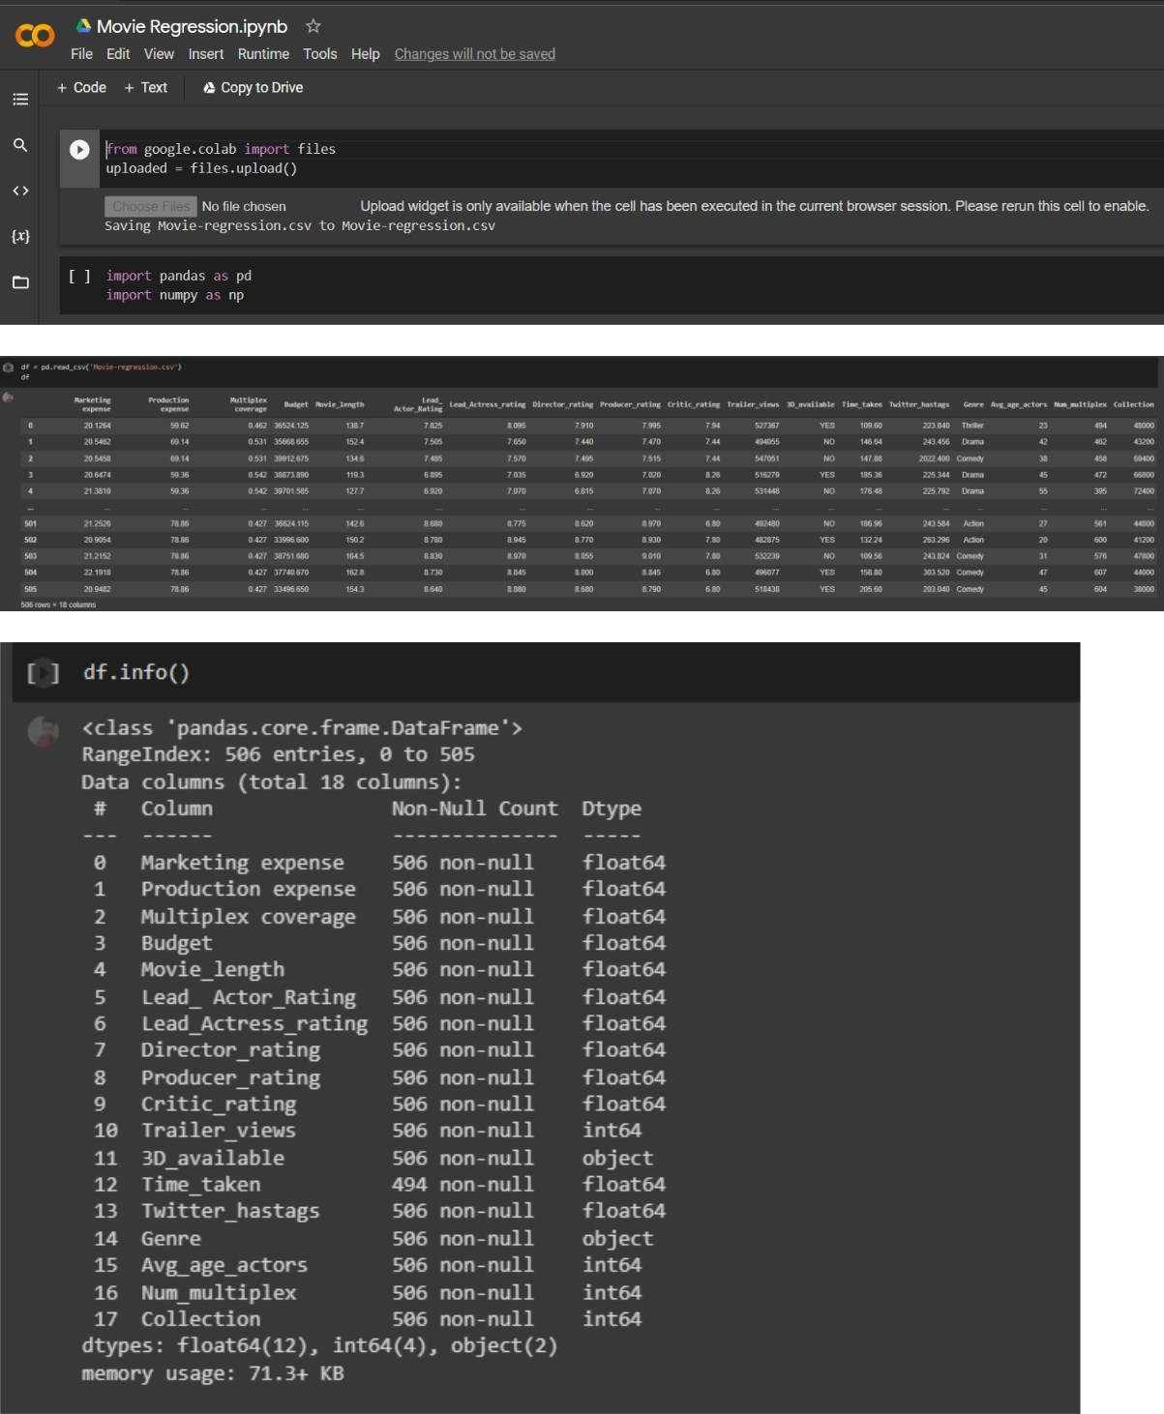

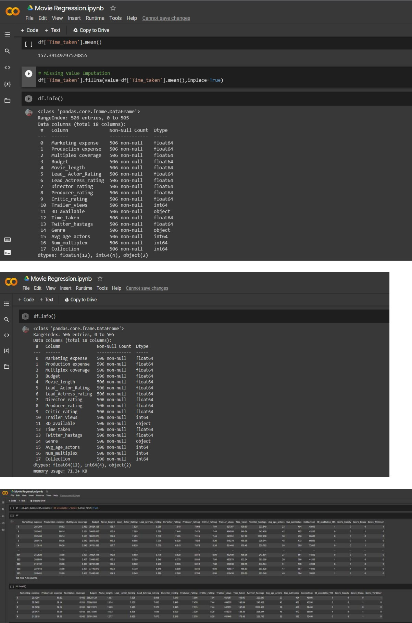

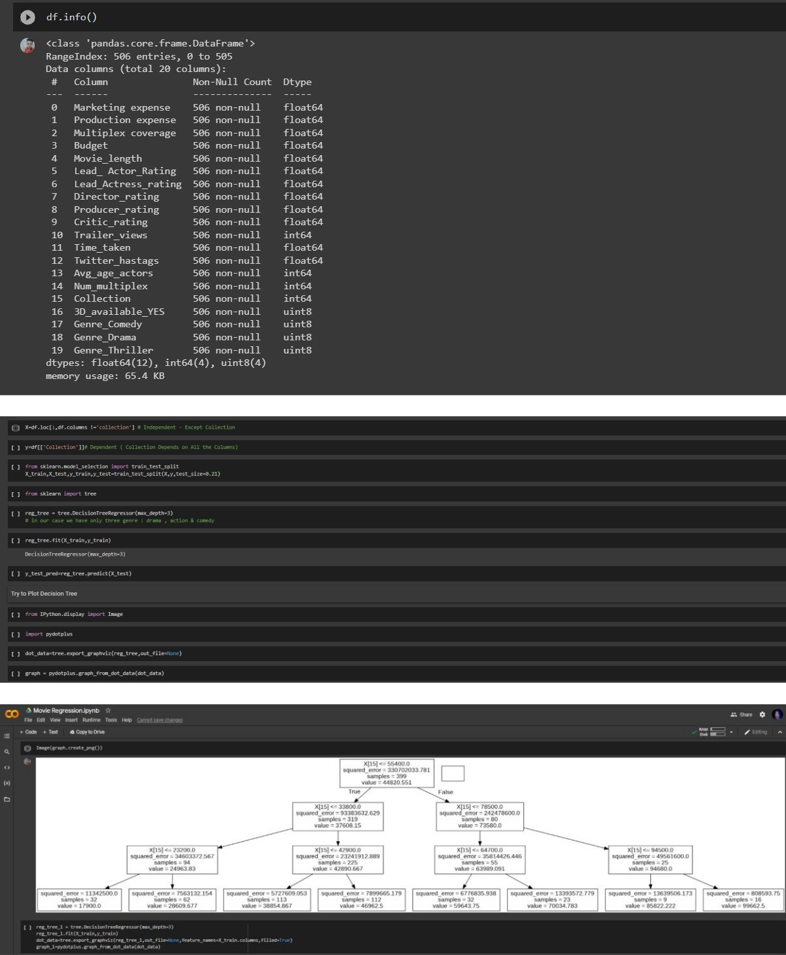

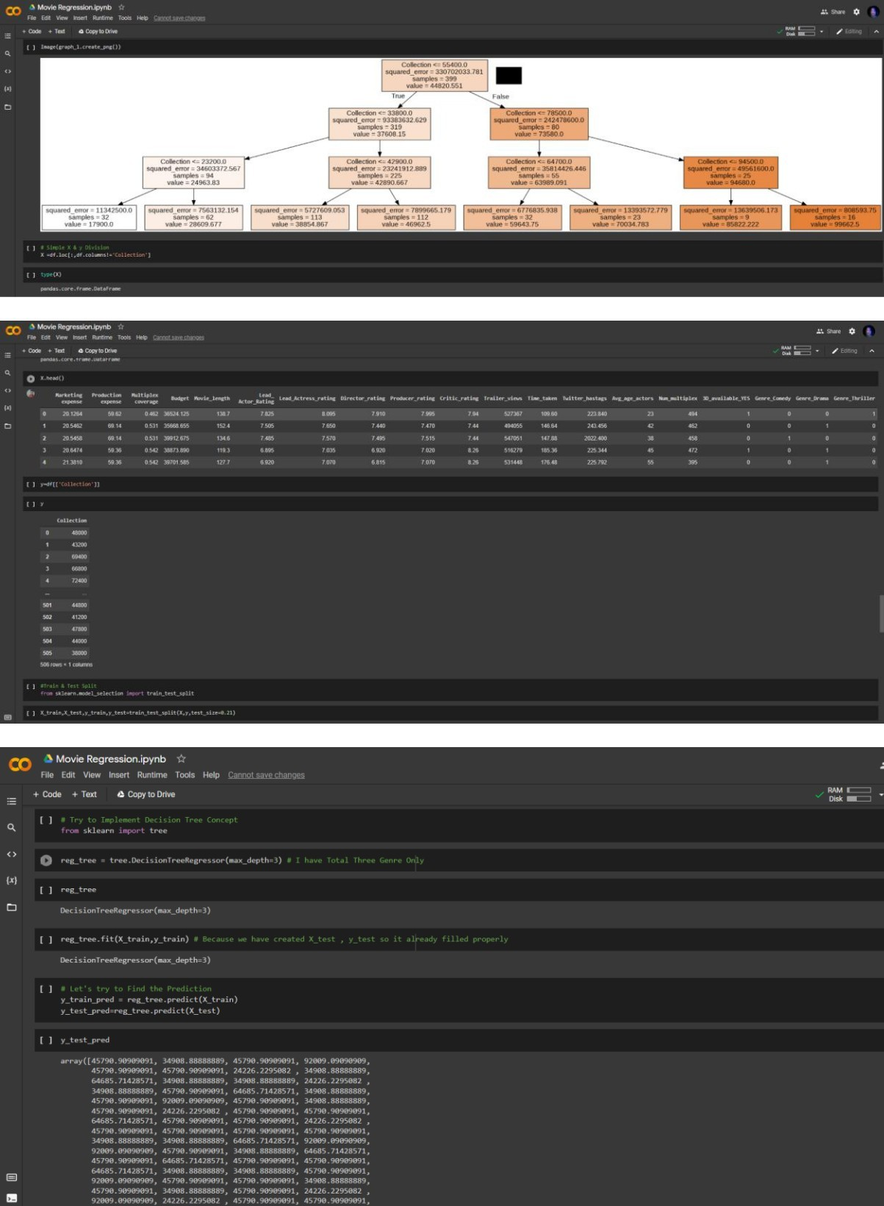

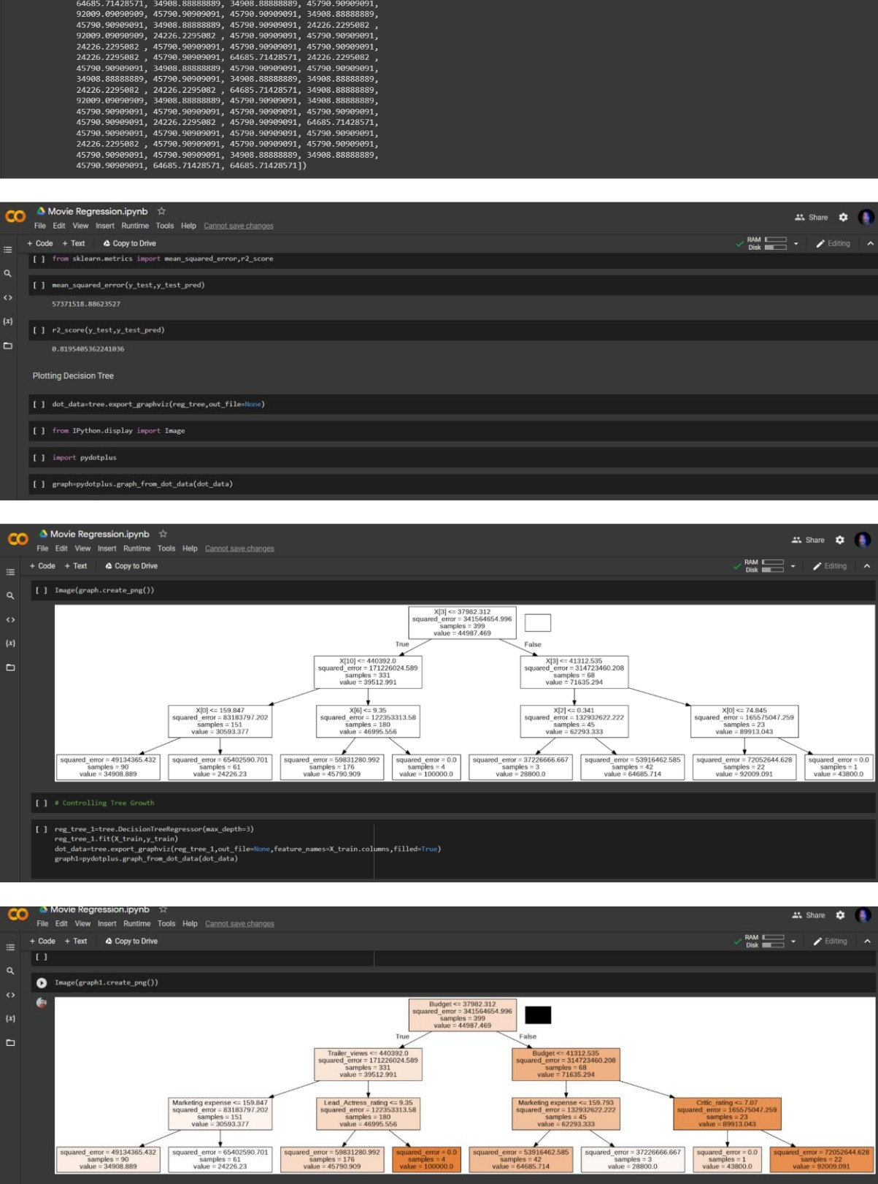

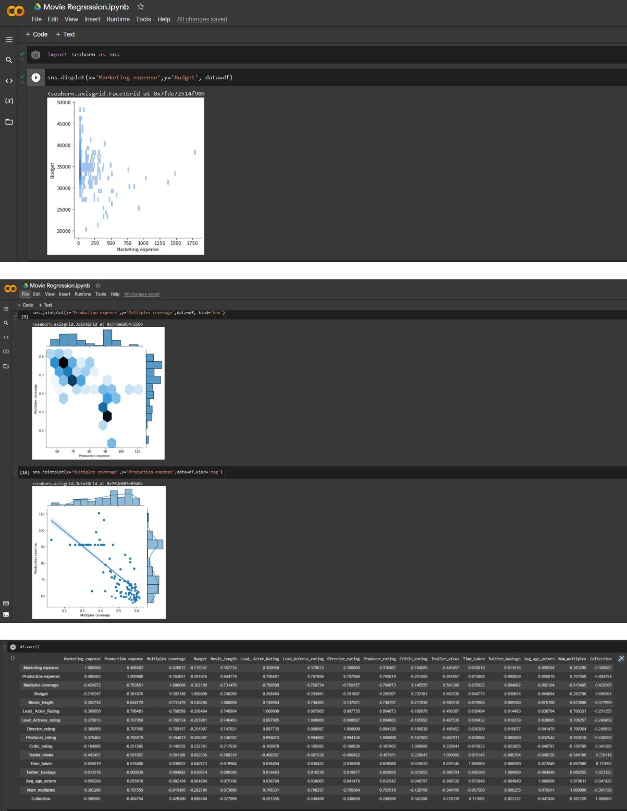

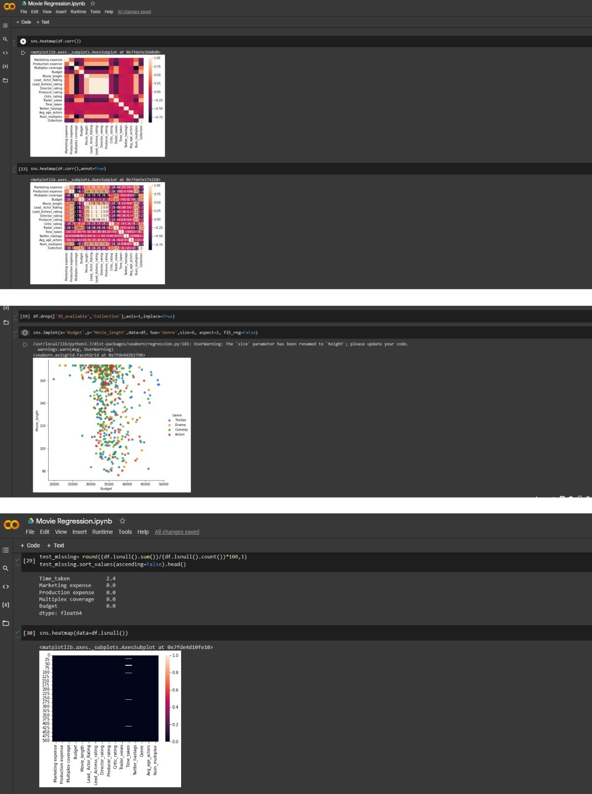

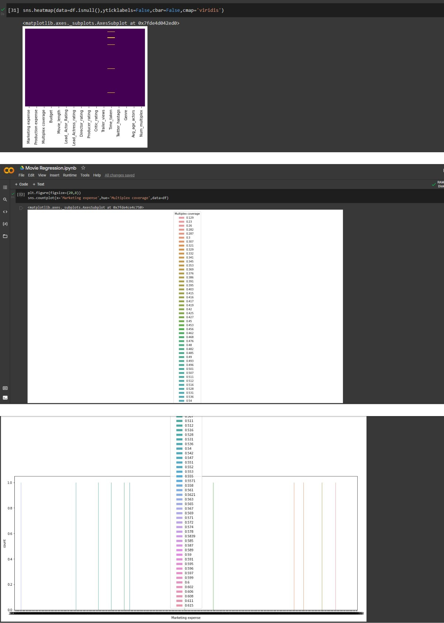

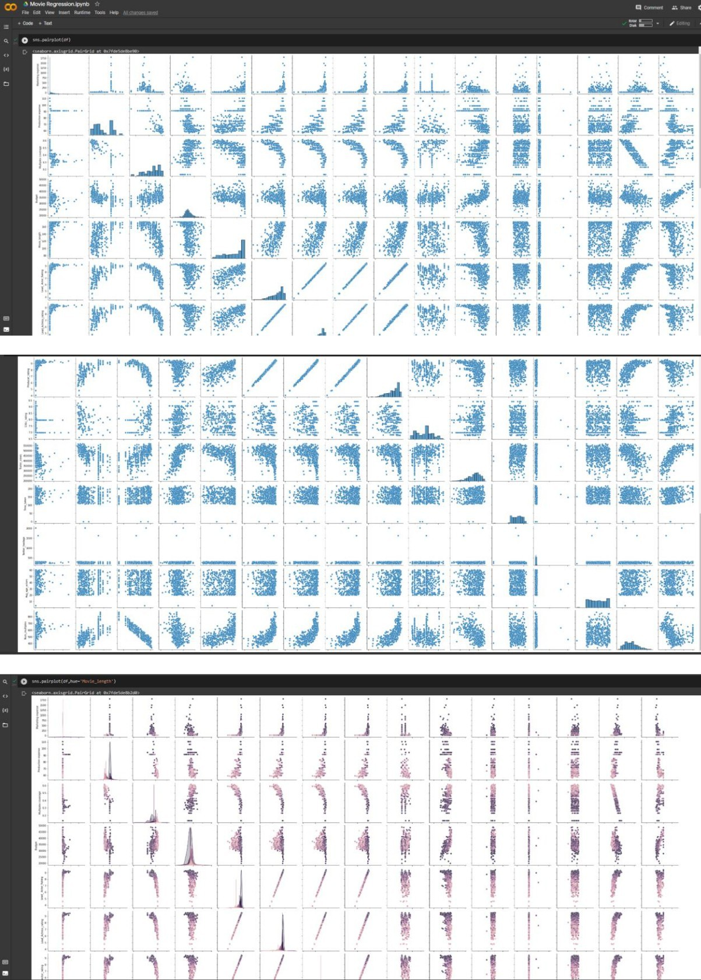

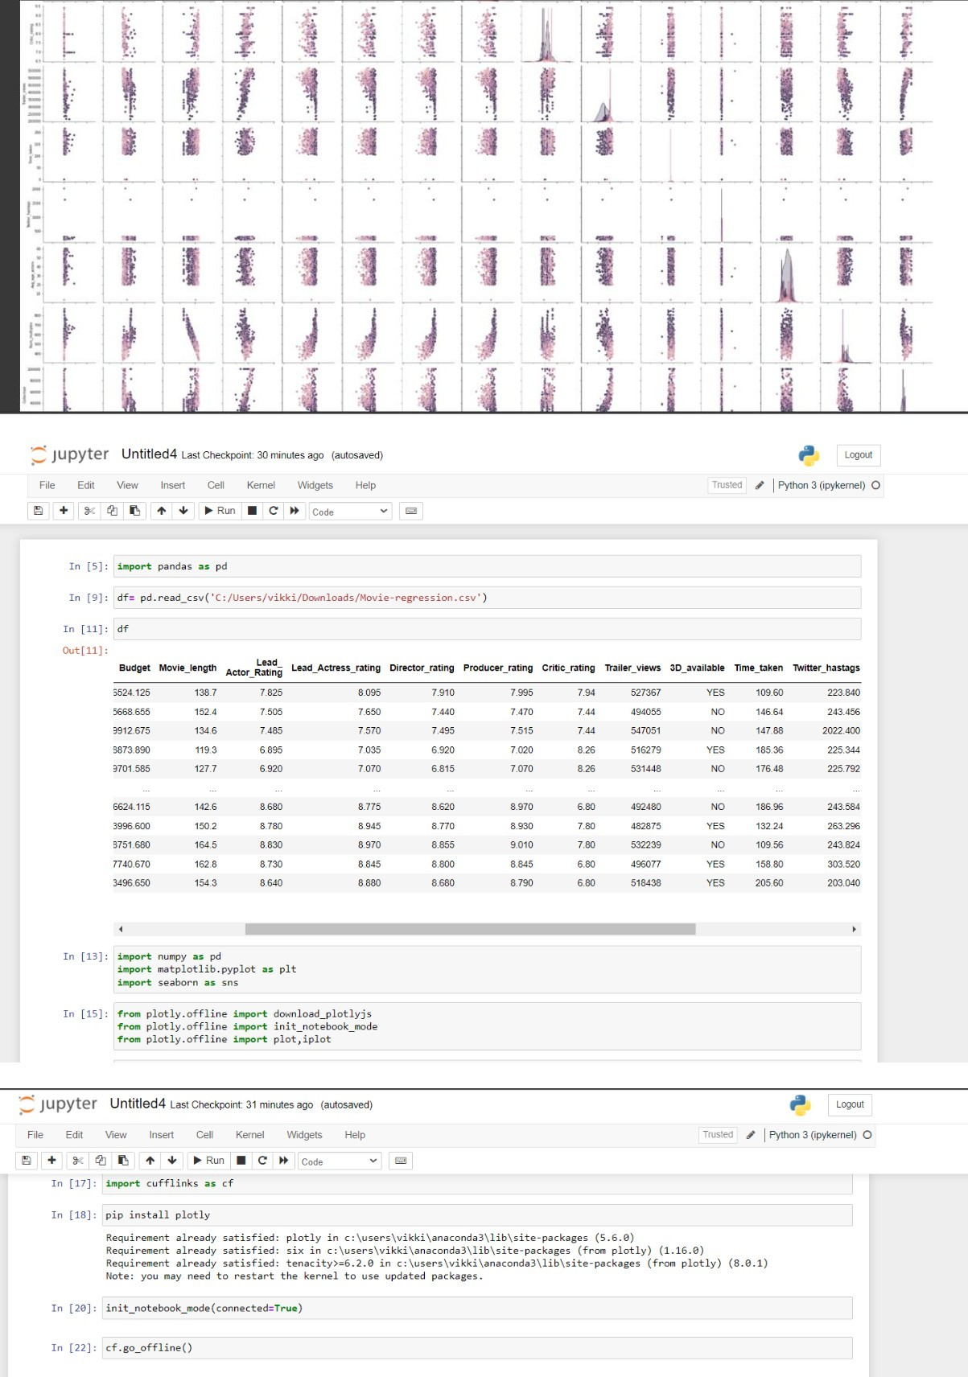

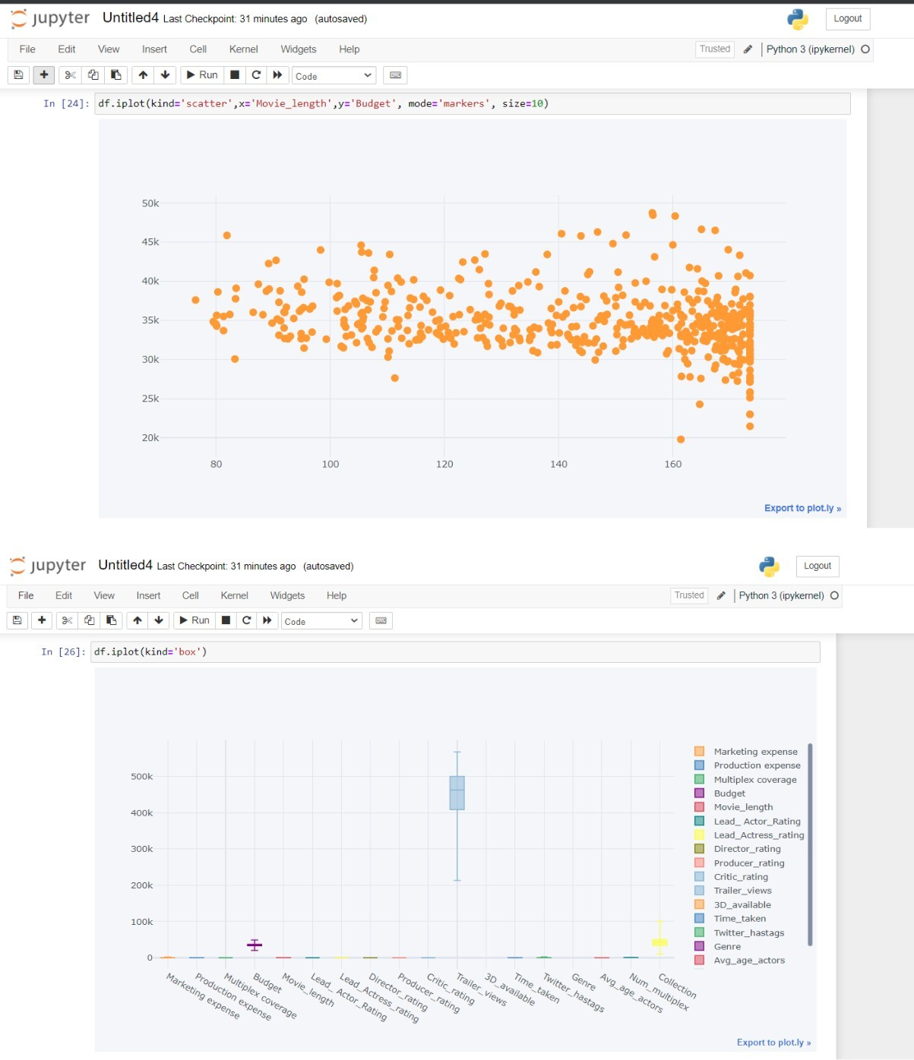

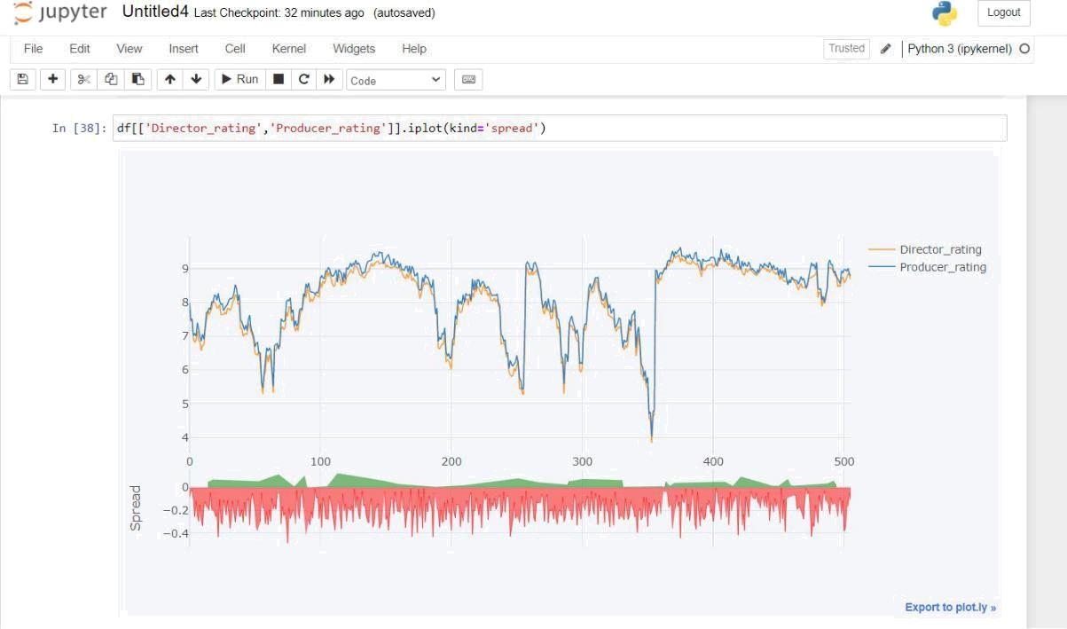

* 1. **AIRLINE PASSENGER**

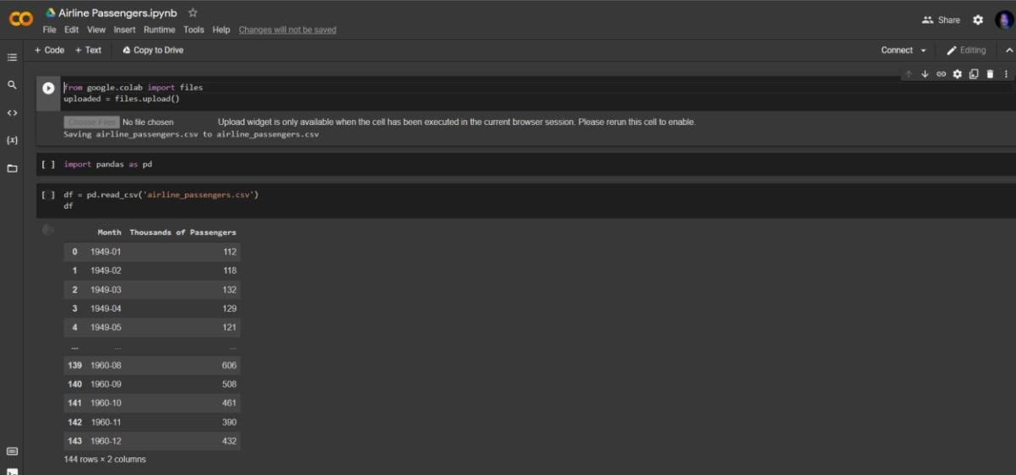

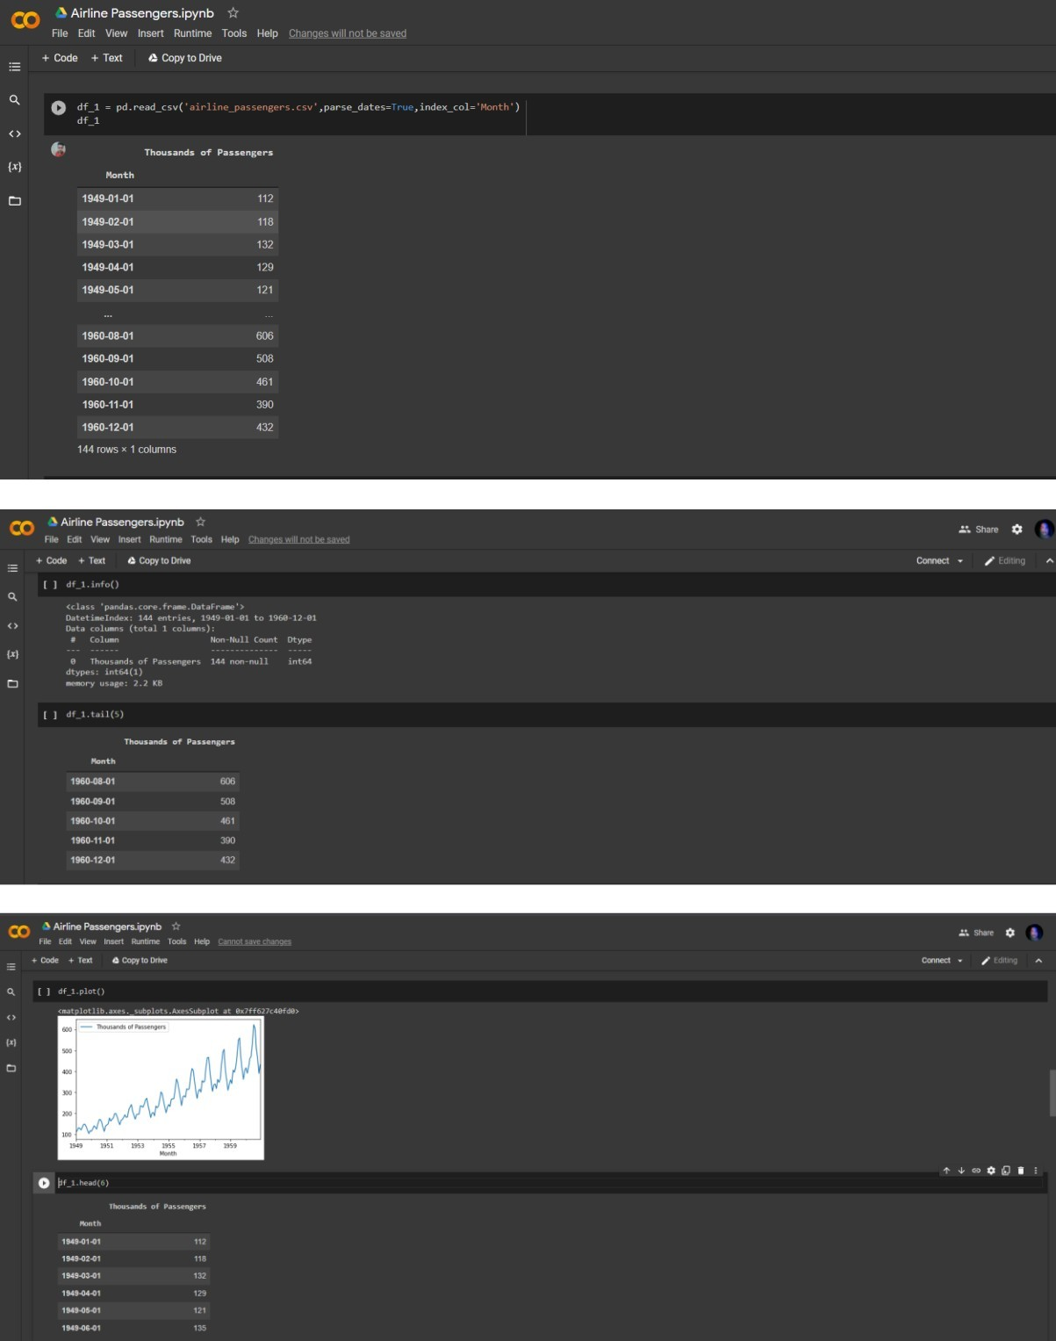

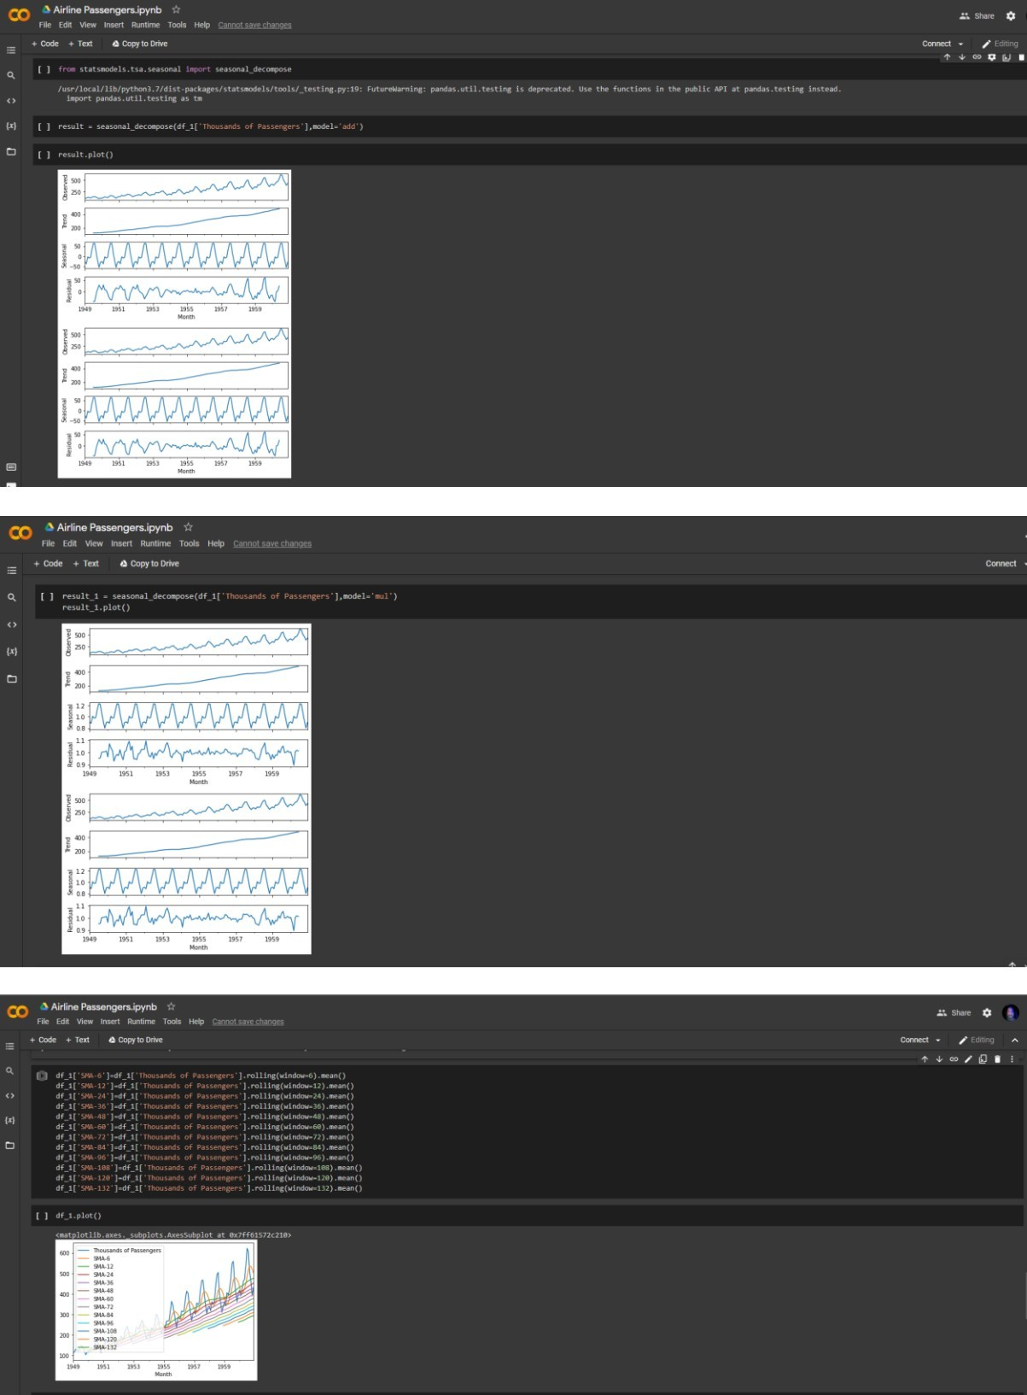

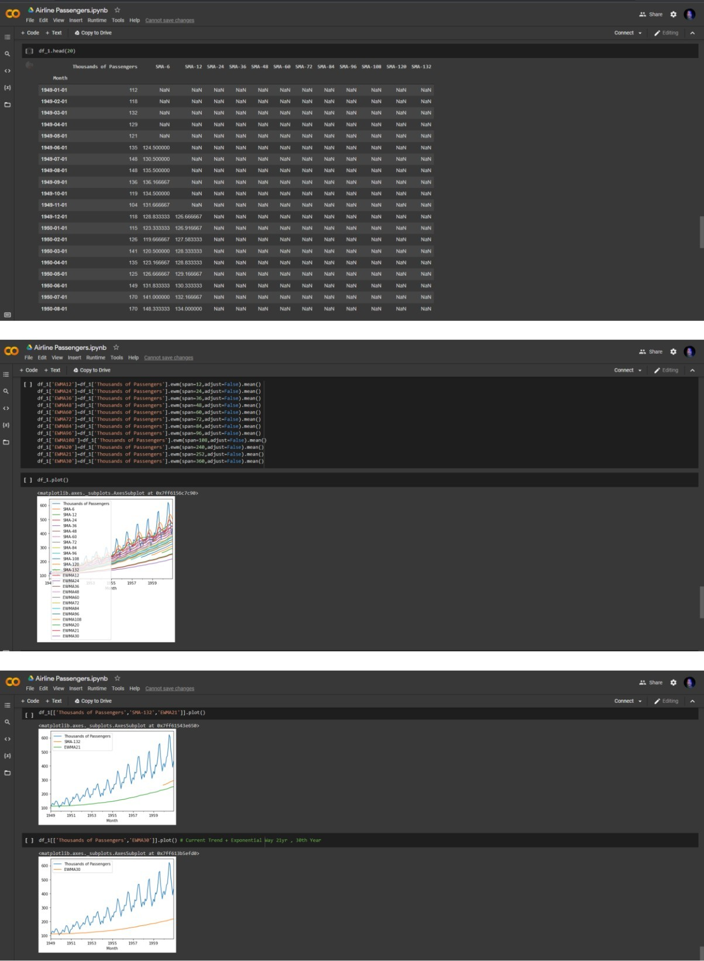

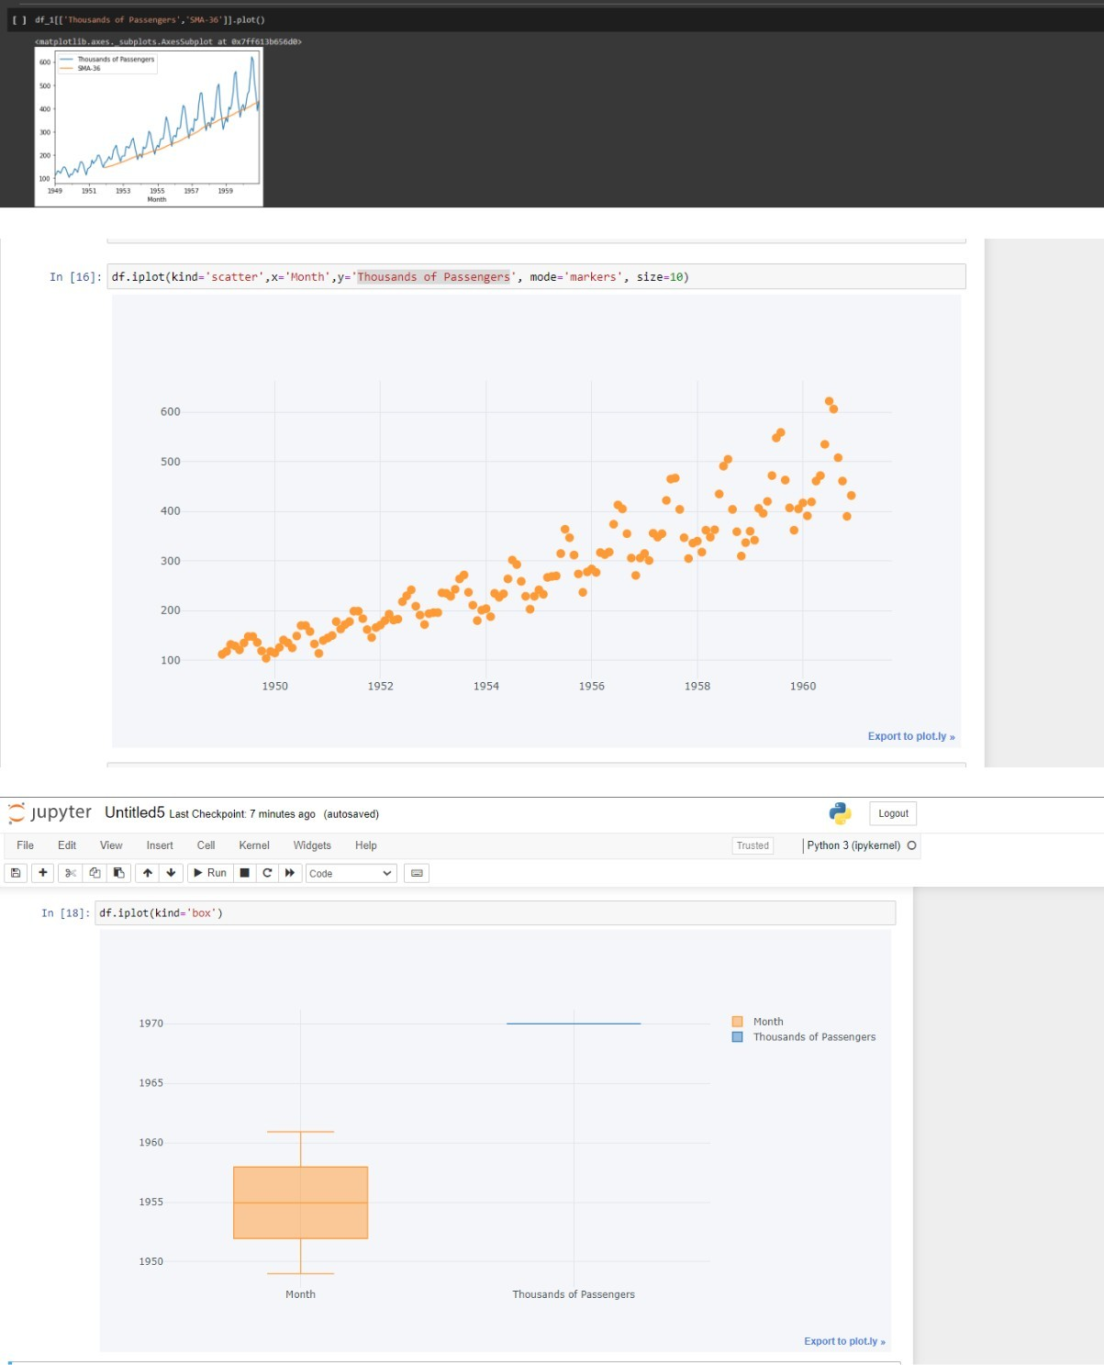

Annexure

|  |  |  |  |  |  |  |  |  |  |  |  |  |  |  |  |  |  |
| --- | --- | --- | --- | --- | --- | --- | --- | --- | --- | --- | --- | --- | --- | --- | --- | --- | --- |
| ***Marketing***  ***expense*** | ***Production***  ***expense*** | ***Multiplex***  ***coverage*** | ***Budget*** | ***Movie_length*** | ***Lead_***  ***Actor_Rating*** | ***Lead_Actress_rating*** | ***Director_rating*** | ***Producer_rating*** | ***Critic_rating*** | ***Trailer_views*** | ***3D_available*** | ***Time_taken*** | ***Twitter_hastags*** | ***Genre*** | ***Avg_age_actors*** | ***Num_multiplex*** | ***Collection*** |
| *20.126* | *59.6* | *0.46* | *36524* | *138.7* | *7.825* | *8.095* | *7.91* | *8* | *7.9* | *5E+05* | *YES* | *110* | *223.8* | *Thriller* | *23* | *494* | *48000* |
| *20.546* | *69.1* | *0.53* | *35669* | *152.4* | *7.505* | *7.65* | *7.44* | *7.47* | *7.4* | *5E+05* | *NO* | *147* | *243.5* | *Drama* | *42* | *462* | *43200* |
| *20.546* | *69.1* | *0.53* | *39913* | *134.6* | *7.485* | *7.57* | *7.5* | *7.52* | *7.4* | *5E+05* | *NO* | *148* | *2022* | *Comedy* | *38* | *458* | *69400* |
| *20.647* | *59.4* | *0.54* | *38874* | *119.3* | *6.895* | *7.035* | *6.92* | *7.02* | *8.3* | *5E+05* | *YES* | *185* | *225.3* | *Drama* | *45* | *472* | *66800* |
| *21.381* | *59.4* | *0.54* | *39702* | *127.7* | *6.92* | *7.07* | *6.82* | *7.07* | *8.3* | *5E+05* | *NO* | *176* | *225.8* | *Drama* | *55* | *395* | *72400* |
| *20.597* | *59.4* | *0.54* | *35719* | *132.2* | *6.89* | *7.1* | *6.89* | *7.01* | *7.3* | *5E+05* | *YES* | *143* | *284.6* | *Comedy* | *53* | *460* | *57400* |
| *21.766* | *70.7* | *0.48* | *33397* | *140.1* | *7.065* | *7.265* | *7.15* | *7.4* | *9* | *5E+05* | *YES* | *139* | *243.7* | *Thriller* | *41* | *522* | *45800* |
| *22.891* | *70.7* | *0.48* | *34285* | *169.6* | *6.98* | *7.075* | *6.88* | *7.17* | *8* | *4E+05* | *NO* | *117* | *243.5* | *Drama* | *56* | *571* | *44200* |
| *24.225* | *70.7* | *0.48* | *31280* | *173.5* | *6.91* | *7.075* | *6.85* | *7* | *8* | *3E+05* | *YES* | *119* | *242.6* | *Comedy* | *55* | *564* | *33000* |
| *23.401* | *70.7* | *0.48* | *33352* | *159.4* | *6.665* | *6.725* | *6.58* | *6.86* | *8* | *4E+05* | *YES* | *190* | *283* | *Thriller* | *45* | *508* | *37800* |
| *24.498* | *70.7* | *0.48* | *35424* | *167.8* | *6.675* | *6.845* | *6.73* | *7.06* | *9* | *4E+05* | *NO* | *120* | *222.4* | *Drama* | *29* | *578* | *30000* |
| *22.349* | *70.7* | *0.48* | *33380* | *156.4* | *6.865* | *7.035* | *6.75* | *6.91* | *9* | *5E+05* | *NO* | *186* | *263* | *Action* | *23* | *553* | *37800* |
| *21.876* | *70.7* | *0.48* | *32713* | *112.5* | *7.12* | *7.43* | *7.21* | *7.34* | *9* | *4E+05* | *YES* | *111* | *203.5* | *Action* | *57* | *575* | *43400* |
| *32.595* | *71.3* | *0.46* | *33047* | *135.3* | *7.64* | *7.705* | *7.54* | *7.71* | *6.8* | *5E+05* | *YES* | *118* | *283.3* | *Comedy* | *39* | *535* | *40800* |
| *32.759* | *71.3* | *0.46* | *33863* | *158* | *7.7* | *7.9* | *7.76* | *7.71* | *7.8* | *5E+05* | *NO* | *139* | *262.9* | *Comedy* | *49* | *599* | *36400* |
| *32.548* | *71.3* | *0.46* | *32408* | *130* | *7.7* | *7.825* | *7.64* | *7.84* | *6.8* | *5E+05* | *YES* | *170* | *283.2* | *Thriller* | *28* | *598* | *39800* |
| *41.079* | *71.3* | *0.46* | *32969* | *102.8* | *7.67* | *7.805* | *7.74* | *7.79* | *7.8* | *5E+05* | *NO* | *109* | *203.7* | *Comedy* | *46* | *547* | *46200* |
| *35.684* | *71.3* | *0.46* | *33274* | *155.2* | *7.72* | *7.925* | *7.82* | *8.02* | *6.8* | *4E+05* | *NO* | *109* | *222.8* | *Drama* | *56* | *548* | *35000* |
| *36.054* | *71.3* | *0.46* | *30308* | *110.1* | *8.1* | *8.24* | *8.07* | *8* | *6.8* | *4E+05* | *YES* | *170* | *243.2* | *Action* | *41* | *543* | *40400* |
| *34.516* | *71.3* | *0.46* | *31813* | *143* | *8.01* | *8.175* | *8* | *8.22* | *7.8* | *5E+05* | *NO* | *171* | *242.9* | *Action* | *27* | *578* | *36400* |
| *45.036* | *71.3* | *0.46* | *30941* | *171.6* | *8.035* | *8.205* | *7.96* | *8.21* | *7.8* | *4E+05* | *YES* |  | *302.2* | *Action* | *44* | *484* | *27200* |
| *37.041* | *71.3* | *0.46* | *33136* | *162.7* | *7.945* | *8.14* | *7.83* | *8.06* | *7.8* | *5E+05* | *YES* | *184* | *283.1* | *Comedy* | *23* | *541* | *39200* |
| *44.649* | *71.3* | *0.46* | *34119* | *165.2* | *7.91* | *8.01* | *7.85* | *8.28* | *6.8* | *4E+05* | *YES* | *116* | *282.4* | *Thriller* | *48* | *575* | *30400* |
| *39.769* | *71.3* | *0.46* | *32291* | *173.5* | *7.825* | *8.01* | *7.94* | *8.04* | *7.8* | *4E+05* | *YES* | *150* | *262.3* | *Drama* | *29* | *527* | *29000* |
| *35.005* | *71.3* | *0.46* | *32908* | *167.6* | *7.655* | *7.965* | *7.64* | *7.94* | *7.8* | *4E+05* | *YES* | *164* | *262.5* | *Drama* | *27* | *502* | *31200* |
| *36.811* | *71.3* | *0.46* | *31102* | *159.2* | *7.655* | *7.835* | *7.64* | *7.96* | *7.8* | *4E+05* | *YES* | *188* | *262.2* | *Thriller* | *35* | *516* | *27800* |
| *33.438* | *71.3* | *0.46* | *32291* | *163.8* | *7.53* | *7.705* | *7.65* | *7.76* | *6.8* | *4E+05* | *NO* | *195* | *242.7* | *Drama* | *59* | *476* | *33200* |
| *39.115* | *71.3* | *0.46* | *33591* | *162.3* | *7.75* | *7.8* | *7.7* | *7.85* | *6.8* | *4E+05* | *YES* | *174* | *262.4* | *Drama* | *20* | *488* | *29600* |
| *35.46* | *71.3* | *0.46* | *36080* | *167.9* | *7.715* | *7.825* | *7.66* | *7.9* | *7.8* | *5E+05* | *YES* | *119* | *302.9* | *Thriller* | *35* | *544* | *36800* |
| *40.049* | *71.3* | *0.46* | *37074* | *160.8* | *7.735* | *8.03* | *7.82* | *7.94* | *6.8* | *5E+05* | *NO* | *180* | *243.4* | *Thriller* | *50* | *488* | *42000* |
| *42.616* | *71.3* | *0.46* | *31736* | *167.6* | *7.74* | *7.91* | *7.82* | *8.07* | *6.8* | *4E+05* | *NO* | *197* | *242* | *Drama* | *34* | *586* | *25400* |
| *47.094* | *71.3* | *0.46* | *33730* | *173.5* | *7.805* | *7.97* | *7.76* | *8.12* | *6.8* | *4E+05* | *YES* | *186* | *242.3* | *Comedy* | *23* | *523* | *29000* |
| *47.76* | *71.3* | *0.46* | *33052* | *155.5* | *7.995* | *8.07* | *7.85* | *8.11* | *7.8* | *3E+05* | *NO* | *175* | *282.1* | *Thriller* | *25* | *533* | *26400* |
| *43.034* | *71.3* | *0.46* | *31669* | *168.5* | *8.1* | *8.165* | *8.02* | *8.14* | *7.8* | *4E+05* | *YES* | *167* | *302.1* | *Comedy* | *25* | *571* | *26200* |
| *52.256* | *71.3* | *0.46* | *33863* | *170.4* | *7.965* | *8.17* | *8.07* | *8.28* | *6.8* | *4E+05* | *YES* | *193* | *222.2* | *Comedy* | *40* | *497* | *27000* |
| *21.283* | *66.9* | *0.5* | *32958* | *141.7* | *8.155* | *8.365* | *8.23* | *8.53* | *7.2* | *5E+05* | *YES* | *190* | *223* | *Thriller* | *43* | *530* | *37800* |
| *21.949* | *66.9* | *0.5* | *32447* | *134.9* | *8.305* | *8.36* | *8.19* | *8.39* | *8.2* | *5E+05* | *NO* | *150* | *303.2* | *Comedy* | *39* | *454* | *40000* |
| *21.603* | *66.9* | *0.5* | *32497* | *115* | *8.01* | *8.125* | *7.94* | *8.06* | *7.2* | *5E+05* | *YES* | *162* | *203.4* | *Thriller* | *21* | *510* | *42000* |
| *23.501* | *66.9* | *0.5* | *33141* | *103.7* | *7.925* | *8.17* | *7.98* | *8.23* | *7.2* | *5E+05* | *YES* | *164* | *203.9* | *Thriller* | *21* | *484* | *48400* |
| *20.553* | *60.9* | *0.57* | *36635* | *95.3* | *7.175* | *7.325* | *7.23* | *7.48* | *8.3* | *6E+05* | *YES* | *138* | *244.9* | *Thriller* | *49* | *451* | *61600* |
| *20.672* | *60.9* | *0.57* | *39018* | *89.3* | *7.185* | *7.345* | *7.24* | *7.43* | *8.3* | *6E+05* | *YES* | *124* | *305.6* | *Thriller* | *20* | *428* | *69800* |
| *22.549* | *68.8* | *0.55* | *37607* | *76.4* | *7.115* | *7.14* | *7* | *7.3* | *7.4* | *5E+05* | *NO* | *155* | *264.3* | *Action* | *30* | *495* | *53200* |
| *22.83* | *68.8* | *0.55* | *34269* | *80.1* | *7.035* | *7.27* | *7.06* | *7.19* | *7.4* | *5E+05* | *NO* | *162* | *304* | *Thriller* | *52* | *419* | *50600* |
| *23.187* | *68.8* | *0.55* | *34502* | *80* | *6.98* | *7.17* | *7.08* | *7.33* | *8.4* | *5E+05* | *YES* | *122* | *304* | *Thriller* | *56* | *449* | *49400* |
| *22.454* | *68.8* | *0.55* | *33713* | *113.5* | *7.095* | *7.245* | *7.05* | *7.17* | *8.4* | *5E+05* | *NO* | *180* | *243.4* | *Thriller* | *53* | *400* | *42400* |

**Ann**exure

|  |  |  |  |  |  |  |  |  |  |  |  |  |  |  |  |  |  |
| --- | --- | --- | --- | --- | --- | --- | --- | --- | --- | --- | --- | --- | --- | --- | --- | --- | --- |
| *23.428* | *68.8* | *0.55* | *31564* | *107.3* | *7.385* | *7.525* | *7.4* | *7.49* | *8.4* | *5E+05* | *NO* | *162* | *223.1* | *Thriller* | *21* | *445* | *38600* |
| *23.767* | *68.8* | *0.55* | *32141* | *106.8* | *7.375* | *7.5* | *7.3* | *7.63* | *8.4* | *4E+05* | *YES* | *186* | *243.2* | *Drama* | *39* | *455* | *40000* |
| *24.585* | *68.8* | *0.55* | *33497* | *159* | *7.085* | *7.18* | *7.13* | *7.23* | *7.4* | *4E+05* | *YES* | *107* | *242.7* | *Thriller* | *44* | *526* | *33200* |
| *25.077* | *68.8* | *0.55* | *29991* | *168.8* | *7.01* | *7.16* | *7.02* | *7.07* | *8.4* | *3E+05* | *NO* | *142* | *282.3* | *Comedy* | *34* | *427* | *28800* |
| *24.395* | *68.8* | *0.55* | *31119* | *135.5* | *6.945* | *7.05* | *6.85* | *6.98* | *7.4* | *4E+05* | *NO* | *120* | *263.1* | *Action* | *45* | *507* | *38800* |
| *21.775* | *66.3* | *0.56* | *33124* | *119.2* | *6.46* | *6.725* | *6.5* | *6.69* | *7.6* | *4E+05* | *YES* | *0* | *223.2* | *Thriller* | *21* | *404* | *39400* |
| *20.867* | *66.3* | *0.56* | *33969* | *136.5* | *6.48* | *6.63* | *6.46* | *6.8* | *8.6* | *5E+05* | *YES* | *140* | *223.3* | *Drama* | *30* | *473* | *41000* |
| *21.072* | *66.3* | *0.56* | *36169* | *94.6* | *6.49* | *6.62* | *6.44* | *6.82* | *8.6* | *5E+05* | *NO* | *198* | *284* | *Thriller* | *56* | *462* | *50000* |
| *20.996* | *66.3* | *0.56* | *33319* | *94.9* | *6.555* | *6.74* | *6.57* | *6.51* | *8.6* | *5E+05* | *NO* | *183* | *223.7* | *Thriller* | *41* | *416* | *46800* |
| *20.272* | *63* | *0.59* | *32708* | *121.1* | *6.3* | *6.365* | *6.2* | *6.5* | *6.8* | *4E+05* | *YES* | *174* | *303* | *Comedy* | *55* | *387* | *37800* |
| *20.262* | *57.4* | *0.6* | *40268* | *95.4* | *5.55* | *5.795* | *5.61* | *5.66* | *8.4* | *5E+05* | *YES* | *150* | *265.7* | *Thriller* | *50* | *480* | *70800* |
| *20.411* | *56.5* | *0.59* | *35458* | *109.2* | *5.34* | *5.535* | *5.29* | *5.47* | *8.5* | *5E+05* | *YES* | *116* | *304* | *Drama* | *22* | *383* | *49400* |
| *20.286* | *57.6* | *0.59* | *37863* | *114* | *5.685* | *5.86* | *5.82* | *5.99* | *9* | *5E+05* | *YES* | *149* | *305.1* | *Drama* | *45* | *426* | *63200* |
| *23.089* | *65.3* | *0.55* | *34135* | *102.7* | *6.01* | *6.115* | *5.97* | *6.28* | *7.1* | *5E+05* | *NO* |  | *283.7* | *Comedy* | *22* | *438* | *46600* |
| *22.066* | *65.3* | *0.55* | *32924* | *120.7* | *6.37* | *6.66* | *6.45* | *6.66* | *7.1* | *5E+05* | *YES* | *124* | *283.1* | *Comedy* | *20* | *460* | *39200* |
| *22.986* | *65.3* | *0.55* | *31891* | *139.7* | *6.335* | *6.42* | *6.24* | *6.56* | *7.1* | *5E+05* | *NO* |  | *223* | *Thriller* | *30* | *439* | *37400* |
| *23.434* | *65.3* | *0.55* | *33141* | *166.9* | *6.58* | *6.665* | *6.46* | *6.66* | *7.1* | *4E+05* | *NO* | *124* | *302.6* | *Thriller* | *48* | *387* | *32000* |
| *22.205* | *65.3* | *0.55* | *35863* | *141.3* | *6.225* | *6.46* | *6.29* | *6.58* | *7.1* | *5E+05* | *YES* | *117* | *203.6* | *Comedy* | *56* | *434* | *44400* |
| *22.53* | *65.3* | *0.55* | *37563* | *116.9* | *5.885* | *6.155* | *5.95* | *6.05* | *8.1* | *5E+05* | *YES* | *118* | *264* | *Action* | *28* | *470* | *50000* |
| *20.39* | *57.8* | *0.58* | *39463* | *133* | *5.28* | *5.455* | *5.32* | *5.51* | *7.3* | *5E+05* | *YES* | *165* | *205.3* | *Action* | *30* | *390* | *66000* |
| *20.717* | *61.7* | *0.6* | *34941* | *91.3* | *6.69* | *6.785* | *6.58* | *6.73* | *8.8* | *5E+05* | *NO* | *189* | *243.8* | *Thriller* | *20* | *375* | *47000* |
| *20.876* | *61.7* | *0.6* | *32147* | *104.6* | *6.65* | *6.78* | *6.58* | *6.77* | *8.8* | *5E+05* | *NO* | *180* | *223.1* | *Action* | *44* | *479* | *38800* |
| *21.158* | *67.1* | *0.59* | *32652* | *94.9* | *6.68* | *6.8* | *6.74* | *6.79* | *8.2* | *5E+05* | *YES* | *143* | *263.5* | *Thriller* | *29* | *406* | *44000* |
| *22.711* | *67.1* | *0.59* | *31075* | *110.3* | *6.745* | *6.915* | *6.73* | *6.62* | *8.2* | *5E+05* | *NO* | *177* | *302.8* | *Thriller* | *40* | *485* | *34800* |
| *22.563* | *67.1* | *0.59* | *32691* | *106.5* | *6.725* | *6.805* | *6.7* | *6.77* | *7.2* | *5E+05* | *NO* | *166* | *223.3* | *Drama* | *56* | *384* | *41800* |
| *21.765* | *76.6* | *0.59* | *35646* | *80.1* | *7.24* | *7.465* | *7.21* | *7.52* | *7.2* | *5E+05* | *YES* | *196* | *283.9* | *Thriller* | *38* | *410* | *48400* |
| *23.175* | *76.6* | *0.59* | *33113* | *91* | *7.28* | *7.4* | *7.29* | *7.46* | *8.2* | *5E+05* | *NO* | *201* | *263.5* | *Action* | *46* | *400* | *43400* |
| *21.833* | *76.6* | *0.59* | *33691* | *81.3* | *7.27* | *7.52* | *7.2* | *7.44* | *7.2* | *5E+05* | *NO* | *117* | *203.6* | *Thriller* | *20* | *361* | *45600* |
| *23.908* | *76.6* | *0.59* | *34691* | *79.7* | *7.32* | *7.385* | *7.25* | *7.47* | *8.2* | *5E+05* | *YES* | *119* | *243.7* | *Drama* | *45* | *434* | *46800* |
| *21.579* | *80.7* | *0.56* | *34847* | *79.5* | *7.73* | *8.025* | *7.72* | *8.03* | *7.3* | *5E+05* | *NO* | *158* | *203.9* | *Thriller* | *40* | *389* | *48200* |
| *21.902* | *80.7* | *0.56* | *34919* | *118.5* | *7.585* | *7.75* | *7.59* | *8.07* | *8.3* | *5E+05* | *NO* | *121* | *203.4* | *Comedy* | *28* | *382* | *42800* |
| *22.031* | *80.7* | *0.56* | *34880* | *148* | *7.835* | *8.14* | *7.87* | *8.05* | *8.3* | *5E+05* | *NO* | *146* | *243.2* | *Comedy* | *22* | *453* | *40000* |
| *21.741* | *80.7* | *0.56* | *34108* | *119.3* | *7.84* | *7.97* | *7.87* | *8.14* | *7.3* | *5E+05* | *YES* | *118* | *223.3* | *Thriller* | *57* | *419* | *41600* |
| *21.129* | *80.7* | *0.56* | *34619* | *127.2* | *7.33* | *7.5* | *7.45* | *7.69* | *8.3* | *4E+05* | *YES* | *176* | *303.4* | *Drama* | *53* | *377* | *42400* |
| *21.677* | *80.7* | *0.56* | *32630* | *110.1* | *7.735* | *7.885* | *7.59* | *7.79* | *8.3* | *5E+05* | *NO* | *128* | *303.2* | *Action* | *37* | *472* | *40600* |
| *20.823* | *64.7* | *0.57* | *37368* | *107* | *7.25* | *7.36* | *7.3* | *7.29* | *8.2* | *5E+05* | *YES* | *129* | *284.5* | *Drama* | *54* | *374* | *56000* |
| *20.892* | *64.7* | *0.57* | *36769* | *143.9* | *7.145* | *7.445* | *7.15* | *7.46* | *7.2* | *5E+05* | *YES* | *112* | *243.8* | *Drama* | *49* | *501* | *47800* |
| *20.732* | *64.7* | *0.57* | *35008* | *105.7* | *7.235* | *7.405* | *7.27* | *7.29* | *8.2* | *5E+05* | *NO* | *122* | *204* | *Thriller* | *20* | *469* | *49600* |
| *20.71* | *64.7* | *0.57* | *34258* | *120.2* | *7.24* | *7.41* | *7.17* | *7.39* | *7.2* | *5E+05* | *YES* | *151* | *203.7* | *Drama* | *34* | *405* | *45800* |
| *21.012* | *64* | *0.55* | *35491* | *121.5* | *7.515* | *7.645* | *7.51* | *7.78* | *7.3* | *5E+05* | *NO* | *134* | *283.8* | *Drama* | *23* | *422* | *47800* |
| *21.147* | *64* | *0.55* | *36830* | *129.6* | *7.625* | *7.925* | *7.76* | *7.82* | *8.3* | *5E+05* | *NO* | *195* | *244.3* | *Thriller* | *56* | *521* | *53200* |
| *21.038* | *64* | *0.55* | *33413* | *118.6* | *7.69* | *7.92* | *7.76* | *7.78* | *7.3* | *4E+05* | *YES* | *119* | *223.6* | *Thriller* | *50* | *472* | *45000* |
| *21.43* | *64* | *0.55* | *34002* | *130.3* | *8.035* | *8.13* | *8.08* | *8.26* | *8.3* | *5E+05* | *YES* | *145* | *243.6* | *Comedy* | *43* | *510* | *44400* |
| *21.132* | *61.8* | *0.51* | *38924* | *159.8* | *8.25* | *8.455* | *8.28* | *8.18* | *8.4* | *5E+05* | *NO* | *139* | *203.8* | *Thriller* | *28* | *456* | *47200* |
| *21.06* | *61.8* | *0.51* | *39324* | *136.6* | *8.17* | *8.31* | *8.14* | *8.56* | *8.4* | *5E+05* | *YES* | *151* | *304.6* | *Comedy* | *31* | *478* | *57400* |
| *20.937* | *61.8* | *0.51* | *35646* | *139.6* | *8.43* | *8.535* | *8.43* | *8.43* | *8.4* | *5E+05* | *YES* | *147* | *303.6* | *Drama* | *58* | *424* | *45200* |

Annexure

|  |  |  |  |  |  |  |  |  |  |  |  |  |  |  |  |  |  |
| --- | --- | --- | --- | --- | --- | --- | --- | --- | --- | --- | --- | --- | --- | --- | --- | --- | --- |
| *20.786* | *61.8* | *0.51* | *35580* | *147.4* | *8.42* | *8.525* | *8.3* | *8.58* | *7.4* | *5E+05* | *NO* | *165* | *263.5* | *Thriller* | *23* | *451* | *44000* |
| *20.841* | *85.1* | *0.54* | *35785* | *127.1* | *8.02* | *8.295* | *8.02* | *8.34* | *8.4* | *5E+05* | *NO* | *183* | *283.7* | *Drama* | *60* | *518* | *45800* |
| *20.575* | *85.1* | *0.54* | *34502* | *102.4* | *8.04* | *8.225* | *8.1* | *8.31* | *8.4* | *5E+05* | *NO* | *206* | *284* | *Action* | *46* | *492* | *50000* |
| *20.859* | *85.1* | *0.54* | *34713* | *150.8* | *8.095* | *8.33* | *8.04* | *8.31* | *8.4* | *5E+05* | *NO* | *114* | *263.3* | *Action* | *54* | *465* | *41200* |
| *22.441* | *60.8* | *0.56* | *36802* | *131.3* | *8.215* | *8.385* | *8.12* | *8.29* | *7.4* | *5E+05* | *NO* | *199* | *284.5* | *Thriller* | *46* | *467* | *56800* |
| *22.301* | *60.8* | *0.56* | *34235* | *143.1* | *8.21* | *8.325* | *8.23* | *8.25* | *8.4* | *5E+05* | *NO* | *205* | *243.4* | *Thriller* | *21* | *463* | *42800* |
| *22.417* | *60.8* | *0.56* | *44823* | *149.5* | *8.15* | *8.34* | *8.22* | *8.31* | *7.4* | *5E+05* | *YES* | *125* | *246.2* | *Thriller* | *53* | *413* | *77400* |
| *21.637* | *60.8* | *0.56* | *43440* | *110.4* | *8.23* | *8.29* | *8.2* | *8.29* | *7.4* | *5E+05* | *YES* | *218* | *207* | *Action* | *25* | *512* | *87600* |
| *21.372* | *60.8* | *0.56* | *41196* | *136* | *8.085* | *8.32* | *8.17* | *8.44* | *8.4* | *5E+05* | *NO* | *131* | *265.3* | *Thriller* | *31* | *510* | *66400* |
| *22.973* | *72.1* | *0.48* | *37368* | *153.4* | *8.45* | *8.66* | *8.6* | *8.74* | *6.8* | *5E+05* | *YES* | *193* | *304.4* | *Drama* | *24* | *470* | *55000* |
| *22.286* | *72.1* | *0.48* | *37668* | *144.8* | *8.425* | *8.63* | *8.44* | *8.79* | *7.8* | *5E+05* | *YES* | *145* | *204.2* | *Thriller* | *58* | *445* | *53000* |
| *24.575* | *72.1* | *0.48* | *35580* | *158.9* | *8.485* | *8.725* | *8.64* | *8.73* | *7.8* | *5E+05* | *NO* | *135* | *263* | *Action* | *57* | *544* | *37200* |
| *24.232* | *72.1* | *0.48* | *34091* | *160.9* | *8.515* | *8.79* | *8.56* | *8.71* | *7.8* | *4E+05* | *YES* | *138* | *283.1* | *Comedy* | *36* | *555* | *38600* |
| *22.792* | *72.1* | *0.48* | *34258* | *163.5* | *8.685* | *8.875* | *8.66* | *8.94* | *6.8* | *4E+05* | *YES* |  | *203.2* | *Comedy* | *20* | *458* | *40200* |
| *22.652* | *72.1* | *0.48* | *32502* | *170.2* | *8.905* | *9.025* | *8.94* | *8.93* | *6.8* | *4E+05* | *YES* |  | *263.1* | *Comedy* | *57* | *515* | *39000* |
| *23.424* | *72.1* | *0.48* | *32419* | *165.4* | *8.815* | *8.965* | *8.76* | *9.04* | *6.8* | *4E+05* | *YES* | *206* | *283.1* | *Drama* | *20* | *482* | *39000* |
| *22.623* | *72.1* | *0.48* | *34035* | *158.7* | *8.825* | *9.025* | *8.92* | *8.99* | *6.8* | *4E+05* | *YES* | *120* | *283.3* | *Action* | *57* | *517* | *40800* |
| *22.56* | *72.1* | *0.48* | *35963* | *170.6* | *8.64* | *8.91* | *8.73* | *8.85* | *7.8* | *5E+05* | *NO* | *172* | *203.2* | *Action* | *48* | *502* | *39600* |
| *25.273* | *72.1* | *0.48* | *34602* | *164.7* | *8.715* | *8.86* | *8.56* | *8.78* | *6.8* | *4E+05* | *YES* | *196* | *283.1* | *Comedy* | *41* | *555* | *38800* |
| *22.159* | *72.1* | *0.48* | *34413* | *127.9* | *8.475* | *8.7* | *8.48* | *8.79* | *7.8* | *4E+05* | *YES* | *139* | *203.5* | *Comedy* | *37* | *453* | *43400* |
| *22.017* | *75* | *0.45* | *37302* | *155.1* | *8.595* | *8.685* | *8.5* | *8.87* | *8.4* | *5E+05* | *YES* | *113* | *263.6* | *Thriller* | *34* | *544* | *45600* |
| *22.466* | *75* | *0.45* | *32847* | *166.4* | *8.725* | *8.885* | *8.72* | *8.97* | *7.4* | *4E+05* | *YES* | *0* | *303* | *Thriller* | *35* | *577* | *37600* |
| *24.442* | *75* | *0.45* | *33841* | *168.9* | *8.705* | *8.875* | *8.73* | *8.6* | *8.4* | *4E+05* | *YES* | *201* | *203* | *Thriller* | *59* | *604* | *37400* |
| *22.846* | *75* | *0.45* | *34741* | *157.7* | *8.73* | *8.93* | *8.86* | *8.98* | *8.4* | *4E+05* | *NO* | *133* | *243* | *Action* | *39* | *570* | *37000* |
| *23.427* | *75* | *0.45* | *32930* | *161.7* | *8.72* | *8.795* | *8.64* | *8.92* | *7.4* | *4E+05* | *NO* | *151* | *222.9* | *Comedy* | *24* | *539* | *36600* |
| *22.632* | *75* | *0.45* | *34308* | *146* | *8.535* | *8.645* | *8.5* | *8.86* | *8.4* | *4E+05* | *NO* | *130* | *263.4* | *Comedy* | *23* | *528* | *42400* |
| *23.02* | *75* | *0.45* | *33447* | *156.1* | *8.615* | *8.755* | *8.54* | *8.6* | *7.4* | *5E+05* | *NO* | *190* | *303.1* | *Action* | *28* | *609* | *38400* |
| *22.612* | *75* | *0.45* | *32619* | *146.6* | *8.6* | *8.865* | *8.69* | *8.89* | *7.4* | *4E+05* | *YES* | *160* | *283.3* | *Thriller* | *40* | *566* | *40800* |
| *22.895* | *75* | *0.45* | *31836* | *138.7* | *8.52* | *8.74* | *8.54* | *8.69* | *8.4* | *5E+05* | *YES* | *204* | *223.1* | *Thriller* | *20* | *530* | *38600* |
| *21.38* | *106* | *0.42* | *32608* | *143.2* | *8.8* | *8.92* | *8.74* | *9.03* | *7.2* | *5E+05* | *YES* | *157* | *203.5* | *Thriller* | *23* | *570* | *44000* |
| *21.433* | *106* | *0.42* | *33352* | *157.6* | *8.78* | *9.02* | *8.82* | *8.99* | *8.2* | *5E+05* | *YES* | *194* | *203.2* | *Action* | *39* | *568* | *40600* |
| *21.86* | *106* | *0.42* | *33113* | *166.4* | *8.83* | *9.075* | *8.87* | *9.05* | *8.2* | *4E+05* | *YES* | *178* | *203.3* | *Comedy* | *51* | *608* | *41000* |
| *23.008* | *106* | *0.42* | *32530* | *170.5* | *8.89* | *9.09* | *8.97* | *9.17* | *8.2* | *3E+05* | *YES* | *183* | *202.8* | *Drama* | *51* | *524* | *34600* |
| *21.97* | *106* | *0.42* | *32658* | *169.3* | *8.895* | *9.13* | *8.9* | *9.06* | *8.2* | *4E+05* | *NO* | *126* | *263* | *Thriller* | *56* | *622* | *37600* |
| *23.38* | *106* | *0.42* | *33252* | *161.9* | *8.935* | *9.075* | *8.86* | *9.16* | *7.2* | *4E+05* | *YES* | *163* | *283.4* | *Drama* | *22* | *608* | *42800* |
| *27.747* | *106* | *0.42* | *31180* | *169.1* | *9.035* | *9.24* | *9.1* | *9.12* | *8.2* | *3E+05* | *NO* | *154* | *202.5* | *Drama* | *42* | *635* | *31400* |
| *25.183* | *98.8* | *0.38* | *31625* | *169.5* | *8.955* | *9.135* | *9.08* | *9.26* | *6.8* | *4E+05* | *YES* | *118* | *302.6* | *Comedy* | *31* | *567* | *32400* |
| *26.509* | *98.8* | *0.38* | *35724* | *172.3* | *9.02* | *9.195* | *9.04* | *9.12* | *7.8* | *4E+05* | *NO* | *163* | *282.9* | *Comedy* | *41* | *564* | *36000* |
| *37.625* | *98.8* | *0.38* | *31314* | *168.2* | *8.85* | *9.06* | *8.95* | *9.18* | *6.8* | *4E+05* | *YES* | *158* | *202.3* | *Drama* | *30* | *581* | *28600* |
| *26.801* | *98.8* | *0.38* | *35874* | *172.4* | *8.815* | *9.035* | *8.82* | *9.1* | *6.8* | *5E+05* | *YES* | *180* | *263.1* | *Comedy* | *25* | *663* | *38400* |
| *43.859* | *98.8* | *0.38* | *35141* | *171.2* | *8.73* | *8.985* | *8.79* | *8.96* | *6.8* | *4E+05* | *YES* | *152* | *243.1* | *Comedy* | *29* | *559* | *39200* |
| *31.801* | *98.8* | *0.38* | *35396* | *171.4* | *8.795* | *8.92* | *8.8* | *8.83* | *6.8* | *5E+05* | *YES* | *179* | *243.7* | *Action* | *57* | *550* | *46000* |
| *26.596* | *98.8* | *0.38* | *32341* | *168.9* | *8.635* | *8.79* | *8.74* | *8.9* | *7.8* | *4E+05* | *YES* | *205* | *202.9* | *Action* | *58* | *617* | *36800* |
| *39.523* | *98.8* | *0.38* | *31980* | *171.9* | *8.825* | *8.86* | *8.74* | *8.89* | *6.8* | *4E+05* | *NO* | *180* | *222.5* | *Action* | *32* | *646* | *31200* |
| *31.156* | *98.8* | *0.38* | *35191* | *171.7* | *8.89* | *8.965* | *8.84* | *9.09* | *6.8* | *4E+05* | *YES* | *157* | *222.9* | *Thriller* | *37* | *663* | *36200* |
| *26.453* | *98.8* | *0.38* | *33008* | *167* | *8.87* | *9.08* | *8.91* | *9.21* | *6.8* | *4E+05* | *NO* | *203* | *202.8* | *Thriller* | *37* | *622* | *34800* |

Annexure

|  |  |  |  |  |  |  |  |  |  |  |  |  |  |  |  |  |  |
| --- | --- | --- | --- | --- | --- | --- | --- | --- | --- | --- | --- | --- | --- | --- | --- | --- | --- |
| *27.047* | *98.8* | *0.38* | *35852* | *171.9* | *8.925* | *9.235* | *8.92* | *9.23* | *7.8* | *4E+05* | *YES* | *139* | *222.7* | *Comedy* | *40* | *674* | *34200* |
| *24.996* | *98.8* | *0.38* | *32536* | *171.7* | *9.055* | *9.295* | *9.08* | *9.24* | *6.8* | *4E+05* | *NO* | *161* | *282.1* | *Thriller* | *39* | *593* | *26600* |
| *30.89* | *98.8* | *0.38* | *34169* | *171.4* | *9.045* | *9.205* | *9.16* | *9.26* | *7.8* | *4E+05* | *YES* | *173* | *202.8* | *Drama* | *29* | *592* | *35600* |
| *25.818* | *98.8* | *0.38* | *34297* | *167.1* | *9.07* | *9.23* | *9.07* | *9.41* | *6.8* | *4E+05* | *NO* | *114* | *202.2* | *Drama* | *28* | *570* | *28000* |
| *52.573* | *98.8* | *0.38* | *27881* | *173.5* | *9.185* | *9.34* | *9.15* | *9.45* | *7.8* | *2E+05* | *YES* | *200* | *242.3* | *Comedy* | *43* | *561* | *28800* |
| *86.421* | *94.2* | *0.13* | *30014* | *173.5* | *9.33* | *9.48* | *9.18* | *9.37* | *9.1* | *3E+05* | *YES* | *105* | *262.1* | *Thriller* | *42* | *807* | *26800* |
| *101.95* | *94.2* | *0.13* | *30375* | *173.5* | *9.18* | *9.4* | *9.21* | *9.39* | *9.1* | *3E+05* | *YES* | *146* | *262.5* | *Comedy* | *25* | *793* | *31200* |
| *75.595* | *94.2* | *0.13* | *27236* | *171.3* | *9.26* | *9.46* | *9.23* | *9.37* | *8.1* | *3E+05* | *YES* | *133* | *261.9* | *Thriller* | *52* | *795* | *23600* |
| *67.587* | *94.2* | *0.13* | *34052* | *173.5* | *9.155* | *9.37* | *9.14* | *9.5* | *8.1* | *3E+05* | *YES* | *156* | *202.2* | *Thriller* | *59* | *846* | *27600* |
| *63.101* | *94.2* | *0.13* | *31264* | *173.5* | *9.09* | *9.255* | *9.16* | *9.47* | *8.1* | *4E+05* | *YES* | *112* | *202.5* | *Thriller* | *32* | *760* | *31200* |
| *67.372* | *94.2* | *0.13* | *27364* | *169.2* | *9.115* | *9.32* | *9.17* | *9.48* | *9.1* | *3E+05* | *NO* | *138* | *222.3* | *Comedy* | *24* | *800* | *29200* |
| *66.62* | *94.2* | *0.13* | *28808* | *167.3* | *9.21* | *9.385* | *9.2* | *9.14* | *8.1* | *3E+05* | *NO* | *197* | *282.8* | *Drama* | *43* | *838* | *35600* |
| *74.679* | *94.2* | *0.13* | *31091* | *168.4* | *9.12* | *9.39* | *9.21* | *9.24* | *8.1* | *3E+05* | *NO* | *202* | *302.5* | *Comedy* | *48* | *759* | *30800* |
| *53.132* | *94.2* | *0.13* | *34008* | *170.8* | *9.175* | *9.24* | *9.04* | *9.32* | *8.1* | *4E+05* | *NO* | *111* | *243.4* | *Thriller* | *34* | *831* | *43000* |
| *49.926* | *94.2* | *0.13* | *30019* | *173.5* | *9.07* | *9.27* | *9.12* | *9.37* | *8.1* | *5E+05* | *NO* | *130* | *223.1* | *Thriller* | *42* | *754* | *39200* |
| *42.532* | *94.2* | *0.13* | *27842* | *161.5* | *9.09* | *9.22* | *9.05* | *9.42* | *9.1* | *5E+05* | *YES* | *108* | *202.4* | *Comedy* | *46* | *851* | *30600* |
| *62.984* | *94.2* | *0.13* | *31713* | *172* | *9.11* | *9.32* | *9.05* | *9.28* | *8.1* | *4E+05* | *NO* | *122* | *243.1* | *Comedy* | *58* | *840* | *38800* |
| *48.277* | *94.2* | *0.13* | *34047* | *169.5* | *9.115* | *9.265* | *9.02* | *9.11* | *9.1* | *4E+05* | *NO* | *149* | *302.7* | *Action* | *48* | *806* | *34000* |
| *90.7* | *94.2* | *0.13* | *34174* | *156.1* | *9.06* | *9.275* | *9.04* | *9.13* | *9.1* | *4E+05* | *NO* | *198* | *222.5* | *Thriller* | *37* | *868* | *31200* |
| *68.934* | *94.2* | *0.13* | *29286* | *167.5* | *9.005* | *9.145* | *9.08* | *9.31* | *8.1* | *4E+05* | *NO* | *127* | *202.1* | *Thriller* | *60* | *749* | *26200* |
| *44.472* | *94.2* | *0.4* | *38568* | *170.9* | *9.005* | *9.12* | *9.04* | *9.08* | *9.1* | *5E+05* | *YES* | *165* | *266.6* | *Comedy* | *57* | *549* | *82600* |
| *46.857* | *94.2* | *0.4* | *33697* | *173.5* | *9.02* | *9.23* | *9.05* | *9.19* | *8.1* | *5E+05* | *NO* | *178* | *263.9* | *Thriller* | *46* | *556* | *48600* |
| *48.5* | *94.2* | *0.13* | *36163* | *173.5* | *9.08* | *9.155* | *9.01* | *9.22* | *9.1* | *5E+05* | *YES* | *143* | *243.7* | *Drama* | *36* | *765* | *46600* |
| *45.469* | *94.2* | *0.4* | *34719* | *166.1* | *9.07* | *9.24* | *9.06* | *9.03* | *9.1* | *5E+05* | *YES* | *169* | *244.3* | *Drama* | *23* | *519* | *54000* |
| *49.267* | *94.2* | *0.4* | *41601* | *164.3* | *8.915* | *9.055* | *8.94* | *9.16* | *8.1* | *5E+05* | *YES* | *210* | *228* | *Comedy* | *35* | *539* | *1E+05* |
| *56.675* | *94.2* | *0.4* | *43340* | *171.7* | *8.87* | *9.12* | *8.95* | *8.98* | *8.1* | *5E+05* | *YES* | *168* | *248* | *Drama* | *22* | *557* | *1E+05* |
| *50.38* | *94.2* | *0.4* | *46523* | *167.4* | *8.87* | *9.03* | *8.8* | *8.98* | *9.1* | *6E+05* | *YES* | *160* | *248* | *Thriller* | *57* | *603* | *1E+05* |
| *64.847* | *94.2* | *0.4* | *32519* | *165.3* | *8.645* | *8.805* | *8.76* | *8.95* | *9.1* | *5E+05* | *YES* | *167* | *303.6* | *Drama* | *56* | *659* | *45400* |
| *78.48* | *94.2* | *0.4* | *33891* | *166.5* | *8.815* | *8.86* | *8.71* | *9.06* | *8.1* | *5E+05* | *YES* | *200* | *244* | *Thriller* | *22* | *533* | *50000* |
| *60.204* | *94.2* | *0.4* | *44046* | *169.7* | *8.945* | *9.045* | *8.85* | *9.07* | *9.1* | *5E+05* | *YES* | *166* | *308* | *Thriller* | *37* | *522* | *1E+05* |
| *56.006* | *94.2* | *0.4* | *32647* | *152.7* | *8.655* | *8.895* | *8.71* | *8.89* | *8.1* | *5E+05* | *YES* | *202* | *203.8* | *Drama* | *22* | *549* | *47600* |
| *66.008* | *94.2* | *0.4* | *35102* | *169.6* | *8.855* | *8.98* | *8.88* | *9.09* | *8.1* | *5E+05* | *NO* | *134* | *223.8* | *Comedy* | *23* | *663* | *47600* |
| *68.991* | *94.2* | *0.4* | *35563* | *168.7* | *8.85* | *8.94* | *8.84* | *8.85* | *8.1* | *4E+05* | *NO* | *111* | *303.6* | *Action* | *22* | *536* | *44600* |
| *44.148* | *94.2* | *0.4* | *32636* | *168.1* | *8.65* | *8.79* | *8.64* | *9.07* | *9.1* | *4E+05* | *NO* | *159* | *222.8* | *Drama* | *28* | *606* | *34800* |
| *66.278* | *94.2* | *0.4* | *32663* | *170.8* | *8.69* | *8.82* | *8.73* | *8.99* | *8.1* | *5E+05* | *NO* | *196* | *243.1* | *Thriller* | *54* | *575* | *38200* |
| *22.783* | *63.1* | *0.49* | *30952* | *162* | *8.65* | *8.73* | *8.64* | *8.79* | *7.7* | *4E+05* | *NO* | *187* | *243.7* | *Thriller* | *38* | *530* | *46200* |
| *21.836* | *63.1* | *0.49* | *35641* | *157.6* | *8.57* | *8.715* | *8.62* | *8.81* | *7.7* | *5E+05* | *YES* | *197* | *203.8* | *Comedy* | *59* | *540* | *47200* |
| *21.689* | *63.1* | *0.49* | *32547* | *142.2* | *8.58* | *8.65* | *8.49* | *8.88* | *7.7* | *5E+05* | *YES* | *195* | *303.6* | *Thriller* | *35* | *530* | *45200* |
| *21.333* | *63.1* | *0.49* | *36363* | *106.6* | *8.39* | *8.545* | *8.4* | *8.41* | *7.7* | *5E+05* | *YES* | *124* | *244.7* | *Comedy* | *48* | *509* | *58800* |
| *21.404* | *63.1* | *0.49* | *33441* | *120.7* | *8.125* | *8.295* | *8.11* | *8.36* | *7.7* | *5E+05* | *YES* | *171* | *303.7* | *Drama* | *49* | *520* | *46400* |
| *21.085* | *63.1* | *0.49* | *35080* | *146.9* | *8.325* | *8.36* | *8.3* | *8.38* | *8.7* | *5E+05* | *YES* | *142* | *283.9* | *Drama* | *31* | *474* | *49200* |
| *21.328* | *63.1* | *0.49* | *38107* | *147.9* | *8.405* | *8.625* | *8.4* | *8.75* | *7.7* | *5E+05* | *NO* | *118* | *224.8* | *Comedy* | *28* | *548* | *59800* |
| *21.156* | *59.9* | *0.51* | *38774* | *131.9* | *8.445* | *8.725* | *8.58* | *8.59* | *8.4* | *5E+05* | *NO* | *195* | *226* | *Drama* | *50* | *456* | *74400* |
| *21.318* | *59.9* | *0.51* | *43135* | *156.8* | *8.51* | *8.67* | *8.52* | *8.82* | *7.4* | *5E+05* | *YES* | *170* | *286.4* | *Action* | *60* | *466* | *79600* |
| *21.378* | *59.9* | *0.51* | *34130* | *135.7* | *8.655* | *8.805* | *8.61* | *8.74* | *7.4* | *5E+05* | *YES* | *132* | *305.8* | *Thriller* | *59* | *561* | *72400* |
| *21.821* | *59.9* | *0.51* | *39746* | *165.7* | *8.64* | *8.675* | *8.54* | *8.75* | *7.4* | *5E+05* | *YES* | *185* | *306.1* | *Thriller* | *56* | *430* | *75800* |

Annexure

|  |  |  |  |  |  |  |  |  |  |  |  |  |  |  |  |  |  |
| --- | --- | --- | --- | --- | --- | --- | --- | --- | --- | --- | --- | --- | --- | --- | --- | --- | --- |
| *22.002* | *59.9* | *0.51* | *36457* | *169.1* | *8.48* | *8.665* | *8.55* | *8.62* | *8.4* | *5E+05* | *YES* | *147* | *285.2* | *Drama* | *60* | *451* | *65000* |
| *21.662* | *59.9* | *0.51* | *31130* | *163.3* | *8.47* | *8.58* | *8.43* | *8.55* | *8.4* | *4E+05* | *YES* | *199* | *204.2* | *Drama* | *27* | *467* | *52800* |
| *21.209* | *59.9* | *0.51* | *34180* | *142.3* | *8.285* | *8.475* | *8.25* | *8.43* | *7.4* | *5E+05* | *YES* | *164* | *224.7* | *Drama* | *45* | *466* | *59200* |
| *21.12* | *59.9* | *0.51* | *43501* | *127.1* | *8.275* | *8.405* | *8.25* | *8.68* | *8.4* | *5E+05* | *YES* | *120* | *268* | *Drama* | *35* | *458* | *1E+05* |
| *21.575* | *61.9* | *0.56* | *37674* | *114.6* | *8.095* | *8.15* | *8.07* | *8.12* | *8* | *5E+05* | *YES* | *157* | *265.1* | *Thriller* | *23* | *423* | *64000* |
| *22.516* | *61.9* | *0.56* | *36419* | *102.6* | *7.69* | *7.86* | *7.66* | *7.66* | *9* | *5E+05* | *YES* | *152* | *204.8* | *Thriller* | *40* | *460* | *59600* |
| *21.674* | *61.9* | *0.56* | *39913* | *112.4* | *7.585* | *7.785* | *7.66* | *7.84* | *9* | *5E+05* | *NO* | *186* | *285.6* | *Thriller* | *20* | *464* | *69800* |
| *21.814* | *61.9* | *0.56* | *38613* | *95* | *6.73* | *6.82* | *6.65* | *6.85* | *9* | *5E+05* | *NO* | *123* | *225.3* | *Comedy* | *55* | *510* | *66000* |
| *21.382* | *61.9* | *0.56* | *37435* | *104.3* | *6.645* | *6.79* | *6.63* | *6.98* | *8* | *5E+05* | *NO* | *176* | *224.9* | *Comedy* | *40* | *384* | *61000* |
| *21.733* | *61.9* | *0.56* | *39874* | *99.8* | *6.62* | *6.83* | *6.7* | *6.9* | *8* | *5E+05* | *YES* | *211* | *225.8* | *Drama* | *40* | *448* | *72800* |
| *20.437* | *60.9* | *0.6* | *37774* | *83.4* | *6.77* | *6.935* | *6.78* | *7.08* | *7.9* | *5E+05* | *NO* | *136* | *265* | *Thriller* | *24* | *412* | *62200* |
| *20.288* | *60.9* | *0.6* | *36685* | *92.3* | *6.745* | *6.985* | *6.77* | *7.06* | *8.9* | *5E+05* | *NO* | *186* | *284.7* | *Thriller* | *59* | *489* | *58200* |
| *20.276* | *55.9* | *0.58* | *43746* | *105.5* | *7.095* | *7.235* | *7.12* | *7.25* | *9.1* | *5E+05* | *YES* | *164* | *288* | *Thriller* | *26* | *430* | *1E+05* |
| *20.802* | *58* | *0.6* | *40479* | *107.6* | *6.21* | *6.4* | *6.25* | *6.53* | *8.5* | *5E+05* | *YES* | *145* | *305.3* | *Action* | *20* | *367* | *66600* |
| *20.933* | *58* | *0.6* | *39479* | *110.1* | *6.18* | *6.49* | *6.3* | *6.41* | *8.5* | *5E+05* | *YES* | *138* | *284.8* | *Action* | *24* | *401* | *60600* |
| *20.754* | *58* | *0.6* | *40407* | *111.8* | *6.235* | *6.39* | *6.27* | *6.49* | *8.5* | *5E+05* | *NO* | *204* | *285.5* | *Drama* | *43* | *412* | *69200* |
| *20.63* | *57.9* | *0.6* | *38746* | *88.8* | *6.015* | *6.24* | *6.11* | *6.33* | *8.6* | *5E+05* | *YES* | *160* | *265.6* | *Comedy* | *24* | *413* | *69800* |
| *20.356* | *57.9* | *0.6* | *39635* | *87.4* | *6.105* | *6.185* | *6.02* | *6.39* | *7.6* | *5E+05* | *NO* | *119* | *205.3* | *Drama* | *22* | *465* | *65800* |
| *20.689* | *59.1* | *0.59* | *34230* | *111.9* | *6.8* | *6.965* | *6.8* | *6.89* | *8.1* | *5E+05* | *YES* | *156* | *243.9* | *Thriller* | *32* | *415* | *48200* |
| *20.435* | *59.1* | *0.59* | *42274* | *89.2* | *6.825* | *6.955* | *6.74* | *6.95* | *9.1* | *6E+05* | *NO* | *211* | *286.8* | *Action* | *30* | *459* | *84600* |
| *20.702* | *60.4* | *0.58* | *43623* | *106.7* | *7.315* | *7.485* | *7.35* | *7.62* | *9.1* | *5E+05* | *NO* | *175* | *227.8* | *Comedy* | *22* | *410* | *97000* |
| *20.402* | *60.4* | *0.58* | *44629* | *105.4* | *7.295* | *7.6* | *7.36* | *7.51* | *8.1* | *5E+05* | *YES* | *178* | *308* | *Thriller* | *51* | *442* | *1E+05* |
| *22.728* | *76.2* | *0.51* | *32725* | *95.8* | *7.88* | *8.19* | *7.95* | *8.09* | *8.3* | *5E+05* | *YES* | *159* | *303.6* | *Thriller* | *26* | *563* | *45200* |
| *24.594* | *76.2* | *0.51* | *35141* | *126* | *7.685* | *7.88* | *7.77* | *7.96* | *7.3* | *4E+05* | *YES* | *134* | *223.9* | *Thriller* | *52* | *511* | *48800* |
| *25.04* | *76.2* | *0.51* | *32125* | *146.2* | *7.68* | *7.875* | *7.7* | *8.04* | *8.3* | *4E+05* | *YES* | *159* | *203.6* | *Comedy* | *38* | *519* | *45000* |
| *22.717* | *76.2* | *0.51* | *33686* | *132.6* | *7.85* | *8.005* | *7.73* | *7.94* | *7.3* | *4E+05* | *YES* | *138* | *283.9* | *Comedy* | *31* | *447* | *48800* |
| *28.714* | *76.2* | *0.51* | *29686* | *173.5* | *8.025* | *8.07* | *7.93* | *8.23* | *7.3* | *4E+05* | *NO* | *158* | *263.2* | *Comedy* | *60* | *562* | *40000* |
| *23.489* | *76.2* | *0.51* | *33108* | *165.6* | *8.045* | *8.185* | *8.02* | *8* | *8.3* | *4E+05* | *YES* | *161* | *243.5* | *Comedy* | *36* | *446* | *43400* |
| *27.516* | *76.2* | *0.51* | *30019* | *162.1* | *8.005* | *8.295* | *8.1* | *8.27* | *7.3* | *3E+05* | *NO* | *120* | *283.1* | *Thriller* | *39* | *489* | *38600* |
| *24.344* | *76.2* | *0.51* | *32258* | *127.3* | *8.17* | *8.21* | *8.1* | *8.22* | *8.3* | *4E+05* | *YES* | *137* | *263.6* | *Thriller* | *20* | *527* | *44800* |
| *22.81* | *76.2* | *0.51* | *35413* | *105.8* | *7.945* | *8.04* | *7.91* | *8.22* | *7.3* | *5E+05* | *YES* | *151* | *204.5* | *Comedy* | *3* | *441* | *56200* |
| *25.791* | *76.2* | *0.51* | *30064* | *83.3* | *8.16* | *8.26* | *8.17* | *8.24* | *8.3* | *3E+05* | *YES* | *113* | *223.8* | *Comedy* | *21* | *562* | *47400* |
| *23.96* | *76.2* | *0.51* | *34341* | *115.9* | *7.925* | *8.095* | *8.02* | *8.07* | *7.3* | *5E+05* | *YES* |  | *244* | *Drama* | *30* | *480* | *50000* |
| *20.912* | *82.8* | *0.45* | *32708* | *129.5* | *8.28* | *8.515* | *8.29* | *8.7* | *8.7* | *4E+05* | *YES* | *109* | *243.7* | *Action* | *22* | *617* | *46600* |
| *21.403* | *82.8* | *0.45* | *36896* | *158.6* | *8.24* | *8.405* | *8.16* | *8.36* | *7.7* | *5E+05* | *NO* | *185* | *284.6* | *Comedy* | *23* | *487* | *57400* |
| *22.214* | *82.8* | *0.45* | *33058* | *167.3* | *8.54* | *8.56* | *8.46* | *8.66* | *7.7* | *4E+05* | *YES* | *175* | *283.4* | *Comedy* | *49* | *481* | *43000* |
| *22.285* | *82.8* | *0.45* | *35402* | *165.9* | *8.175* | *8.375* | *8.32* | *8.41* | *8.7* | *5E+05* | *YES* | *123* | *263.7* | *Comedy* | *21* | *561* | *46000* |
| *27.162* | *67.4* | *0.49* | *38613* | *162* | *8.485* | *8.64* | *8.49* | *8.67* | *8.5* | *5E+05* | *NO* | *175* | *224.3* | *Thriller* | *23* | *536* | *53400* |
| *28.154* | *67.4* | *0.49* | *34241* | *164.8* | *8.345* | *8.48* | *8.42* | *8.66* | *8.5* | *4E+05* | *YES* | *115* | *283.5* | *Comedy* | *37* | *574* | *43400* |
| *32.471* | *67.4* | *0.49* | *38213* | *151.2* | *8.295* | *8.395* | *8.31* | *8.46* | *7.5* | *5E+05* | *YES* | *189* | *244.4* | *Action* | *50* | *469* | *55000* |
| *32.294* | *67.4* | *0.49* | *36763* | *154.3* | *8.25* | *8.4* | *8.23* | *8.58* | *7.5* | *5E+05* | *YES* | *194* | *244.8* | *Thriller* | *39* | *491* | *60200* |
| *26.307* | *67.4* | *0.5* | *45918* | *151.8* | *8.52* | *8.635* | *8.44* | *8.62* | *8.5* | *5E+05* | *YES* | *136* | *247.2* | *Drama* | *47* | *570* | *89600* |
| *30.539* | *67.4* | *0.5* | *48467* | *156.5* | *8.435* | *8.695* | *8.53* | *8.56* | *7.5* | *5E+05* | *YES* | *150* | *268* | *Thriller* | *20* | *570* | *1E+05* |
| *27.643* | *67.4* | *0.5* | *44662* | *160* | *8.255* | *8.52* | *8.35* | *8.45* | *7.5* | *6E+05* | *YES* | *119* | *206* | *Action* | *54* | *532* | *75200* |
| *28.248* | *67.4* | *0.5* | *39790* | *153.4* | *8.345* | *8.44* | *8.36* | *8.42* | *7.5* | *5E+05* | *NO* | *127* | *205.1* | *Thriller* | *34* | *541* | *63200* |
| *25.964* | *67.4* | *0.5* | *42696* | *90.5* | *8.225* | *8.35* | *8.2* | *8.48* | *8.5* | *5E+05* | *YES* | *203* | *287.5* | *Drama* | *43* | *550* | *93400* |

Annexure

|  |  |  |  |  |  |  |  |  |  |  |  |  |  |  |  |  |  |
| --- | --- | --- | --- | --- | --- | --- | --- | --- | --- | --- | --- | --- | --- | --- | --- | --- | --- |
| *28.836* | *67.4* | *0.5* | *36396* | *94.9* | *8.22* | *8.36* | *8.29* | *8.39* | *8.5* | *6E+05* | *YES* | *147* | *305* | *Comedy* | *47* | *444* | *63000* |
| *30.74* | *67.4* | *0.5* | *33224* | *141.6* | *8.015* | *8.31* | *8.06* | *8.27* | *8.5* | *5E+05* | *NO* | *166* | *203.9* | *Comedy* | *59* | *467* | *48600* |
| *29.259* | *67.4* | *0.5* | *41174* | *150.4* | *8.06* | *8.33* | *8.07* | *8.2* | *7.5* | *5E+05* | *YES* | *135* | *205.1* | *Comedy* | *26* | *540* | *63400* |
| *31.506* | *67.4* | *0.49* | *46312* | *146.8* | *7.97* | *8.09* | *8.05* | *8.21* | *7.5* | *5E+05* | *YES* | *133* | *226.7* | *Thriller* | *28* | *574* | *83400* |
| *26.629* | *67.4* | *0.49* | *45812* | *143.9* | *8.09* | *8.255* | *8.13* | *8.23* | *7.5* | *5E+05* | *YES* | *181* | *227.7* | *Comedy* | *23* | *504* | *96600* |
| *28.958* | *67.4* | *0.49* | *37363* | *140* | *8.165* | *8.31* | *8.02* | *8.21* | *8.5* | *5E+05* | *YES* | *198* | *264.6* | *Thriller* | *32* | *441* | *58000* |
| *26.609* | *67.4* | *0.49* | *33808* | *135* | *8.045* | *8.305* | *8.1* | *8.26* | *8.5* | *5E+05* | *YES* | *184* | *283.8* | *Comedy* | *57* | *525* | *48000* |
| *30.412* | *67.4* | *0.49* | *36835* | *150* | *7.77* | *8.05* | *7.9* | *7.99* | *7.5* | *5E+05* | *YES* | *188* | *304* | *Action* | *36* | *464* | *50200* |
| *30.237* | *67.4* | *0.49* | *40874* | *145.1* | *7.88* | *8.09* | *7.84* | *7.9* | *7.5* | *5E+05* | *YES* | *211* | *245* | *Thriller* | *34* | *562* | *63000* |
| *21.649* | *64.9* | *0.57* | *36002* | *92* | *6.87* | *6.94* | *6.78* | *7.04* | *8.7* | *5E+05* | *YES* | *147* | *243.8* | *Action* | *48* | *491* | *47400* |
| *21.85* | *64.9* | *0.57* | *36696* | *115.7* | *6.875* | *6.945* | *6.8* | *7.01* | *7.7* | *5E+05* | *NO* | *111* | *303.7* | *Action* | *51* | *413* | *46600* |
| *22.266* | *64.9* | *0.57* | *38313* | *127.8* | *6.755* | *6.935* | *6.8* | *6.84* | *8.7* | *5E+05* | *YES* | *205* | *224.3* | *Comedy* | *24* | *387* | *54000* |
| *22.122* | *64.9* | *0.57* | *33858* | *138.6* | *6.785* | *6.96* | *6.69* | *6.9* | *7.7* | *5E+05* | *NO* | *166* | *263.2* | *Comedy* | *41* | *397* | *40200* |
| *22.058* | *64.9* | *0.57* | *35319* | *126.4* | *6.445* | *6.595* | *6.41* | *6.49* | *8.7* | *5E+05* | *YES* | *121* | *203.6* | *Thriller* | *42* | *412* | *44400* |
| *22.551* | *64.9* | *0.57* | *35513* | *81.3* | *6.47* | *6.515* | *6.44* | *6.51* | *7.7* | *5E+05* | *YES* | *147* | *303.8* | *Thriller* | *26* | *481* | *47400* |
| *24.122* | *66.7* | *0.57* | *31069* | *150* | *5.925* | *6.19* | *5.94* | *6.04* | *8.2* | *5E+05* | *NO* | *125* | *242.8* | *Comedy* | *42* | *412* | *35200* |
| *23.827* | *66.7* | *0.57* | *31136* | *143.7* | *5.86* | *6.085* | *5.86* | *6.29* | *8.2* | *4E+05* | *YES* | *185* | *203* | *Comedy* | *59* | *438* | *37000* |
| *26.797* | *66.7* | *0.57* | *33930* | *108.4* | *5.815* | *6.11* | *5.81* | *6.16* | *8.2* | *5E+05* | *YES* | *142* | *223.9* | *Comedy* | *25* | *489* | *48600* |
| *23.931* | *66.7* | *0.57* | *34585* | *152.7* | *5.915* | *6.005* | *5.85* | *6.12* | *7.2* | *5E+05* | *NO* | *196* | *243.3* | *Thriller* | *31* | *466* | *41000* |
| *23.288* | *66.7* | *0.57* | *35735* | *122.6* | *5.975* | *6.13* | *6.06* | *6.19* | *7.2* | *5E+05* | *YES* | *168* | *303.9* | *Thriller* | *43* | *494* | *49000* |
| *23.815* | *66.7* | *0.57* | *37318* | *91* | *5.96* | *6.2* | *5.96* | *6.23* | *8.2* | *5E+05* | *YES* | *186* | *224.2* | *Comedy* | *39* | *443* | *52400* |
| *22.806* | *66.7* | *0.57* | *36035* | *86.5* | *6.25* | *6.34* | *6.19* | *6.43* | *7.2* | *5E+05* | *YES* | *124* | *283.9* | *Thriller* | *38* | *389* | *48800* |
| *24.282* | *66.7* | *0.57* | *35763* | *82.4* | *6.285* | *6.41* | *6.3* | *6.22* | *7.2* | *5E+05* | *NO* | *206* | *244* | *Drama* | *50* | *469* | *49600* |
| *21.644* | *66.7* | *0.57* | *38646* | *80.3* | *5.41* | *5.575* | *5.45* | *5.76* | *7.2* | *5E+05* | *NO* | *180* | *244.7* | *Action* | *57* | *396* | *59200* |
| *27.379* | *66.7* | *0.57* | *45879* | *81.9* | *5.485* | *5.555* | *5.47* | *5.68* | *7.2* | *5E+05* | *NO* | *217* | *266.8* | *Thriller* | *53* | *509* | *85600* |
| *20.964* | *62.3* | *0.61* | *33930* | *105.5* | *5.305* | *5.495* | *5.35* | *5.42* | *7.7* | *5E+05* | *NO* | *131* | *243.5* | *Thriller* | *56* | *370* | *43800* |
| *20.71* | *62.3* | *0.61* | *32641* | *92.6* | *5.385* | *5.445* | *5.26* | *5.47* | *7.7* | *5E+05* | *NO* | *156* | *303.3* | *Comedy* | *31* | *438* | *41800* |
| *20.308* | *62.5* | *0.61* | *41407* | *107.7* | *6.67* | *6.985* | *6.67* | *7.01* | *8.8* | *5E+05* | *NO* | *134* | *267* | *Thriller* | *38* | *422* | *88000* |
| *32.231* | *62.9* | *0.35* | *48351* | *160.4* | *8.955* | *9.235* | *9.09* | *9.12* | *9.4* | *5E+05* | *YES* | *172* | *228* | *Thriller* | *54* | *552* | *1E+05* |
| *33.27* | *62.9* | *0.35* | *40735* | *173.5* | *8.9* | *9.13* | *8.99* | *9.2* | *8.4* | *5E+05* | *YES* | *160* | *305.8* | *Thriller* | *58* | *601* | *72000* |
| *33.133* | *62.9* | *0.35* | *38007* | *173.5* | *8.9* | *9.09* | *8.84* | *9.15* | *8.4* | *5E+05* | *YES* | *146* | *224.8* | *Thriller* | *40* | *599* | *60200* |
| *30.802* | *62.9* | *0.35* | *40013* | *155.3* | *8.94* | *9.025* | *8.82* | *9* | *9.4* | *5E+05* | *YES* |  | *225.4* | *Drama* | *21* | *681* | *67600* |
| *30.682* | *62.9* | *0.35* | *41774* | *162.9* | *8.8* | *9* | *8.93* | *9* | *9.4* | *5E+05* | *YES* | *133* | *226.9* | *Action* | *24* | *651* | *86200* |
| *30.403* | *62.9* | *0.35* | *46651* | *165* | *8.725* | *8.98* | *8.81* | *8.92* | *8.4* | *5E+05* | *YES* | *202* | *307.8* | *Thriller* | *24* | *552* | *97600* |
| *36.505* | *62.9* | *0.35* | *40701* | *168* | *8.795* | *8.99* | *8.9* | *9.16* | *8.4* | *5E+05* | *YES* | *114* | *225* | *Comedy* | *60* | *555* | *62000* |
| *31.001* | *62.9* | *0.35* | *40029* | *165.1* | *9.02* | *9.045* | *8.89* | *9.19* | *8.4* | *5E+05* | *YES* | *171* | *285.8* | *Thriller* | *36* | *588* | *73000* |
| *35.232* | *62.9* | *0.35* | *30886* | *136.3* | *8.95* | *9.015* | *8.97* | *9.1* | *8.4* | *5E+05* | *NO* | *149* | *263.6* | *Comedy* | *59* | *589* | *45600* |
| *35.714* | *62.9* | *0.35* | *38963* | *158.1* | *8.89* | *9.07* | *8.82* | *8.96* | *9.4* | *4E+05* | *NO* | *122* | *204.9* | *Thriller* | *41* | *578* | *61400* |
| *31.567* | *62.9* | *0.43* | *46090* | *140.5* | *8.7* | *8.935* | *8.79* | *8.74* | *9.4* | *5E+05* | *YES* | *160* | *308* | *Comedy* | *42* | *633* | *1E+05* |
| *30.81* | *62.9* | *0.43* | *41496* | *126.1* | *8.415* | *8.69* | *8.51* | *8.65* | *9.4* | *6E+05* | *NO* | *181* | *307* | *Drama* | *43* | *504* | *87000* |
| *21.813* | *68.9* | *0.54* | *32886* | *135* | *7.89* | *8.185* | *8.02* | *8.08* | *8.3* | *4E+05* | *NO* | *208* | *283.3* | *Action* | *29* | *524* | *41400* |
| *25.983* | *68.9* | *0.54* | *32530* | *115.6* | *7.67* | *7.895* | *7.75* | *7.83* | *7.3* | *4E+05* | *YES* | *124* | *303.4* | *Comedy* | *27* | *466* | *42200* |
| *23.242* | *68.9* | *0.54* | *34663* | *89.8* | *7.72* | *7.815* | *7.66* | *7.95* | *7.3* | *5E+05* | *NO* | *132* | *204* | *Thriller* | *25* | *434* | *50400* |
| *22.292* | *68.9* | *0.54* | *36319* | *132.2* | *7.995* | *8.185* | *7.94* | *8.05* | *7.3* | *5E+05* | *YES* | *170* | *263.9* | *Thriller* | *40* | *440* | *48800* |
| *24.438* | *68.9* | *0.54* | *42724* | *125.3* | *7.735* | *7.95* | *7.76* | *7.82* | *8.3* | *5E+05* | *YES* | *120* | *205.6* | *Thriller* | *39* | *425* | *70400* |
| *21.129* | *67.8* | *0.55* | *37541* | *106.4* | *7.9* | *8.01* | *7.81* | *8.12* | *8.5* | *5E+05* | *NO* | *213* | *245.2* | *Thriller* | *30* | *426* | *64800* |

Annexure

|  |  |  |  |  |  |  |  |  |  |  |  |  |  |  |  |  |  |
| --- | --- | --- | --- | --- | --- | --- | --- | --- | --- | --- | --- | --- | --- | --- | --- | --- | --- |
| *21.921* | *67.8* | *0.55* | *38074* | *116.3* | *7.86* | *7.95* | *7.73* | *7.93* | *8.5* | *5E+05* | *YES* | *177* | *245.1* | *Thriller* | *23* | *385* | *64000* |
| *22.094* | *67.8* | *0.55* | *40368* | *122.5* | *7.53* | *7.66* | *7.52* | *7.72* | *7.5* | *5E+05* | *NO* | *171* | *225.3* | *Drama* | *35* | *424* | *66400* |
| *21.225* | *67.8* | *0.55* | *37918* | *101.1* | *7.43* | *7.58* | *7.54* | *7.73* | *7.5* | *5E+05* | *NO* | *125* | *225.3* | *Thriller* | *21* | *417* | *66200* |
| *21.596* | *67.8* | *0.55* | *36008* | *105.6* | *7.89* | *7.96* | *7.8* | *8.08* | *8.5* | *5E+05* | *YES* | *126* | *204.7* | *Thriller* | *38* | *478* | *58200* |
| *24.208* | *61.7* | *0.56* | *37841* | *105.7* | *7.825* | *8.04* | *7.89* | *8.05* | *9* | *5E+05* | *NO* | *192* | *245.6* | *Drama* | *26* | *513* | *70200* |
| *20.716* | *61.7* | *0.56* | *43440* | *138* | *7.51* | *7.665* | *7.58* | *7.86* | *9* | *5E+05* | *NO* | *142* | *207.3* | *Comedy* | *50* | *420* | *90800* |
| *20.741* | *61.7* | *0.56* | *38707* | *110.7* | *7.225* | *7.54* | *7.22* | *7.53* | *9* | *5E+05* | *YES* | *170* | *285.7* | *Comedy* | *48* | *422* | *70800* |
| *21.226* | *61.7* | *0.56* | *42468* | *123.2* | *7.27* | *7.53* | *7.29* | *7.5* | *8* | *5E+05* | *YES* | *174* | *247.4* | *Drama* | *25* | *512* | *92000* |
| *20.3* | *57.4* | *0.6* | *44012* | *98.3* | *6.925* | *7.08* | *7.02* | *7.21* | *9.3* | *6E+05* | *YES* | *174* | *268* | *Drama* | *20* | *489* | *1E+05* |
| *20.181* | *60.9* | *0.6* | *39374* | *94.3* | *6.28* | *6.5* | *6.18* | *6.43* | *7.9* | *5E+05* | *YES* | *157* | *245.2* | *Action* | *30* | *424* | *64400* |
| *20.219* | *59.5* | *0.61* | *35846* | *105.4* | *6.335* | *6.445* | *6.26* | *6.35* | *7.9* | *5E+05* | *YES* | *209* | *283.5* | *Comedy* | *55* | *347* | *44000* |
| *20.393* | *58.5* | *0.62* | *34608* | *105* | *5.395* | *5.54* | *5.3* | *5.6* | *8.4* | *4E+05* | *YES* | *166* | *203.2* | *Comedy* | *39* | *333* | *40200* |
| *20.774* | *65.6* | *0.6* | *34491* | *104.8* | *6.275* | *6.4* | *6.21* | *6.48* | *7.7* | *5E+05* | *YES* | *199* | *283.7* | *Drama* | *60* | *433* | *46400* |
| *20.918* | *65.6* | *0.6* | *35080* | *119.1* | *6.185* | *6.48* | *6.27* | *6.43* | *7.7* | *5E+05* | *NO* | *117* | *243.6* | *Thriller* | *22* | *349* | *44600* |
| *20.859* | *65.6* | *0.6* | *36469* | *96.4* | *6.335* | *6.505* | *6.28* | *6.25* | *8.7* | *5E+05* | *NO* | *182* | *284* | *Comedy* | *60* | *411* | *49600* |
| *20.7* | *64.9* | *0.59* | *38113* | *101.4* | *7.39* | *7.59* | *7.42* | *7.37* | *7.2* | *6E+05* | *YES* | *161* | *224.6* | *Thriller* | *53* | *397* | *57000* |
| *21.577* | *64.9* | *0.59* | *39707* | *101.2* | *7.44* | *7.515* | *7.3* | *7.52* | *8.2* | *5E+05* | *YES* | *163* | *206* | *Comedy* | *37* | *475* | *74600* |
| *20.723* | *64.9* | *0.59* | *36830* | *96.9* | *7.375* | *7.48* | *7.32* | *7.6* | *8.2* | *5E+05* | *NO* | *169* | *244.5* | *Thriller* | *37* | *390* | *55800* |
| *21.653* | *82.8* | *0.56* | *34035* | *91.9* | *7.12* | *7.305* | *7.17* | *7.4* | *7.8* | *5E+05* | *YES* | *146* | *283.8* | *Thriller* | *46* | *485* | *47800* |
| *21.64* | *82.8* | *0.56* | *33380* | *115.8* | *7.23* | *7.265* | *7.22* | *7.28* | *7.8* | *5E+05* | *NO* | *177* | *223.5* | *Drama* | *23* | *386* | *43400* |
| *22.586* | *82.8* | *0.56* | *37096* | *104.6* | *6.9* | *7.135* | *6.97* | *7.08* | *8.8* | *5E+05* | *YES* | *139* | *204.6* | *Thriller* | *44* | *421* | *57200* |
| *21.074* | *82.8* | *0.56* | *36380* | *124.5* | *6.89* | *7.125* | *6.87* | *7.2* | *7.8* | *5E+05* | *NO* | *209* | *204.3* | *Comedy* | *26* | *454* | *54200* |
| *22.821* | *82.8* | *0.56* | *32163* | *131.5* | *6.72* | *6.85* | *6.83* | *6.97* | *7.8* | *4E+05* | *YES* | *152* | *223.2* | *Comedy* | *42* | *521* | *40600* |
| *21.293* | *59.5* | *0.6* | *35246* | *93.6* | *6* | *6.165* | *5.99* | *6.2* | *9* | *5E+05* | *NO* | *189* | *263.6* | *Drama* | *48* | *369* | *45000* |
| *21.112* | *59.5* | *0.6* | *39113* | *83.5* | *6.08* | *6.095* | *5.95* | *6.22* | *8* | *5E+05* | *YES* | *160* | *224.6* | *Drama* | *36* | *414* | *58000* |
| *20.883* | *59.5* | *0.6* | *38168* | *120.9* | *5.955* | *6.16* | *6.06* | *6.18* | *9* | *5E+05* | *YES* | *182* | *224* | *Thriller* | *29* | *429* | *49600* |
| *20.707* | *67.2* | *0.57* | *36607* | *113.9* | *7.185* | *7.4* | *7.25* | *7.18* | *8.8* | *5E+05* | *YES* | *199* | *243.5* | *Thriller* | *21* | *372* | *44000* |
| *21.853* | *67.2* | *0.57* | *36080* | *91.9* | *7.1* | *7.4* | *7.16* | *7.36* | *8.8* | *5E+05* | *YES* | *159* | *224.2* | *Action* | *42* | *373* | *52800* |
| *22* | *67.2* | *0.57* | *38785* | *91.2* | *7.095* | *7.32* | *7.25* | *7.36* | *8.8* | *5E+05* | *NO* | *165* | *285.3* | *Comedy* | *34* | *511* | *66200* |
| *21.103* | *59.4* | *0.53* | *40196* | *114.6* | *7.95* | *8.02* | *7.96* | *8.03* | *7.3* | *5E+05* | *NO* | *138* | *205.8* | *Thriller* | *55* | *524* | *72200* |
| *21.096* | *59.4* | *0.53* | *36752* | *131.6* | *8.185* | *8.475* | *8.18* | *8.43* | *7.3* | *5E+05* | *NO* | *131* | *304.5* | *Comedy* | *22* | *454* | *56800* |
| *21.501* | *59.4* | *0.53* | *41218* | *145.4* | *8.345* | *8.54* | *8.36* | *8.56* | *7.3* | *5E+05* | *YES* | *213* | *245.3* | *Thriller* | *23* | *506* | *66800* |
| *20.986* | *59.4* | *0.53* | *38046* | *143.8* | *8.36* | *8.555* | *8.35* | *8.38* | *8.3* | *5E+05* | *YES* | *209* | *244.5* | *Action* | *46* | *470* | *56400* |
| *29.86* | *74.8* | *0.46* | *36857* | *156* | *8.215* | *8.38* | *8.3* | *8.48* | *7.3* | *5E+05* | *NO* | *143* | *223.6* | *Thriller* | *31* | *581* | *45600* |
| *26.988* | *74.8* | *0.46* | *33174* | *150.2* | *8.3* | *8.545* | *8.36* | *8.59* | *8.3* | *5E+05* | *YES* | *202* | *223.2* | *Comedy* | *51* | *568* | *40600* |
| *72.71* | *74.8* | *0.46* | *27625* | *111.3* | *8.685* | *8.86* | *8.69* | *8.74* | *7.3* | *4E+05* | *NO* | *146* | *222.6* | *Thriller* | *27* | *562* | *32200* |
| *35.808* | *74.8* | *0.46* | *34008* | *126.3* | *8.555* | *8.83* | *8.62* | *8.73* | *7.3* | *5E+05* | *YES* | *165* | *303.5* | *Thriller* | *46* | *558* | *44200* |
| *25.234* | *74.8* | *0.46* | *33458* | *163.9* | *8.5* | *8.665* | *8.43* | *8.75* | *7.3* | *5E+05* | *YES* | *126* | *263.1* | *Comedy* | *26* | *535* | *38800* |
| *25.388* | *74.8* | *0.46* | *34808* | *156.3* | *8.31* | *8.51* | *8.3* | *8.36* | *8.3* | *5E+05* | *YES* | *177* | *283.5* | *Comedy* | *33* | *543* | *43200* |
| *27.384* | *74.8* | *0.46* | *36480* | *160.8* | *8.04* | *8.345* | *8.1* | *8.31* | *7.3* | *5E+05* | *YES* | *192* | *263.8* | *Drama* | *56* | *544* | *47600* |
| *25.071* | *74.8* | *0.46* | *31691* | *151.2* | *7.99* | *8.1* | *7.95* | *8.08* | *7.3* | *5E+05* | *NO* | *134* | *242.6* | *Thriller* | *58* | *559* | *32400* |
| *26.365* | *74.8* | *0.46* | *32852* | *156.7* | *7.9* | *8.09* | *7.96* | *8.06* | *7.3* | *4E+05* | *NO* | *145* | *242.8* | *Thriller* | *43* | *520* | *35600* |
| *24.904* | *74.8* | *0.46* | *32119* | *145.2* | *7.935* | *8.03* | *7.83* | *8.14* | *8.3* | *4E+05* | *NO* | *196* | *243.2* | *Thriller* | *50* | *471* | *39600* |
| *28.04* | *74.8* | *0.46* | *35452* | *140.7* | *8.1* | *8.325* | *8.21* | *8.3* | *8.3* | *5E+05* | *NO* | *111* | *203.7* | *Comedy* | *53* | *515* | *46200* |
| *29.509* | *74.8* | *0.46* | *33958* | *132.3* | *7.965* | *8.07* | *7.88* | *8.08* | *7.3* | *5E+05* | *NO* | *206* | *243.4* | *Action* | *36* | *542* | *42000* |
| *23.352* | *69.8* | *0.51* | *35696* | *125.8* | *7.63* | *7.84* | *7.62* | *7.83* | *8.1* | *5E+05* | *YES* | *136* | *263.8* | *Thriller* | *48* | *554* | *47600* |

Annexure

|  |  |  |  |  |  |  |  |  |  |  |  |  |  |  |  |  |  |
| --- | --- | --- | --- | --- | --- | --- | --- | --- | --- | --- | --- | --- | --- | --- | --- | --- | --- |
| *23.632* | *69.8* | *0.51* | *35419* | *127.8* | *7.575* | *7.81* | *7.6* | *7.94* | *8.1* | *5E+05* | *YES* | *155* | *283.7* | *Drama* | *40* | *470* | *46200* |
| *27.023* | *69.8* | *0.51* | *33558* | *123.4* | *7.535* | *7.785* | *7.57* | *7.67* | *8.1* | *5E+05* | *NO* | *178* | *263.3* | *Comedy* | *40* | *457* | *40800* |
| *25.678* | *69.8* | *0.51* | *31708* | *147.8* | *7.545* | *7.7* | *7.55* | *7.77* | *8.1* | *4E+05* | *YES* | *131* | *303* | *Comedy* | *25* | *501* | *37000* |
| *26.822* | *69.8* | *0.51* | *35635* | *113.6* | *7.5* | *7.75* | *7.49* | *7.82* | *7.1* | *5E+05* | *NO* | *172* | *304* | *Thriller* | *52* | *474* | *50000* |
| *23.837* | *69.8* | *0.51* | *35724* | *88.2* | *7.245* | *7.45* | *7.22* | *7.26* | *8.1* | *5E+05* | *NO* | *160* | *303.9* | *Comedy* | *45* | *454* | *49200* |
| *26.069* | *69.8* | *0.51* | *35063* | *102.4* | *7.265* | *7.455* | *7.15* | *7.3* | *7.1* | *5E+05* | *YES* | *141* | *243.7* | *Thriller* | *36* | *485* | *46000* |
| *24.821* | *69.8* | *0.51* | *33791* | *117.2* | *7.205* | *7.31* | *7.26* | *7.4* | *8.1* | *4E+05* | *NO* | *181* | *303.6* | *Comedy* | *27* | *509* | *44400* |
| *21.323* | *61.5* | *0.54* | *32597* | *99.3* | *7.29* | *7.47* | *7.27* | *7.54* | *8.6* | *5E+05* | *YES* | *200* | *203.1* | *Drama* | *35* | *395* | *38600* |
| *21.345* | *61.5* | *0.54* | *35180* | *90.7* | *7.32* | *7.46* | *7.28* | *7.52* | *8.6* | *5E+05* | *NO* | *111* | *283.6* | *Comedy* | *53* | *452* | *45200* |
| *20.909* | *61.5* | *0.54* | *34130* | *105.7* | *6.99* | *7.225* | *7.05* | *6.99* | *7.6* | *5E+05* | *NO* | *188* | *223.2* | *Thriller* | *26* | *431* | *39600* |
| *21.005* | *67.1* | *0.56* | *31697* | *101.9* | *6.665* | *6.72* | *6.67* | *6.67* | *8.6* | *5E+05* | *NO* | *135* | *282.7* | *Drama* | *21* | *522* | *34200* |
| *20.693* | *67.1* | *0.56* | *33502* | *96.8* | *6.525* | *6.71* | *6.6* | *6.89* | *8.6* | *5E+05* | *YES* | *150* | *283.1* | *Comedy* | *22* | *518* | *38800* |
| *21.017* | *65.4* | *0.49* | *35085* | *111.6* | *6.62* | *6.9* | *6.74* | *6.83* | *8* | *5E+05* | *NO* | *183* | *223.6* | *Comedy* | *34* | *499* | *44400* |
| *20.748* | *65.4* | *0.49* | *35052* | *112* | *6.74* | *6.83* | *6.66* | *6.86* | *7* | *5E+05* | *YES* | *150* | *303.3* | *Action* | *53* | *555* | *41400* |
| *20.792* | *65.4* | *0.49* | *33536* | *108* | *6.87* | *7.15* | *6.87* | *7.15* | *7* | *5E+05* | *YES* | *178* | *283.4* | *Comedy* | *57* | *506* | *42200* |
| *20.685* | *65.4* | *0.49* | *32602* | *119.8* | *7.25* | *7.545* | *7.25* | *7.5* | *7* | *5E+05* | *NO* | *202* | *303.1* | *Thriller* | *53* | *447* | *39000* |
| *20.608* | *65.4* | *0.49* | *32747* | *133.1* | *7.07* | *7.255* | *7.16* | *7.29* | *8* | *5E+05* | *YES* | *165* | *243* | *Thriller* | *21* | *567* | *37000* |
| *20.661* | *65.4* | *0.49* | *33658* | *110.8* | *7.545* | *7.74* | *7.47* | *7.63* | *8* | *5E+05* | *YES* | *162* | *283.3* | *Thriller* | *26* | *535* | *41200* |
| *21.099* | *65.4* | *0.49* | *33247* | *118.9* | *7.555* | *7.68* | *7.48* | *7.67* | *7* | *5E+05* | *NO* | *128* | *223* | *Drama* | *28* | *477* | *38000* |
| *21.23* | *65.4* | *0.49* | *33152* | *132* | *7.47* | *7.62* | *7.52* | *7.77* | *8* | *5E+05* | *YES* | *129* | *263* | *Comedy* | *20* | *534* | *37400* |
| *20.26* | *58* | *0.56* | *40224* | *122.8* | *6.34* | *6.52* | *6.41* | *6.66* | *8.9* | *5E+05* | *YES* | *125* | *265.2* | *Comedy* | *48* | *525* | *65400* |
| *20.5* | *58.8* | *0.48* | *36330* | *133.2* | *6.77* | *6.895* | *6.71* | *7.1* | *7.8* | *5E+05* | *YES* | *147* | *222.6* | *Thriller* | *40* | *566* | *33000* |
| *20.509* | *62.6* | *0.52* | *37196* | *129.9* | *6.985* | *7.19* | *7.08* | *7.28* | *7.5* | *5E+05* | *YES* | *180* | *303.8* | *Action* | *52* | *479* | *47800* |
| *20.61* | *62.6* | *0.52* | *38185* | *101.6* | *6.645* | *6.91* | *6.67* | *6.85* | *8.5* | *5E+05* | *NO* | *212* | *225* | *Thriller* | *23* | *464* | *62400* |
| *20.623* | *63.8* | *0.56* | *33408* | *122* | *5.88* | *6.045* | *5.89* | *6.17* | *7.2* | *5E+05* | *YES* | *143* | *262.8* | *Drama* | *26* | *507* | *35000* |
| *21.232* | *63.8* | *0.56* | *32763* | *125.8* | *5.965* | *6.075* | *5.84* | *6.1* | *7.2* | *5E+05* | *NO* | *121* | *262.8* | *Thriller* | *46* | *441* | *34400* |
| *20.374* | *63.3* | *0.57* | *36196* | *101.2* | *5.565* | *5.855* | *5.71* | *5.8* | *8.4* | *5E+05* | *YES* | *163* | *243.7* | *Drama* | *47* | *385* | *46200* |
| *20.3* | *59* | *0.57* | *36857* | *103.2* | *5.69* | *5.91* | *5.73* | *5.99* | *8.6* | *5E+05* | *YES* | *126* | *263.9* | *Comedy* | *45* | *490* | *49000* |
| *20.58* | *57.5* | *0.57* | *38546* | *108* | *5.56* | *5.73* | *5.52* | *5.61* | *8.1* | *5E+05* | *YES* | *113* | *224.3* | *Comedy* | *30* | *393* | *53200* |
| *21.242* | *57.5* | *0.57* | *36052* | *117.9* | *5.5* | *5.685* | *5.45* | *5.79* | *8.1* | *5E+05* | *NO* | *145* | *303.7* | *Thriller* | *55* | *389* | *45800* |
| *21.59* | *58.4* | *0.59* | *36546* | *109.4* | *4.51* | *4.785* | *4.58* | *4.71* | *7.3* | *5E+05* | *YES* | *112* | *203.9* | *Thriller* | *45* | *363* | *48200* |
| *21.449* | *58.4* | *0.59* | *32686* | *92* | *4.585* | *4.725* | *4.52* | *4.75* | *8.3* | *5E+05* | *YES* | *147* | *223* | *Thriller* | *50* | *397* | *37200* |
| *20.342* | *59* | *0.59* | *37374* | *109.6* | *3.84* | *4.035* | *3.84* | *4.03* | *8.6* | *5E+05* | *YES* | *122* | *244.8* | *Drama* | *40* | *474* | *60200* |
| *20.86* | *58.8* | *0.59* | *31458* | *95.4* | *4.62* | *4.815* | *4.62* | *4.78* | *7.6* | *5E+05* | *NO* | *175* | *242.9* | *Comedy* | *34* | *470* | *36400* |
| *22.132* | *58.8* | *0.59* | *32974* | *93* | *4.59* | *4.75* | *4.69* | *4.8* | *6.6* | *5E+05* | *NO* | *186* | *263.3* | *Thriller* | *53* | *444* | *41200* |
| *199.66* | *91.2* | *0.23* | *34508* | *170.9* | *8.92* | *9.095* | *8.79* | *8.96* | *7* | *4E+05* | *NO* | *119* | *282.8* | *Comedy* | *39* | *773* | *35600* |
| *96.994* | *91.2* | *0.23* | *35524* | *164.5* | *8.585* | *8.775* | *8.69* | *8.94* | *8* | *5E+05* | *NO* | *141* | *263.5* | *Drama* | *56* | *756* | *43400* |
| *124.04* | *91.2* | *0.23* | *34035* | *156.9* | *8.52* | *8.8* | *8.55* | *8.69* | *7* | *5E+05* | *NO* | *127* | *303.6* | *Action* | *42* | *767* | *45400* |
| *105.23* | *91.2* | *0.23* | *33952* | *154.8* | *8.61* | *8.81* | *8.72* | *8.85* | *7* | *4E+05* | *NO* |  | *283.6* | *Drama* | *26* | *743* | *45200* |
| *110.84* | *91.2* | *0.23* | *35541* | *161.5* | *8.635* | *8.79* | *8.66* | *8.89* | *7* | *5E+05* | *NO* | *176* | *204* | *Comedy* | *37* | *673* | *50000* |
| *96.737* | *91.2* | *0.23* | *34724* | *164.6* | *8.71* | *9.01* | *8.85* | *8.84* | *7* | *5E+05* | *YES* | *178* | *263.2* | *Thriller* | *56* | *733* | *39800* |
| *93.564* | *91.2* | *0.23* | *29786* | *169.7* | *8.865* | *9.1* | *8.9* | *8.93* | *7* | *5E+05* | *NO* | *160* | *283.3* | *Drama* | *52* | *700* | *41600* |
| *104.45* | *91.2* | *0.23* | *32236* | *162.5* | *9.01* | *9.15* | *9.02* | *9.02* | *8* | *4E+05* | *YES* | *195* | *302.7* | *Action* | *57* | *803* | *33600* |
| *89.486* | *91.2* | *0.28* | *48773* | *156.4* | *9.015* | *9.145* | *9.04* | *8.99* | *7* | *5E+05* | *NO* | *161* | *243.5* | *Thriller* | *26* | *622* | *43800* |
| *111.12* | *91.2* | *0.28* | *19781* | *161.4* | *9.185* | *9.225* | *9.16* | *9.21* | *7* | *5E+05* | *YES* | *161* | *244.4* | *Thriller* | *51* | *680* | *55000* |
| *93.939* | *91.2* | *0.28* | *27569* | *164.9* | *8.96* | *9.225* | *9.07* | *9.25* | *8* | *4E+05* | *NO* | *205* | *283.5* | *Drama* | *58* | *757* | *43800* |

Annexure

|  |  |  |  |  |  |  |  |  |  |  |  |  |  |  |  |  |  |
| --- | --- | --- | --- | --- | --- | --- | --- | --- | --- | --- | --- | --- | --- | --- | --- | --- | --- |
| *290.44* | *91.2* | *0.37* | *21459* | *173.5* | *9.235* | *9.305* | *9.23* | *9.22* | *8* | *5E+05* | *NO* | *199* | *223.7* | *Drama* | *24* | *559* | *46200* |
| *117.96* | *91.2* | *0.37* | *27608* | *173.5* | *9.265* | *9.445* | *9.24* | *9.39* | *8* | *5E+05* | *NO* | *194* | *268* | *Thriller* | *41* | *624* | *1E+05* |
| *133.4* | *91.2* | *0.37* | *37124* | *170.3* | *9.225* | *9.36* | *9.18* | *9.53* | *8* | *5E+05* | *YES* | *134* | *308* | *Thriller* | *58* | *675* | *1E+05* |
| *150.78* | *91.2* | *0.37* | *38974* | *171* | *9.3* | *9.54* | *9.4* | *9.36* | *7* | *5E+05* | *YES* | *202* | *248* | *Comedy* | *46* | *593* | *1E+05* |
| *204.65* | *91.2* | *0.37* | *34530* | *173.5* | *9.31* | *9.525* | *9.32* | *9.51* | *8* | *5E+05* | *YES* | *196* | *268* | *Comedy* | *25* | *609* | *1E+05* |
| *185.35* | *91.2* | *0.33* | *32636* | *163.1* | *9.435* | *9.495* | *9.38* | *9.44* | *7* | *5E+05* | *YES* | *216* | *248* | *Comedy* | *57* | *645* | *1E+05* |
| *242.16* | *91.2* | *0.33* | *27253* | *173.5* | *9.26* | *9.505* | *9.36* | *9.53* | *8* | *2E+05* | *YES* | *138* | *262.2* | *Comedy* | *56* | *611* | *27600* |
| *389.96* | *91.2* | *0.33* | *22987* | *173.5* | *9.27* | *9.48* | *9.43* | *9.55* | *7* | *2E+05* | *NO* | *142* | *262.2* | *Drama* | *35* | *712* | *27600* |
| *412.18* | *91.2* | *0.33* | *40624* | *171.4* | *9.19* | *9.345* | *9.2* | *9.64* | *8* | *4E+05* | *NO* | *178* | *302.4* | *Comedy* | *45* | *625* | *30000* |
| *325.76* | *91.2* | *0.33* | *36935* | *166.8* | *9.175* | *9.445* | *9.32* | *9.38* | *8* | *4E+05* | *YES* | *190* | *302.2* | *Comedy* | *26* | *705* | *27800* |
| *216.47* | *91.2* | *0.33* | *37741* | *172.3* | *9.215* | *9.465* | *9.24* | *9.37* | *8* | *3E+05* | *YES* | *121* | *282.1* | *Comedy* | *22* | *691* | *26600* |
| *492.96* | *91.2* | *0.33* | *35441* | *169.7* | *9.24* | *9.39* | *9.24* | *9.37* | *7* | *4E+05* | *YES* | *185* | *282.1* | *Drama* | *54* | *632* | *26200* |
| *377.33* | *91.2* | *0.33* | *34569* | *173.5* | *9.26* | *9.435* | *9.26* | *9.27* | *8* | *4E+05* | *NO* | *158* | *221.6* | *Action* | *46* | *581* | *20400* |
| *1799.5* | *91.2* | *0.33* | *38707* | *165.4* | *9.17* | *9.43* | *9.16* | *9.41* | *7* | *4E+05* | *YES* | *188* | *281.7* | *Comedy* | *21* | *666* | *20800* |
| *337.49* | *91.2* | *0.33* | *36357* | *172.6* | *9.11* | *9.35* | *9.18* | *9.33* | *7* | *4E+05* | *NO* | *172* | *201.7* | *Action* | *60* | *582* | *21800* |
| *203.74* | *91.2* | *0.3* | *30752* | *173.5* | *9.05* | *9.225* | *9.14* | *9.43* | *8* | *4E+05* | *YES* | *165* | *221.8* | *Thriller* | *46* | *607* | *22600* |
| *179.85* | *91.2* | *0.3* | *30664* | *173.5* | *9.145* | *9.335* | *9.14* | *9.31* | *8* | *3E+05* | *NO* | *135* | *302* | *Drama* | *41* | *702* | *24600* |
| *421.7* | *91.2* | *0.3* | *24264* | *164.7* | *9.25* | *9.33* | *9.26* | *9.28* | *8* | *3E+05* | *NO* | *114* | *281.4* | *Thriller* | *25* | *626* | *17600* |
| *356.24* | *91.2* | *0.3* | *29314* | *171.6* | *9.27* | *9.385* | *9.19* | *9.3* | *7* | *3E+05* | *NO* | *203* | *261.2* | *Action* | *36* | *600* | *14400* |
| *507.88* | *91.2* | *0.3* | *25842* | *173.5* | *9.145* | *9.32* | *9.14* | *9.46* | *8* | *3E+05* | *YES* | *154* | *301.7* | *Thriller* | *34* | *597* | *21000* |
| *471.94* | *91.2* | *0.3* | *27775* | *163* | *9.105* | *9.26* | *9.12* | *9.48* | *8* | *3E+05* | *NO* | *167* | *301.2* | *Action* | *54* | *617* | *14800* |
| *306.67* | *91.2* | *0.3* | *27108* | *173.5* | *9.115* | *9.315* | *9.18* | *9.22* | *7* | *3E+05* | *NO* | *122* | *201.6* | *Drama* | *25* | *711* | *20400* |
| *183.03* | *91.2* | *0.3* | *29941* | *172.4* | *9* | *9.25* | *9.03* | *9.27* | *8* | *4E+05* | *NO* | *121* | *241.8* | *Action* | *51* | *616* | *23000* |
| *159.24* | *91.2* | *0.3* | *31736* | *170.5* | *8.9* | *9.145* | *8.89* | *9.22* | *7* | *4E+05* | *YES* | *194* | *222.4* | *Thriller* | *20* | *711* | *30200* |
| *125.86* | *91.2* | *0.3* | *33613* | *156* | *8.915* | *9.045* | *8.76* | *8.94* | *8* | *4E+05* | *YES* | *193* | *203.7* | *Thriller* | *53* | *619* | *46400* |
| *251.56* | *91.2* | *0.3* | *27975* | *170.5* | *9.01* | *9.125* | *9.04* | *9.29* | *7* | *3E+05* | *NO* | *110* | *281.6* | *Comedy* | *51* | *686* | *19400* |
| *192.9* | *91.2* | *0.31* | *34402* | *166.1* | *9.055* | *9.17* | *8.96* | *9.24* | *8* | *4E+05* | *NO* | *182* | *282.2* | *Thriller* | *55* | *628* | *27600* |
| *287.2* | *91.2* | *0.31* | *32702* | *168.2* | *9.005* | *9.23* | *8.97* | *9.23* | *8* | *4E+05* | *NO* | *135* | *302* | *Comedy* | *40* | *654* | *25400* |
| *194.34* | *91.2* | *0.31* | *35946* | *172.3* | *8.98* | *9.26* | *9.09* | *9.23* | *8* | *4E+05* | *NO* | *115* | *302.1* | *Action* | *29* | *712* | *26200* |
| *137.44* | *91.2* | *0.31* | *35580* | *169.5* | *9.115* | *9.18* | *9.1* | *9.26* | *7* | *4E+05* | *YES* | *109* | *222* | *Thriller* | *24* | *685* | *25000* |
| *173.44* | *91.2* | *0.31* | *31925* | *172.4* | *9.135* | *9.23* | *9.13* | *9.24* | *7* | *4E+05* | *NO* | *185* | *281.4* | *Comedy* | *22* | *663* | *17000* |
| *787.04* | *91.2* | *0.31* | *30291* | *173.5* | *9.215* | *9.37* | *9.11* | *9.33* | *7* | *3E+05* | *NO* | *186* | *260.8* | *Drama* | *26* | *653* | *10000* |
| *218.33* | *91.2* | *0.31* | *32508* | *151.3* | *9.15* | *9.38* | *9.14* | *9.33* | *7* | *3E+05* | *NO* | *135* | *281* | *Thriller* | *42* | *613* | *12600* |
| *520.92* | *91.2* | *0.31* | *33258* | *173.5* | *9.135* | *9.31* | *9.04* | *9.34* | *8* | *3E+05* | *YES* | *184* | *220.9* | *Drama* | *30* | *618* | *11200* |
| *304.72* | *91.2* | *0.31* | *35235* | *173.5* | *9.12* | *9.33* | *9.1* | *9.31* | *8* | *4E+05* | *YES* | *147* | *201.2* | *Comedy* | *50* | *703* | *14400* |
| *211.91* | *91.2* | *0.31* | *35574* | *173.5* | *9.17* | *9.32* | *9.12* | *9.12* | *8* | *4E+05* | *NO* | *109* | *281.9* | *Thriller* | *42* | *689* | *24200* |
| *516.03* | *91.2* | *0.31* | *29714* | *169.5* | *9.125* | *9.31* | *9.06* | *9.1* | *7* | *4E+05* | *YES* |  | *301.3* | *Thriller* | *40* | *677* | *16600* |
| *850.58* | *91.2* | *0.31* | *30725* | *158.9* | *9.05* | *9.22* | *9.19* | *9.33* | *8* | *3E+05* | *NO* | *169* | *221.4* | *Comedy* | *56* | *615* | *17000* |
| *1378.4* | *91.2* | *0.31* | *31569* | *173.5* | *9.235* | *9.405* | *9.28* | *9.23* | *7* | *3E+05* | *YES* | *146* | *280.8* | *Thriller* | *38* | *654* | *10000* |
| *434.32* | *91.2* | *0.34* | *22987* | *173.5* | *9.27* | *9.495* | *9.3* | *9.58* | *7* | *4E+05* | *YES* | *171* | *281.9* | *Thriller* | *53* | *620* | *23800* |
| *259.02* | *91.2* | *0.34* | *31152* | *173.5* | *9.27* | *9.46* | *9.31* | *9.39* | *8* | *4E+05* | *YES* | *133* | *264.5* | *Thriller* | *26* | *672* | *55800* |
| *168.08* | *91.2* | *0.4* | *31202* | *171.4* | *9.235* | *9.325* | *9.22* | *9.32* | *7* | *3E+05* | *NO* | *129* | *242.8* | *Thriller* | *25* | *528* | *34400* |
| *308.77* | *91.2* | *0.4* | *38063* | *173.5* | *9.24* | *9.36* | *9.26* | *9.21* | *7* | *4E+05* | *YES* | *153* | *284.4* | *Drama* | *57* | *566* | *55000* |
| *1042.7* | *91.2* | *0.4* | *31980* | *173.5* | *9.155* | *9.34* | *9.21* | *9.47* | *7* | *5E+05* | *NO* | *192* | *222.4* | *Thriller* | *52* | *617* | *30000* |
| *301.01* | *91.2* | *0.4* | *36980* | *173.5* | *9.22* | *9.295* | *9.17* | *9.26* | *8* | *4E+05* | *NO* | *193* | *282.8* | *Comedy* | *44* | *552* | *34400* |
| *396.22* | *91.2* | *0.4* | *25709* | *173.5* | *9.115* | *9.23* | *9.11* | *9.44* | *8* | *2E+05* | *NO* | *167* | *302.9* | *Comedy* | *40* | *587* | *35800* |

Annexure

|  |  |  |  |  |  |  |  |  |  |  |  |  |  |  |  |  |  |
| --- | --- | --- | --- | --- | --- | --- | --- | --- | --- | --- | --- | --- | --- | --- | --- | --- | --- |
| *593.12* | *91.2* | *0.4* | *28636* | *173.5* | *9.08* | *9.315* | *9.2* | *9.24* | *8* | *4E+05* | *NO* | *133* | *282.6* | *Thriller* | *58* | *559* | *32600* |
| *934.92* | *91.2* | *0.31* | *25103* | *173.5* | *9.13* | *9.25* | *9.05* | *9.26* | *8* | *2E+05* | *YES* | *121* | *241.1* | *Thriller* | *40* | *693* | *14000* |
| *381.69* | *91.2* | *0.32* | *35741* | *173.5* | *9.06* | *9.125* | *9.08* | *9.07* | *7* | *3E+05* | *NO* | *173* | *221.2* | *Comedy* | *59* | *588* | *14400* |
| *236.68* | *91.2* | *0.32* | *37674* | *164.3* | *9.05* | *9.23* | *8.98* | *9.1* | *8* | *3E+05* | *YES* |  | *201.2* | *Thriller* | *35* | *647* | *15000* |
| *538.81* | *91.2* | *0.32* | *29464* | *162.6* | *9.135* | *9.305* | *9.1* | *9.17* | *7* | *3E+05* | *YES* | *172* | *301.7* | *Action* | *60* | *589* | *20800* |
| *1490.7* | *91.2* | *0.32* | *33091* | *173.5* | *9.02* | *9.155* | *9.08* | *9.15* | *8* | *4E+05* | *NO* | *170* | *241.4* | *Comedy* | *52* | *680* | *17600* |
| *256.25* | *91.2* | *0.28* | *37907* | *150* | *8.975* | *9.105* | *8.96* | *9.38* | *8* | *4E+05* | *NO* | *119* | *261.3* | *Comedy* | *26* | *633* | *16800* |
| *241.75* | *91.2* | *0.28* | *35613* | *173.5* | *9.035* | *9.095* | *9.06* | *9.1* | *7* | *4E+05* | *YES* | *121* | *262.7* | *Action* | *48* | *649* | *33400* |
| *160.45* | *91.2* | *0.28* | *33363* | *168.8* | *9.01* | *9.215* | *9.06* | *8.97* | *8* | *4E+05* | *NO* | *166* | *202.3* | *Comedy* | *29* | *756* | *28400* |
| *260.96* | *91.2* | *0.39* | *31375* | *161.1* | *8.935* | *9.03* | *8.9* | *9.23* | *8* | *5E+05* | *NO* | *178* | *223.3* | *Comedy* | *36* | *581* | *41600* |
| *161.01* | *91.2* | *0.39* | *33902* | *158.6* | *8.96* | *9.1* | *8.83* | *9.07* | *8* | *3E+05* | *NO* | *165* | *1622* | *Drama* | *29* | *634* | *26800* |
| *195.84* | *91.2* | *0.42* | *30914* | *144.1* | *8.87* | *9.005* | *8.81* | *9.19* | *7* | *4E+05* | *NO* | *157* | *221.9* | *Comedy* | *57* | *638* | *23400* |
| *337.21* | *91.2* | *0.32* | *32752* | *168.9* | *8.925* | *9.145* | *9.02* | *9.1* | *8* | *3E+05* | *YES* | *111* | *301.3* | *Drama* | *51* | *674* | *16600* |
| *264.94* | *91.2* | *0.42* | *32425* | *133.2* | *8.865* | *9.165* | *8.91* | *9.07* | *7* | *4E+05* | *NO* | *182* | *281.6* | *Comedy* | *33* | *558* | *20400* |
| *773.24* | *91.2* | *0.32* | *34452* | *152.2* | *8.965* | *9.17* | *8.94* | *9.2* | *8* | *4E+05* | *NO* | *150* | *221.7* | *Drama* | *42* | *663* | *21800* |
| *167.34* | *91.2* | *0.32* | *34402* | *151.6* | *8.94* | *9.07* | *9.01* | *9.11* | *8* | *4E+05* | *YES* | *170* | *241.8* | *Thriller* | *45* | *679* | *22000* |
| *206.78* | *91.2* | *0.32* | *35441* | *169.1* | *9.01* | *9.155* | *8.94* | *8.97* | *8* | *4E+05* | *YES* | *176* | *241.5* | *Comedy* | *52* | *641* | *19000* |
| *189.84* | *91.2* | *0.42* | *35263* | *159.6* | *8.86* | *9.105* | *8.92* | *9.01* | *7* | *4E+05* | *NO* | *182* | *222.3* | *Thriller* | *53* | *637* | *29000* |
| *221.25* | *91.2* | *0.42* | *37957* | *167.8* | *8.95* | *9.055* | *8.87* | *8.96* | *8* | *4E+05* | *YES* | *134* | *282.3* | *Drama* | *29* | *547* | *28200* |
| *148.88* | *91.2* | *0.42* | *35691* | *148.3* | *8.8* | *9.04* | *8.83* | *8.93* | *8* | *5E+05* | *YES* | *174* | *202.6* | *Comedy* | *42* | *538* | *32200* |
| *131.62* | *91.2* | *0.29* | *35752* | *161.4* | *8.83* | *8.885* | *8.8* | *8.85* | *8* | *4E+05* | *NO* | *124* | *202.3* | *Action* | *46* | *615* | *28600* |
| *298.27* | *91.2* | *0.29* | *34485* | *168.5* | *8.78* | *8.955* | *8.85* | *8.98* | *8* | *4E+05* | *NO* | *157* | *221.9* | *Comedy* | *37* | *749* | *23400* |
| *243.21* | *91.2* | *0.26* | *36824* | *168.1* | *8.925* | *9.015* | *8.93* | *8.88* | *8* | *3E+05* | *NO* | *203* | *242.1* | *Action* | *46* | *769* | *26800* |
| *308.42* | *91.2* | *0.26* | *35891* | *166.8* | *8.84* | *9.09* | *8.95* | *9.13* | *7* | *4E+05* | *YES* | *122* | *201.5* | *Thriller* | *57* | *702* | *19200* |
| *323.54* | *91.2* | *0.26* | *34174* | *173.5* | *8.995* | *9.07* | *9.02* | *9.1* | *7* | *3E+05* | *NO* | *197* | *221.3* | *Comedy* | *60* | *674* | *16400* |
| *293.56* | *91.2* | *0.26* | *32969* | *161.4* | *9.075* | *9.195* | *9.07* | *9.03* | *7* | *3E+05* | *YES* | *191* | *281.3* | *Comedy* | *57* | *712* | *16800* |
| *207.81* | *91.2* | *0.26* | *31258* | *167.4* | *9.065* | *9.14* | *9* | *9.17* | *7* | *3E+05* | *YES* | *169* | *302* | *Comedy* | *50* | *731* | *25600* |
| *461.02* | *91.2* | *0.26* | *32319* | *165.9* | *8.985* | *9.17* | *9.02* | *9.1* | *8* | *4E+05* | *NO* |  | *241.7* | *Comedy* | *38* | *753* | *21000* |
| *214.48* | *91.2* | *0.26* | *35585* | *170.7* | *8.835* | *9.015* | *8.92* | *9.1* | *7* | *4E+05* | *YES* | *185* | *302.7* | *Action* | *58* | *775* | *34200* |
| *133.33* | *91.2* | *0.26* | *34547* | *173.5* | *8.96* | *9.015* | *8.99* | *9.03* | *8* | *4E+05* | *NO* | *142* | *282.4* | *Thriller* | *54* | *772* | *29600* |
| *219.33* | *91.2* | *0.26* | *36024* | *173.5* | *8.855* | *9.1* | *8.9* | *9.19* | *7* | *4E+05* | *NO* | *132* | *282.5* | *Thriller* | *21* | *670* | *30800* |
| *276.05* | *91.2* | *0.26* | *32519* | *170.1* | *9.035* | *9.105* | *8.97* | *9.1* | *8* | *3E+05* | *NO* | *110* | *241.7* | *Action* | *34* | *654* | *21600* |
| *233.44* | *91.2* | *0.26* | *35880* | *168.3* | *8.9* | *9.15* | *9* | *8.98* | *7* | *3E+05* | *YES* | *107* | *241.9* | *Thriller* | *28* | *762* | *23600* |
| *145.76* | *91.2* | *0.26* | *35224* | *169.9* | *8.885* | *8.98* | *8.89* | *9.11* | *8* | *4E+05* | *NO* | *204* | *302.4* | *Comedy* | *41* | *707* | *29800* |
| *218.5* | *91.2* | *0.26* | *34724* | *170.1* | *8.745* | *8.995* | *8.89* | *8.98* | *8* | *4E+05* | *YES* | *195* | *222* | *Comedy* | *37* | *650* | *25200* |
| *206.58* | *91.2* | *0.29* | *34358* | *172.2* | *8.785* | *8.9* | *8.82* | *8.98* | *7* | *4E+05* | *YES* | *182* | *262.3* | *Comedy* | *52* | *680* | *28200* |
| *170.52* | *91.2* | *0.29* | *35646* | *171.8* | *8.75* | *8.945* | *8.91* | *9.03* | *7* | *4E+05* | *YES* | *161* | *242.1* | *Comedy* | *27* | *735* | *26000* |
| *154.35* | *91.2* | *0.29* | *37491* | *166.1* | *8.8* | *8.945* | *8.82* | *8.8* | *8* | *4E+05* | *YES* | *181* | *262.1* | *Drama* | *59* | *614* | *26800* |
| *128.82* | *91.2* | *0.29* | *36969* | *171.7* | *8.745* | *8.885* | *8.68* | *8.99* | *7* | *4E+05* | *YES* | *162* | *222.4* | *Comedy* | *41* | *614* | *30400* |
| *121.8* | *91.2* | *0.29* | *34980* | *165.3* | *8.76* | *8.87* | *8.82* | *8.82* | *8* | *4E+05* | *NO* | *134* | *302.6* | *Comedy* | *21* | *646* | *32200* |
| *184.96* | *91.2* | *0.29* | *41068* | *172.8* | *8.615* | *8.845* | *8.68* | *8.96* | *7* | *4E+05* | *YES* | *119* | *222.8* | *Thriller* | *42* | *692* | *35600* |
| *210.27* | *91.2* | *0.29* | *37374* | *167.6* | *8.75* | *8.9* | *8.63* | *8.73* | *7* | *4E+05* | *NO* | *118* | *282.3* | *Thriller* | *34* | *661* | *28800* |
| *115.05* | *91.2* | *0.29* | *36246* | *160* | *8.695* | *8.79* | *8.63* | *9.02* | *7* | *4E+05* | *NO* | *156* | *282.3* | *Thriller* | *36* | *620* | *28200* |
| *113.38* | *91.2* | *0.29* | *33197* | *161.4* | *8.675* | *8.85* | *8.61* | *8.71* | *7* | *4E+05* | *NO* | *143* | *302* | *Thriller* | *31* | *638* | *25400* |
| *184.01* | *91.2* | *0.29* | *32974* | *153.8* | *8.57* | *8.755* | *8.6* | *8.52* | *8* | *4E+05* | *NO* | *177* | *262.2* | *Comedy* | *46* | *749* | *27000* |
| *175.04* | *91.2* | *0.29* | *35002* | *157.2* | *8.45* | *8.715* | *8.59* | *8.68* | *8* | *4E+05* | *NO* | *112* | *302.4* | *Thriller* | *39* | *650* | *29800* |

Annexure

|  |  |  |  |  |  |  |  |  |  |  |  |  |  |  |  |  |  |
| --- | --- | --- | --- | --- | --- | --- | --- | --- | --- | --- | --- | --- | --- | --- | --- | --- | --- |
| *156.02* | *91.2* | *0.29* | *33780* | *157.9* | *8.63* | *8.76* | *8.6* | *8.58* | *8* | *4E+05* | *YES* | *108* | *283.2* | *Drama* | *27* | *727* | *40000* |
| *116.24* | *91.2* | *0.29* | *37224* | *163.5* | *8.55* | *8.81* | *8.69* | *8.76* | *8* | *4E+05* | *YES* | *189* | *242.6* | *Thriller* | *29* | *609* | *32800* |
| *93.862* | *91.2* | *0.29* | *35419* | *161.9* | *8.59* | *8.885* | *8.71* | *8.69* | *8* | *4E+05* | *YES* | *197* | *262.8* | *Comedy* | *24* | *630* | *35400* |
| *153.1* | *91.2* | *0.29* | *35091* | *156.5* | *8.48* | *8.785* | *8.6* | *8.67* | *8* | *5E+05* | *NO* | *118* | *303.1* | *Thriller* | *22* | *708* | *39000* |
| *136.42* | *91.2* | *0.29* | *36180* | *163.4* | *8.47* | *8.695* | *8.58* | *8.65* | *7* | *5E+05* | *YES* | *176* | *303.2* | *Comedy* | *30* | *752* | *40400* |
| *176.79* | *91.2* | *0.35* | *34491* | *138.9* | *8.42* | *8.56* | *8.45* | *8.64* | *8* | *5E+05* | *NO* | *157* | *223.4* | *Action* | *55* | *577* | *42800* |
| *83.272* | *91.2* | *0.35* | *31991* | *121.7* | *8.37* | *8.595* | *8.37* | *8.54* | *7* | *4E+05* | *NO* | *200* | *243.2* | *Comedy* | *43* | *660* | *39800* |
| *95.5* | *91.2* | *0.35* | *33063* | *158.2* | *8.435* | *8.73* | *8.46* | *8.63* | *8* | *4E+05* | *YES* | *168* | *203* | *Comedy* | *21* | *572* | *38000* |
| *108.45* | *91.2* | *0.42* | *33347* | *168* | *8.68* | *8.895* | *8.58* | *8.77* | *8* | *4E+05* | *NO* | *190* | *263.1* | *Action* | *21* | *506* | *38200* |
| *331.51* | *91.2* | *0.42* | *32919* | *144.5* | *8.52* | *8.55* | *8.44* | *8.67* | *7* | *4E+05* | *NO* | *118* | *303.1* | *Comedy* | *28* | *494* | *38200* |
| *281.5* | *91.2* | *0.42* | *31736* | *130.2* | *8.49* | *8.705* | *8.44* | *8.72* | *7* | *4E+05* | *NO* | *126* | *263.2* | *Comedy* | *27* | *512* | *40200* |
| *106.98* | *91.2* | *0.42* | *34258* | *157.5* | *8.39* | *8.515* | *8.47* | *8.56* | *8* | *4E+05* | *NO* | *112* | *243.2* | *Thriller* | *36* | *638* | *39800* |
| *100.77* | *91.2* | *0.47* | *34602* | *164.2* | *8.36* | *8.605* | *8.42* | *8.43* | *7* | *5E+05* | *YES* | *174* | *263.1* | *Action* | *52* | *475* | *39200* |
| *91.374* | *91.2* | *0.42* | *35758* | *148.5* | *8.48* | *8.685* | *8.5* | *8.55* | *8* | *4E+05* | *YES* | *169* | *303.7* | *Action* | *39* | *635* | *46400* |
| *112.94* | *91.2* | *0.39* | *38774* | *141.1* | *8.615* | *8.825* | *8.73* | *8.77* | *7* | *5E+05* | *YES* | *148* | *304.8* | *Action* | *56* | *630* | *59600* |
| *181.12* | *91.2* | *0.42* | *30147* | *168.9* | *8.695* | *8.835* | *8.72* | *8.9* | *8* | *4E+05* | *NO* | *182* | *222.2* | *Action* | *47* | *498* | *27600* |
| *147.86* | *91.2* | *0.42* | *34230* | *170.9* | *8.75* | *8.915* | *8.75* | *9.18* | *8* | *3E+05* | *YES* | *181* | *222.1* | *Drama* | *27* | *631* | *26600* |
| *117.43* | *91.2* | *0.39* | *36019* | *167.1* | *8.71* | *8.85* | *8.76* | *9.08* | *8* | *4E+05* | *YES* | *123* | *282.7* | *Thriller* | *22* | *567* | *33400* |
| *320.47* | *91.2* | *0.39* | *29464* | *170.8* | *8.86* | *9.005* | *8.8* | *9.14* | *7* | *3E+05* | *NO* | *187* | *301.9* | *Drama* | *39* | *620* | *24000* |
| *224.66* | *91.2* | *0.39* | *34358* | *170.2* | *8.855* | *9.01* | *8.82* | *8.98* | *8* | *4E+05* | *YES* | *106* | *302.3* | *Drama* | *60* | *653* | *29200* |
| *306.67* | *91.2* | *0.39* | *34602* | *161.5* | *8.865* | *9.09* | *8.96* | *9.19* | *7* | *5E+05* | *NO* | *123* | *203.4* | *Thriller* | *32* | *632* | *42800* |
| *136.48* | *91.2* | *0.47* | *34674* | *138.2* | *8.26* | *8.31* | *8.14* | *8.45* | *7* | *5E+05* | *NO* | *171* | *263.7* | *Thriller* | *22* | *461* | *46000* |
| *134.16* | *91.2* | *0.47* | *37496* | *148.4* | *8.28* | *8.37* | *8.31* | *8.38* | *8* | *5E+05* | *NO* | *139* | *303.8* | *Comedy* | *46* | *470* | *47400* |
| *134.62* | *91.2* | *0.47* | *39224* | *150.5* | *8.165* | *8.335* | *8.27* | *8.41* | *7* | *5E+05* | *NO* | *110* | *224* | *Drama* | *29* | *584* | *50000* |
| *76.368* | *91.2* | *0.47* | *32008* | *113.8* | *7.795* | *8.055* | *7.88* | *8.08* | *8* | *5E+05* | *NO* | *193* | *283.5* | *Action* | *57* | *483* | *43600* |
| *67.571* | *91.2* | *0.42* | *32613* | *115.4* | *8.035* | *8.22* | *8.12* | *8.19* | *8* | *4E+05* | *YES* | *162* | *243.3* | *Drama* | *31* | *609* | *41200* |
| *93.473* | *91.2* | *0.42* | *35063* | *125.4* | *7.985* | *8.075* | *7.97* | *8* | *8* | *5E+05* | *NO* | *180* | *263.4* | *Action* | *51* | *500* | *42400* |
| *133.84* | *91.2* | *0.42* | *33963* | *153.3* | *8.225* | *8.33* | *8.12* | *8.24* | *7* | *4E+05* | *YES* | *172* | *243.1* | *Comedy* | *57* | *596* | *38200* |
| *116.71* | *91.2* | *0.42* | *32802* | *126.7* | *8.32* | *8.575* | *8.42* | *8.39* | *7* | *5E+05* | *NO* | *168* | *223.3* | *Comedy* | *44* | *621* | *41200* |
| *23.017* | *110* | *0.39* | *30297* | *166.2* | *8.95* | *9.215* | *9.02* | *9.18* | *8* | *4E+05* | *NO* | *120* | *282.4* | *Comedy* | *28* | *605* | *30400* |
| *23.667* | *110* | *0.39* | *30075* | *171.8* | *8.96* | *9.235* | *9.03* | *9.26* | *7* | *4E+05* | *NO* | *197* | *301.1* | *Comedy* | *29* | *659* | *14000* |
| *24.149* | *110* | *0.39* | *28292* | *171.5* | *9.015* | *9.2* | *9.03* | *9.12* | *8* | *3E+05* | *YES* | *183* | *201.3* | *Action* | *49* | *628* | *16200* |
| *22.115* | *110* | *0.39* | *33236* | *172.3* | *9.02* | *9.155* | *8.97* | *9.12* | *7* | *4E+05* | *NO* | *141* | *282.2* | *Comedy* | *47* | *563* | *27200* |
| *22.226* | *110* | *0.39* | *33236* | *157* | *8.875* | *9.09* | *8.94* | *8.88* | *7* | *4E+05* | *YES* | *178* | *263.2* | *Thriller* | *57* | *623* | *40200* |
| *23.466* | *74.4* | *0.42* | *31702* | *127.5* | *8.65* | *8.865* | *8.79* | *8.93* | *8.2* | *4E+05* | *YES* | *119* | *283.5* | *Thriller* | *31* | *581* | *43600* |
| *25.591* | *74.4* | *0.42* | *32919* | *116.1* | *8.725* | *8.93* | *8.81* | *8.78* | *7.2* | *5E+05* | *YES* | *176* | *223.9* | *Thriller* | *47* | *546* | *49000* |
| *23.58* | *74.4* | *0.42* | *31497* | *102.3* | *8.46* | *8.755* | *8.47* | *8.72* | *8.2* | *4E+05* | *NO* | *169* | *283.7* | *Action* | *55* | *556* | *46200* |
| *25.792* | *74.4* | *0.42* | *29941* | *146.4* | *8.57* | *8.695* | *8.51* | *8.63* | *7.2* | *4E+05* | *NO* |  | *243.2* | *Thriller* | *44* | *611* | *39400* |
| *25.368* | *74.4* | *0.42* | *32186* | *144.1* | *8.48* | *8.705* | *8.47* | *8.56* | *7.2* | *4E+05* | *YES* | *107* | *282.9* | *Drama* | *55* | *580* | *36600* |
| *24.782* | *74.4* | *0.42* | *33436* | *138.8* | *8.66* | *8.875* | *8.71* | *8.94* | *7.2* | *5E+05* | *YES* | *116* | *283.4* | *Thriller* | *32* | *546* | *42400* |
| *23.557* | *74.4* | *0.42* | *30936* | *147* | *8.77* | *8.805* | *8.76* | *8.87* | *7.2* | *4E+05* | *NO* | *197* | *282.8* | *Drama* | *47* | *635* | *35000* |
| *24.488* | *74.4* | *0.42* | *33480* | *153.2* | *8.68* | *8.765* | *8.59* | *8.97* | *7.2* | *4E+05* | *NO* | *125* | *282.7* | *Drama* | *54* | *525* | *33600* |
| *21.253* | *78.9* | *0.43* | *36624* | *142.6* | *8.68* | *8.775* | *8.62* | *8.97* | *6.8* | *5E+05* | *NO* | *187* | *243.6* | *Action* | *27* | *561* | *44800* |
| *20.905* | *78.9* | *0.43* | *33997* | *150.2* | *8.78* | *8.945* | *8.77* | *8.93* | *7.8* | *5E+05* | *YES* | *132* | *263.3* | *Action* | *20* | *600* | *41200* |
| *21.215* | *78.9* | *0.43* | *38752* | *164.5* | *8.83* | *8.97* | *8.86* | *9.01* | *7.8* | *5E+05* | *NO* | *110* | *243.8* | *Comedy* | *31* | *576* | *47800* |
| *22.192* | *78.9* | *0.43* | *37741* | *162.8* | *8.73* | *8.845* | *8.8* | *8.85* | *6.8* | *5E+05* | *YES* | *159* | *303.5* | *Comedy* | *47* | *607* | *44000* |

**Annexure**

|  |  |  |  |  |  |  |  |  |  |  |  |  |  |  |  |  |  |
| --- | --- | --- | --- | --- | --- | --- | --- | --- | --- | --- | --- | --- | --- | --- | --- | --- | --- |
| *20.948* | *78.9* | *0.43* | *33497* | *154.3* | *8.64* | *8.88* | *8.68* | *8.79* | *6.8* | *5E+05* | *YES* | *206* | *203* | *Comedy* | *45* | *604* | *38000* |

|  |  |
| --- | --- |
| **Month** | **Thousands of**  **Passengers** |
| **1949-01** | 112 |
| **1949-02** | 118 |
| **1949-03** | 132 |
| **1949-04** | 129 |
| **1949-05** | 121 |
| **1949-06** | 135 |
| **1949-07** | 148 |
| **1949-08** | 148 |
| **1949-09** | 136 |
| **1949-10** | 119 |
| **1949-11** | 104 |
| **1949-12** | 118 |
| **1950-01** | 115 |
| **1950-02** | 126 |
| **1950-03** | 141 |
| **1950-04** | 135 |
| **1950-05** | 125 |
| **1950-06** | 149 |
| **1950-07** | 170 |
| **1950-08** | 170 |
| **1950-09** | 158 |
| **1950-10** | 133 |
| **1950-11** | 114 |
| **1950-12** | 140 |
| **1951-01** | 145 |
| **1951-02** | 150 |
| **1951-03** | 178 |
| **1951-04** | 163 |
| **1951-05** | 172 |
| **1951-06** | 178 |
| **1951-07** | 199 |
| **1951-08** | 199 |
| **1951-09** | 184 |
| **1951-10** | 162 |
| **1951-11** | 146 |
| **1951-12** | 166 |
| **1952-01** | 171 |
| **1952-02** | 180 |
| **1952-03** | 193 |
| **1952-04** | 181 |
| **1952-05** | 183 |

Annexure

|  |  |
| --- | --- |
| **1952-06** | 218 |
| **1952-07** | 230 |
| **1952-08** | 242 |
| **1952-09** | 209 |
| **1952-10** | 191 |
| **1952-11** | 172 |
| **1952-12** | 194 |
| **1953-01** | 196 |
| **1953-02** | 196 |
| **1953-03** | 236 |
| **1953-04** | 235 |
| **1953-05** | 229 |
| **1953-06** | 243 |
| **1953-07** | 264 |
| **1953-08** | 272 |
| **1953-09** | 237 |
| **1953-10** | 211 |
| **1953-11** | 180 |
| **1953-12** | 201 |
| **1954-01** | 204 |
| **1954-02** | 188 |
| **1954-03** | 235 |
| **1954-04** | 227 |
| **1954-05** | 234 |
| **1954-06** | 264 |
| **1954-07** | 302 |
| **1954-08** | 293 |
| **1954-09** | 259 |
| **1954-10** | 229 |
| **1954-11** | 203 |
| **1954-12** | 229 |
| **1955-01** | 242 |
| **1955-02** | 233 |
| **1955-03** | 267 |
| **1955-04** | 269 |
| **1955-05** | 270 |
| **1955-06** | 315 |
| **1955-07** | 364 |
| **1955-08** | 347 |
| **1955-09** | 312 |
| **1955-10** | 274 |
| **1955-11** | 237 |
| **1955-12** | 278 |
| **1956-01** | 284 |
| **1956-02** | 277 |
| **1956-03** | 317 |

Annexure

|  |  |
| --- | --- |
| **1956-04** | 313 |
| **1956-05** | 318 |
| **1956-06** | 374 |
| **1956-07** | 413 |
| **1956-08** | 405 |
| **1956-09** | 355 |
| **1956-10** | 306 |
| **1956-11** | 271 |
| **1956-12** | 306 |
| **1957-01** | 315 |
| **1957-02** | 301 |
| **1957-03** | 356 |
| **1957-04** | 348 |
| **1957-05** | 355 |
| **1957-06** | 422 |
| **1957-07** | 465 |
| **1957-08** | 467 |
| **1957-09** | 404 |
| **1957-10** | 347 |
| **1957-11** | 305 |
| **1957-12** | 336 |
| **1958-01** | 340 |
| **1958-02** | 318 |
| **1958-03** | 362 |
| **1958-04** | 348 |
| **1958-05** | 363 |
| **1958-06** | 435 |
| **1958-07** | 491 |
| **1958-08** | 505 |
| **1958-09** | 404 |
| **1958-10** | 359 |
| **1958-11** | 310 |
| **1958-12** | 337 |
| **1959-01** | 360 |
| **1959-02** | 342 |
| **1959-03** | 406 |
| **1959-04** | 396 |
| **1959-05** | 420 |
| **1959-06** | 472 |
| **1959-07** | 548 |
| **1959-08** | 559 |
| **1959-09** | 463 |
| **1959-10** | 407 |
| **1959-11** | 362 |
| **1959-12** | 405 |
| **1960-01** | 417 |

Annexure

|  |  |
| --- | --- |
| **1960-02** | 391 |
| **1960-03** | 419 |
| **1960-04** | 461 |
| **1960-05** | 472 |
| **1960-06** | 535 |
| **1960-07** | 622 |
| **1960-08** | 606 |
| **1960-09** | 508 |
| **1960-10** | 461 |
| **1960-11** | 390 |
| **1960-12** | 432 |