**What is a Buzzer?**

An audio signaling device like a beeper or buzzer may be electromechanical or [piezoelectric](https://www.elprocus.com/what-is-a-piezoelectric-material-working/) or mechanical type. The main function of this is to convert the signal from audio to sound. Generally, it is powered through DC voltage and used in timers, alarm devices, printers, alarms, computers, etc. Based on the various designs, it can generate different sounds like alarm, music, bell & siren.

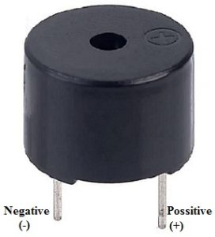Buzzer Pin Configuration

The **pin configuration of the buzzer** is shown below. It includes two pins namely positive and negative. The positive terminal of this is represented with the ‘+’ symbol or a longer terminal. This terminal is powered through 6Volts whereas the negative terminal is represented with the ‘-‘symbol or short terminal and it is connected to the GND terminal.

A buzzer is available in different types which include the following.

* Piezoelectric
* Electromagnetic
* Mechanical
* Electromechanical
* Magnetic

### ****What is a Servo Motor?****

A **servo motor** is a type of motor that can rotate with great precision. Normally this type of motor consists of a control circuit that provides feedback on the current position of the motor shaft, this feedback allows the servo motors to rotate with great precision. If you want to rotate an object at some specific angles or distance, then you use a servo motor. It is just made up of a simple motor which runs through a **servo mechanism**.

Servo motors are rated in kg/cm (kilogram per centimeter) most hobby servo motors are rated at 3kg/cm or 6It consists of three parts:

1. Controlled device
2. Output sensor
3. Feedback system

# DHT11 Sensor and Its Working

Humidity is the measure of water vapour present in the air. The level of humidity in air affects various physical, chemical and biological processes.  In industrial applications, humidity can affect the business cost of the products, health and safety of the employees. So, in [semiconductor](https://www.elprocus.com/why-do-we-use-semiconductors-instead-of-conductors-in-electronic-circuit-design/) industries and control system industries measurement of humidity is very important.  Humidity measurement determines the amount of moisture present in the gas that can be a mixture of water vapour, nitrogen, argon or pure gas etc…  Humidity sensors are of two types based on their measurement units.  They are a relative humidity sensor and Absolute humidity sensor. DHT11 is a digital temperature and humidity sensor.

## ****What is a DHT11 Sensor?****

DHT11 is a low-cost digital sensor for sensing temperature and humidity.  This sensor can be easily interfaced with any micro-controller such as Arduino, Raspberry Pi etc… to measure humidity and temperature instantaneously.

DHT11 humidity and temperature sensor is available as a sensor and as a module. The difference between this sensor and module is the pull-up resistor and a power-on LED. DHT11 is a relative humidity sensor.  To measure the surrounding air this sensor uses a [thermistor](https://www.elprocus.com/introduction-to-thermistor-types-with-its-workings-and-applications/" \t "_blank) and a capacitive humidity sensor.

## Applications

This sensor is used in various applications such as measuring humidity and temperature values in heating, ventilation and air conditioning systems. Weather stations also use these sensors to predict weather conditions.  The humidity[sensor](https://en.wikipedia.org/wiki/Humidity) is used as a preventive measure in homes where people are affected by humidity.  Offices, cars, museums, greenhouses and industries use this sensor for measuring humidity values and as a safety measure.

## ****Working Principle of DHT11 Sensor****

DHT11 sensor consists of a capacitive humidity sensing element and a thermistor for sensing temperature.  The humidity sensing [capacitor](https://www.elprocus.com/construction-of-capacitor-with-working/) has two electrodes with a moisture holding substrate as a dielectric between them. Change in the capacitance value occurs with the change in humidity levels. The IC measure, process this changed resistance values and change them into digital form.

For measuring temperature this sensor uses a Negative Temperature coefficient thermistor, which causes a decrease in its resistance value with increase in temperature. To get larger resistance value even for the smallest change in temperature, this sensor is usually made up of semiconductor ceramics or polymers.

The temperature range of DHT11 is from 0 to 50 degree Celsius with a 2-degree accuracy. Humidity range of this sensor is from 20 to 80% with 5% accuracy. The sampling rate of this sensor is 1Hz .i.e. it gives one reading for every second.  DHT11 is small in size with operating voltage from 3 to 5 volts. The maximum current used while measuring is 2.5mA.

A pull-up resistor of 5k to 10k ohms is provided for communication between sensor and micro-controller.

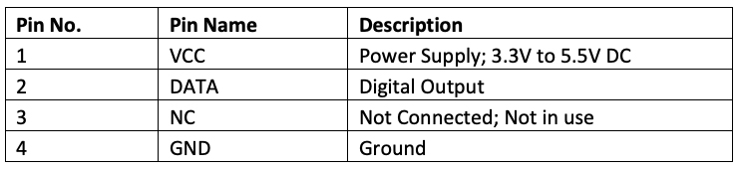

[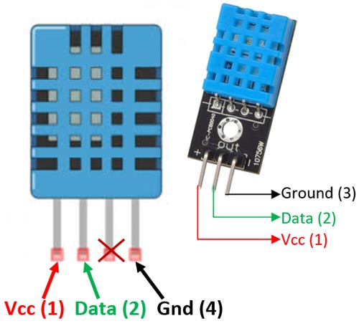](https://components101.com/sites/default/files/component_pin/DHT11%E2%80%93Temperature-Sensor-Pinout.jpg)

## ****DHT11 Specifications****

* Operating Voltage: 3.5V to 5.5V
* Operating current: 0.3mA (measuring) 60uA (standby)
* Output: Serial data
* Temperature Range: 0°C to 50°C
* Humidity Range: 20% to 90%
* Resolution: Temperature and Humidity both are 16-bit
* Accuracy: ±1°C and ±1%

**CODE:**

#include <dht.h>

#define dht\_apin A0 // Analog Pin sensor is connected to

dht DHT;

void setup(){

Serial.begin(9600);

delay(500);//Delay to let system boot

Serial.println("DHT11 Humidity & temperature Sensor\n\n");

delay(1000);//Wait before accessing Sensor

}//end "setup()"

void loop(){

//Start of Program

DHT.read11(dht\_apin);

Serial.print("Current humidity = ");

Serial.print(DHT.humidity);

Serial.print("% ");

Serial.print("temperature = ");

Serial.print(DHT.temperature);

Serial.println("C ");

delay(5000);//Wait 5 seconds before accessing sensor again.

//Fastest should be once every two seconds.

}// end loop

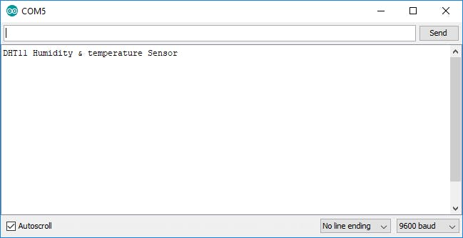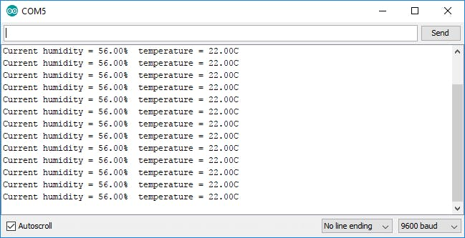

## What is a Soil Moisture Sensor?

The soil moisture sensor is one [kind of sensor](https://www.elprocus.com/accelerometer-sensor-working-and-applications/) used to gauge the volumetric content of water within the soil. As the straight gravimetric dimension of soil moisture needs eliminating, drying, as well as sample weighting. These sensors measure the volumetric water content not directly with the help of some other rules of soil like dielectric constant, electrical resistance, otherwise interaction with neutrons, and replacement of the moisture content.

The relation among the calculated property as well as moisture of soil should be adjusted & may change based on ecological factors like temperature, type of soil, otherwise electric conductivity. The microwave emission which is reflected can be influenced by the moisture of soil as well as mainly used in agriculture and remote sensing within hydrology.

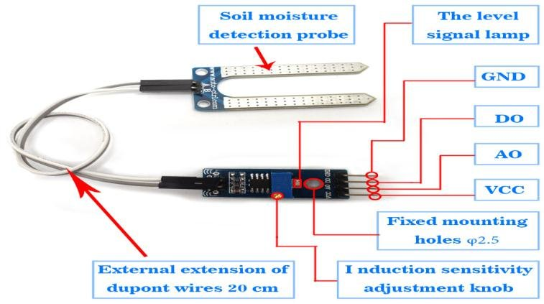

soil-moisture-sensor-device

These [sensors](https://www.elprocus.com/types-of-sensors-with-circuits/) normally used to check volumetric water content, and another group of sensors calculates a new property of moisture within soils named water potential. Generally, these sensors are named as soil water potential sensors which include gypsum blocks and tensiometer.

Soil Moisture Sensor Pin Configuration

The FC-28 soil moisture sensor includes 4-pins

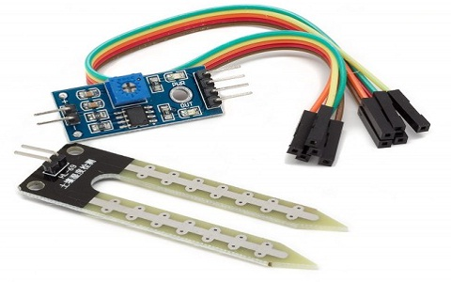

soil-moisture-sensor

* VCC pin is used for power
* A0 pin is an analog output
* D0 pin is a digital output
* GND pin is a Ground

This module also includes a potentiometer that will fix the threshold value, & the value can be evaluated by the [comparator-LM393](https://www.elprocus.com/lm393-ic-pin-configuration-circuit-diagram-and-its-working/). The [LED](https://www.elprocus.com/bipolar-led-driver-circuit-working-application/) will turn on/off based on the threshold value.

Working Principle:This sensor mainly utilizes capacitance to gauge the water content of the soil (dielectric permittivity). The working of this sensor can be done by inserting this sensor into the earth and the status of the water content in the soil can be reported in the form of a percent.

This sensor makes it perfect to execute experiments within science courses like environmental science, agricultural science, biology, soil science, botany, and horticulture.

Specifications

* The required voltage for working is 5V
* The required current for working is <20mA
* Type of interface is analog
* The required working temperature of this sensor is 10°C~30°C

**CODE**

|  |
| --- |
| /\* |
| Soil Moisture with Arduino - Analog Output |
| For more details, visit: https://techzeero.com/arduino-tutorials/soil-moisture-sensor-arduino/ |
| \*/ |
|  |
| int sensorPin = A0; |
| int outputValue ; |
|  |
| void setup() |
| { |
| Serial.begin(9600); |
| Serial.println("Reading Data From the Sensor ..."); |
| delay(2000); |
| } |
|  |
| void loop() |
| { |
| outputValue= analogRead(sensorPin); |
| outputValue = map(outputValue,550,0,0,100); |
|  |
| Serial.print("Moisture Value : "); |
| Serial.print(outputValue); |
| Serial.println("%"); |
| delay(1000); |
| } |

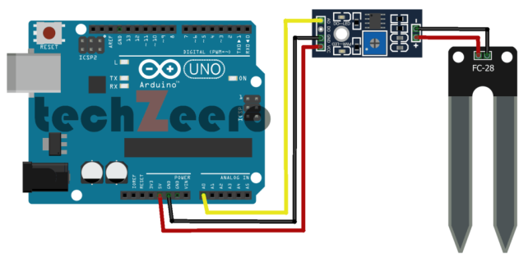

## ultrasonic sensor

An ultrasonic sensor is an electronic device that measures the distance of a target object by emitting ultrasonic sound waves, and converts the reflected sound into an electrical Ultrasonic sensors have two main components: the transmitter signal and the receiver

In order to calculate the distance between the sensor and the object, the sensor measures the time it takes between the emission of the sound by the transmitter to its contact with the receiver. The formula for this calculation is [D = ½ T x C](https://www.arrow.com/en/research-and-events/articles/ultrasonic-sensors-how-they-work-and-how-to-use-them-with-arduino) (where D is the distance, T is the time, and C is the speed of sound ~ 343 meters/second). For example, if a scientist set up an ultrasonic sensor aimed at a box and it took 0.025 seconds for the sound to bounce back, the distance between the ultrasonic sensor and the box would be: D = 0.5 x 0.025 x 343

* The sensing range lies between 40 cm to 300 cm.
* The response time is between 50 milliseconds to 200 milliseconds.
* The Beam angle is around 50.
* It operates within the voltage range of 20 VDC to 30 VDC
* Preciseness is ±5%
* The frequency of the ultrasound wave is 120 kHz
* Resolution is 1mm
* The voltage of sensor output is between 0 VDC – 10 VDC
* The ultrasonic sensor weight nearly 150 grams
* Ambient [temperature](https://www.watelectronics.com/temperature-sensor/) is -250C to +700C
* The target dimensions to measure maximum distance is 5 cm × 5 cm

#### Working

#### In general, an ultrasonic sensor has two sections which are the transmitter and receiver. These sections are closely placed so that the sound travel in a straight line from the transmitter to the target and travels back to the receiver.

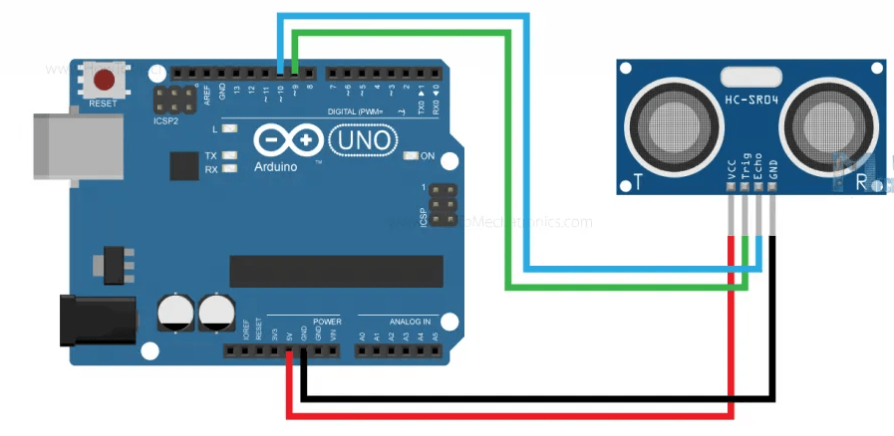

[Integration of Ultrasonic Transducer with Arduino](https://howtomechatronics.com/)

* These devices are also termed ultrasonic transceivers because both the transmitter and receiver sections are combined in a single unit which considerably minimizes the PCB footprint.
* Here, the sensor operates as a burst signal and it is transmitted for some period. Later the transmission, there exists a **silent period** and this period is termed **response time**. The response time indicates that it is waiting for the reflected waves.
* The shape of the acoustic waves that leave the transmitter section resembles the same shape of the light emitted from a laser so beam angle and spread have to be measured. When the sound waves move away from the transmitter, the detection area increases vertically and sideways too. Because of the varying detection area, the coverage specification is considered either as beam angle/beamwidth other than the standard area of detection.
* The transmitted/acoustic signals might find a hindrance or not. When there is any hindrance, the acoustic wave bounces back from the hindrance. This bounced signal is termed ECHO. This echo travels to the receiver.
* Then the received signal is either filtered or amplified and then transformed into a digital signal. With the time between transmission and reception of acoustic waves, the distance between the ultrasonic system and hindrance can be known.

## Code:

/\*

\* Arduino - Ultrasonic Sensor HC-SR04

\* Wiring: Ultrasonic Sensor -> Arduino:

\* - VCC -> 5VDC

\* - TRIG -> Pin 9

\* - ECHO -> Pin 8

\* - GND -> GND

\*/

int trigPin = 9; // TRIG pin

int echoPin = 8; // ECHO pin

float duration\_us, distance\_cm;

void setup() {

// begin serial port

Serial.begin (9600);

// configure the trigger pin to output mode

pinMode(trigPin, OUTPUT);

// configure the echo pin to input mode

pinMode(echoPin, INPUT);

}

void loop() {

// generate 10-microsecond pulse to TRIG pin

digitalWrite(trigPin, HIGH);

delayMicroseconds(10);

digitalWrite(trigPin, LOW);

// measure duration of pulse from ECHO pin

duration\_us = pulseIn(echoPin, HIGH);

// calculate the distance

distance\_cm = 0.017 \* duration\_us;

// print the value to Serial Monitor

Serial.print("distance: ");

Serial.print(distance\_cm);

Serial.println(" cm");

delay(500);

}

## What is an IR Sensor/Infrared Sensor?

An infrared sensor is an electronic device, that emits in order to sense some aspects of the surroundings. An IR sensor can measure the heat of an object as well as detects the motion. These types of sensors measure only infrared radiation, rather than emitting it that is called a [passive IR sensor](https://www.elprocus.com/passive-infrared-pir-sensor-with-applications/). Usually, in the infrared spectrum, all the objects radiate some form of thermal radiation.

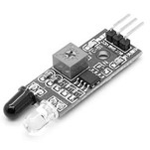Infrared Sensor

These types of radiations are invisible to our eyes, which can be detected by an infrared sensor. The emitter is simply an IR LED ([Light Emitting Diode](https://www.elprocus.com/explain-different-types-leds-working-applications-engineering-students/)) and the detector is simply an IR photodiode that is sensitive to IR light of the same wavelength as that emitted by the IR LED. When IR light falls on the photodiode, the resistances and the output voltages will change in proportion to the magnitude of the IR light received.

### Working Principle

The working principle of an infrared sensor is similar to the object detection sensor. This sensor includes an IR LED & an IR Photodiode, so by combining these two can be formed as a photo-coupler otherwise optocoupler. The physics laws used in this sensor are planks radiation, Stephan Boltzmann & weins displacement.

IR LED is one kind of transmitter that emits IR radiations. This LED looks similar to a standard LED and the radiation which is generated by this is not visible to the human eye. Infrared receivers mainly detect the radiation using an infrared transmitter. These infrared receivers are available in photodiodes form. IR Photodiodes are dissimilar as compared with usual photodiodes because they detect simply IR radiation. Different kinds of infrared receivers mainly exist depending on the voltage, wavelength, package, etc.

Once it is used as the combination of an IR transmitter & receiver, then the receiver’s wavelength must equal the transmitter. Here, the transmitter is IR LED whereas the receiver is IR photodiode. The infrared photodiode is responsive to the infrared light that is generated through an infrared LED. The resistance of photo-diode & the change in output voltage is in proportion to the infrared light obtained. This is the IR sensor’s fundamental working principle.

Once the infrared transmitter generates emission, then it arrives at the object & some of the emission will reflect back toward the infrared receiver. The sensor output can be decided by the IR receiver depending on the intensity of the response.

### Types of Infrared Sensor

Infrared sensors are classified into two types like active IR sensor and passive IR sensor.

#### Active IR Sensor

This active infrared sensor includes both the transmitter as well as the receiver. In most of the applications, the light-emitting diode is used as a source. LED is used as a non-imaging infrared sensor whereas the laser diode is used as an imaging infrared sensor.

These sensors work through energy radiation, received & detected through radiation. Further, it can be processed by using the signal processor to fetch the necessary information. The best examples of this active infrared sensor are reflectance and break beam sensor.

#### Passive IR Sensor

The passive infrared sensor includes detectors only but they don’t include a transmitter. These sensors use an object like a transmitter or IR source. This object emits energy and detects through infrared receivers. After that, a signal processor is used to understand the signal to obtain the required information.

The best examples of this sensor are pyroelectric detector, bolometer, thermocouple-thermopile, etc. These sensors are classified into two types like thermal IR sensor and quantum IR sensor. The thermal IR sensor doesn’t depend on wavelength. The energy source used by these sensors is heated. Thermal detectors are slow with their response and detection time. The quantum IR sensor depends on the wavelength and these sensors include high response and detection time. These sensors need regular cooling for specific measurements.

### IR Sensor Circuit Diagram

An infrared sensor circuit is one of the basic and popular sensor modules in an [electronic device](https://www.elprocus.com/basic-components-used-electronics-electrical/). This sensor is analogous to human’s visionary senses, which can be used to detect obstacles and it is one of the common applications in real-time. This circuit comprises the following components

* [LM358 IC](https://www.elprocus.com/op-amp-ics-pin-configuration-features-working/) 2 IR transmitter and receiver pair
* Resistors of the range of kilo-ohms.
* Variable resistors.
* LED (Light Emitting Diode).

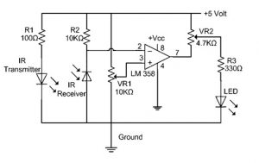Infrared Sensor Circuit Diagram

In this project, the transmitter section includes an IR sensor, which transmits continuous IR rays to be received by an IR receiver module. An IR output terminal of the receiver varies depending upon its receiving of IR rays. Since this variation cannot be analyzed as such, therefore this output can be fed to a comparator circuit. Here an [operational amplifier](https://www.elprocus.com/op-amp-ics-pin-configuration-features-working/) (op-amp) of LM 339 is used as a comparator circuit.

When the IR receiver does not receive a signal, the potential at the inverting input goes higher than that non-inverting input of the comparator IC (LM339). Thus the output of the comparator goes low, but the LED does not glow. When the IR receiver module receives a signal to the potential at the inverting input goes low. Thus the output of the comparator (LM 339) goes high and the LED starts glowing.

Resistor R1 (100 ), R2 (10k ), and R3 (330) are used to ensure that a minimum of 10 mA current passes through the IR LED Devices like Photodiode and normal LEDs respectively. Resistor VR2 (preset=5k ) is used to adjust the output terminals. Resistor VR1 (preset=10k ) is used to set the sensitivity of the circuit Diagram. Read more about IR sensors.